Microeconomics- All of the Chapters Combined
Chapter 1- Macroeconomics and Microeconomics: The Basics
In this chapter, we will learn that economics (eh-koe-nah-mics) is all about the choices we make with scarce resources. Economics is the study of how people deal with scarcity. Scarcity is a situation in which individuals, businesses, and governments have unlimited wants but their resources are limited. Economic interaction between people occurs every time they trade or exchange goods with each other, usually in a market. A market is an arrangement by which buyers and sellers can interact and exchange goods and services with each other.
Scarcity of funds and resources causes everyone to make choices. The opportunity cost of a choice is the value or cost of a positive alternative that was not chosen. If you buy sunglasses instead of a hat, then the opportunity cost (or, as we call it in class, the opportunity lost) is the hat. In teenager terminology, the
opportunity cost (or lost) is the girl or boy you decided not to go out with when you chose to date someone. But, the loss must be a positive loss. Choosing not to date someone who cheats all the time is not an example of opportunity cost; that is just a smart decision.
Free Response Question (FRQ) #1
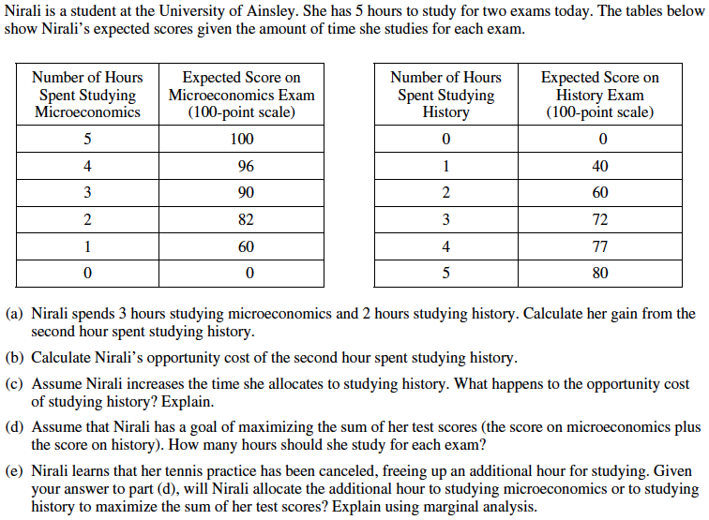

Free Response Question (FRQ) #1 (answer)
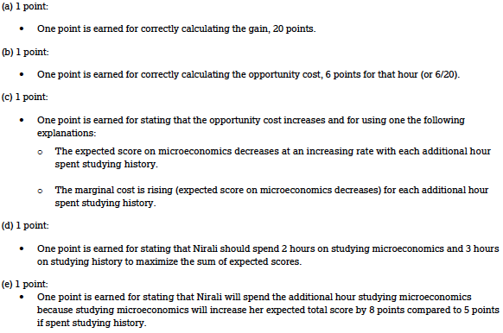

Economic interaction between multiple people, companies, countries, etc. can lead to gains from trade which reallocates (exchanges) goods in a way that benefits everyone involved. Economic interaction allows for specialization: people concentrating on what they are good at). Economic interaction also can allow for a division of labor (when some workers specialize in one task while others specialize in another task).
Suppose that an economy can produce either computers or movies. With a scarcity of resources such as labor (workers) and capital (money for business), there is a choice between producing some goods versus others. The table below gives an example of the alternative choices, or the production possibilities, for computers and movies. Each choice, A-F, leads to different production numbers. Marginal analysis (a cost-benefit analysis) is used to determine if the potential increase in profits outweigh the costs of making different decisions.
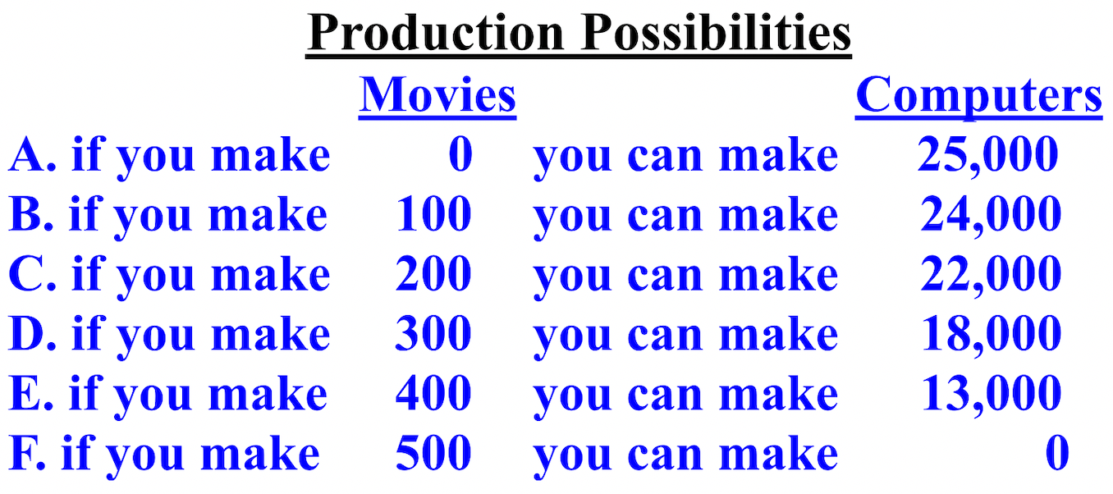

The opportunity cost of producing more movies is the value of the computers not produced, and vice versa. The opportunity cost, or lost, in terms of computers, of producing more movies increases as we require a loss of more and more computers. This is called increasing opportunity costs. Moving from production possibility A to B requires an opportunity cost of 1,000 computers (25,000 to 24,000), but moving from production possibility A to C increases the opportunity cost to 3,000 computers (25,000 to 22,000).
A production possibilities curve/frontier (PPC/PPF) graphs both short-run (SR) and long-run (LR) tradeoffs, communicates choices, scarcity, and opportunity costs. A production possibilities curve/frontier with a curved curve indicates increasing/not proportional opportunity costs anywhere on the line for both items. When moving from point D to E, to make 6 cars (0 to 6) requires an opportunity cost (loss) of 2 bikes (10 to 8). Moving from E to B increases the number of cars by 2 (6 to 8), but the opportunity cost is now another 2 bikes (8 to 6). The changes aren't constant/proportional and the resources being used are not easily adaptable between both products.
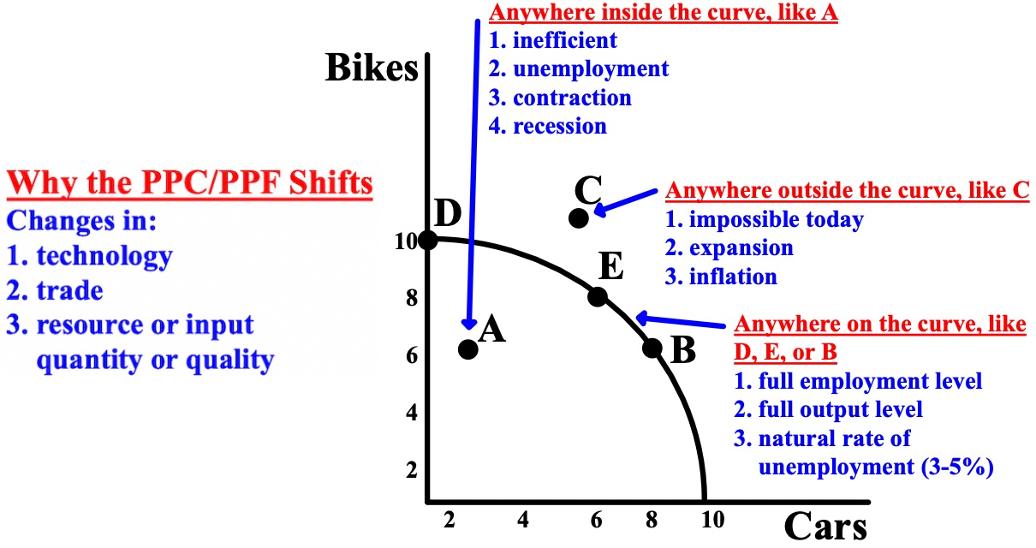

A production possibilities curve/frontier with a straight curve indicates constant and proportional opportunity costs anywhere on the curve. The resources are easily adaptable between both products are perfect substitutes. If the PPC/PPF is a straight curve, the amount of Good A you have to give up to make one more of Good B is the same everywhere, and the amount of B you have to give up to make one more A is the same everywhere as well.
For every increase of 30 of Good B, there is a decrease of Good A by 60. For every increase of Good A by 60, there is a decrease of Good B by 30. Both goods have constant opportunity costs.

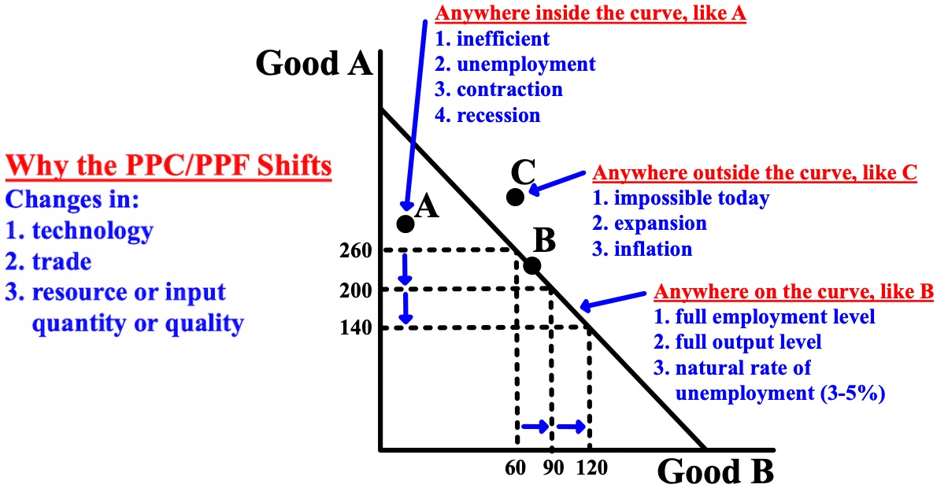
Depending on where an economy is, this determines the location of the dot ".". On either curve, curved or straight, indicates efficient or production efficient (the maximum amount that can be produced with the available resources at that time). On either curve usually but not always indicates full use of resources, full employment, and peak output in an economy. This means that production is allocatively efficient (the most efficient distribution of available resources for a firm/country). On either curve can also mean that production is socially optimal (the optimal distribution of resources in society that is best for firms/countries and for society itself).

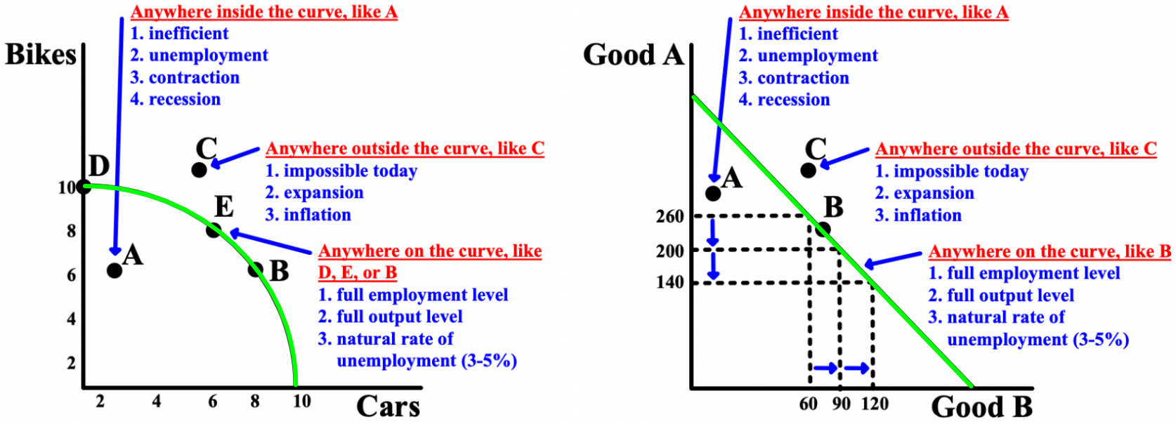

To the left of the line indicates unemployment, contraction of the economy, under production, possible labor force reduction and recession, and inefficiency because the economy can produce a larger number. Points inside the production possibilities curve/frontier, like A, are possible, but they are inefficient.
To the right of the line indicates long-run aggregate supply (LRAS) (a country’s total supply of goods and services in the long-run) expansion, over production, and an impossibility because the economy does not have the resources at that time to produce those quantities.
Free Response Question (FRQ) #2
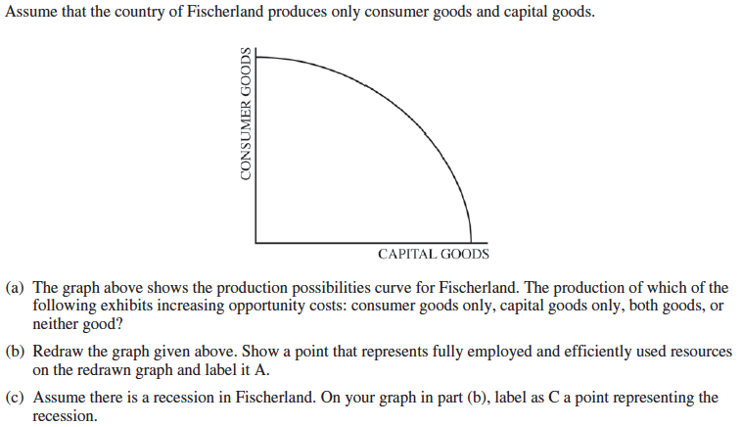
Free Response Question (FRQ) #2 (answer)
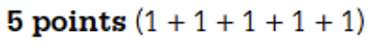
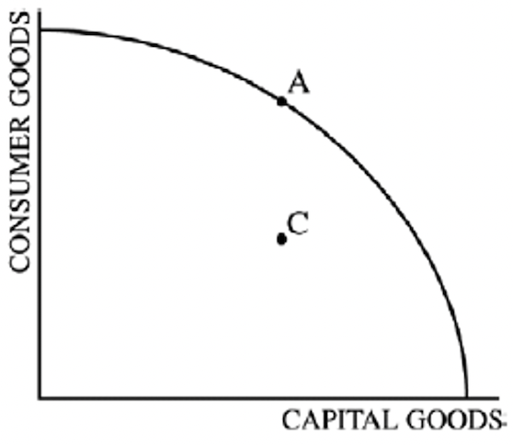
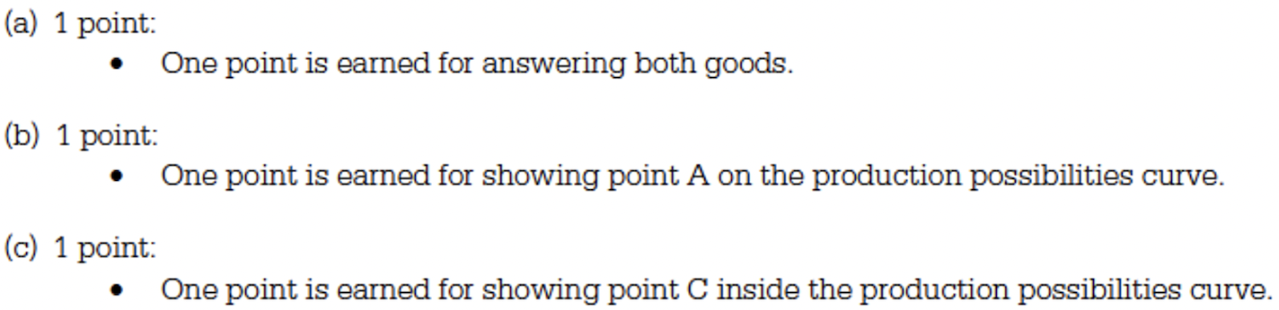

Regardless of which production possibilities curve/frontier (PPC/PPF) is graphed, both represent a tradeoff and decisions about scarce resources. When the PPC/PPF shifts out, the economy grows because more goods and services are being produced (#1 below), but it can also shift in, usually during natural disasters. The PPC/PPF can also shift in or out for only one of the variables while the other variable remains the same (#2 and #3 below). The PPC/PPF can also show an increase or decrease in the quantity demanded (Qd) of only one of the variables (#4 below).

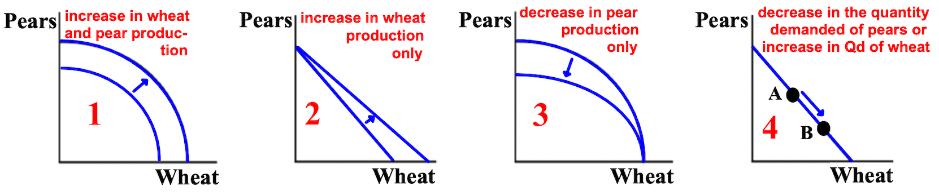

Absolute advantage is a situation in which a person, business, or country can produce more of a good than another can. One entity can simply make more of a product than another. Comparative advantage is a situation in which a person, business, or country can produce a good more efficiently and with less opportunity cost (loss) than another. McDonalds can certainly produce hamburgers more efficiently and with less opportunity cost than Best Buy. Comparative advantage is the most important calculation because it determines who should make what products allowing many to benefit from trade and specialization in the production of a product.
The USA has an absolute advantage in producing both food and clothing; they made more of both than Japan, but, comparative advantage matters more. To calculate opportunity costs= what we give up / what we get. The lowest opportunity cost (lost)/most efficient is the winner. In food, the USA has a comparative advantage: 3/6 = .5 vs. 2/1= 2 (Japan), and .5 is less than 2. In clothing, Japan wins: 1/2 = .5 vs. 6/3= 2 (USA), and .5 is less than 2.
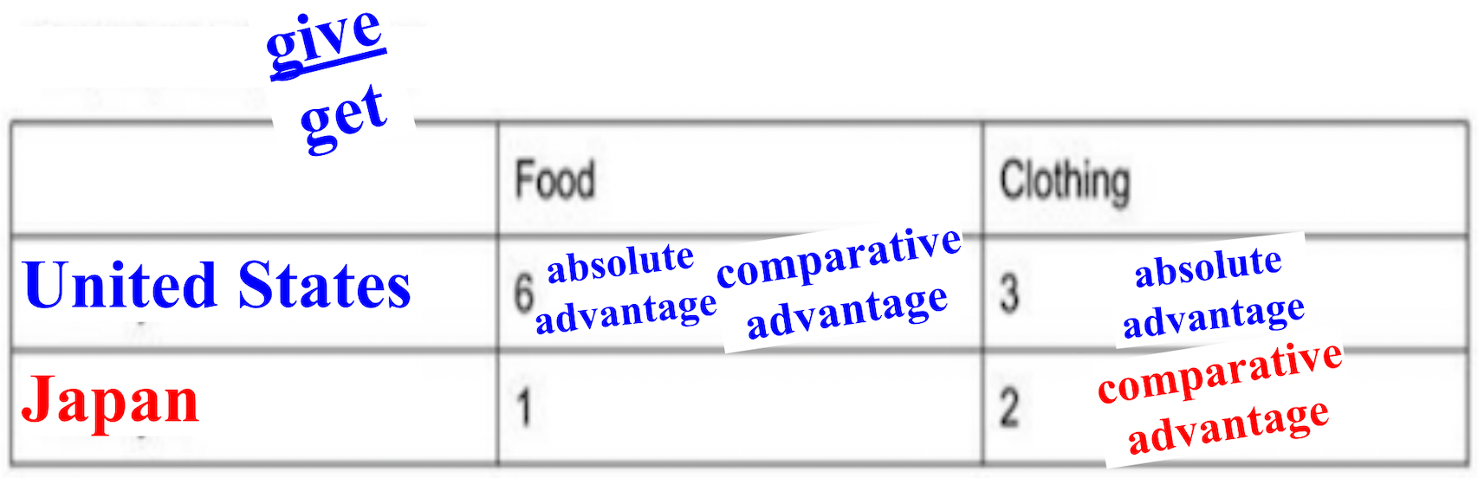
In the production possibilities curve/frontier, India has the absolute advantage in nuts and China in grapes. In grapes, China has the comparative advantage:10/10= 1 vs. 12/8= 1 1/2 (India), and 1 is less than 1 1/2. In nuts, India has the comparative advantage, 8/12= .66 to 10/10= 1 (China). China will grow grapes and India will grow nuts and both will benefit.
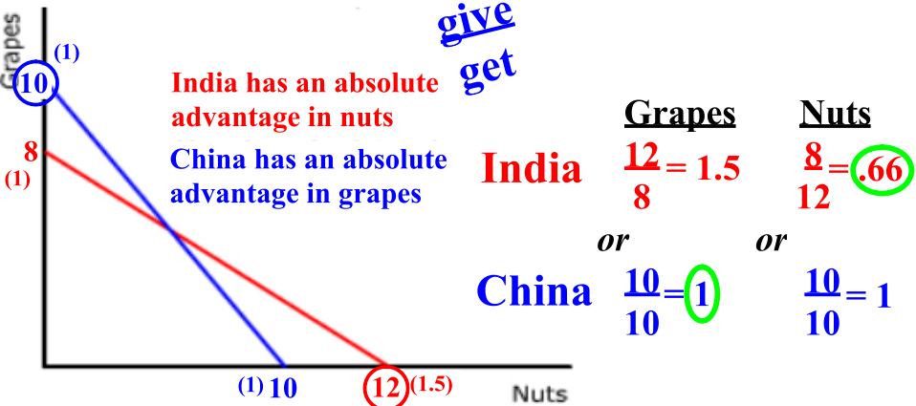
In the PPC/PPF, India has the absolute advantage in nuts and grapes. In grapes, China has the comparative advantage, 4/6 vs. 18/9. In nuts, India has the comparative advantage, 9/18 vs. 6/4. China will grow grapes and India will grow nuts.
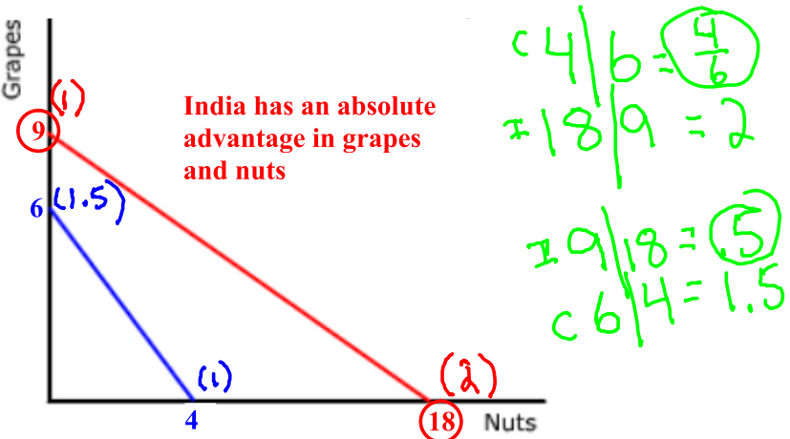
Free Response Question (FRQ) #3
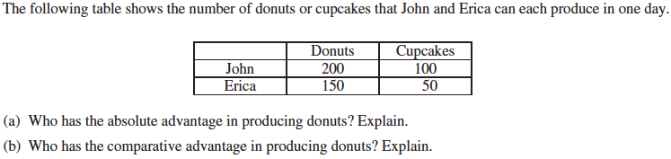

Free Response Question (FRQ) #3 (answer)
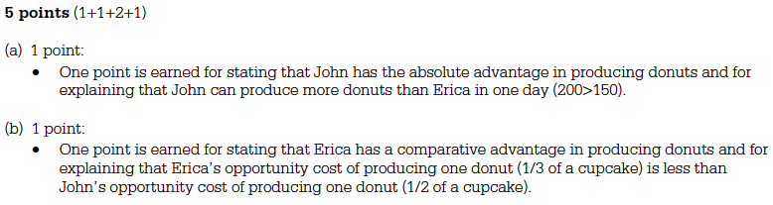
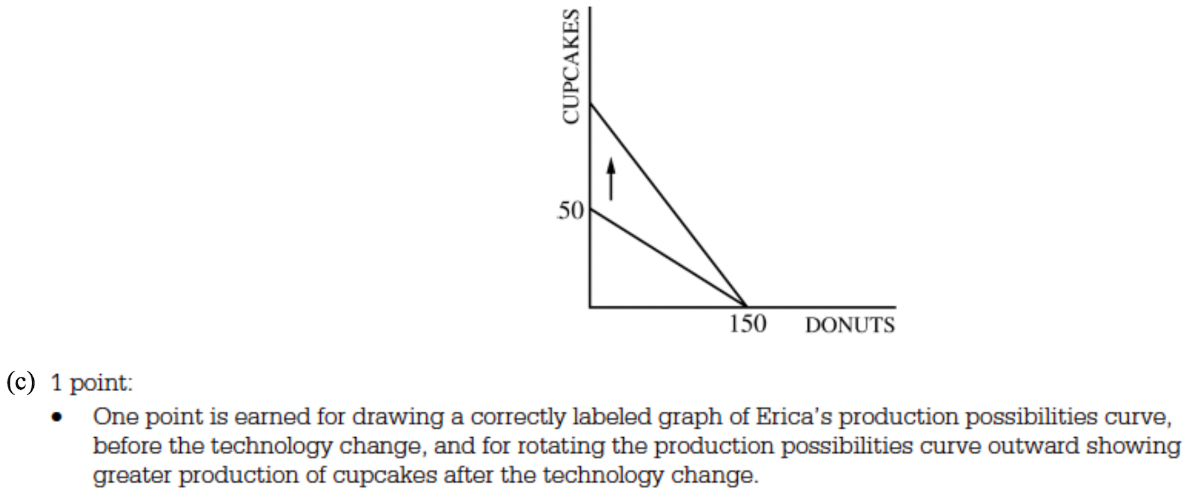

Free Response Question (FRQ) #4 and answer
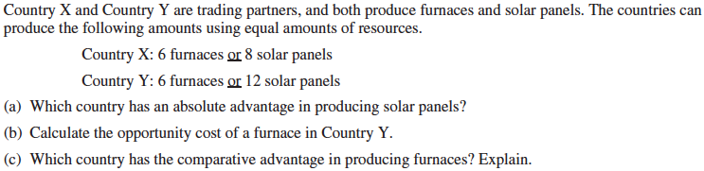

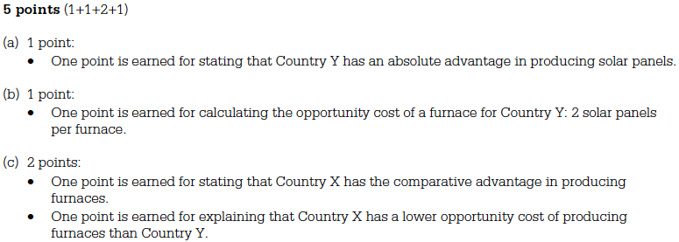
Free Response Question (FRQ) #5 and answer
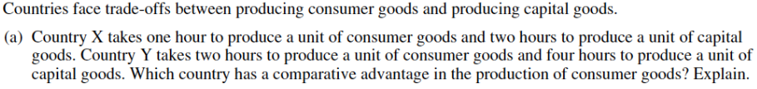

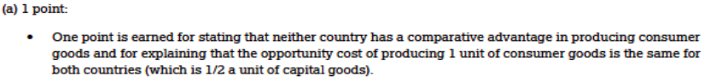
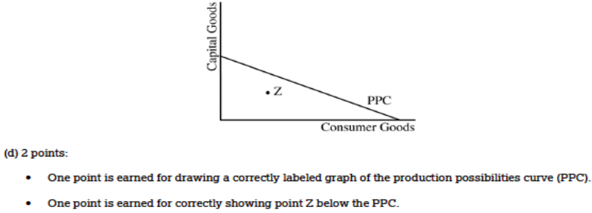

There are three essential questions or problems that every economy must find a way to solve: 1) what is to be produced, 2) how are those goods to be produced, and 3) for whom are the goods to be produced? A free market economy and a command/centrally planned economy offer different approaches to these questions. In a free market economy, democracies base their economies on capitalism and most decisions about what, how, and for whom to produce are made by individual consumers (those who buy), firms (companies), governments, and other organizations interacting in the markets. In a command or centrally planned economy, such as in a communist or socialist country, decisions about what, how, and for whom to produce are made by those in control of the government. Many economies are mixed economies, or a mixture of both.
In order to use models for prediction, economists use the assumption ceteris paribus, which means "all other things equal"; (the prediction that a variable will not change assumes there is nothing that can change it). A key belief of classical economists is the concept of laissez faire ("hands off" or little government control, where the role of the government is mainly to promote competition and reduce restrictions on the exchange of goods and services.

Chapter 2- Macro. and Micro.: The Basics: Supply and Demand
This chapter is about how the supply and demand model is used to explain how markets, such as the healthcare or car market, determine prices (P) and quantity (Q). Markets consists of three elements: 1) quantity demanded (Qd)- describing the behavior of consumers (those who demanded/buy) in the market), 2) quantity supplied (Qs)- describing the behavior of firms/businesses (those who supply/produce) in the market), and 3) market equilibrium (Me)- connecting quantity demanded and quantity supplied; the point where consumers and firms agree on the price and quantity in the market.
Classical economics- the belief that economies will self-correct over time and that governments should not get involved. If an economy is expanding (growing) or contracting (shrinking) and no financial actions are taken by the Federal Reserve or Congress, the economy will eventually return to its typical equilibrium by itself. This happens because in most situations, if an economy is in expansion/has high inflation (high prices), workers' wages will increase which will decrease how much companies have to spend. If an economy is in contraction/in recession, workers' wages will decrease which will increase how much companies have to spend.
Demand (D) is a relationship between two economic variables factors): 1) the price (P) of a particular good and 2) the quantity demanded (Qd) of a particular good (how much consumers are willing to buy at a specific price). The law of demand says that the higher the price of a good is in a market, the lower the quantity demanded of the good by consumers, and the lower the price of a good, the higher the quantity demanded.

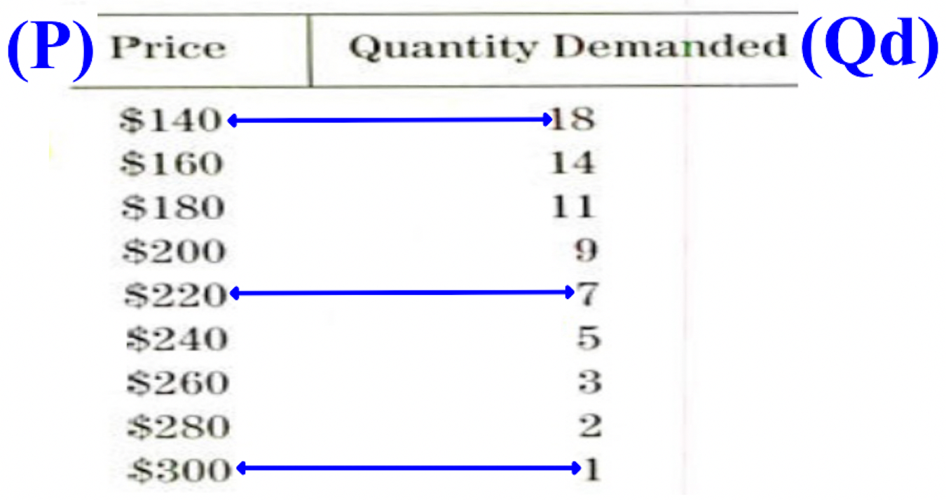

The graph below is a demand curve. It represents the law of demand graphically. The market demand curve slopes downward left to right and shows the market quantity (the quantity demanded of goods and services at any given price.
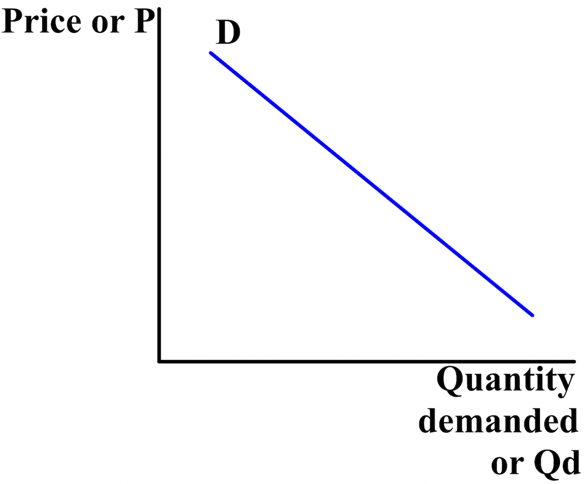
The quantity demanded (Qd) of a good or service that people buy is affected by the item's price (P), consumers' tastes and preferences, the number of consumers in the market, the price of similar goods, consumers' incomes, and consumers' expectations of the future market price (the price of something that is sold in a market). An increase in quantity demanded shifts (moves) the demand curve up/to the right (left graph). A decrease in quantity demanded shifts the demand curve down/to the left (right graph).

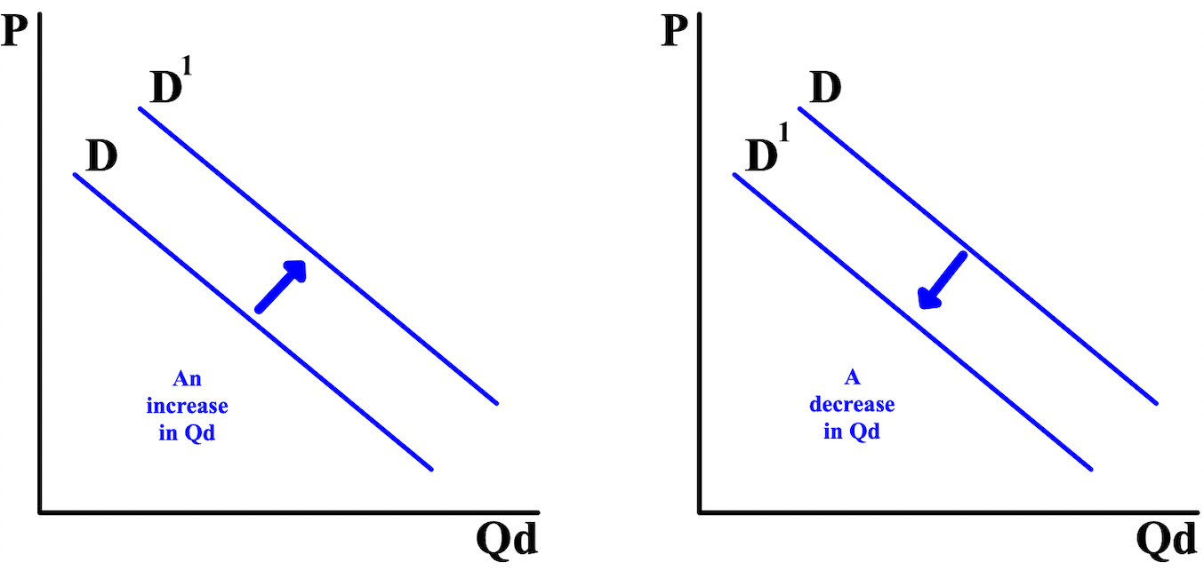

Goods for which quantity demanded (Qd) increases when income rises and decreases when income falls are called normal goods. The quantity demanded for inferior goods may decline when income increases. The prices (P) of closely related goods are also a factor. A substitute is a good that provides some of the same uses or enjoyment as another good, like buying a, electric bike instead of a motorcycle. But, a sharp increase in the cost of bicycle helmets, a good closely related to bicycles, will decrease the quantity demanded for bicycles, especially if there is a law requiring helmets. A good that tends to be consumed together with another good is called a complementary good and it plays a factor in how much another good made is wanted.
When graphing demand (D) curves, it is very important to distinguish shifts of the demand curve from movements along the demand curve. A movement along the demand curve occurs when the quantity demanded (Qd) changes as a result of a change in the price (P) of the good or service.
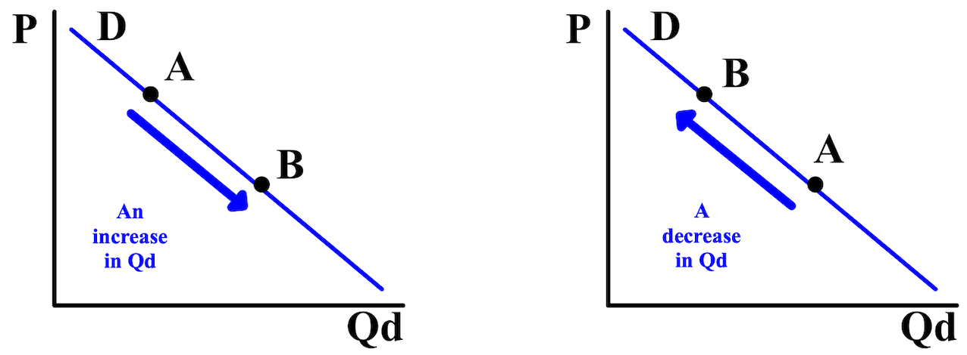
For example, if the price of bicycles decreases for any reason, the quantity demanded (Qd) by consumers will show a movement along the demand curve to the right from point A to point B (left graph). If the price of bicycles increases for any reason, the quantity demanded by consumers will show a movement along the demand curve to the left from point A to point B (right graph).
Supply (S) is a relationship between two economic variables (factors): 1) the price (P) of a particular good and 2) the quantity supplied (Qs) of a particular good (how much firms are willing to sell at a specific price). The law of supply states that the higher the price of a good is in a market, the higher the quantity supplied of the good by sellers, and the lower the price of a good, the lower the quantity supplied. When the price for a product increases, suppliers will attempt to maximize their profits by increasing the quantity supplied for sale before quantity demanded starts to fall. When the price for a product decreases, suppliers will attempt to minimize their losses by producing less.
The graph below is a supply curve. It represents the law of supply graphically. The market demand curve slopes upward left to right and shows the market quantity (the quantity supplied of goods and services at any
given price.
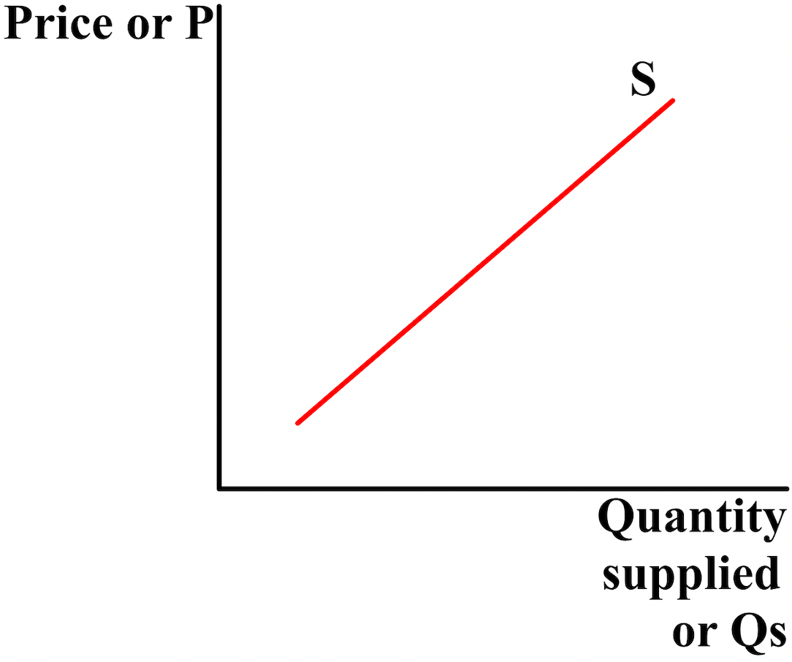

The quantity supplied (Qs) of a good or service that firms/businesses produce is affected by the price (P) and availability of inputs/resources used in production, the number of firms in the market, technology, government taxes and subsidies, and regulations, and the expectations of future prices and profit. An increase in quantity supplied shifts the supply curve down/to the right (left graph). A decrease in quantity demanded shifts the demand curve down/to the left (right graph).
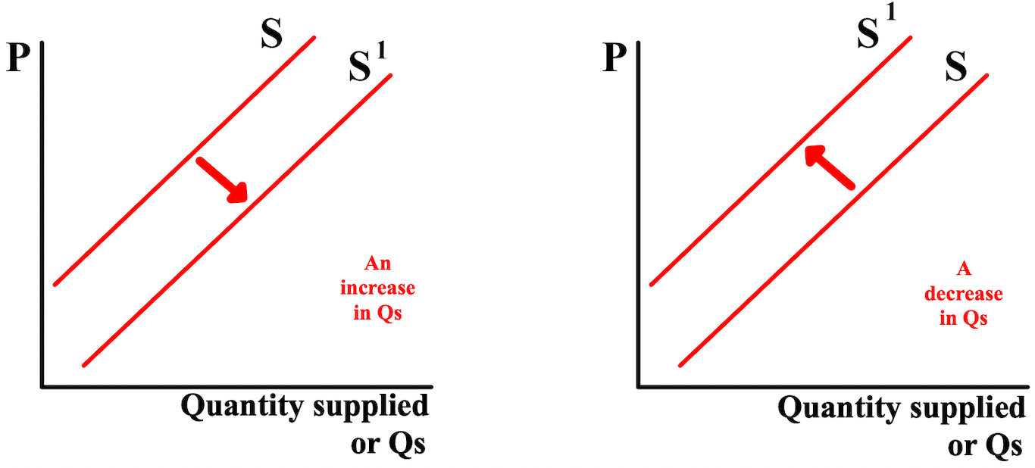

When graphing demand (S) curves, it is very important to distinguish shifts of the supply curve from movements along the demand curve. Just like with the demand curve, a movement along the supply curve
occurs when the quantity demanded (Qd) changes as a result of a change in the price (P) of the good or service.

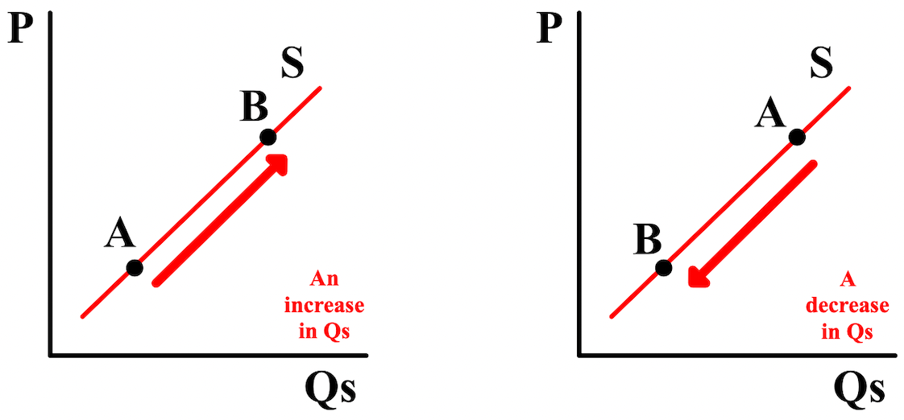

Double-shifts occur when both demand and supply shift at the same time. when this happens, both demand and supply can increase of decrease or one can increase while the other decreases. When a double-shift occurs, of the new quantity (Q) or price (P), one of them can be determined but the other will be indeterminate. The only way to know is to graph the double-shift. Below, the new price is indeterminate but the new quantity can be determined.
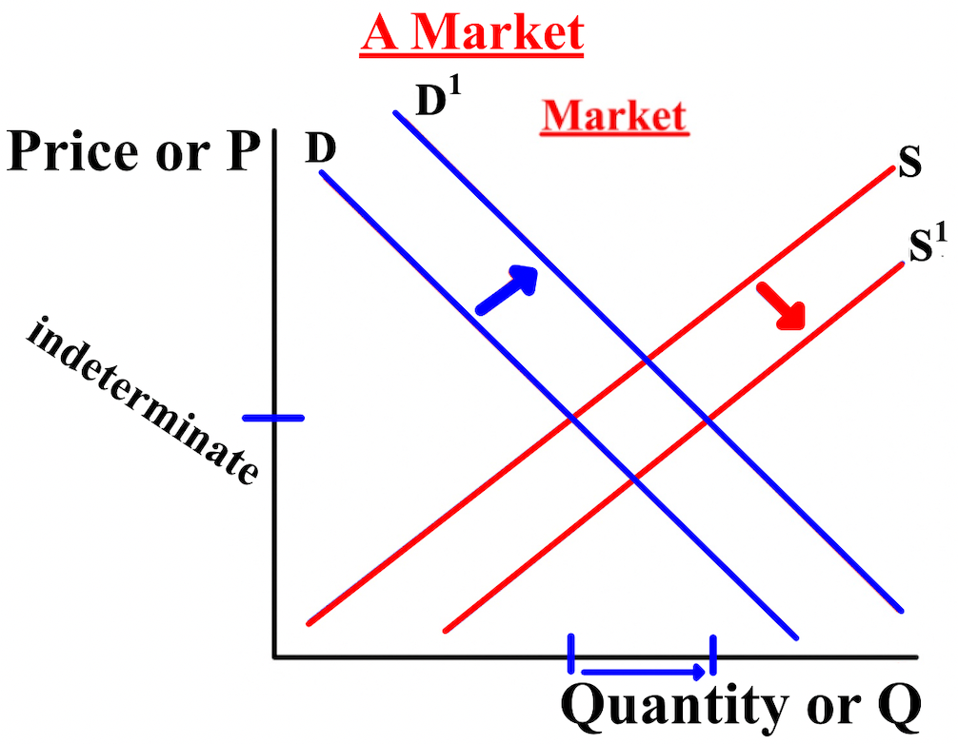
Markets determines prices. Buyers (Qd) and sellers (Qs) interact. A price that both determine and accept comes about. The prices are high enough for the sellers to cover their costs and make a profit and low enough for the buyers to afford and feel like they are benefiting from the purchase.
Looking at the bicycle price (P) of $160 below, the quantity demanded (Qd) by consumers (14 bicycles) is greater than the quantity supplied (Qs) by firms (4 bicycles); there is a shortage of 10 bicycles (14-4). A shortage, or excess demand, is a situation in which the quantity demanded is greater than the quantity supplied.
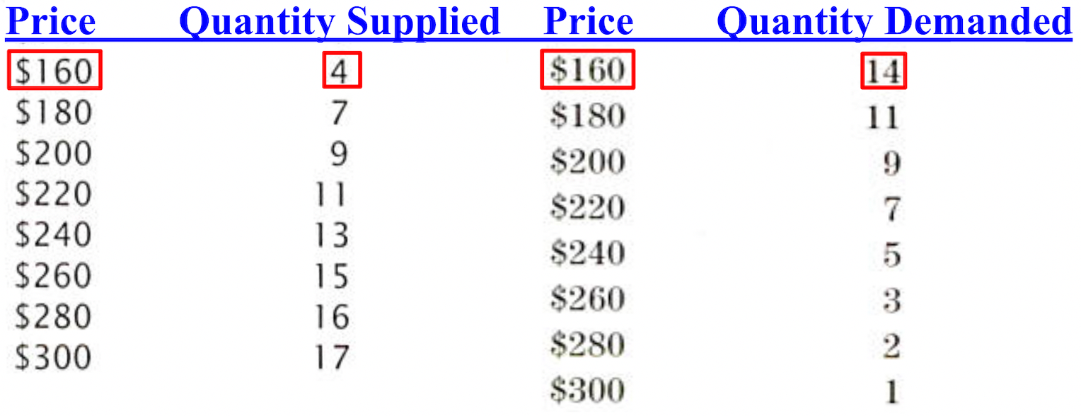
Looking at the bicycle price (P) of $260 below, the quantity demanded (Qd) by consumers (3 bicycles) is less than the quantity supplied (Qs) by firms (15 bicycles); there is a surplus of 12 bicycles (15-3). A surplus, or excess supply, is a situation in which the quantity supplied is greater than the quantity demanded.
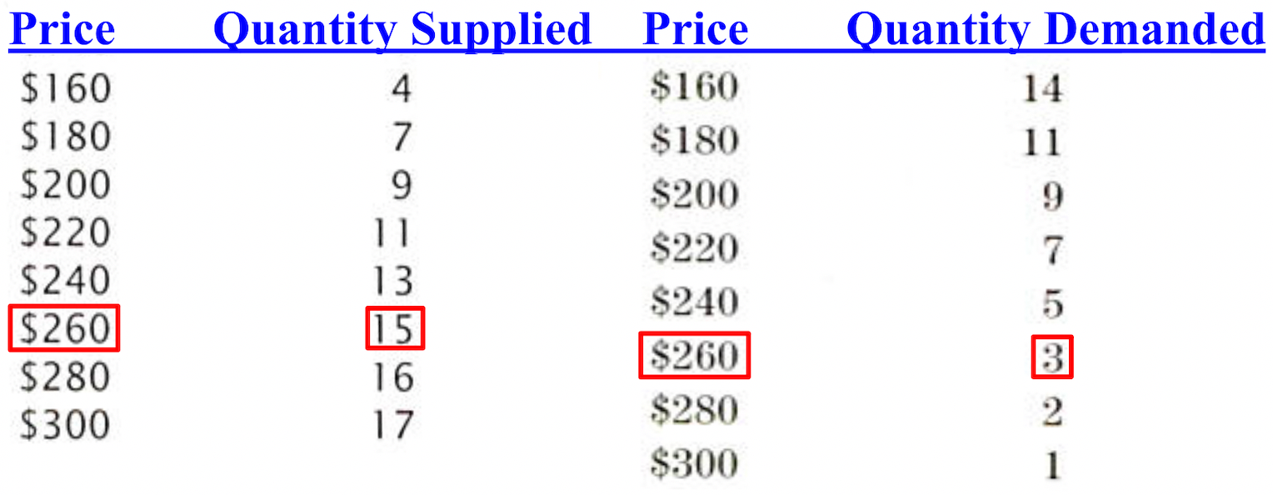
The equilibrium price (Pe) is the price at equilibrium (the price where supply (S) and demand (D) meet). The equilibrium quantity (Qe) is the quantity at equilibrium (the quantity where supply (S) and demand (D) meet). Often in our class, a market supply (S) and demand (D) diagram will not have any numerical data;
unless you are told to include numbers, don't.

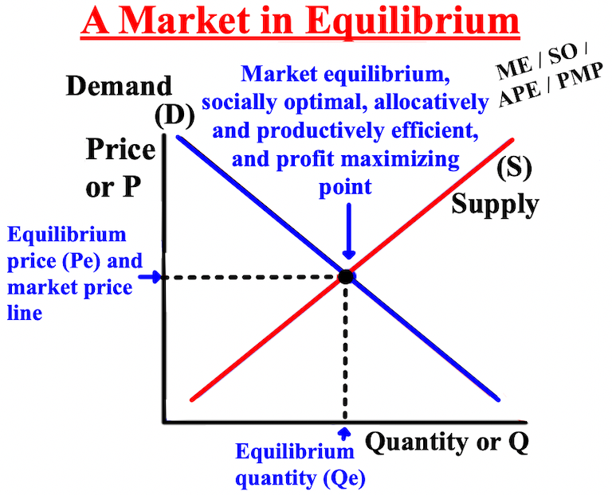
The graphs below show the effects of an increase in quantity demanded (Qd) (left graph) and a decrease in quantity demanded (right graph). The demand curves before and after the shift are labeled D for the "old
demand curve and D1 for the "new demand curve." With a shift and a new demand curve, there is a new intersection and, therefore, a new equilibrium quantity (Qe1), equilibrium price (Pe1), and market equilibrium (Me1).
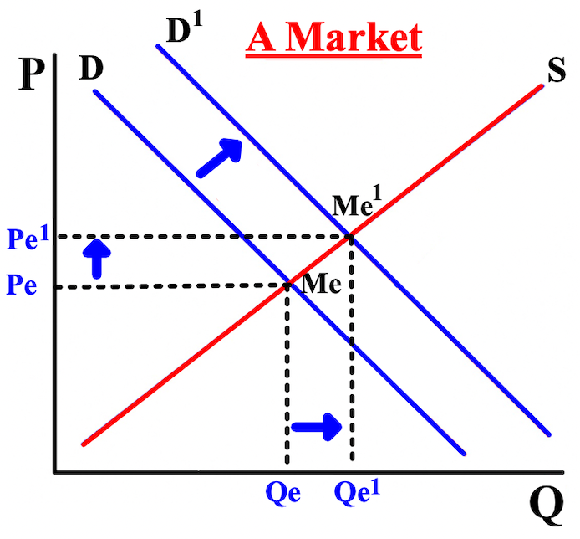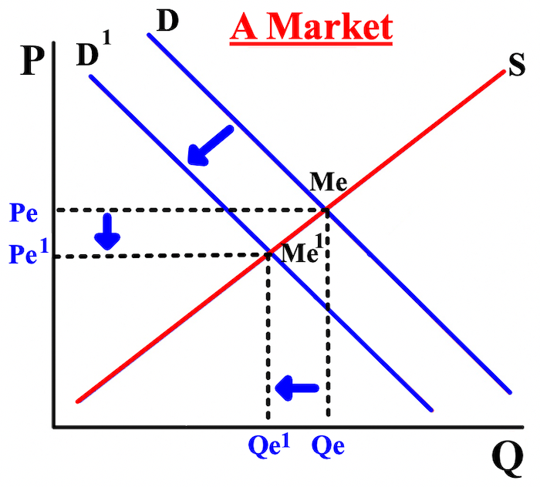

The graphs show the effects of an increase in quantity supplied (Qs) (left graph) and a decrease in quantity supplied (right graph). The supply curves before and after the shift are labeled S for the old supply curve and S1 for the new supply curve. With a shift and a new supply curve, there is a new intersection and, therefore, a new equilibrium quantity (Qe1), equilibrium price (Pe1), and market equilibrium (Me1).
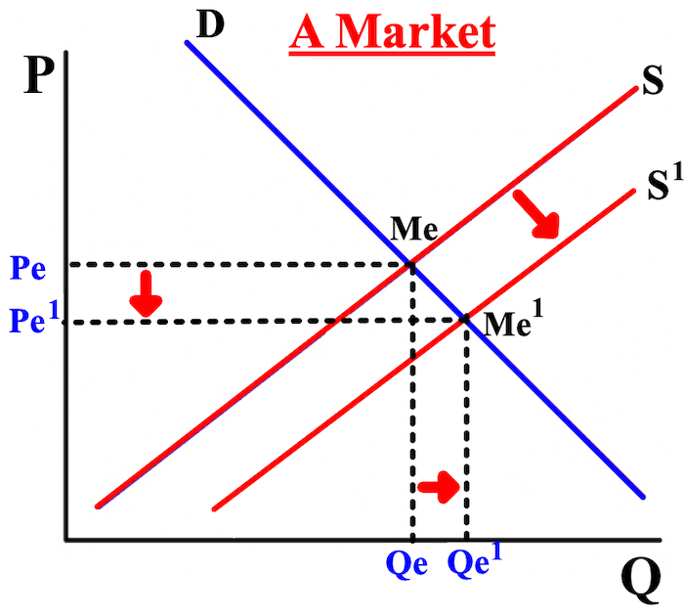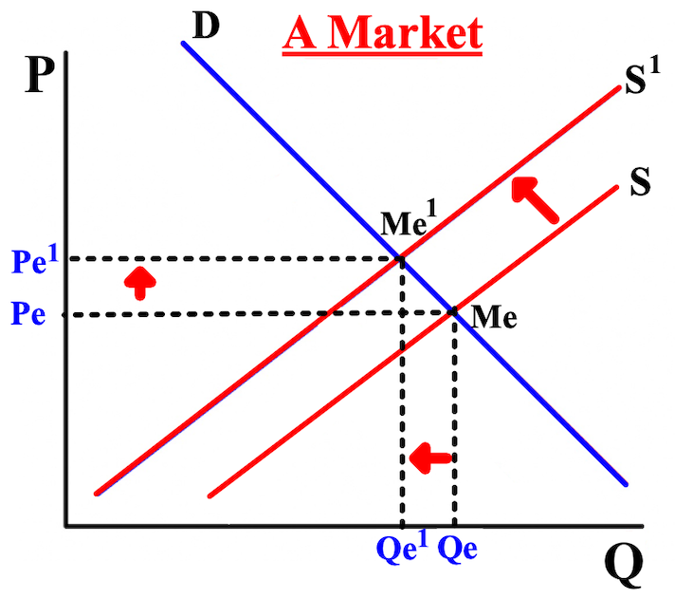
In free market economies, demand (D) and supply (S) usually determine the price (P) and quantity supplied (Qs) without government control, called freely determined prices. In socialist and communist countries, governments attempt to make the decisions and to control market prices, referred to as price controls.

There are two types of government price (P) controls. Controls can stipulate a price ceiling, or a maximum price at which a good can be bought and sold, like price controls on rental apartments. If the government sets a price ceiling, the product will be cheaper and more consumers will be able to purchase it, resulting in a shortage of the good in the market. Controls can also stipulate a price floor, or a minimum price at which a good can be bought and sold, like workers' wages. If the government sets a price floor, the product will be more expensive
and fewer consumers will be able to purchase it, resulting in a surplus of the good in the market.
If a price ceiling is set below the equilibrium price (Pe), the price ceiling is binding (also referred to as mandatory or effective) since the equilibrium price and market equilibrium (Me) can't be reached. If the price ceiling is set above the equilibrium price and market equilibrium, then the price ceiling doesn't matter since the price ceiling is above the equilibrium price and market equilibrium; the price ceiling is not binding and the equilibrium price will stay the same.
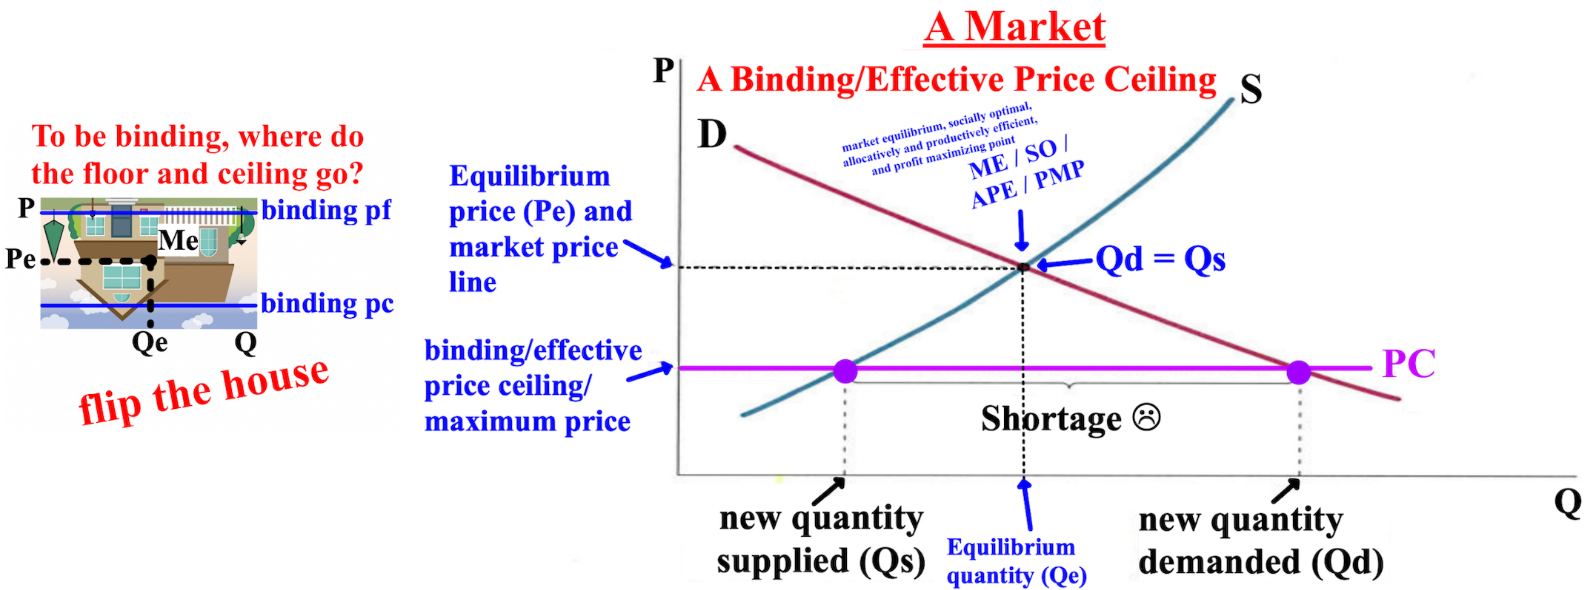

If a price floor is set above the equilibrium price (Pe), the price floor is binding (also referred to as mandatory or effective) since the equilibrium price and market equilibrium (Me) can't be reached. If the price floor is set below the equilibrium price, then the price floor doesn't matter since the price floor is below the equilibrium price/market equilibrium; the price floor is not binding and the equilibrium price will stay the same.
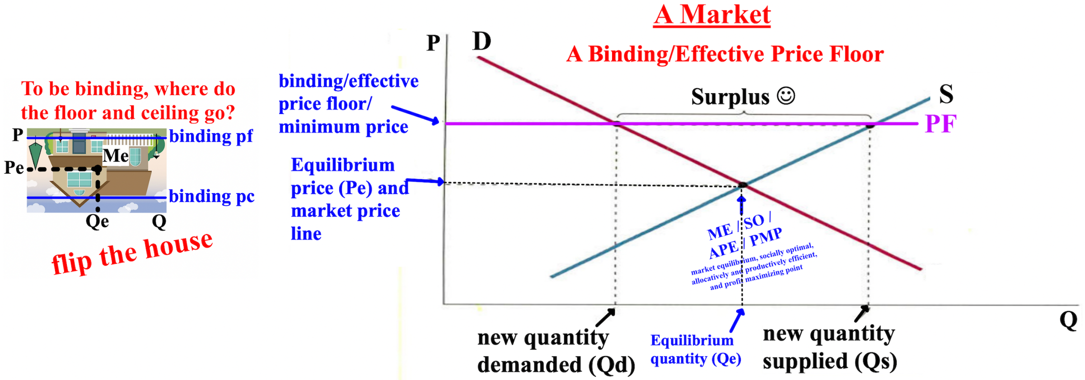

Free Response Question (FRQ) #1, and answer

Free Response Question (FRQ) #2, and answer
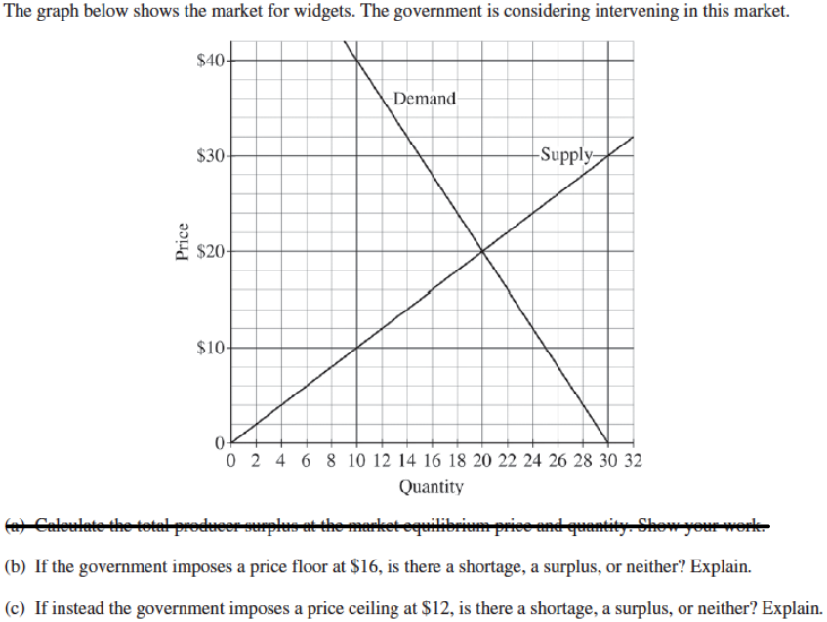

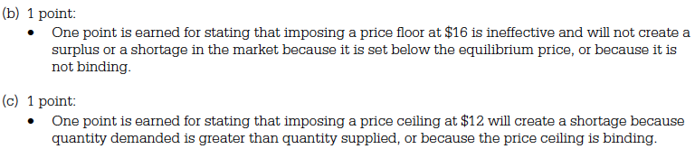

Free Response Question (FRQ) #3, and answer
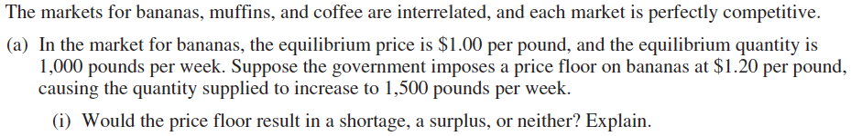

Chapter 7- The Behavior of Buyers and Sellers in Markets
This chapter is about the behavior of consumers/buyers and producers/sellers in markets, including their elasticity, which is a measure of how sensitive one variable is to another. Elasticity measures how sensitive the quantity demanded (Qd) of a good or service by people, or the quantity supplied (Qs) by firms/businesses, is to the price (P) of the good or service.
Elasticity can also measure cross-price elasticity (cross-product sensitivity), which measures the responsiveness of the quantity demanded (Qd) for a good to a change in the price of another good. The formula for cross-price elasticity is:

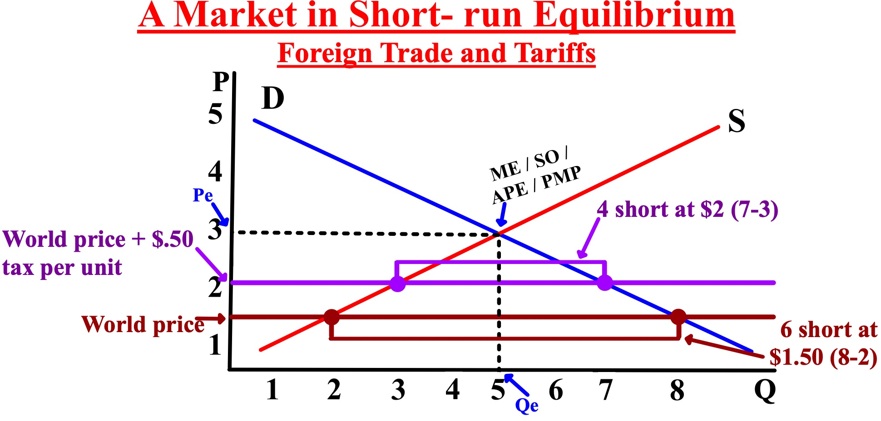

Free Response Question (FRQ) #1, and answer

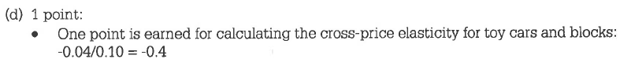

The price elasticity of demand (PED) is a measure of the sensitivity of the quantity demanded (Qd) of a good or service to the price (P) of the good. The price elasticity of demand measures how a change in price impacts how much people want of something, like buying cigarettes when the tax on it increases. The answer is always reported as a positive, even if the result is negative, when determining the level elasticity
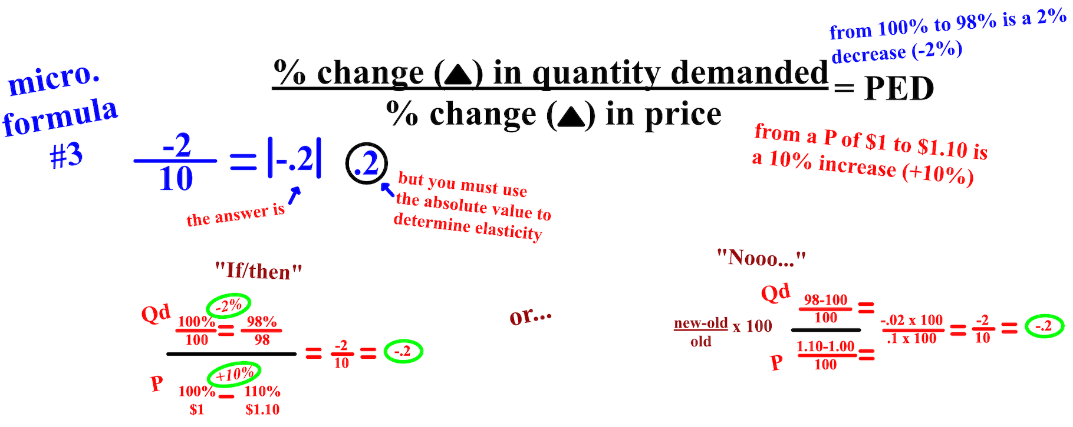

Free Response Question (FRQ) #2, and answer
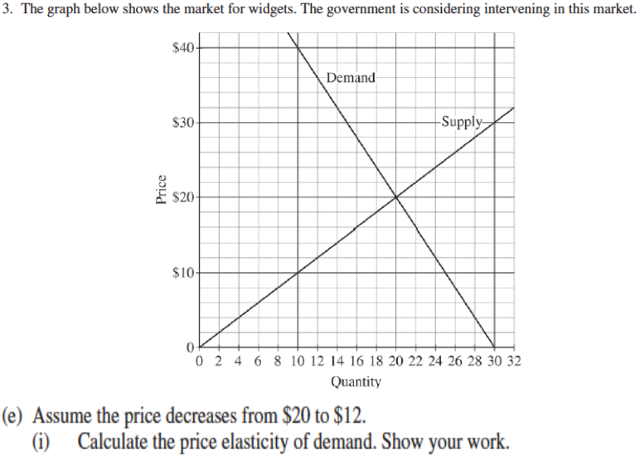

Goods for which the price elasticity of demand or supply is greater than 1 are called elastic or relatively elastic. People are sensitive to the price of these goods and buy less when they have less money, like traveling overseas. These goods are luxuries and have many substitutes. Goods for which the price elasticity of demand or supply is less than 1 are called inelastic or relatively inelastic. People are not sensitive to the price of these goods and buy the same amount even if they have less money, like buying eggs. When the percentage change in quantity supplied (Qs) or quantity demanded (Qd) of a good is the same percentage as the change in price, elasticity = 1, the good is called unit elastic.
Perfectly elastic demand (D) is a perfectly horizontal demand curve at a specific price. People are completely sensitive to the price. An increase in price (P) by a business reduces demand to zero; a decrease in price increases demand infinitely. Perfectly elastic demand deals with goods and services are not usually necessary and have many substitutes, like plumbers.

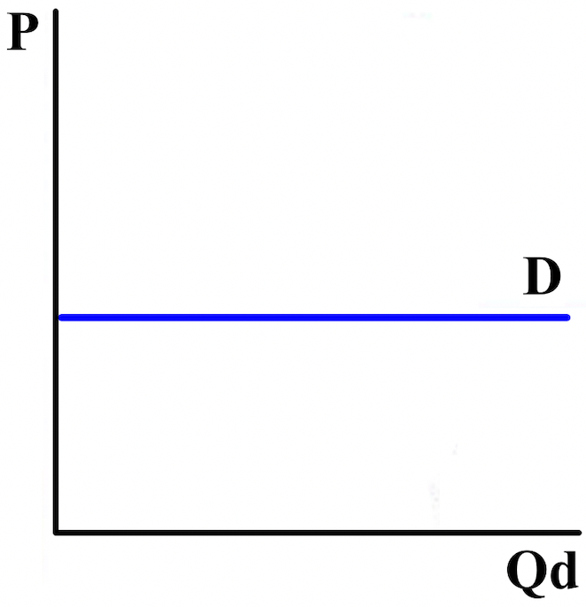

Perfectly inelastic demand is a perfectly vertical demand (D) curve at a specific quantity demanded (Qd). People are completely insensitive to the price. The price elasticity of demand is "0" because when the price (P) changes, the quantity demanded (Qd) does not change, like with life-saving insulin.

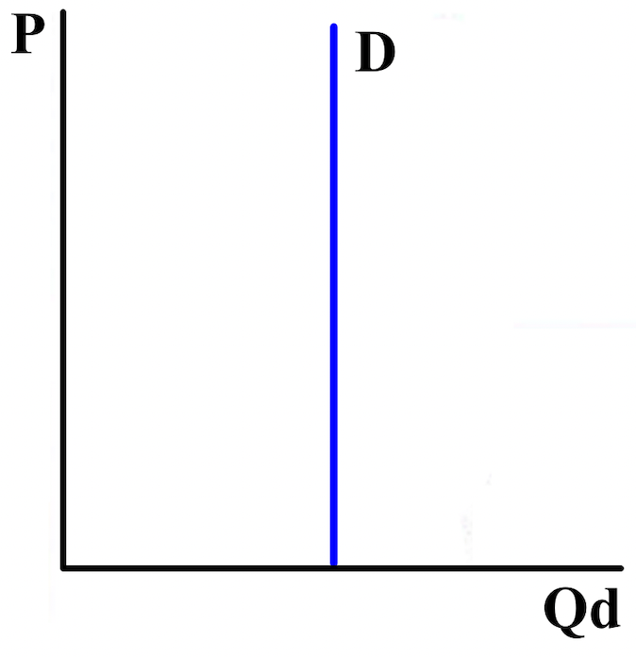
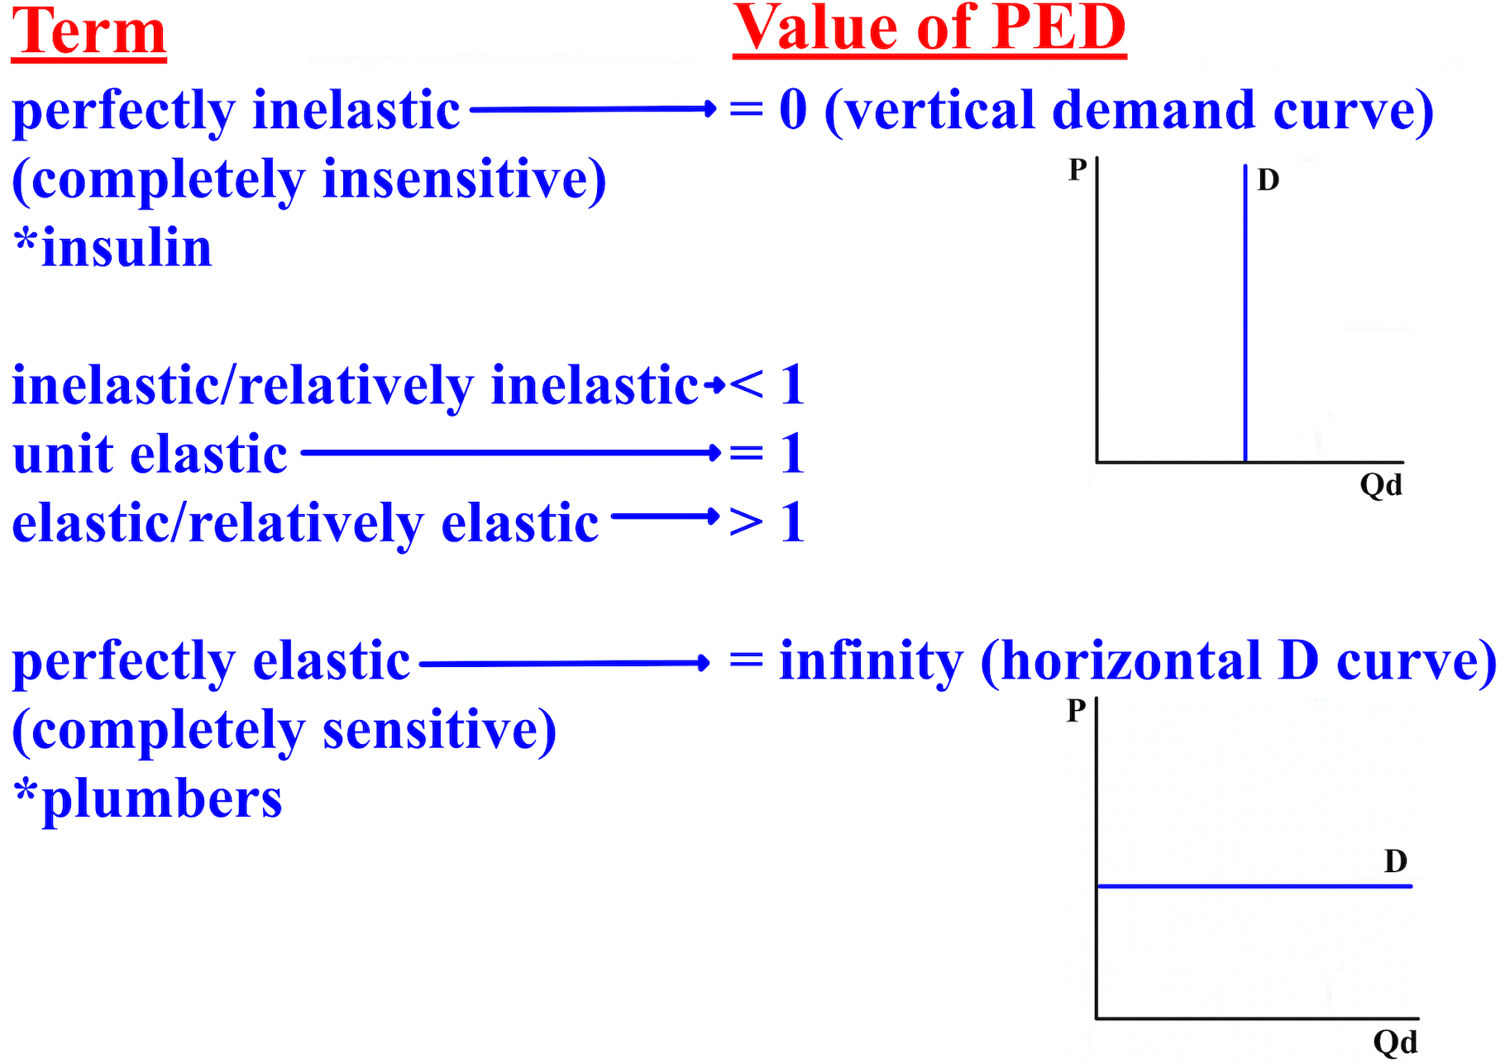
Free Response Question (FRQ) #3, and answer
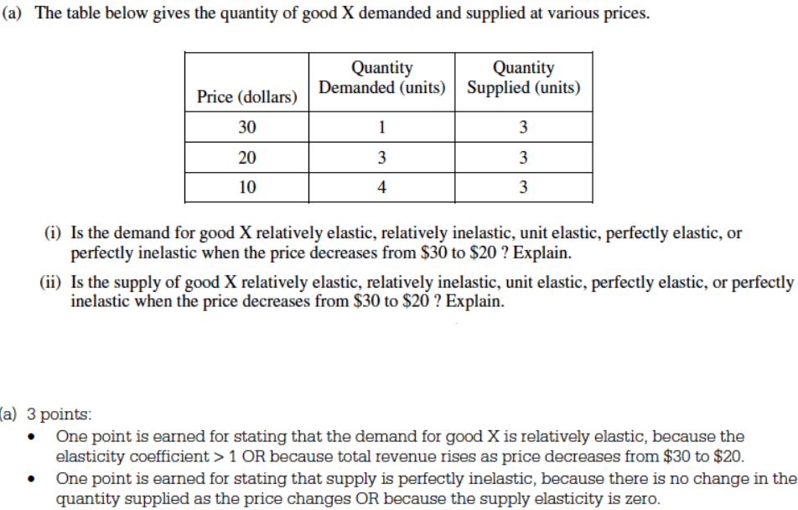

Revenue is what a business earns before paying any costs. Revenue is calculated as the price (P) times the quantity (Q). When the price increases for a good, people pay more for each item, and this increases a firm's revenue at first. Over time people will buy fewer items because of the increase in price, and this decrease in the quantity demanded (Qd) reduces revenue. The table summarizes the relationship between revenue and the price elasticity of demand (PED).

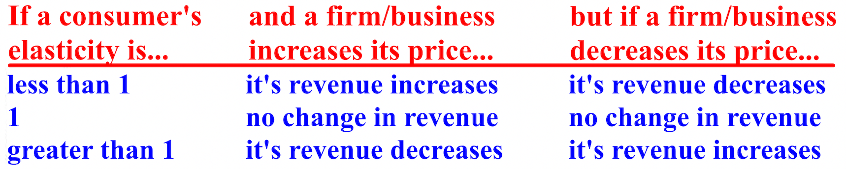

The income elasticity of demand (YED) is the quantity demanded (Qd) consumers are willing to buy because of a change in their income.

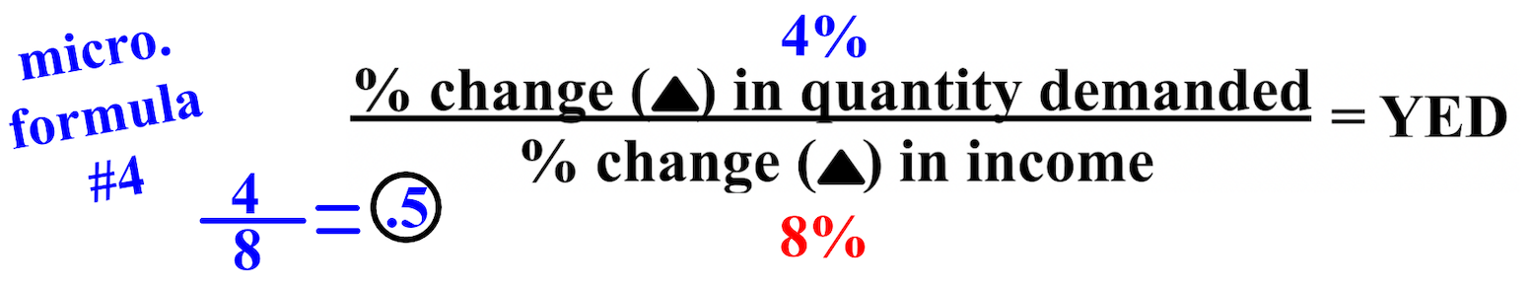

If your income rises by 8% and because of that you buy 4% more ice cream, your income elasticity of demand is .5. If the answer is positive, the good you are buying is a normal good. If the answer is negative, the good you are buying is an inferior good.
Free Response Question (FRQ) #4, and answer
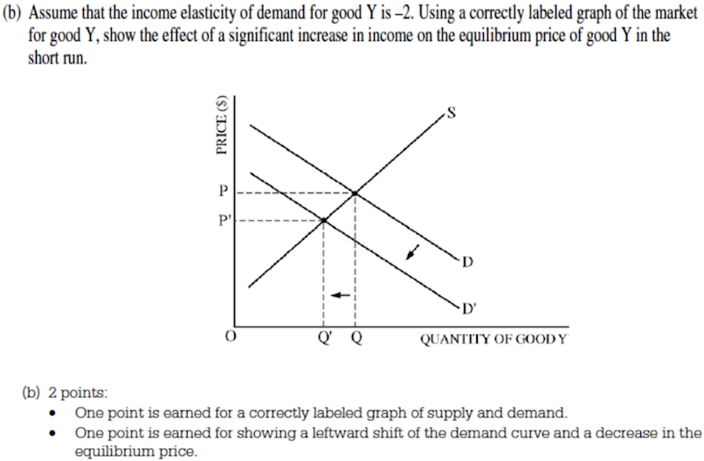

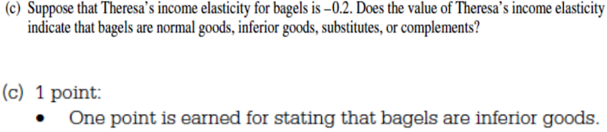

Utility is a numerical indicator (any number) of a person's preference (benefit or satisfaction) for some goods compared to others, like Coke over Pepsi or chocolate over gummy bears. It is the level of satisfaction or benefit attained. Utility simply means that the choice is preferred to another choice. Utility can be any number

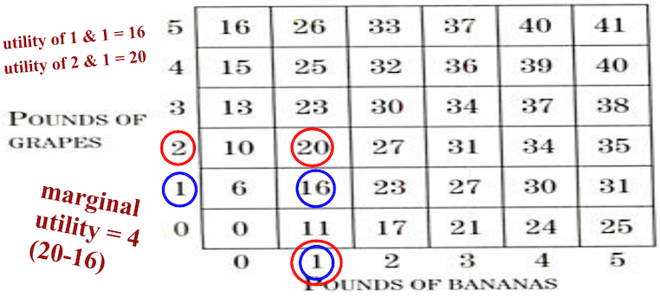
One additional pound of grapes, from 1 pound of grapes and 1 pound of bananas to 2 pounds of grapes and 1 pound of bananas, increases utility by 4 (from 16 to 20). This increase in utility is called the marginal utility (the difference (the margin) in utility (satisfaction) from consuming an additional unit of a good.
Total utility or utility is the total benefit or satisfaction received from consuming a given total quantity of a good or service; all of the marginal utilities added up. Buying 1 unit gives someone the utility or total utility of 15. Buying 2 units gives someone the utility or total utility of 25 (15 + 10). Buying 3 units gives someone the utility or total utility of 34 (15 + 10 + 9).
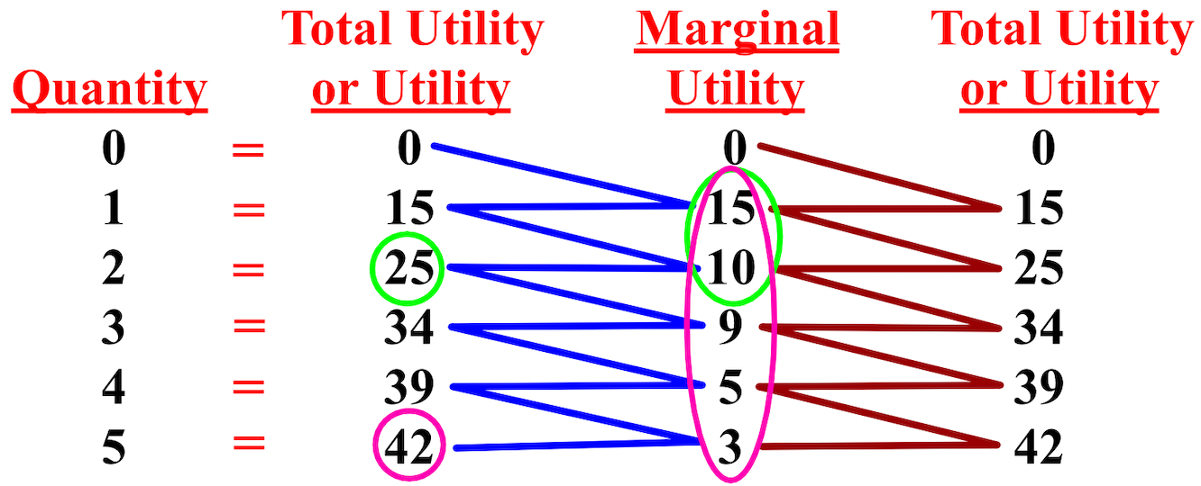

Free Response Question (FRQ) #5, and answer
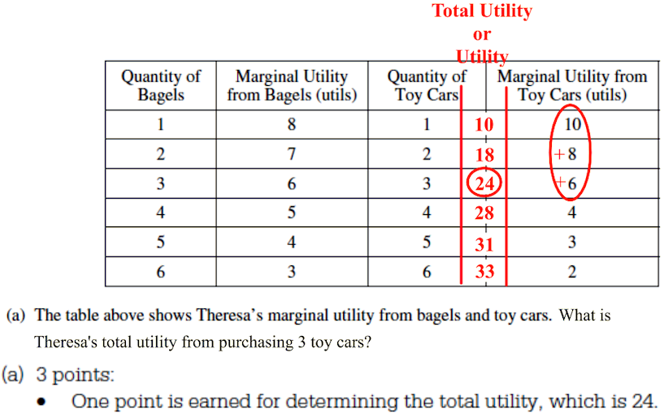

Marginal benefit (MB) is the increase in benefit from, or the willingness to pay for, one more unit of a good. As a person consumes more and more of a good, the marginal benefit from additional amounts usually diminishes, like eating slice after slice of pizza. If you don't buy any pizza, the quantity is 0 and so is your willingness to pay and the benefit from not buying it. If you buy 1 slice of pizza, you may be willing to pay $5 and your benefit is $5. If you buy a second slice, you won't want to pay $5, but maybe $3, and thus $3 is
your marginal benefit
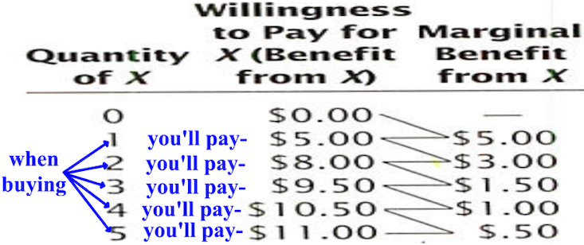

Price equals marginal benefit (P = MB) is a rule firms/businesses follow in order to maximize their profits: the price of an item sold should always be at least equal to the marginal benefit people are receiving from it. Why charge less than it costs to make it and less than consumers are willing to pay for it.
People often are willing to pay more for an item than they have to. You might be willing to pay $16 to see your favorite movie, but like everyone else, you pay only the $8 admission price. The difference between the $16, the marginal benefit (MB) price, and the $8, is called consumer surplus (CS). Consumer surplus is the difference between your willingness to pay for an item (say $16 for a movie), and the price you actually paid for it ($8). In this case, the consumer surplus is $8 ($16-$8)

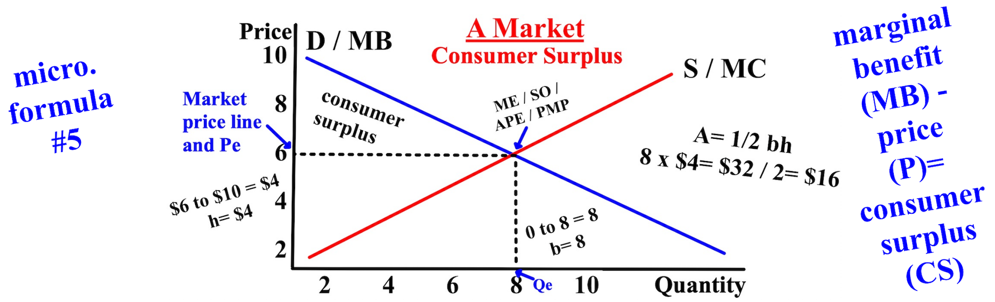

The total consumer surplus would be the marginal benefit (MB) of each product minus the price (P) of each product. At $3 per unit, the total consumer surplus of consuming 3 units is $16: $12-$3 + $8-$3 + $5-$3 or $16. The more that is consumed, the less marginal benefit is obtained and eventually the price per unit is more than the marginal benefit. Buying less can sometimes be more beneficial.
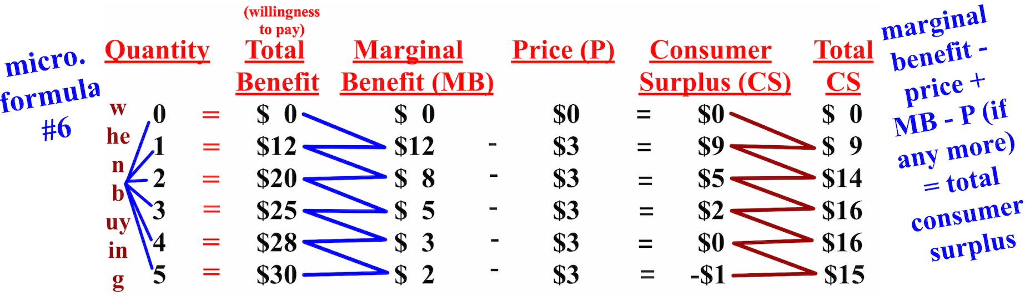

Free Response Question (FRQ) #6
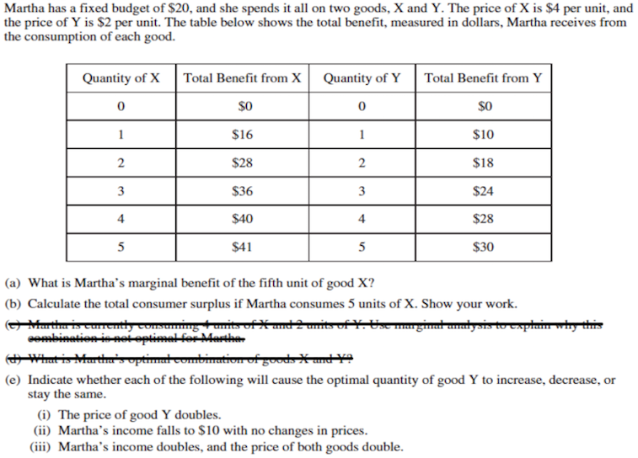

Free Response Question (FRQ) #6 answer
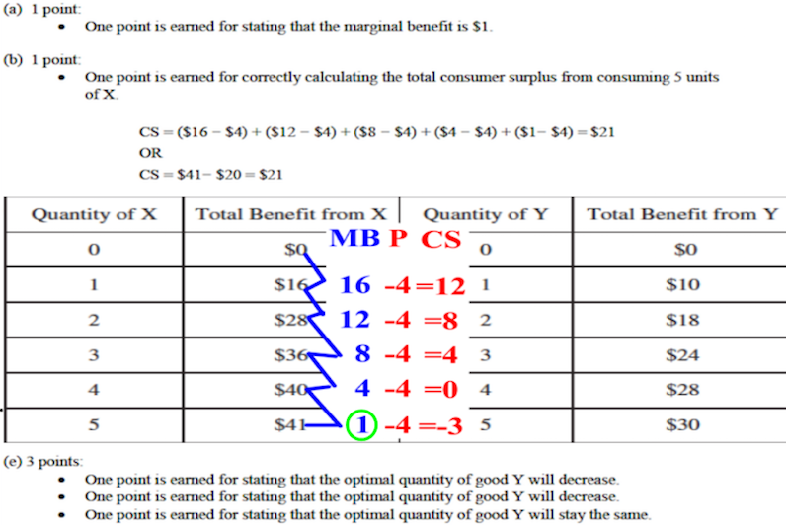

Now we'll talk about the behavior of firms who supply the goods that people consume/demand. The behavior of firms/businesses can be visually described by the supply (S) curve. Notice that with individual firms, the demand (D) curve is perfectly elastic because competitive firms are price-takers.
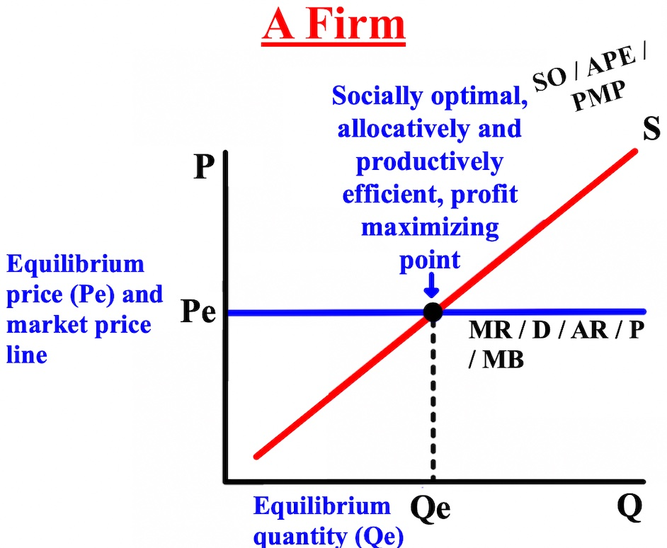

The type of firm/business we'll talk about is typical of many small and large firms: the firm is one with a single product and two factors of production, the price of land and the price of labor. One of the factors of production, land, cannot be changed in the short-run because the rent was already paid. This makes land a fixed factor. The other factor, labor, can be varied in the short-run because you can choose to hire more or less workers. This makes labor a variable factor. Each firm in the market is a price-taker because the firm must use the market's equilibrium price (Pe) as the price to charge customers for a good. This type of market is called a competitive market because a single firm cannot choose or affect the market price; it is competitive for all of the firms in the market. All of the firms as a whole eventually determine the market's equilibrium
price and equilibrium quantity (Qe).
A perfectly competitive/pure market is a specific and mostly fictional market structure. In it 1) all firms sell an identical product, 2) all firms are price-takers, 3) buyers have complete information about the product being sold and the prices charged by each firm, 4) the industry is characterized by freedom of entry and exit by firms, 5) no long-run (LR) profits exist, and 6) the market is efficient.
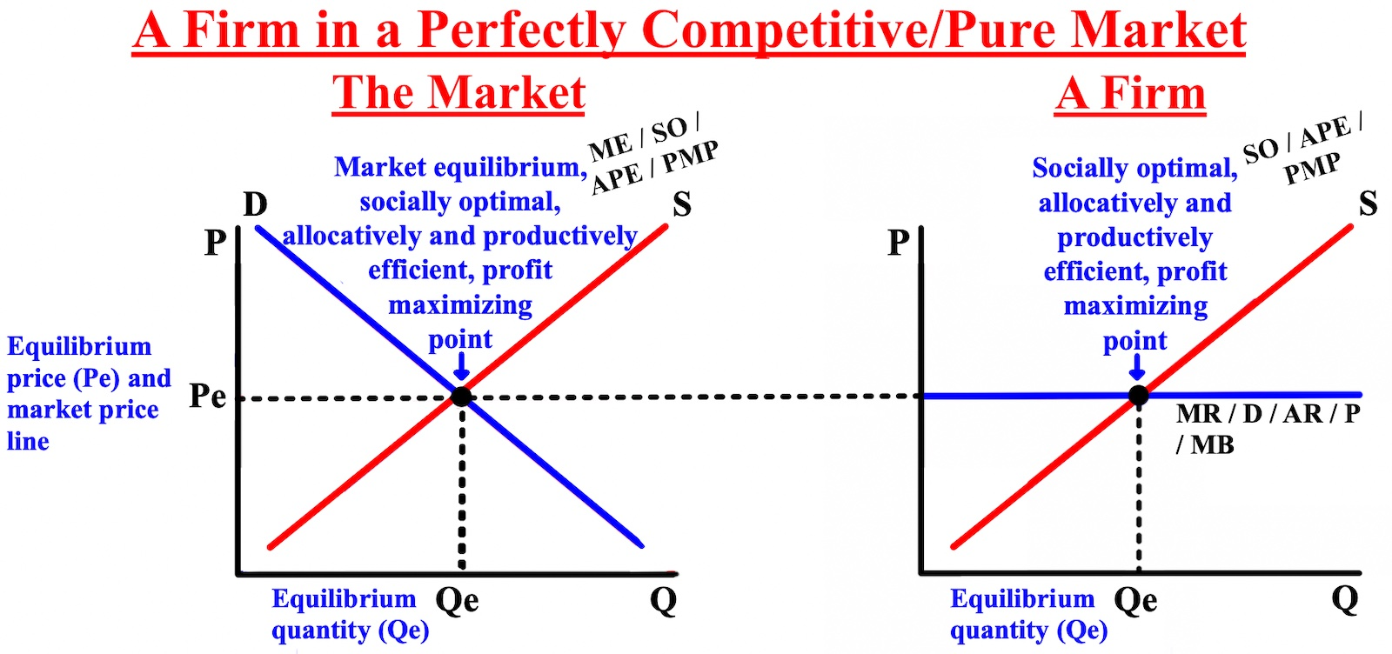

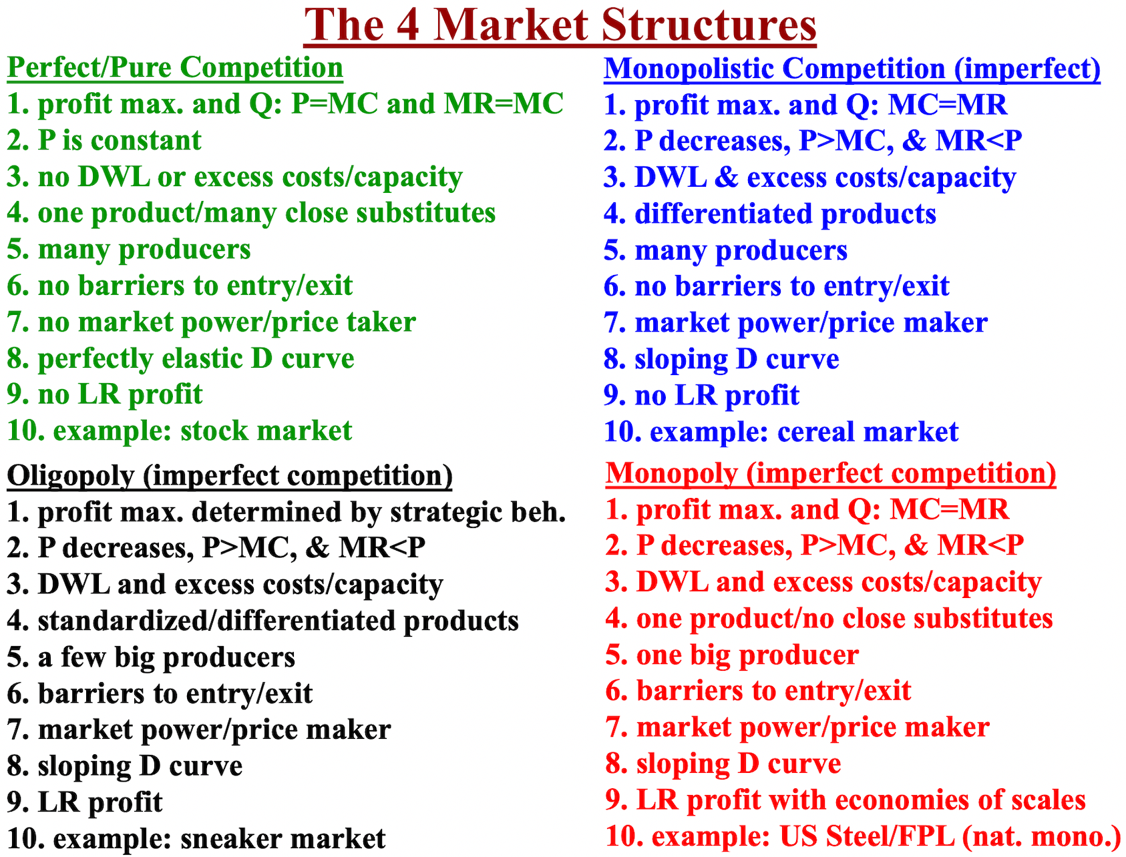
The price elasticity of supply (PES) is a measure of the sensitivity of the quantity supplied (Qs) of a good or service to the price (P) of the good. Measures how a change in price impacts how much firms/businesses will produce of something, like the price of TVs. The answer is always reported as a positive, even if the result is negative, when determining the level elasticity.
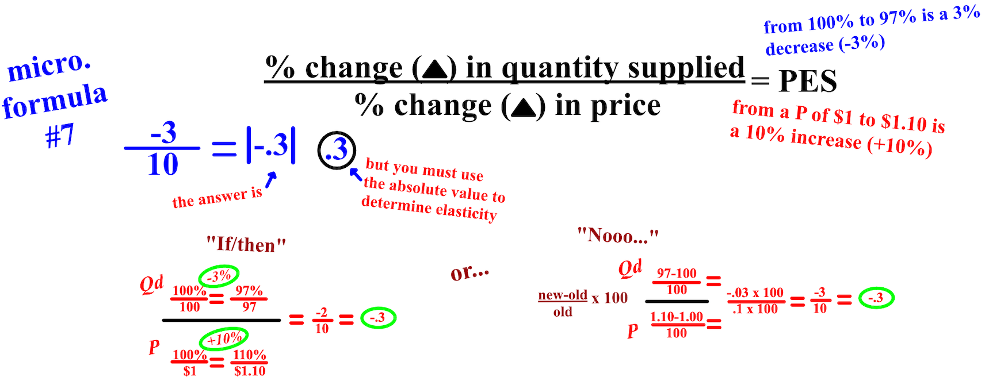

Total revenue (TR) is the total number of dollars a firm receives from people who buy its product(s). Profit is the total revenue (TR) (the total number of dollars a firm receives) received from selling a product minus the total costs (TC) of producing the product.
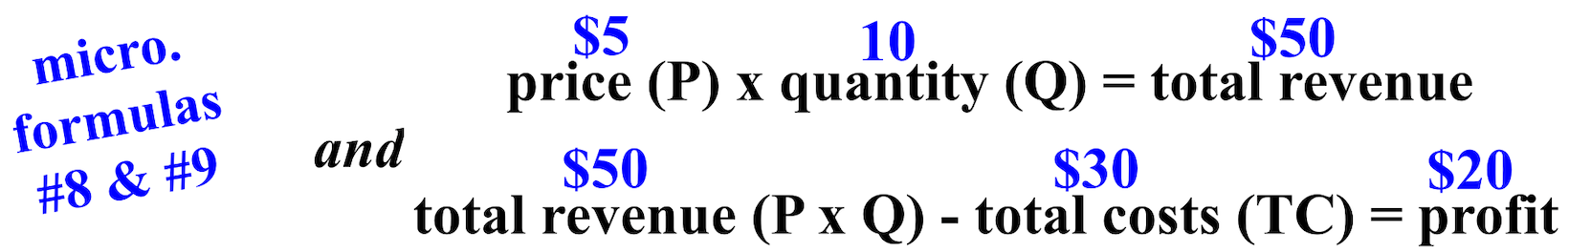

The marginal product of labor (MPL), also called marginal product (MP), is the increase in production of a good that comes from an additional unit of labor, either hours or workers. By working an additional five hours (from five to ten), an extra car is produced. Compare this to the increase from eighteen to thirty hours to produce an additional car.

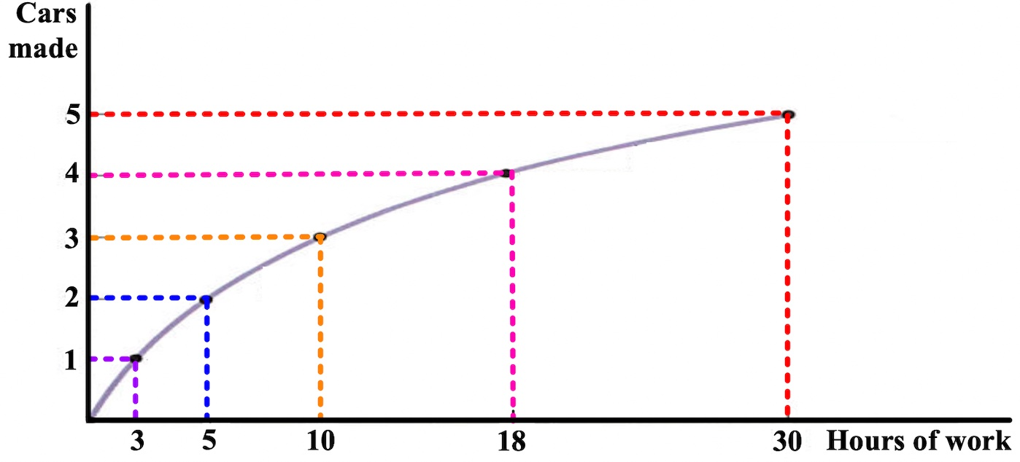
But at some point, the amount of workers or hours worked doesn't produce as much and is not worth adding is called diminishing returns to labor. If an additional labor input, either one more worker or one more hour of work, costs more than is beneficial, the worker won't be hired or a worker won't work so many hours.
Variable costs (VC) are costs that vary according to how much is produced; the more workers or hours the more the cost. This is why you don't hire more workers or have workers work more hours than is beneficial to your firm. Fixed costs (FC) are the part of the total cost that does not depend on how much is produced, like rent for a store paid in advance. Total costs are what a firm has to incur financially in order to produce their
product(s), the fixed costs (FC) and the variable costs (VC).

variable costs (VC) + fixed costs (FC) = total cost (TC)

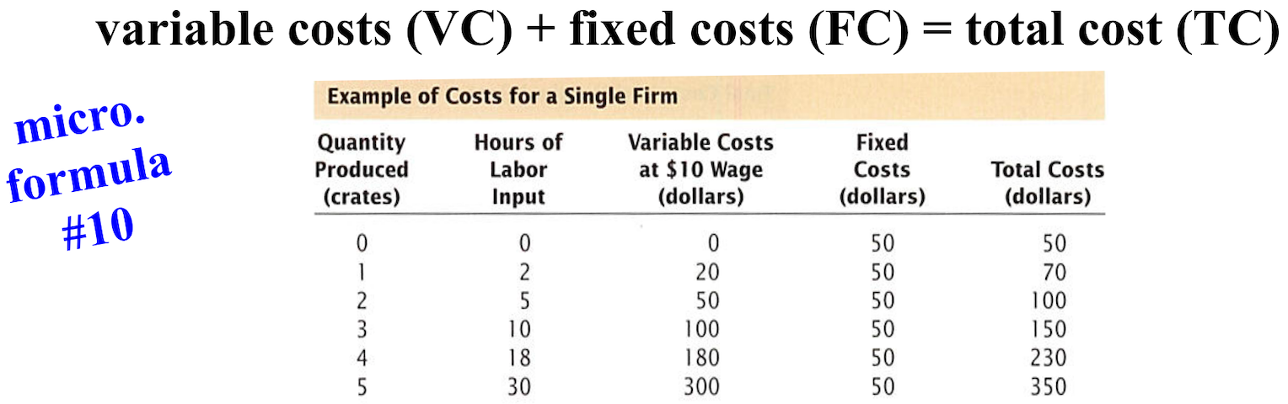

Marginal cost (MC) is the increase in total costs (TC) associated with making one more unit of production. The marginal cost below of increasing production from 1 to 2 is $30 ($100 - $70 = $30), and the marginal cost of increasing production from 2 to 3 is $50 ($150 - $100 = $50). You can see that because costs increase as a firm produces more, there will be a time when the cost of additional labor input (either a workers or hours) will lead to no additional profit and will actually lose a firm money. The most important key condition for profit maximization and allocative efficiency for a firm in a competitive market: the firm should choose to produce a quantity (Q) such that price (P) equals marginal cost (MC)
.
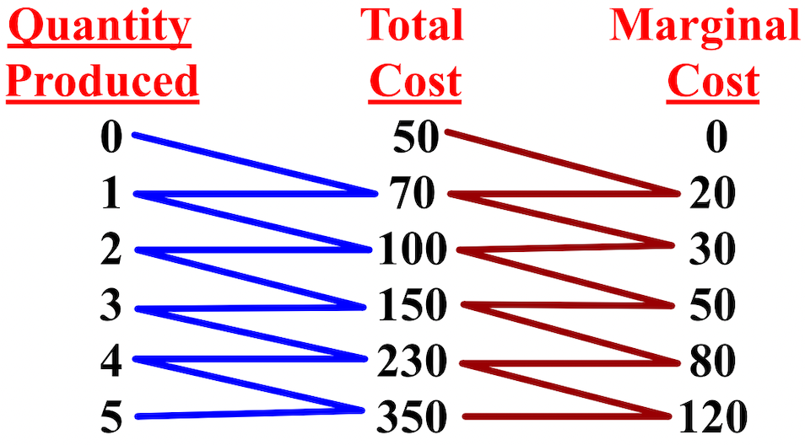

Marginal cost (MC) increases as production increases. Marginal cost is greater when we go from 2 to 3 ($50) than when we go from 1 to 2 ($30). Increasing marginal cost is due to the diminishing marginal product of labor (the increase in production that comes from additional labor). The marginal cost of going from 2 to 3 is greater than going from 1 to 2 because more workers or hours are required.

The table below shows how total costs (TC) increase with production. The last column shows that profits are negative at all production levels. It seems foolish, but you already paid $50 for the use of something; it is a
fixed cost (FC). It is best to produce 2 and cut your losses at -$30 instead of producing nothing and keeping your loss at -$50. 2 then is the profit maximizing quantity you should produce.

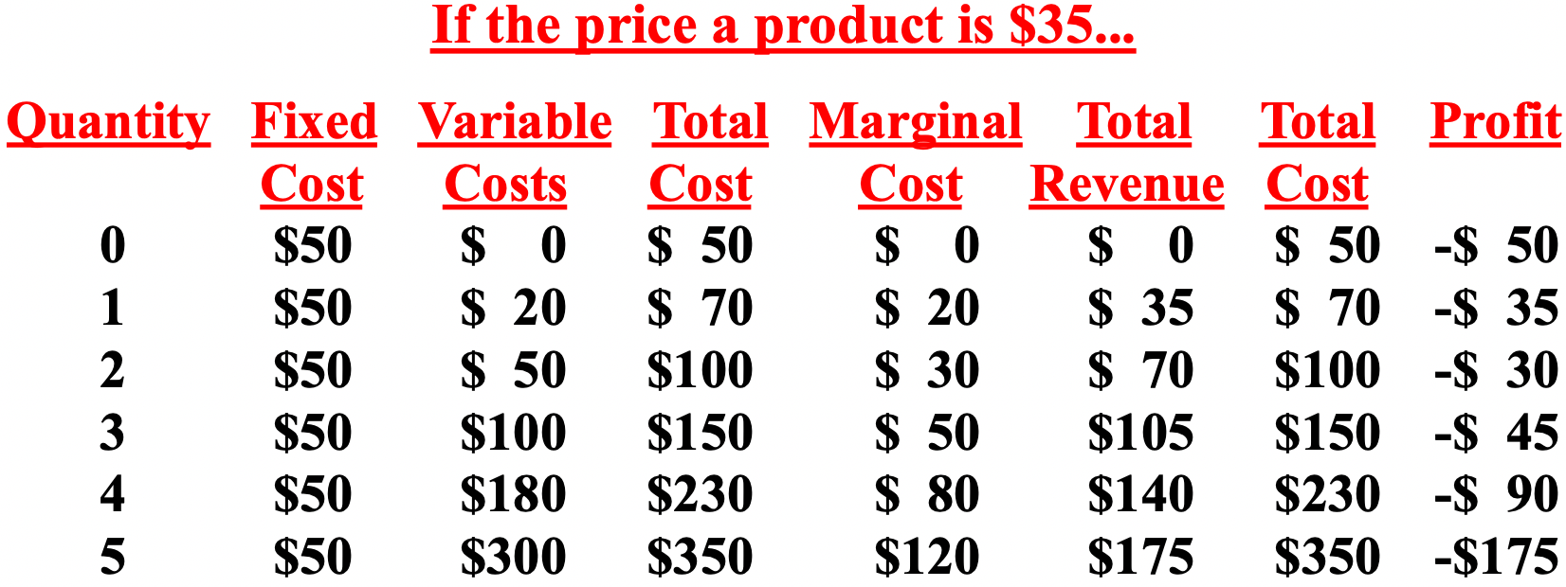

The extra revenue that results from producing and selling one more unit of an item is called marginal revenue (MR). The price of each product is $70, so the total revenue (TR) is higher then
when the price was $35. If you sell 1, total revenue is $70 and profits are zero; if you sell 2, total
costs are $100 and total revenue is $140. The profit-maximizing level of production is 3 because at 3, marginal
revenue is still more than marginal costs (MC) (revenue is more than cost).

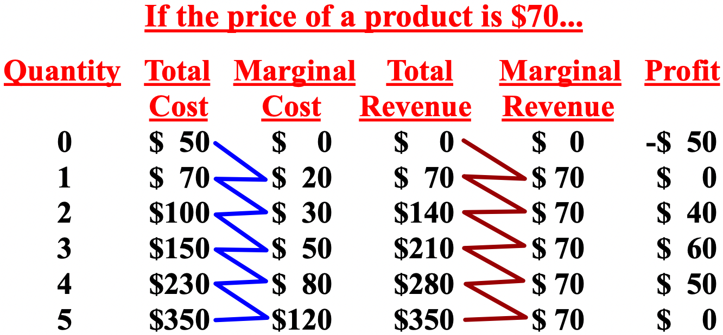

The marginal revenue (MR) should always be at least marginal cost (MC). The marginal revenue product of labor (MRP), or marginal revenue product (the amount of revenue gained from adding one more unit of
labor), should always be at least the same as the marginal revenue cost of labor (MRC) (the cost to increase your labor force to produce one more item).
Producer surplus is the difference between the cost for the producer, the marginal cost (MC), and the price that consumers do pay for a product; you simply add up the differences if there is more than one. If you sell 2 for $70 each, your producer surplus would be $90 ($70-$20 + $70-$30); if you sell 3 for $70 each, your producer surplus would be $110 ($70-$20 + $70-$30 + $70-$50).

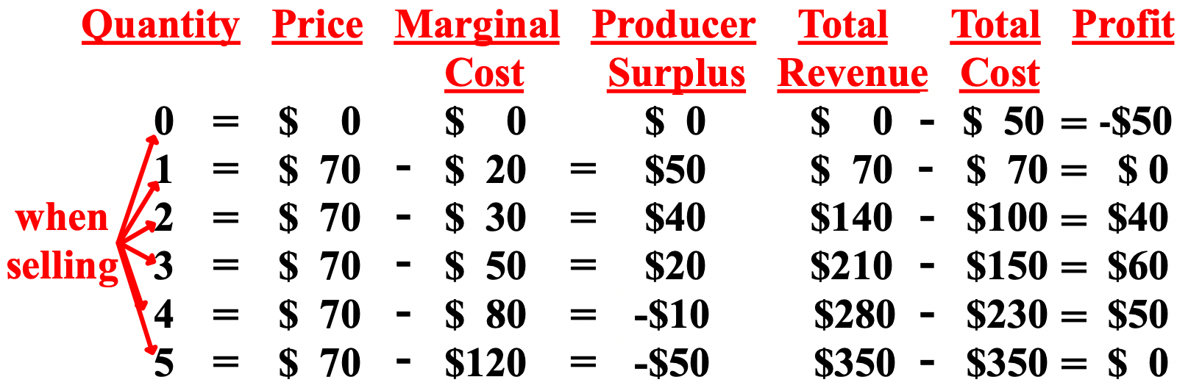
Producers often are able to sell their products at a cheaper price, but they don't have to. Consumers are willing to pay the market or equilibrium price (Pe), at the least. The difference between the cost is for the producer, the marginal cost (MC), and the price that consumers do pay, is called the producer surplus (PS).

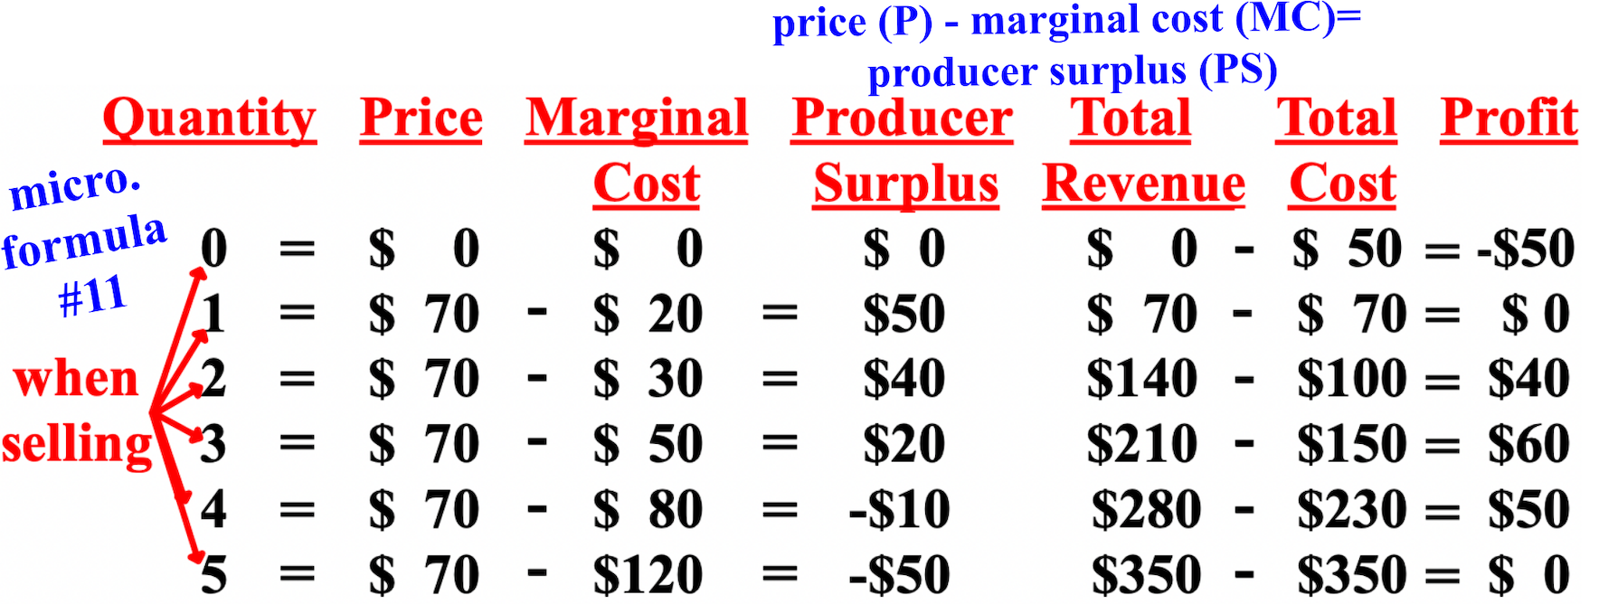

The total producer surplus would be the price (P) of each product minus the marginal cost (MC) of each product added together. At $70 per unit, the total producer surplus of selling 2 is $90: $70-$20 + $70-$30. At $70 per unit, the total producer surplus of selling 3 is $110: $70-$20 + $70-$30 + $70-$50.

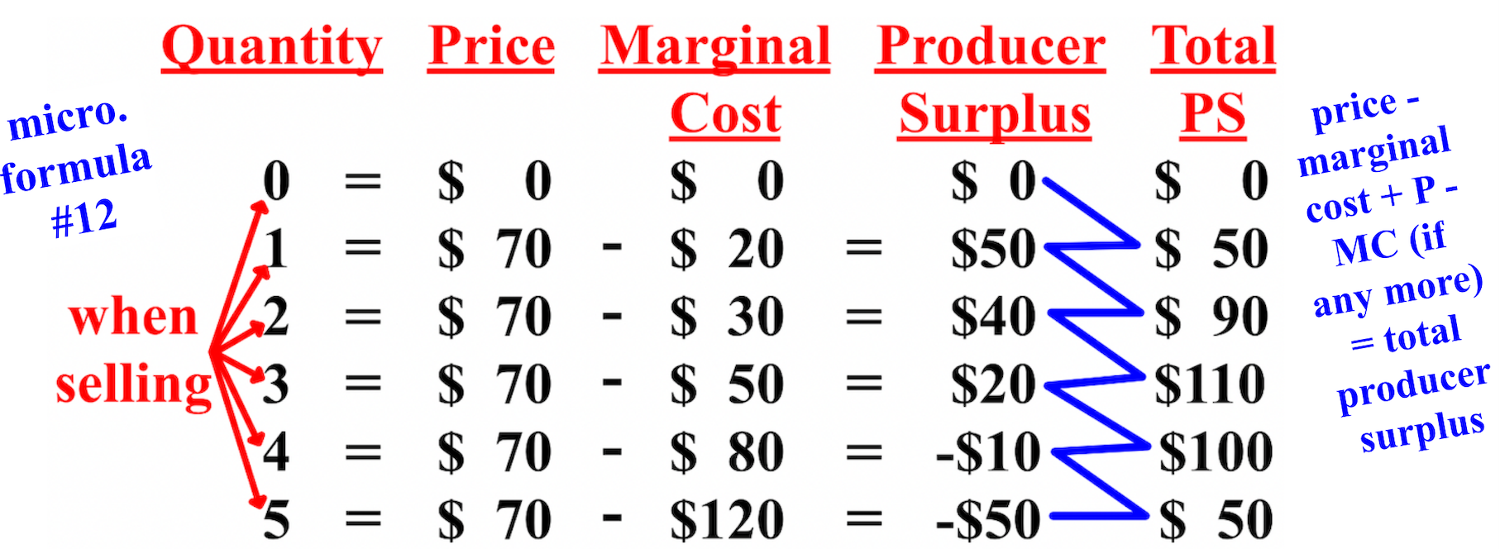

Free Response Question (FRQ) #7, and answer
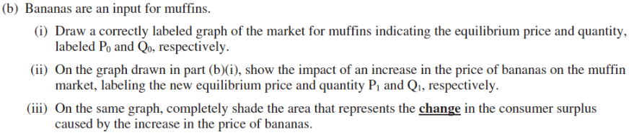
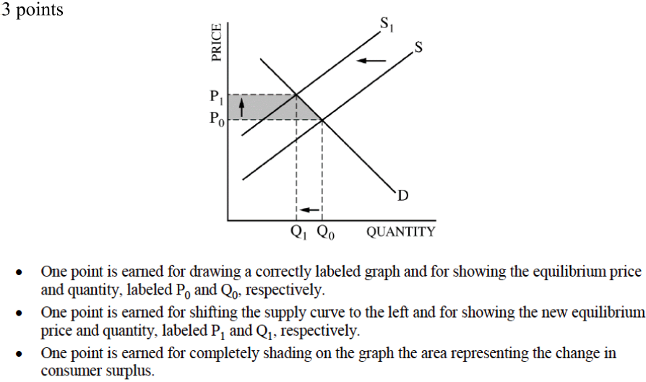
Chapter 8- People, Firms, and Monopolies in Markets
This chapter is about the interaction of consumers/buyers and firms/businesses in competitive markets, the expansion and contraction of markets/industries in the long-run (4-5 years out), and the existence of all-powerful monopolies.
To see how much a country will import of something at a certain price (P) to decrease a shortage, like when the quantity (Q) produced is at a set price or the world price instead of market equilibrium (Me), find the shortage before any imports are included.
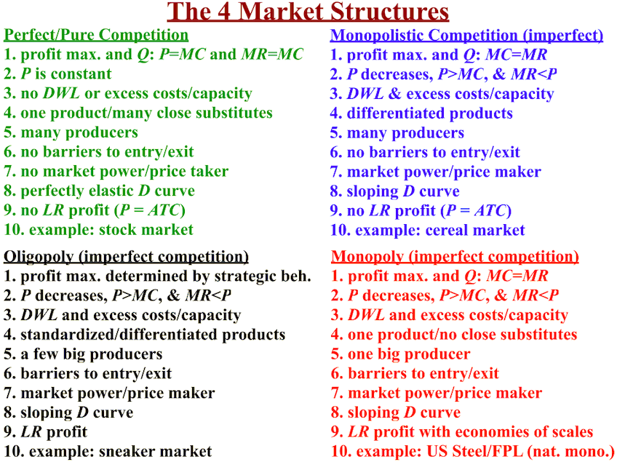
At the world price of $1.50, 8 are demanded but only 2 are supplied; 6 will be imported; if the tariff is $10 per unit, then the tax collected by the country from the tariff would be $60 (6 x $10). At $2 (the world price plus a tariff (a tax on imports) of $.50), domestic production is now only 4 short (7-3); 4 will be imported and the tax collected by the country from the tariff would be $40 (4 x $10).
With a $2 binding price ceiling, quantity demanded (Qd) exceeds quantity supplied (Qs) by 4 (7-3) and 4 will be imported. With a tariff of $100 per unit, the government will receive $400 in tariff revenue (4 x $100).
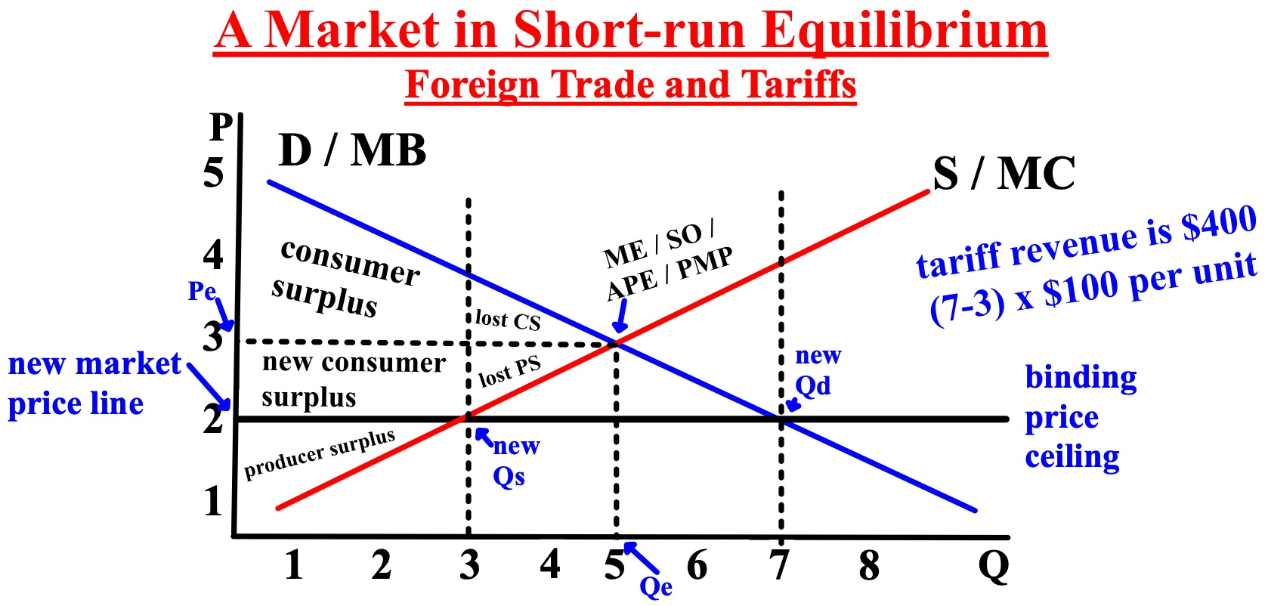
With an original market price of $3, the original consumer surplus (CS) was $5 (price (P) = $2 ($5-$3 = $2) and quantity demanded (Qd) was 5, so $2 x 5 divided by 2 = $5. Because of the binding/effective price ceiling, consumer surplus and producer surplus (PS) both lose some of the original total surplus, but consumers gain back some because the price decreased. The total surplus is the consumer surplus plus the producer surplus.
Free Response Question (FRQ) #1, and answer
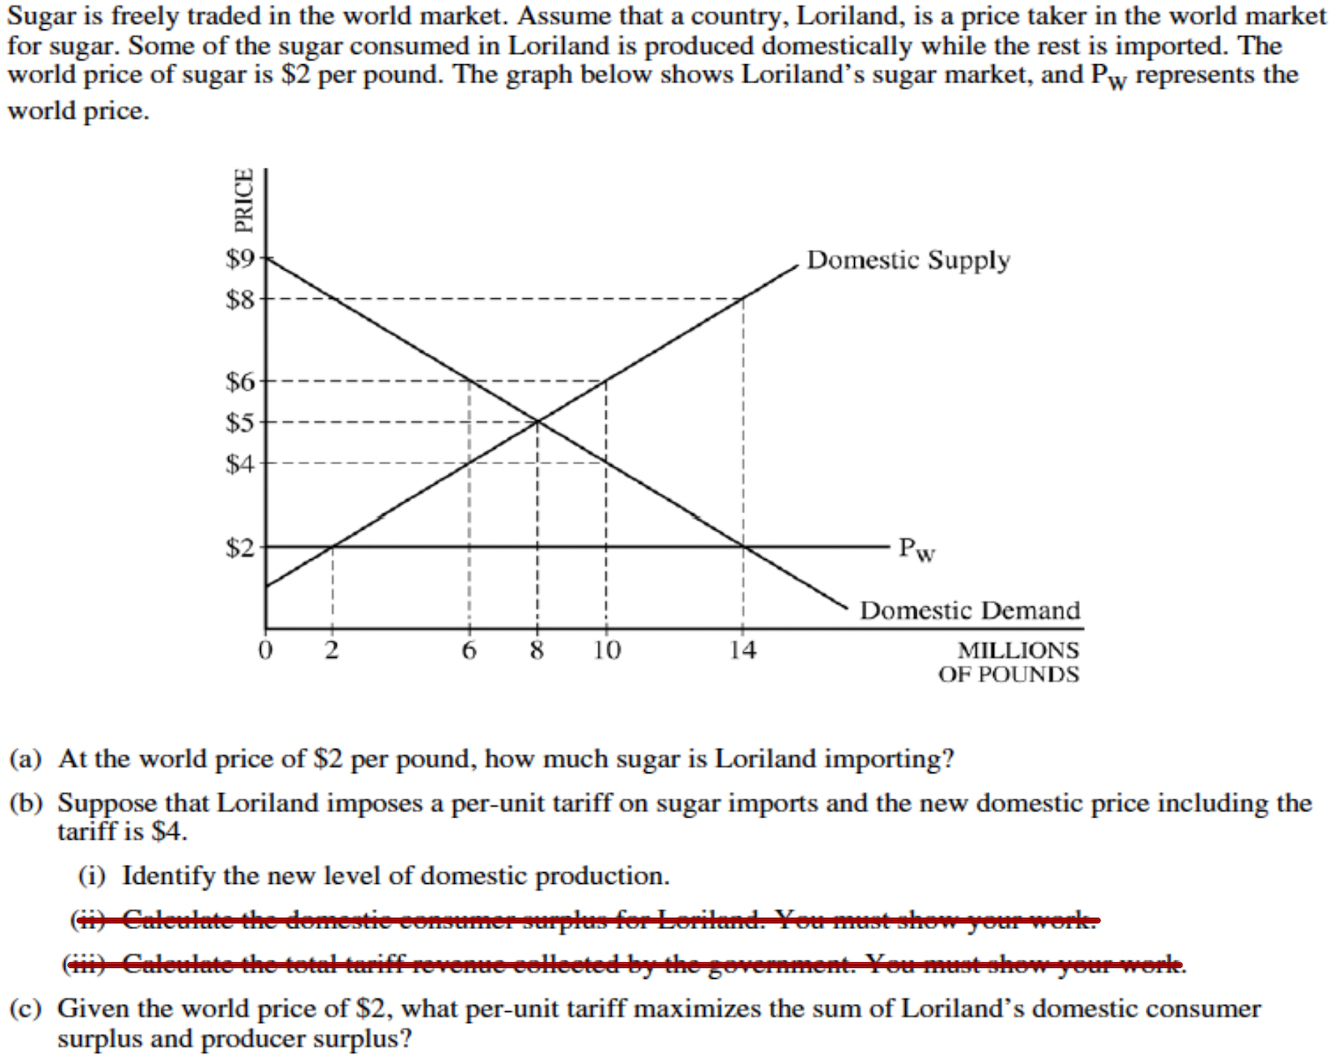

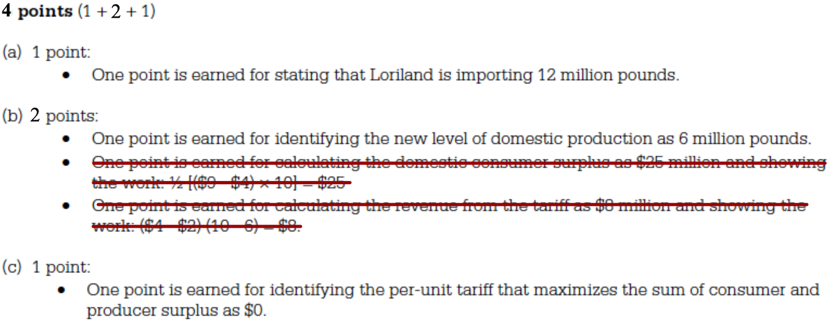
Deadweight loss (DWL) is what happens to consumer surplus (CS) and producer surplus (PS) when the efficient level of production does not occur, when too little or too much is produced. Deadweight loss is always a triangle in shape (base x height / 2). Because of the price ceiling, the sum of consumer and producer surplus (total surplus) is now less and both loose surplus; no one gets it.

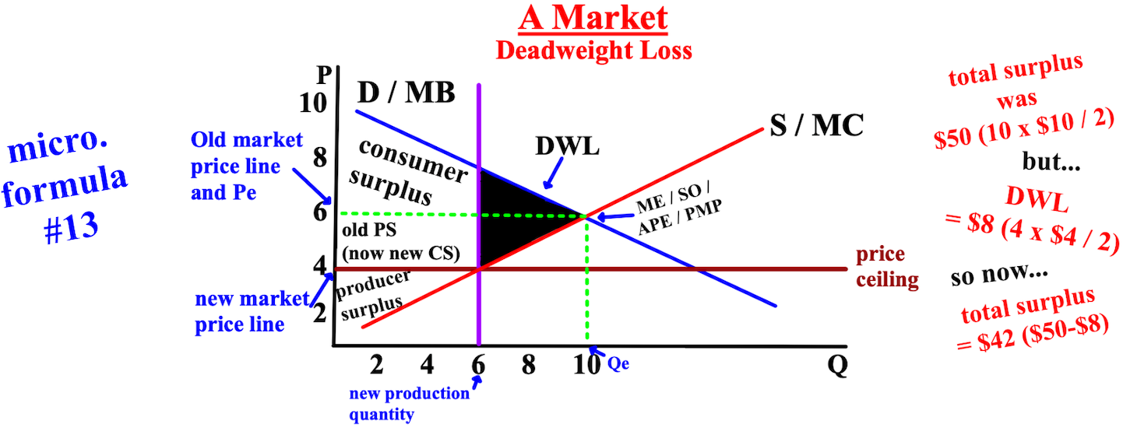

A tax on sales is a payment that must be made to the government by the seller of a product, of which some part of it is always passed along to consumers. The tax may be a percentage of the dollar value spent on the products sold, in which case it is called an ad valorem tax or a lump sum tax, like a 6% state tax on purchases. The tax may be proportional to the number of items sold, a per-unit tax, in which case the tax is called a specific tax or an excise tax, like a tax on gasoline of $.08 per gallon. When taxes are created, the tax benefit created for the government is the area from the current price (P) to the new price. If consumers (D) and firms (S) are equally elastic, the cost of a tax is split equally, and if one is more elastic than the other, the inelastic will pay more. The immediate impact of the tax is to add to the marginal cost (MC) of producing a product, and the supply (S) curve shifts to the left.
The supply curve below has shifted to the left because of a $2 tax. The $2 tax can be determined: the new price buyers (PB) will pay is $6 and the new price sellers (PS) will receive is $4... $6- $4 = $2 tax. The new price the seller will receive is the intersection of the old supply curve and the new quantity (Q) of 5. The total taxes paid are taken 50% from each, $1 from consumers and $1 from sellers because the gray rectangular box below is split evenly by the old price.
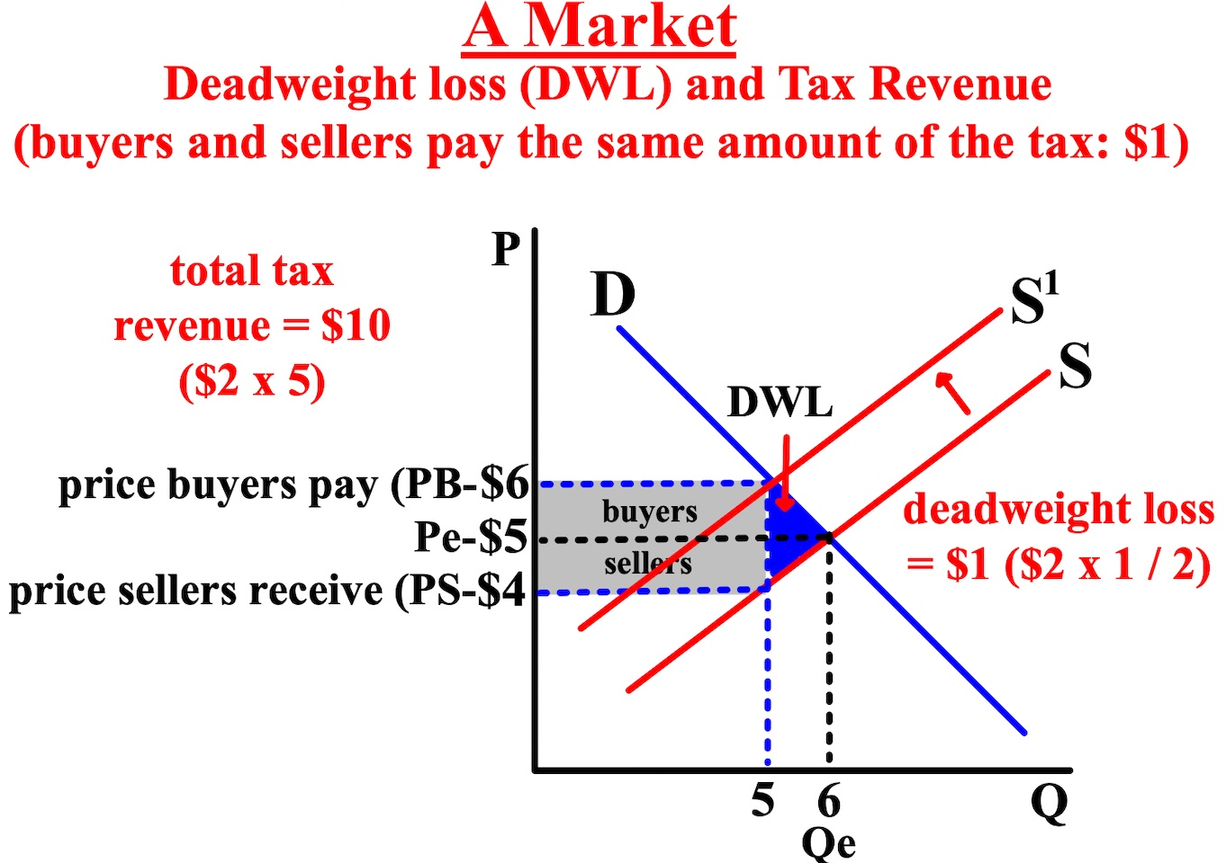
$10 in tax revenue goes to the government because the tax revenue is the tax times the number of items sold, shown by the gray rectangle ($2 x 5). Some of the producer surplus and some of the consumer surplus went to the government, but the deadweight loss (DWL) is no longer available.
If either side was more elastic than the other, the sensitive party would pay a smaller portion of the taxes and the less sensitive a larger portion. The left graph shows buyers being more inelastic than sellers and buyers have/pay more of the gray area (the total tax); sellers are elastic and will pay less of the tax.

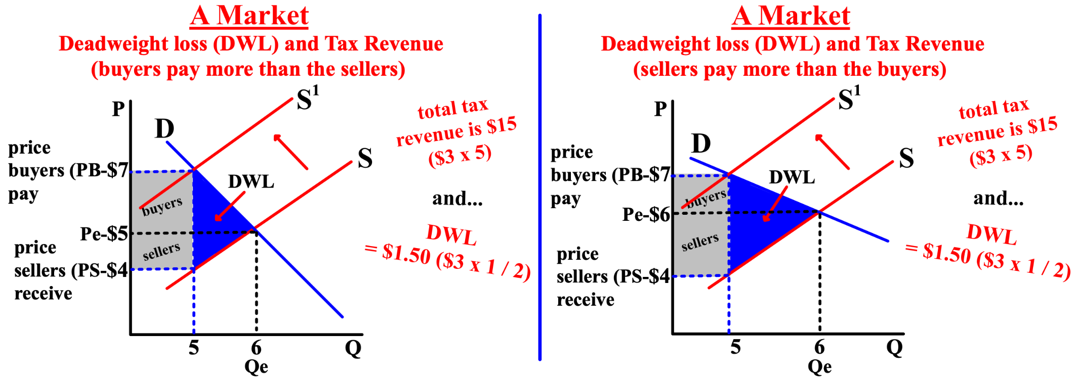
The right graph shows sellers being more inelastic than consumers and sellers have/pay more of the gray area; buyers are elastic and will pay less of the tax. To draw a graph to show who will pay more of the tax, angle the demand curve more vertically to show buyers paying more or more horizontally to show sellers paying more.
Free Response Question (FRQ) #2
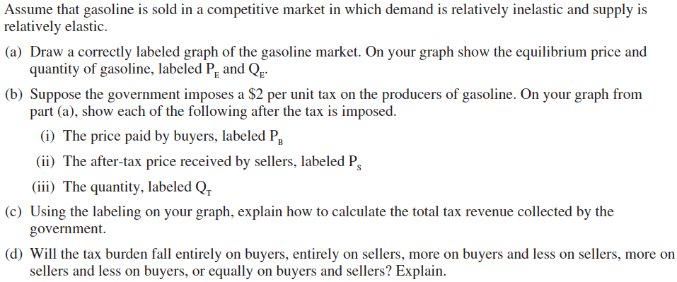

Free Response Question (FRQ) #2 (answer)

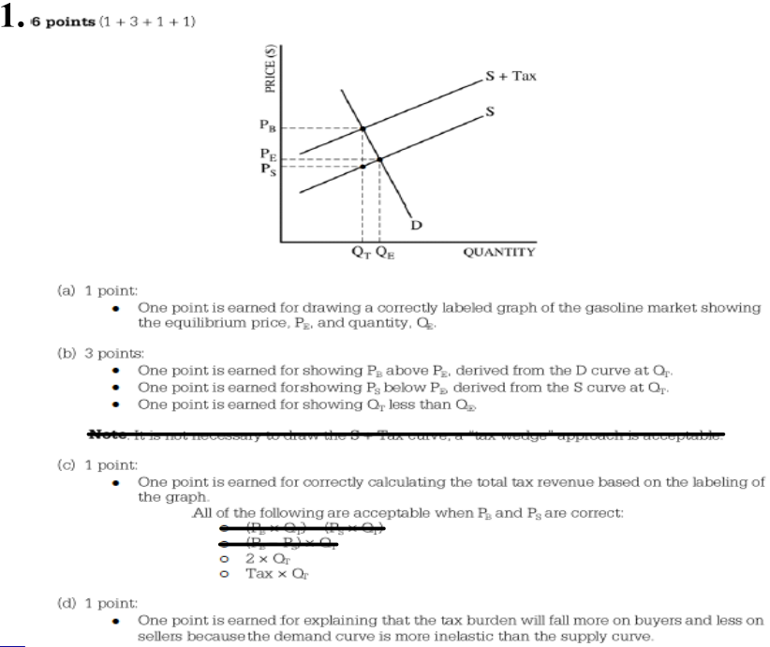

Observe that marginal cost (MC) declines at low levels of production and then begins to increase again. This is due to the increase of variable costs (labor) as more is made. The average total cost (ATC) or cost per unit is the total cost (TC) of production divided by the quantity (Q) produced. If the total cost of producing 5 items is $900, then the average total cost or cost per unit is $180 ($900/5). ATC first decreases then increases as variable costs increase. The average fixed cost (AFC) is fixed costs divided by the quantity produced. The average variable cost (AVC) is variable costs divided by the quantity produced.

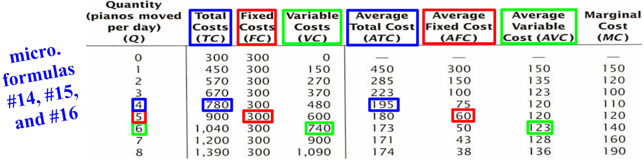
The average product of labor is the quantity produced, or total product, divided by the total amount of labor input. Be careful to distinguish between the average product of labor and the marginal product of labor... the marginal product of labor is the difference in production due to one more unit of labor.
The three graphed curves on the right use exactly the same information as the table on the left but are more useful and easier to understand. The curves are called the marginal cost curve (MC/S), the average total cost curve (ATC), and the average variable cost curve (AVC). The three cost curves visually show the status of a firm, but the average variable cost curve is only needed when graphing shutdown for a firm.

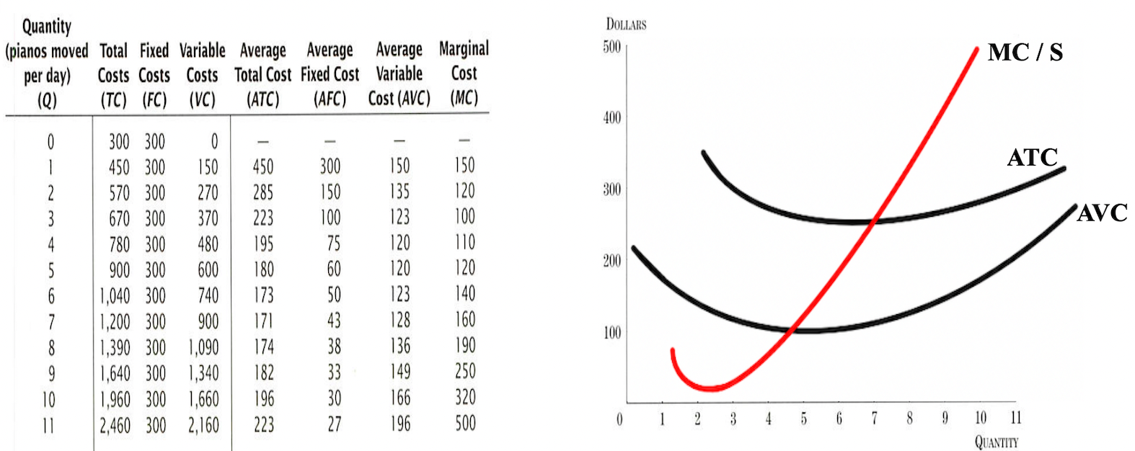

The distance between the average total cost (ATC) curve and the average variable cost (AVC) curve gets smaller as production increases because fixed costs (FC) are a smaller proportion of the total cost (TC) as production increases and more labor is needed, either workers or hours.
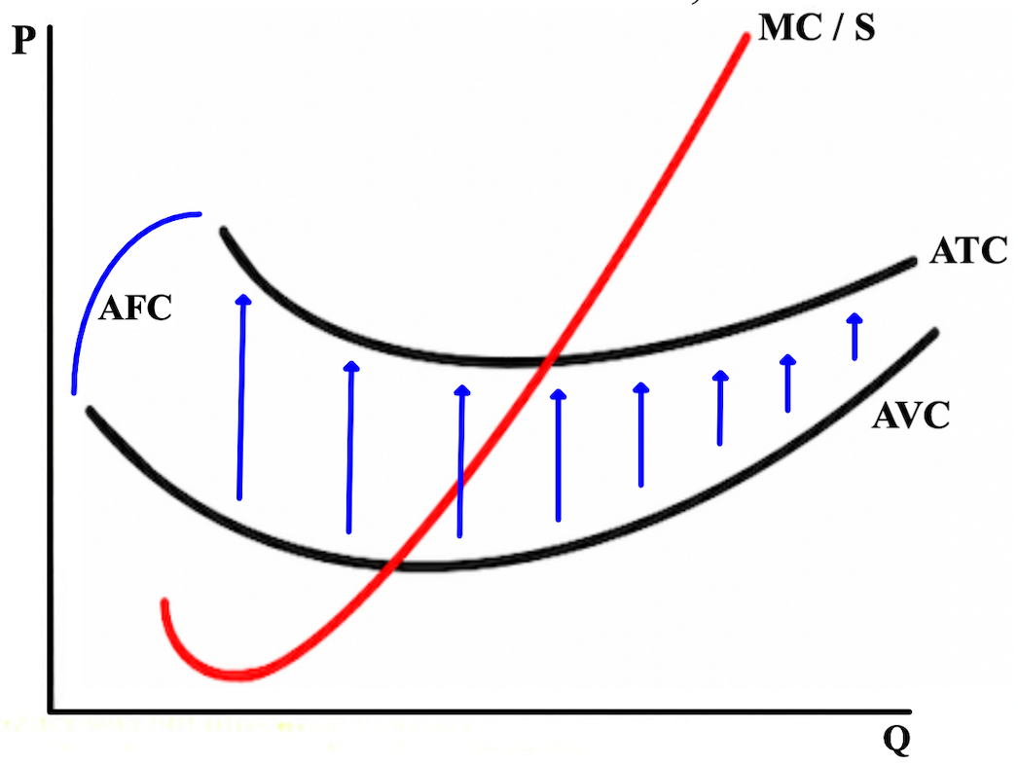
The marginal cost curve (MC/S) intersects both the average variable cost (AVC) curve and the average total cost curve (ATC) at their minimum points because this shows that firms in perfectly competitive markets are productively efficient. The perfectly horizontal market price line is also the firm's demand (D) curve because competitive firms are price-takers... they charge the market's price.
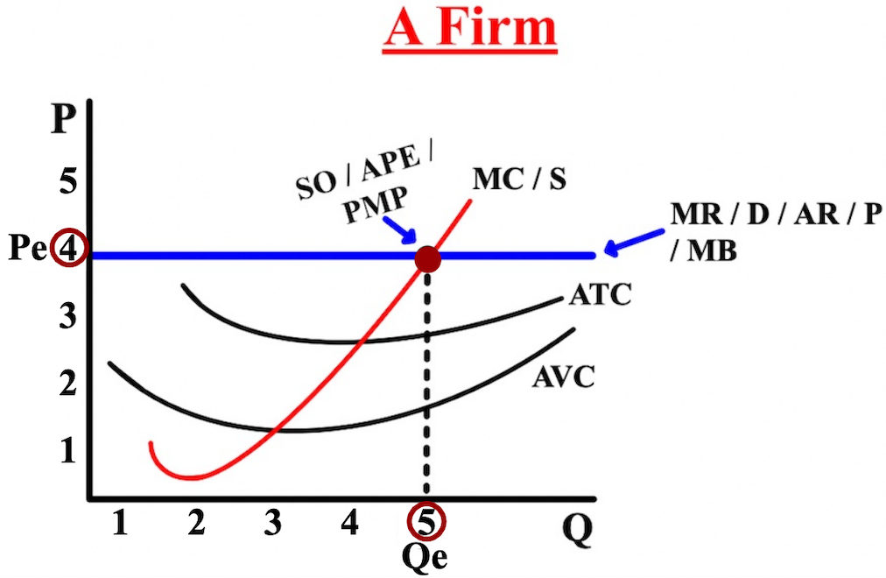
Where the demand curve intersects with the marginal cost curve (MC/S) establishes the equilibrium price (Pe) ($4) and equilibrium quantity (Qe) (5). At the intersection of the demand and the marginal cost curve is the socially optimal (SO), allocatively and productively efficient (APE), and profit maximizing point (PMP). SO, APE, and PMP will all have the same price ($4) and quantity (5).
Profit occurs when total revenue (TR) is greater than total cost (TC), and the areas of total revenue and total cost will always each be a rectangle. The area of a rectangle is height (P) width (Q). The revenue rectangle's height (quantity)(10) and width (price)($6) are determined by the intersection of the marginal cost curve/supply curve (MC/S) and the demand curve (D), which also determines the equilibrium quantity and the equilibrium price/market price.
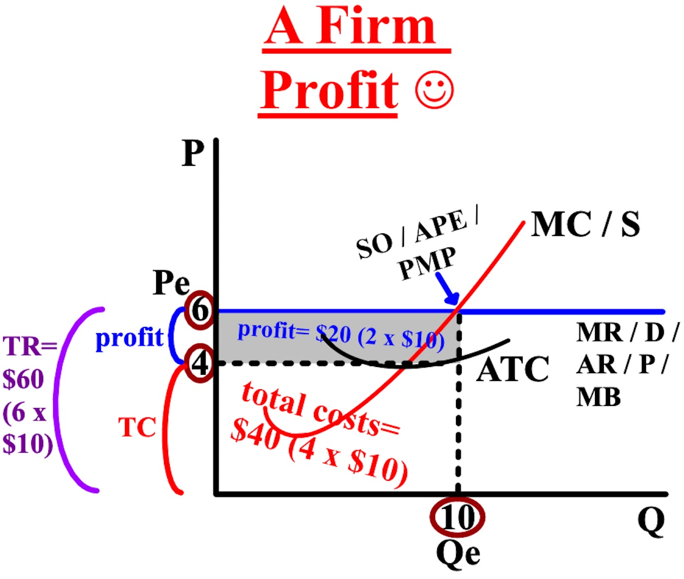
The total cost rectangle always encompasses at least part of the revenue rectangle (the area from the ATC price of $4 down and with a quantity of 10). $60 is the total revenue (10 x $6) and the total cost is $40 (4 x $10), which means the profit is $20 (TR$60- TC$40= $20 profit). Where the average total cost curve (ATC) intersects the quantity produced (10), the average total cost or cost per unit ($4) is determined. At the quantity of production of 10, average total cost of $4 is below the equilibrium price/market price of $6. There will be a positive profit because the price (P) charged by the firm ($6) is greater than the average total cost or cost per unit ($4): P > ATC.
Negative profit (a loss) occurs when total revenue (TR) is less than total cost (TC). $60 is the total revenue (10 x $6), but the average total cost curve (ATC) intersects the quantity produced (10) at $8. There will be a loss because the price (P) charged by the firm ($6) is less than the average total cost or cost per unit ($8) to make each item: P < ATC.
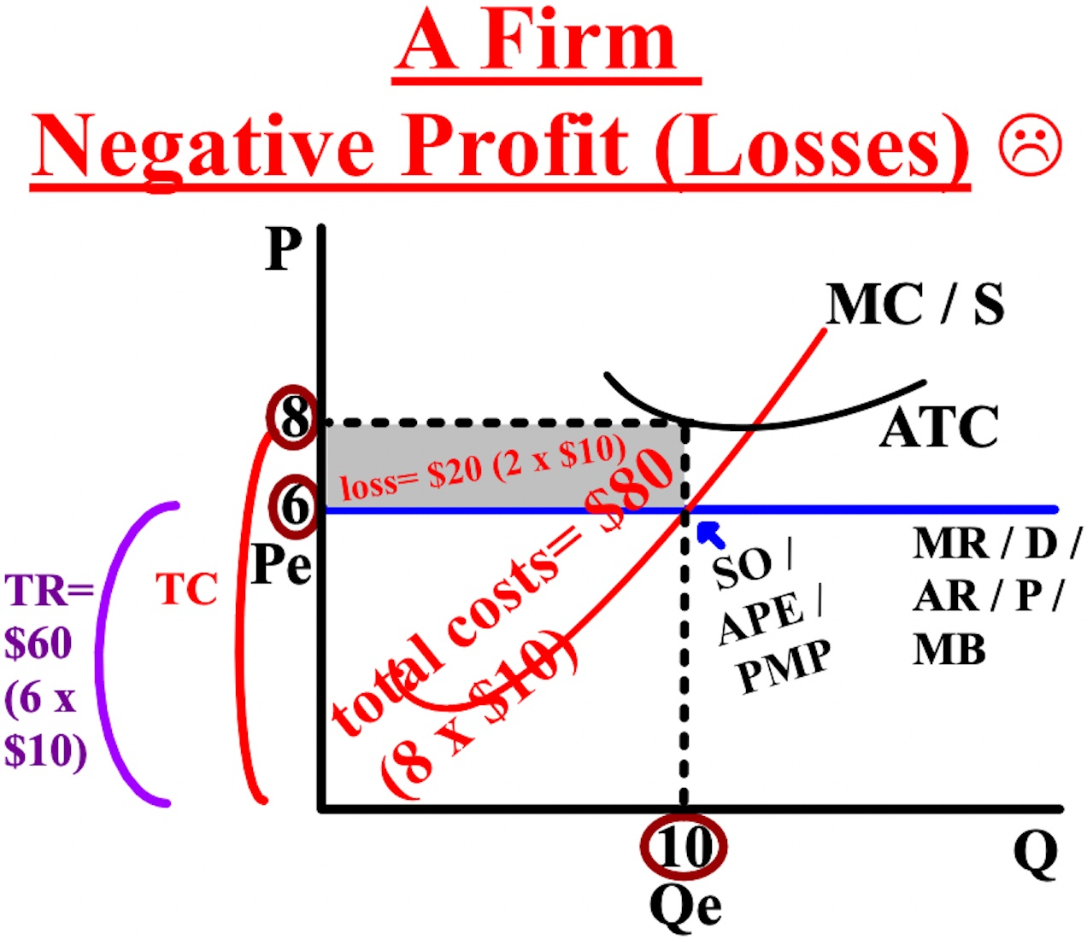
$60 is the total revenue (10 x $6) but the total cost is $80 (8 x $10), which means the negative profit is $20 (TR of $60- TC of $80= $20 loss). Firms continue to operate in the short-run even with losses because of the
concept of a sunk cost (a cost that you have committed to pay and that you cannot recover), like property rental payments.
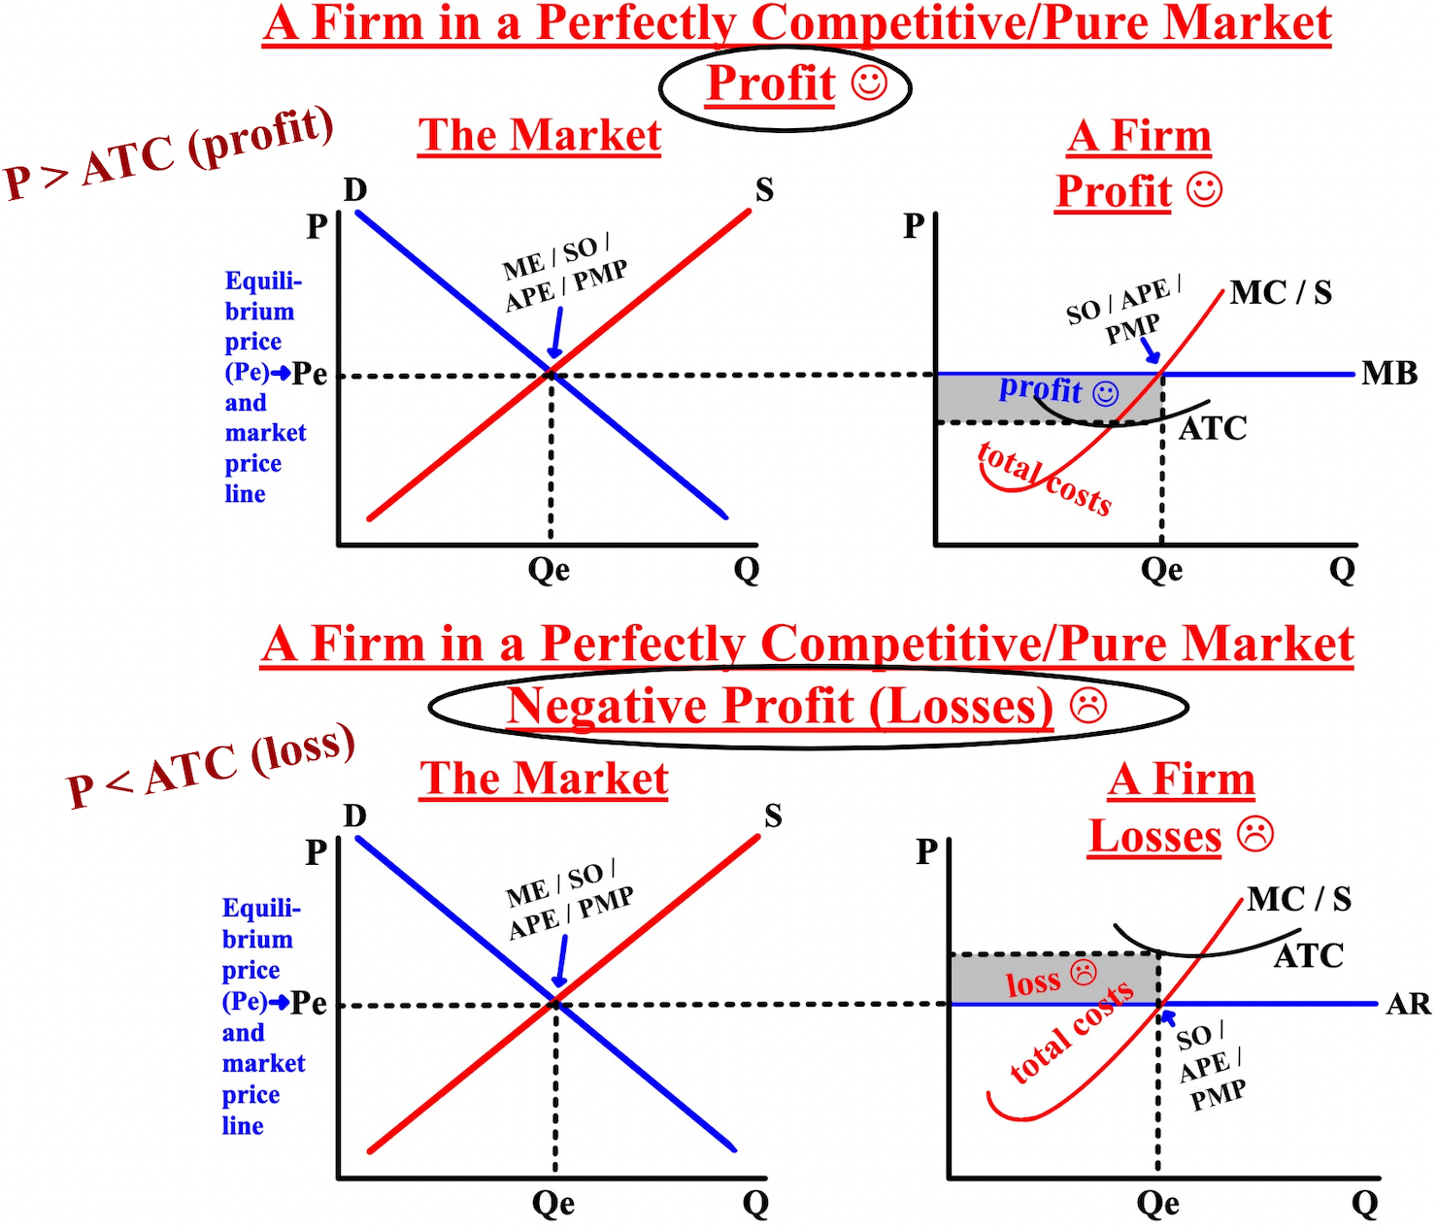

Free Response Question (FRQ) #3, and answer
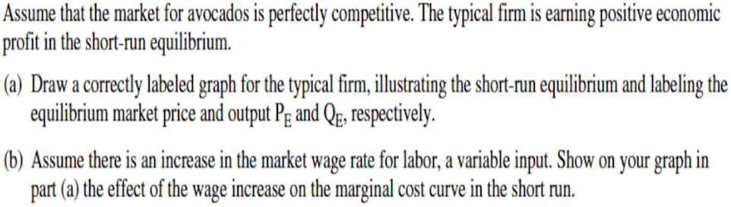
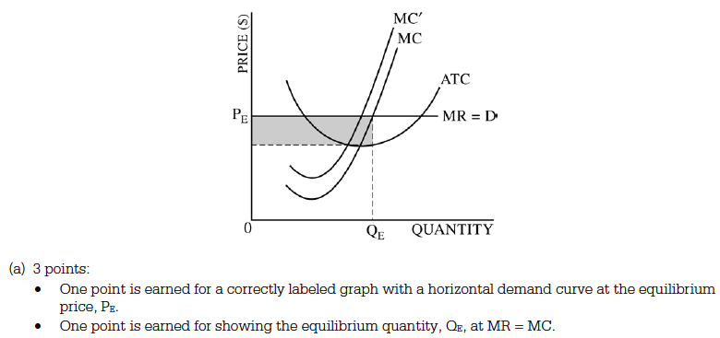

Free Response Question (FRQ) #4
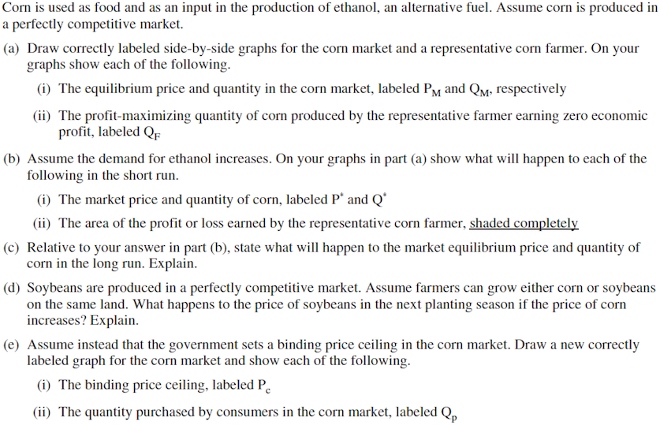
Free Response Question (FRQ) #4 (answer)

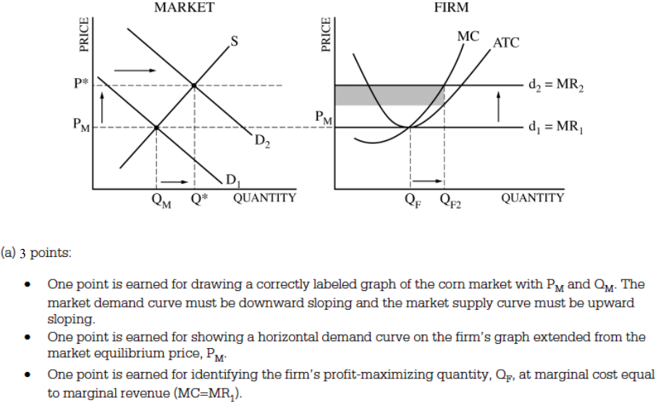

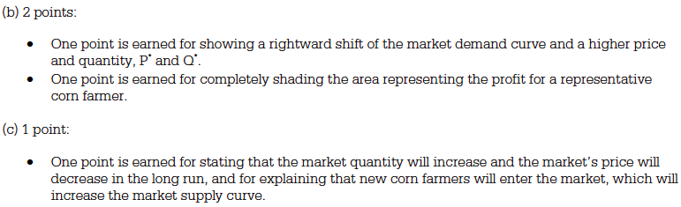
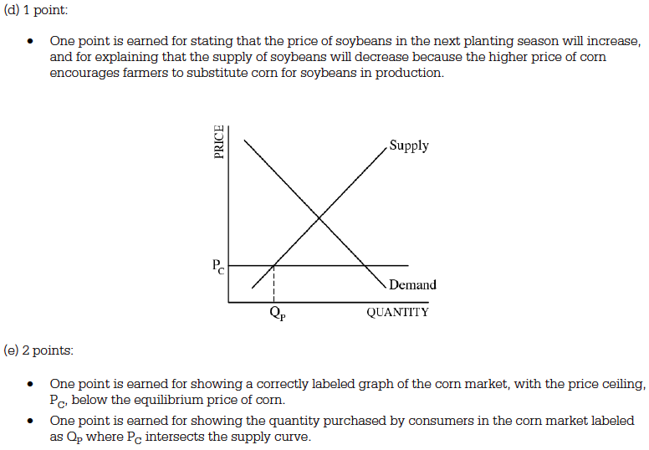
When the minimum point on the average total cost curve (ATC) intersects the marginal cost curve/supply curve (MC/S) and the demand curve (D) at the same point, the firm is at the breakeven point (left graph). The revenue rectangle's width (quantity) is 10 and the height (market price) is $6, but the average total cost curve (ATC) also intersects the MC/S and demand curves at $6. At the breakeven point, a firm's average total cost per unit ($6) equals the price ($6) they are selling it at: the total revenue (TR) rectangle and the total cost (TC) rectangle are exactly the same and economic profits are zero: P =ATC
If the price (P) charged by the firm falls below where the average variable cost curve (AVC) intersects the quantity produced, this is referred to as the shutdown point: P < AVC (right graph). The AVC intersects the quantity produced (10) at $7, but the price (P) charged by the firm ($6) is less than the average variable cost ($7) of paying the workers. This is the only situation you need to use the average variable cost curve for.

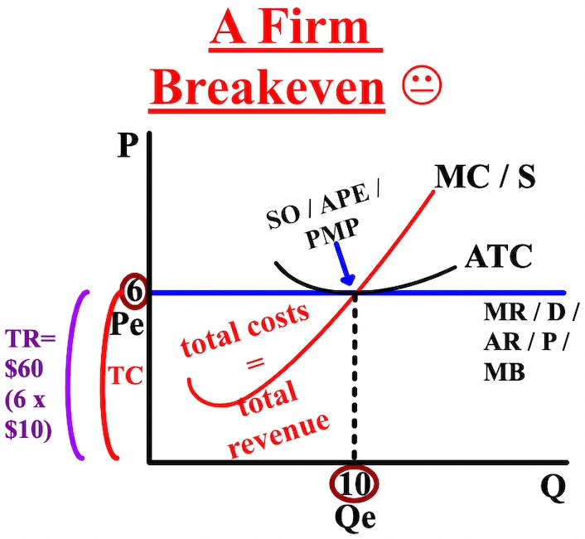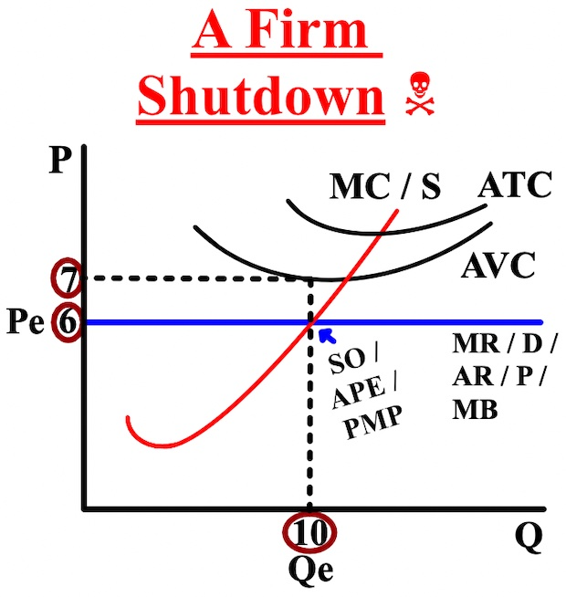
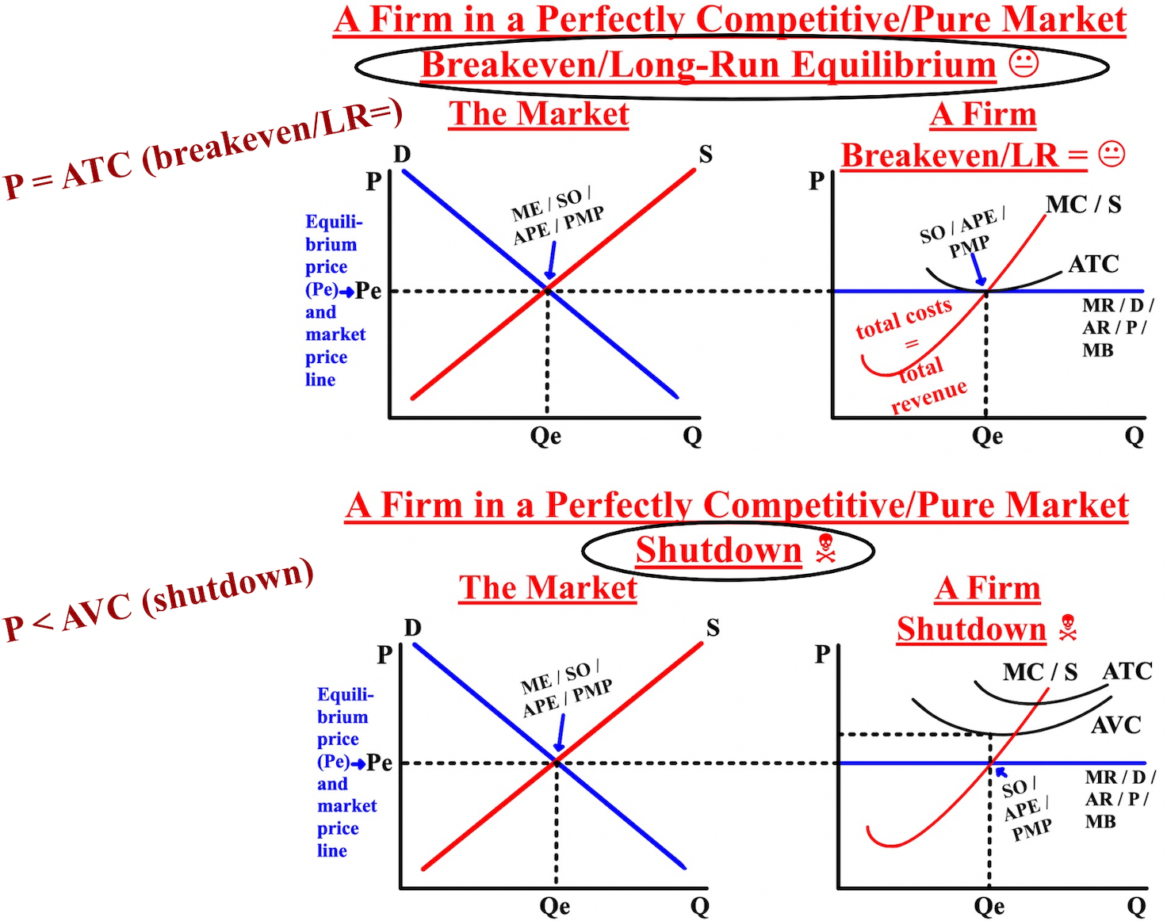
Free Response Question (FRQ) #5, and answer
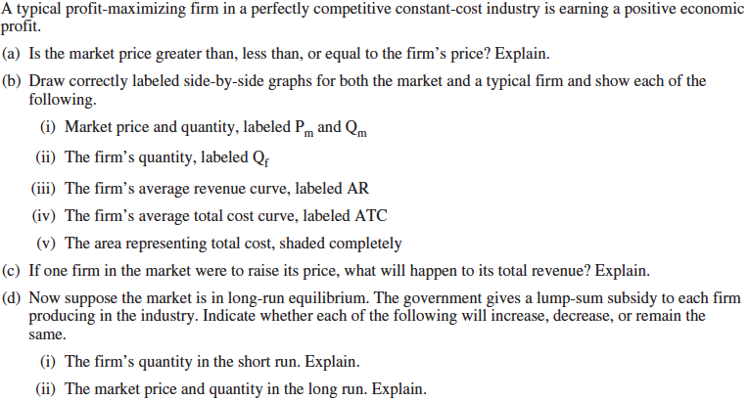

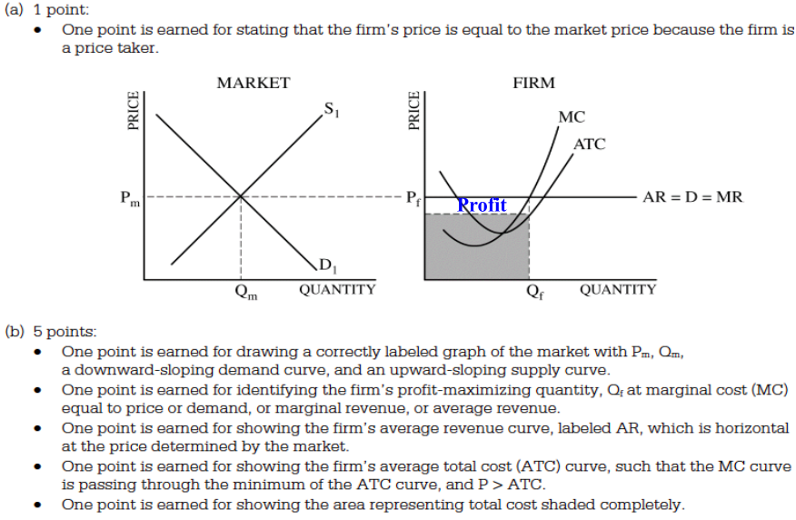

Free Response Question (FRQ) #5 (answer, cont.)
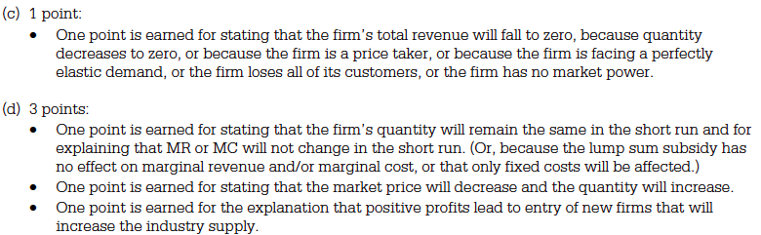

The thick light green curve is tracing the long-run average total cost curve (LRATC)... the curve that traces out the lowest points on the average total cost curves over time. The line tells firms what the average total cost is in the long-run when considering different business options.

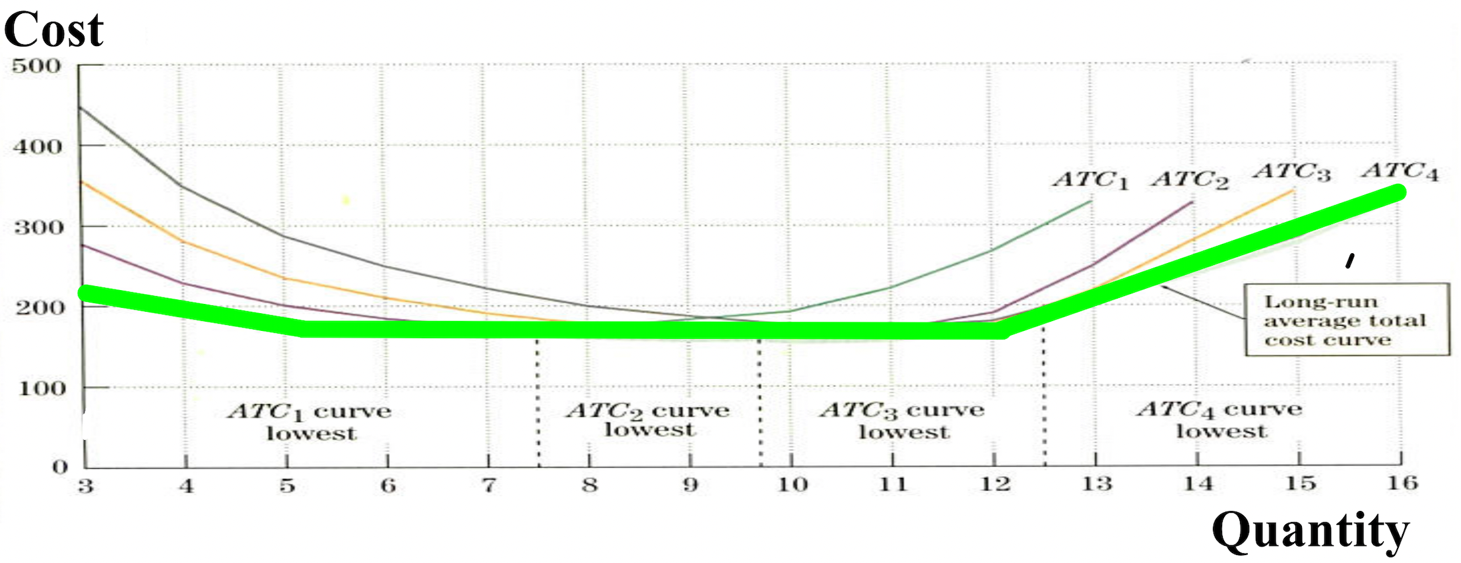
The long-run average total cost curve describes what happens to a firm's average total cost when its scale (size) increases. When all of a firm's inputs increase, like physical and human capital, we say that the scale of the firm increases. For example: if the number of workers at the firm doubles, the number of trucks doubles, the number of buildings doubles, then we say that the scale of the firm doubles.
There are economies of scale, or increasing returns to scale/size, if the long-run average total cost (LRATC) decreases as the scale increases. There are diseconomies of scale, or decreasing returns to scale/size, if the
long-run average total cost increases as the scale increases. The minimum efficient scale or constant returns to scale is the situation in the middle (dot to dot) where the long-run average total cost is flat and at the minimum and is when a firm's output increases at the same rate the firm is utilizing its inputs.

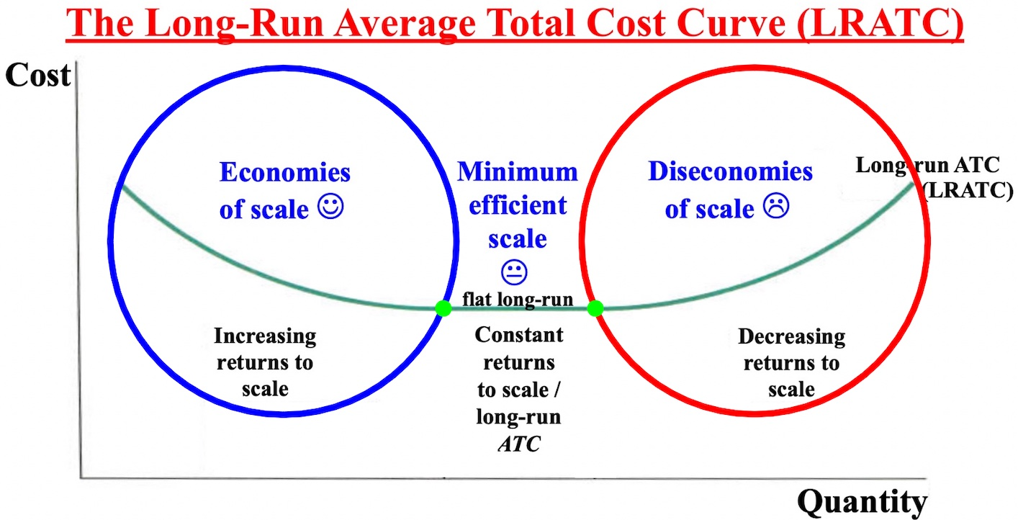
Internal economies of scale occur when the long-run average total cost (LRATC) decreases because of a reason internal to a firm, such as a grape firm hiring a specialist. External diseconomies of scale occur when the long-run average total cost (LRATC) increases because of a reason external to a firm, such as an increase in water prices for farmers.
Both external and internal economies of scale can occur at the same time. Federal Express achieved internal economies of scale by improving its computer tracking system and the industry achieved external economies
of scale by using the scanners Federal Express pioneered.
Below is a graph showing a typical market with its market supply (S) and demand (D) curve and a firm in that market with a flat demand curve. Where price (P) = marginal costs (MC), the profit maximizing price and
quantity are determined for a firm. There are no generic cost curves below because this is short-run equilibrium
(1 year or less).
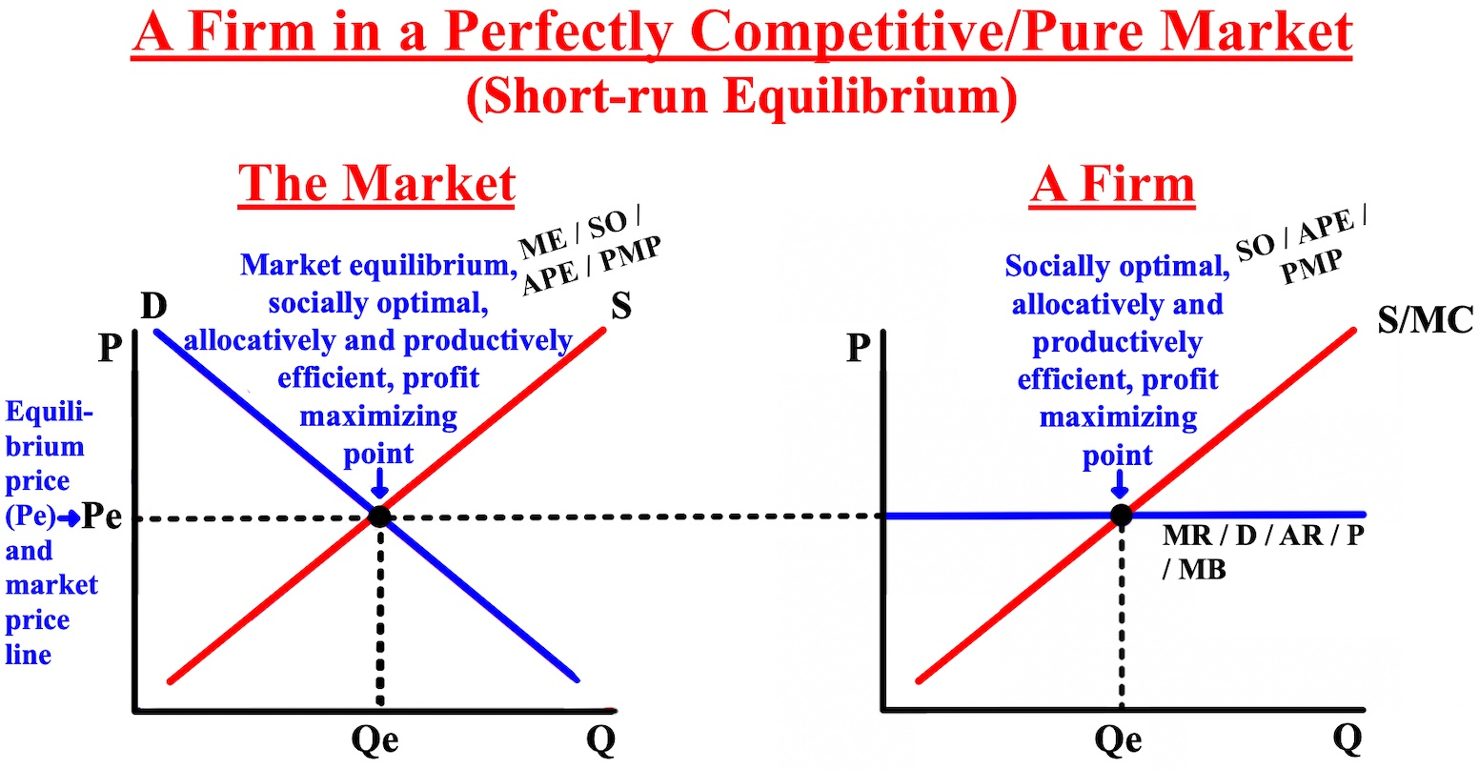

Now we'll talk about the expansion and contraction of markets/industries over time (the long-run, 4-5 years out), like the cell phone or car market. Long-run equilibrium is a situation in a market when the average total
cost curve (ATC) intersects the price line, profits are zero, and there is no incentive for any firm to enter or exit the market/industry. During long-run equilibrium, firms are at the breakeven point. The addition of generic cost curves is the only difference between short-run equilibrium and long-run equilibrium.
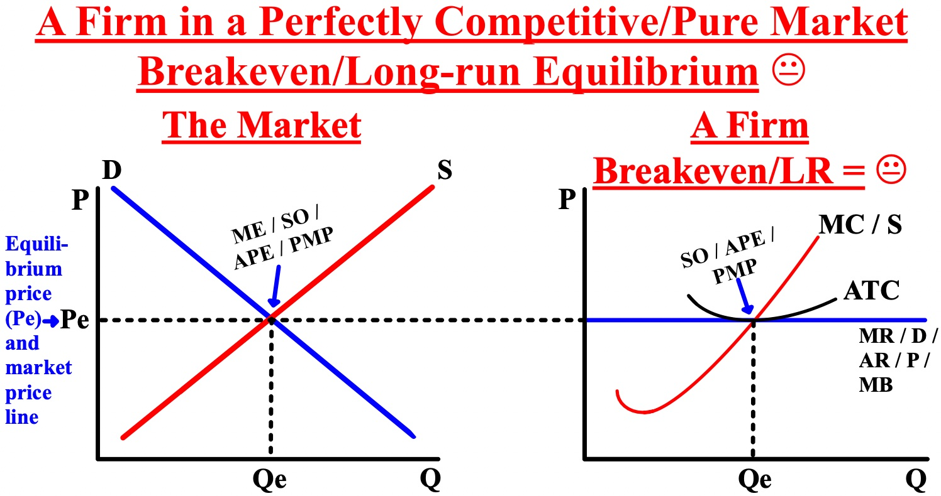

The long-run equilibrium model can be used to explain the expansion of a market and the firms in that market. Demand (D) increases in the market from D to D1 (purple to green). As firms make profit, the supply (S) curve for the whole market shifts to the right from S to S1 (from green to orange) because now there are firms entering the industry to make a profit, increasing supply.
As supply increases from green to orange, it intersects the market demand curve at a lower price (P), causing the market to return to long-run equilibrium and zero profit. Markets might expand, but they always return to long-run equilibrium.

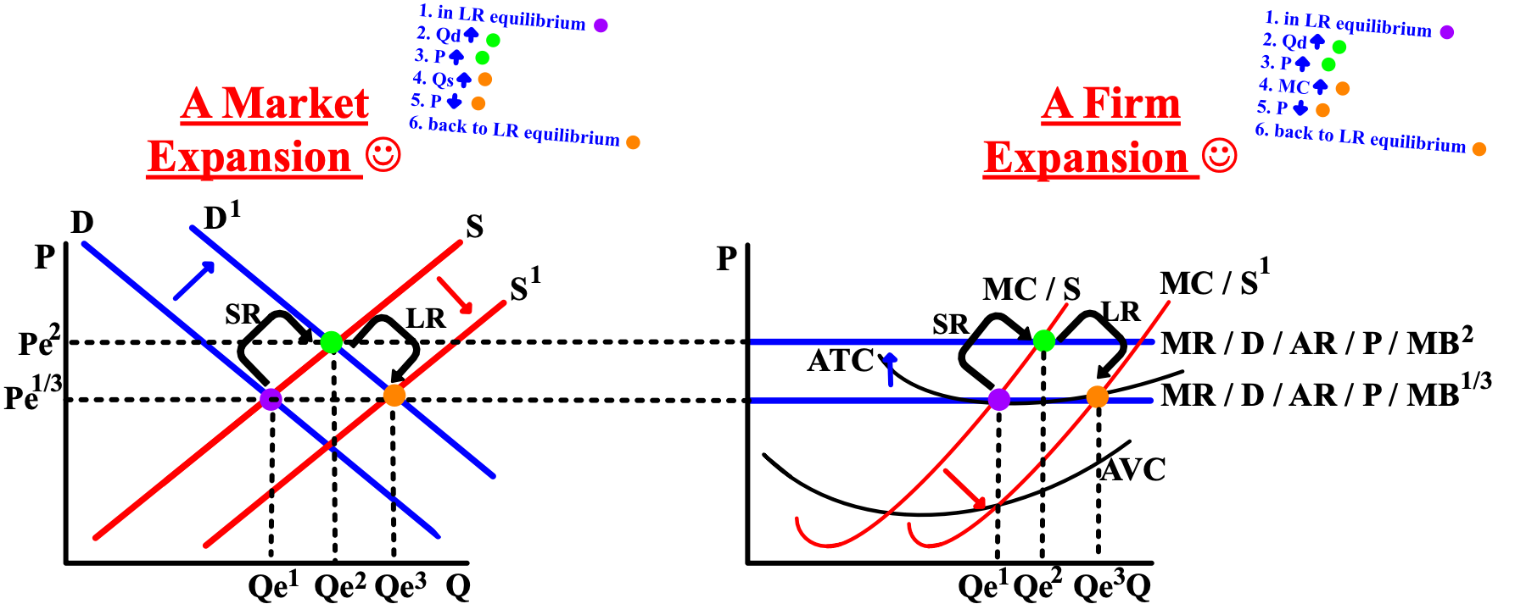

The long-run equilibrium model can also be used to explain the contraction of a market and the firms in that market. Demand (D) decreases in the market from D to D1 (orange to black). As firms make negative profit (losses), the supply (S) curve for the whole market shifts to the left from S to S1 (from black to purple) because now there are firms leaving the market because of their losses, decreasing supply.
As supply decreases from black to purple, it intersects the market demand curve at a higher price (P), causing the market to return to long-run equilibrium and zero profit. Markets might contract, but they always return to long-run equilibrium.
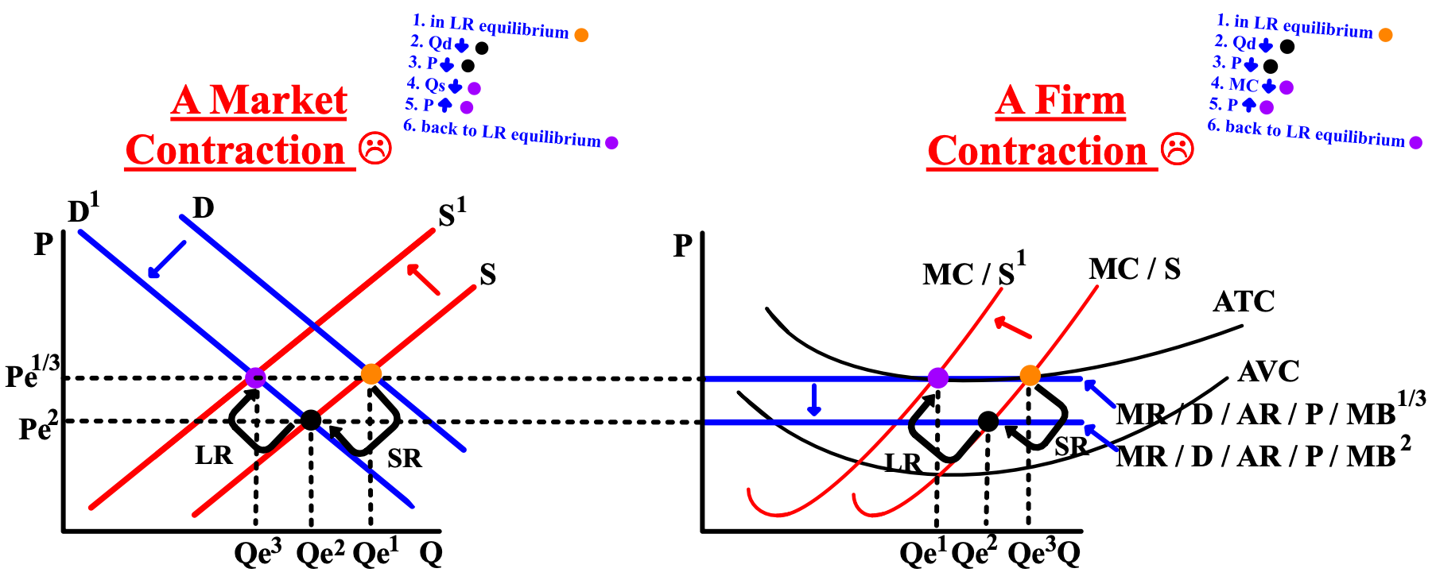

Accounting profit (also called bookkeeping profit) for a firm consists of total revenue minus explicit costs, a firm's expenses).

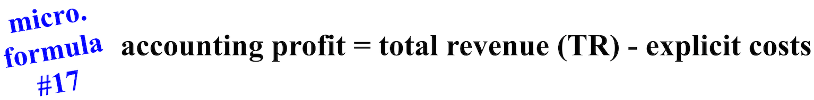

For an accountant, the total cost does not include the implicit costs (the opportunity cost of the owner's time, money, or the firm's resources). An accountant only cares about the difference between total revenue and
explicit costs
Economic profit is a more accurate and more used measure of the incentive for a firm to stay in business or enter a market because it takes into account all of the important financial factors.

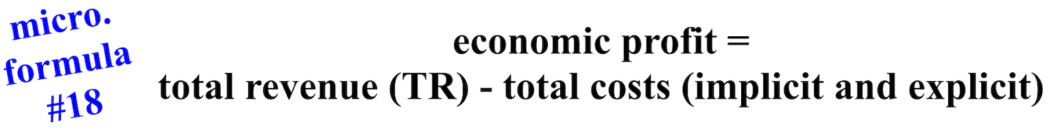

Assume the profits for a bakery are $40,000 a year after deducting explicit costs like electricity and dough. Now assume the owner of the bakery could earn $35,000 a year working at another job and invest money and earn $3,000 per year (implicit costs = $38,000). Economists would say the owner would have an economic profit of $2,000 keeping his bakery ($40,000 - $38,000), which is enough of an incentive for the firm to stay in business versus doing something else. Accountants don't care about implicit costs and would say that the
accounting profit is $40,000.
The term normal profit is an economic condition that occurs when economic profits equal zero; the minimum level of profit needed for a company to remain in business (long-run equilibrium or the breakeven
point when total revenue (TR) = total costs (TC). If a firm's economic total revenue (TR) is $40,000 and their total costs (TC) (explicit and implicit) equal $40,000, their economic profit and thus their normal profit would be $0.

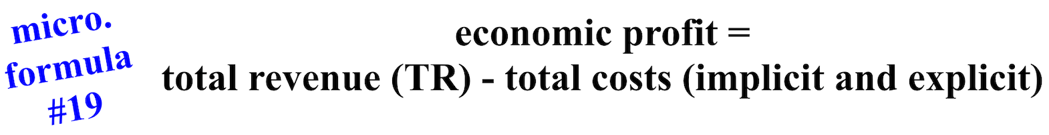

Finally, we'll talk about monopolies and how they decide what price (P) to charge their customers and what quantity (Q) to produce/sell, because profit is their one and only goal. Even though monopolies are illegal, sometimes they exist for the benefit of society, like having only one water company or one electric company in an area.
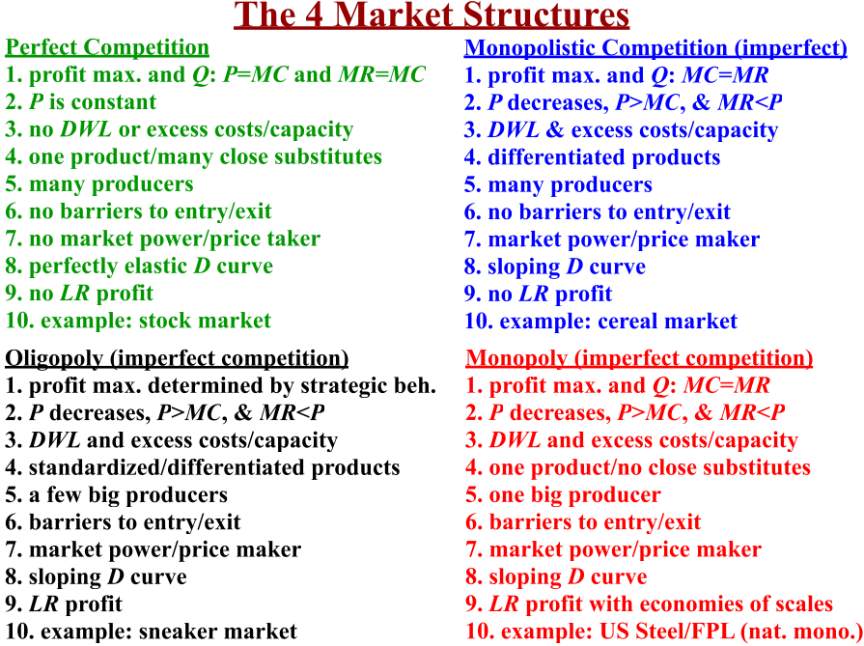

A monopoly occurs when there is only one firm in a market selling a product for which there are no close substitutes. Monopolies create barriers to entry (when monopolies take active action to prevent other firms from entering the market they are in). Monopolies have market power. Monopolies are price-makers and not price-takers and there is no company that can undercut a monopoly's price, and what a monopoly does with its production levels can greatly impact its prices.
To maximize profit, the monopoly should produce the quantity where marginal cost equals marginal revenue: MC = MR, which is 5. The marginal revenue curve becoming negative shows that as total revenue continues to fall, at some point marginal revenue will become negative. Where marginal revenue= 0, total revenue (TR) is at its maximum.
Where marginal revenue (MR) equals/intersects marginal cost (MC), a monopoly's profit maximizing quantity produced is determined... 5. Where the monopoly's quantity produced intersects with demand (D), the profit maximizing and monopoly's price is determined... 10.
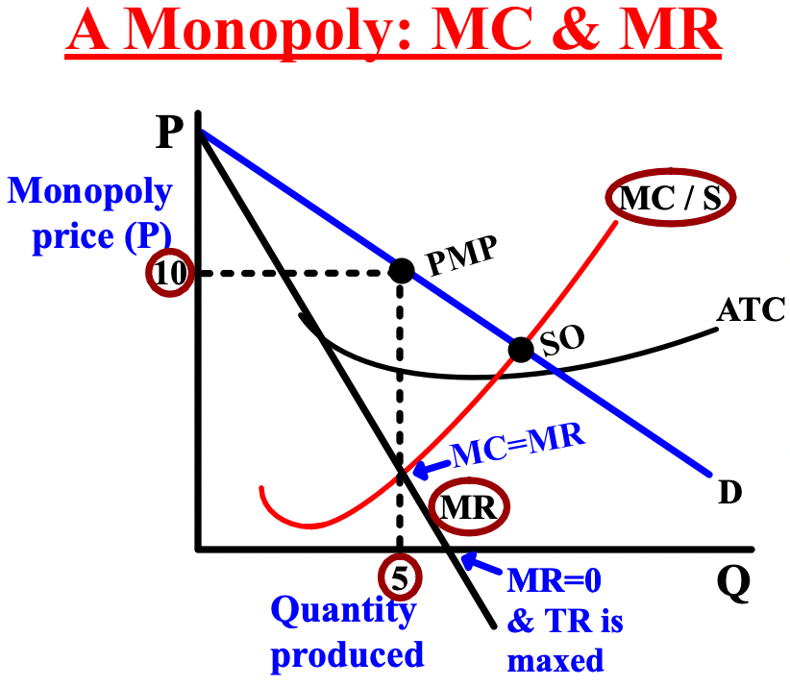

For a monopoly, its marginal revenue (MR) is always less than the price (P) it charges for their products because a monopoly has to decrease the price of their products to sell more. When marginal cost (MC) becomes greater than marginal revenue (MR) at 4 produced/sold, the profit maximizing quantity of 3 has been surpassed.
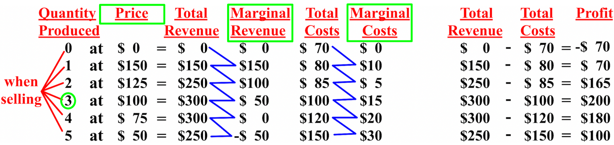

Unlike a firm in a perfectly competitive market, monopolies charge a higher price and produce a smaller quantity and therefore have excess capacity, are inefficient, create deadweight loss (DWL), and are not socially optimal in their business structure. On a graph of a monopoly, you can determine the socially optimal (SO),
allocatively and productively efficient (APE), profit maximizing point (PMP) and the equilibrium quantity (8) equilibrium price ($7) for a firm.
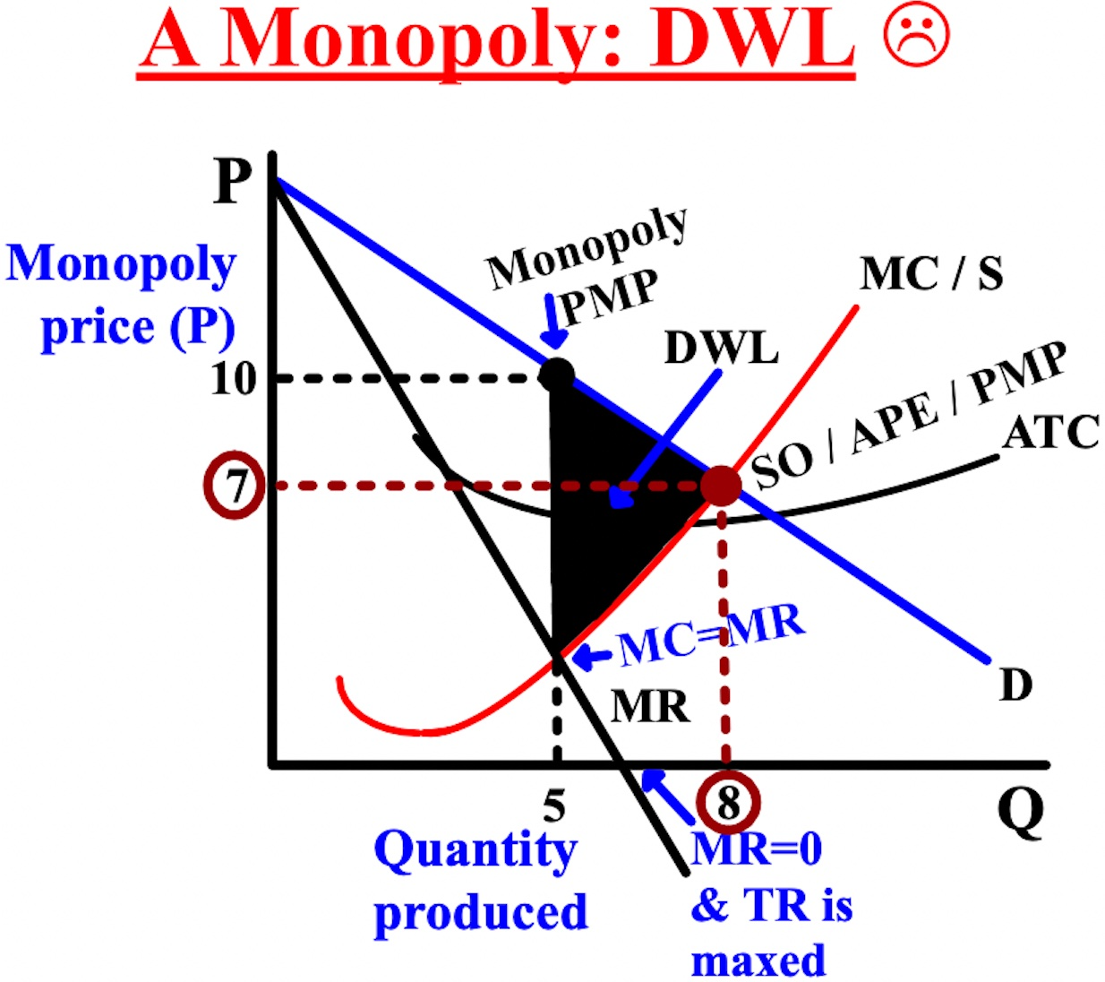

Where marginal revenue (MR) = 0, the demand (D) curve is divided between the elastic range (sensitive area) and the inelastic range (insensitive area). In the elastic range (PED or PES >1), consumers are sensitive to increases in prices and will pay less of any increase in price; producers will pay more. In the inelastic range (PED or PES >1), consumers are insensitive to increases in prices and will pay more of any increase in price; producers will pay less.
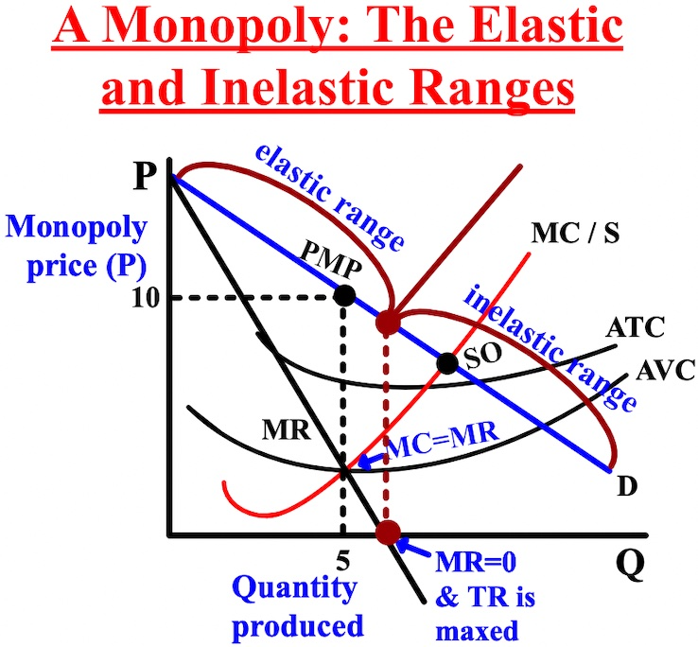
At a production quantity of 5, the monopoly's price (P) would be $10 and total revenue (TR), which is always a rectangle, would be $50 (5 x $10). The average total cost curve (ATC) intersects the monopoly's quantity produced (5) at $6, so the total costs (TC), also always a rectangle, would be $30 (5 x $6). Economic profit would be $20 because TR ($50) - TC ($30) = $20, which is the difference between the area of the two rectangles.
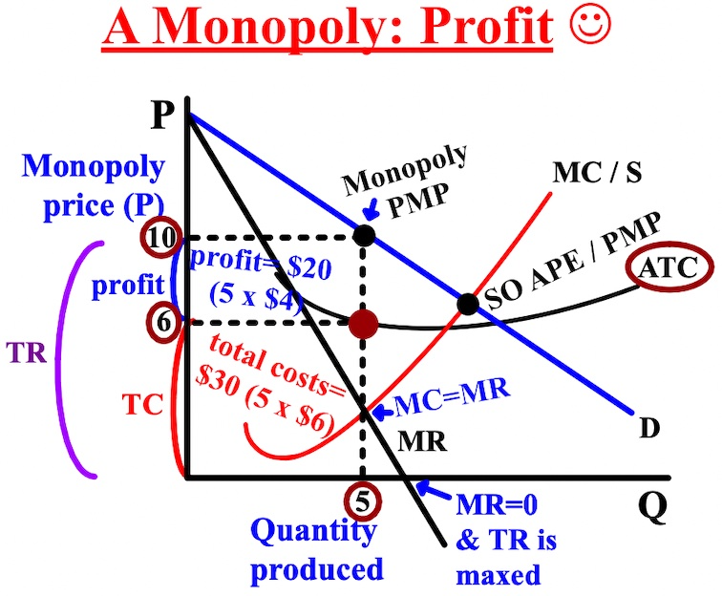

At a production quantity of 5, the monopoly's price (P) would be $8 and total revenue (TR) would be $40 (5 x $8). But, the average total cost curve (ATC) intersects the monopoly's quantity produced (5) at $10, so the total costs (TC) would be $50 (5 x $10). In this case, the price is below average total cost: negative profit (losses). Like a competitive firm, a monopoly with negative profits will only shutdown if the price is less than the average variable cost (AVC).

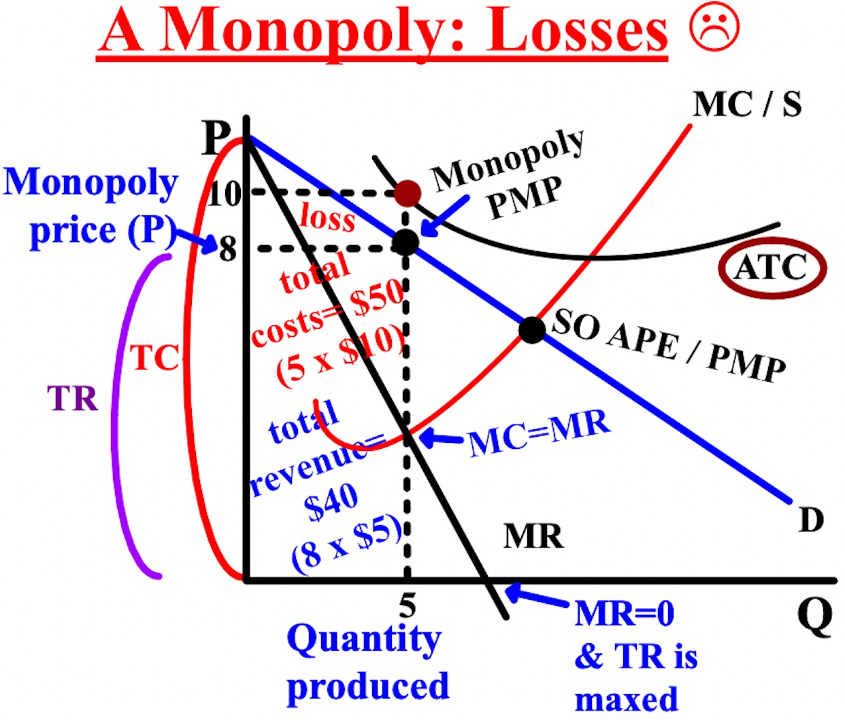
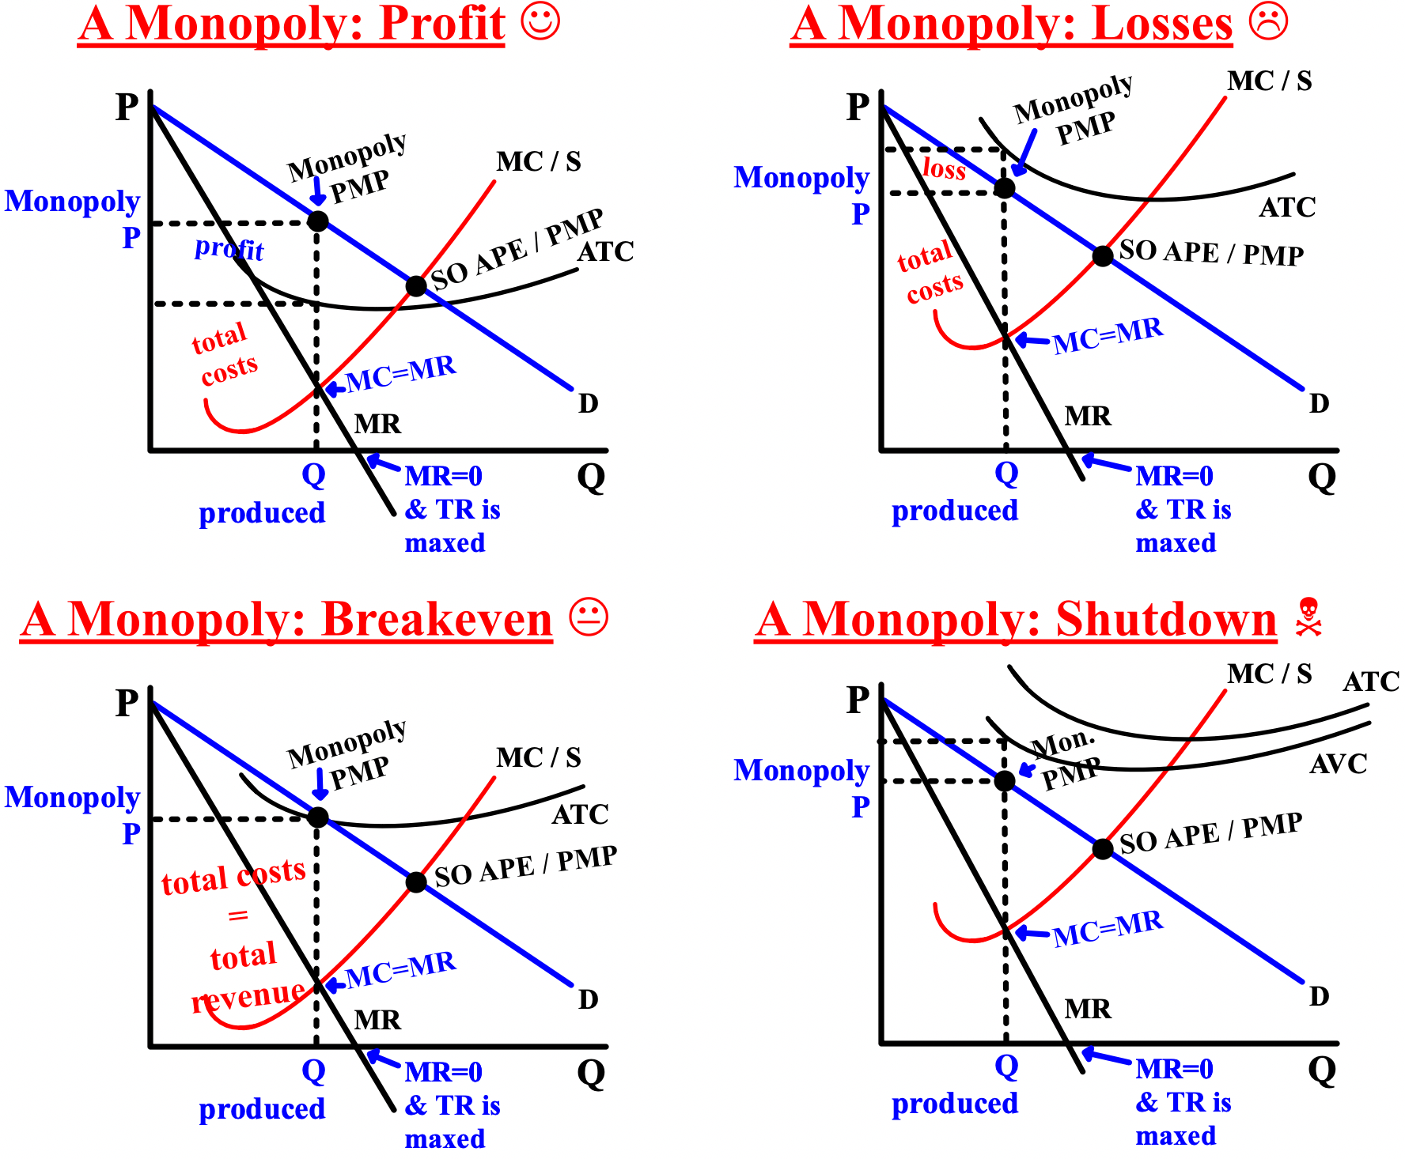

Free Response Question (FRQ) #6
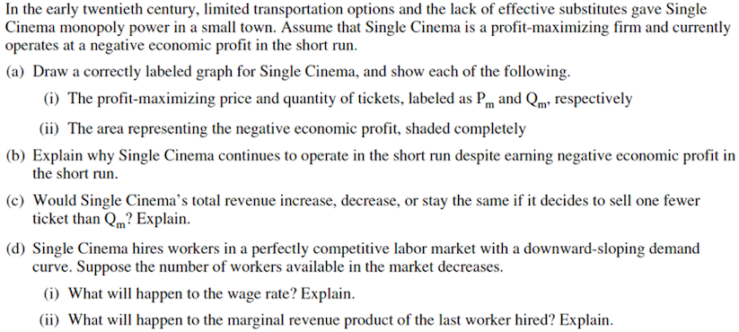
Free Response Question (FRQ) #6 (answer)
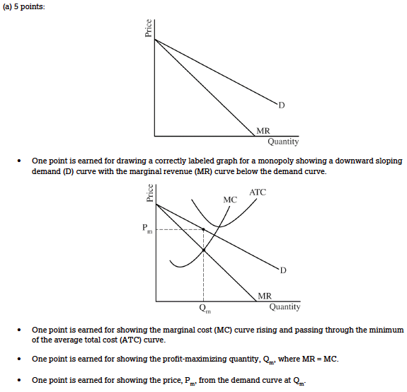

Free Response Question (FRQ) #6 (answer, cont.)

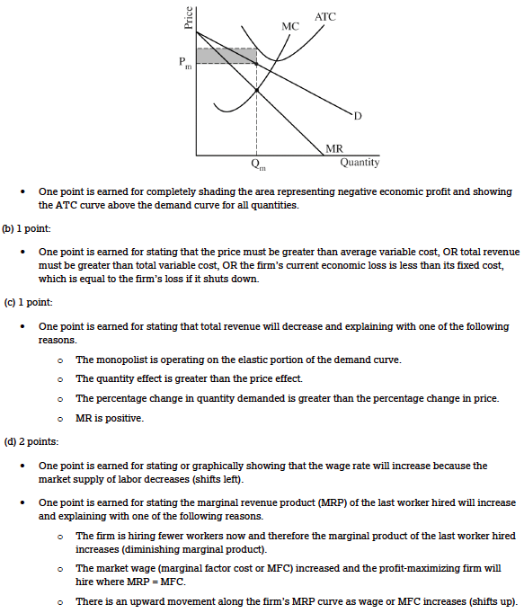

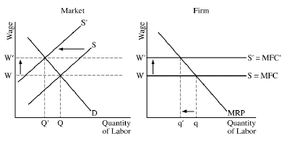
Natural monopolies exist when the average total cost (ATC) in a market is declining and the possible production is more than the market needs, like a water or electric company. The prices charged by many natural monopolies are regulated by the government and are set equal to the firm's ATC (P=ATC). The purpose of the regulation is to keep the price below what a monopoly would charge and closer to the competitive price.
In some cases, monopolies charge different people different prices for the same product in order to make more profit, like senior citizen discounts at movie theaters. This is called price discrimination or perfect price discrimination. To maximize their profits when they price discriminate, monopolies set their price (P) and quantity (Q) equal to MC=D/MR/P, just like a firm in a perfectly competitive market. Extra profit is earned because MR is now the same as D, which is an increase.

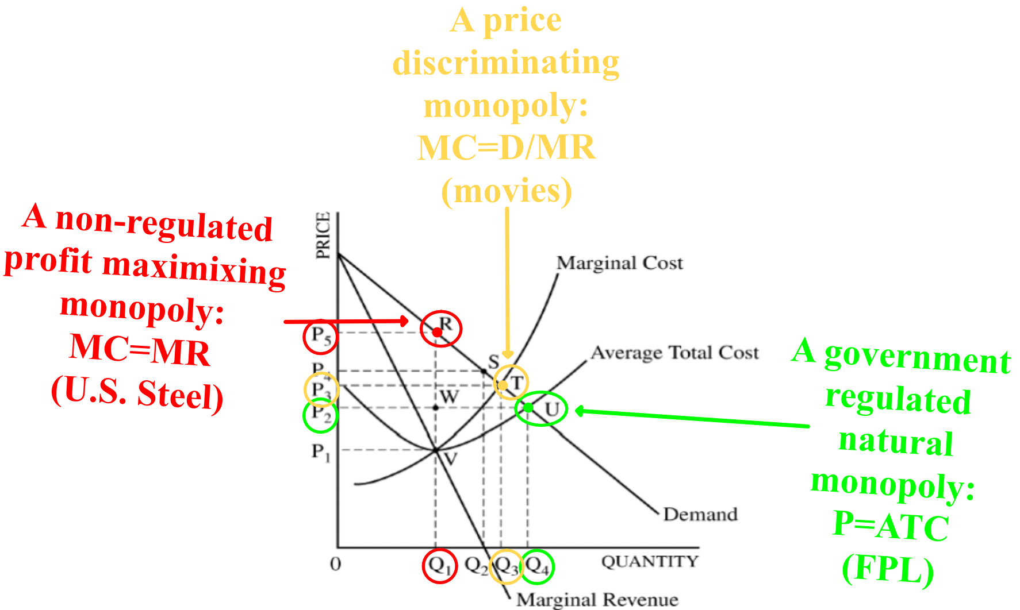

Chapter 9- Monopolistic Competition, Oligopolies, Antitrust Policy, Labor Markets, and Taxes
This chapter is about hybrid firms that are a mix of characteristics of competitive firms and monopolies (monopolistic competition). We will also talk about when there are very few firms in an industry and each firm has market power and can significantly affect the market price (P) (oligopoly). Finally, we'll discuss government practices to prevent anticompetitive business practices (antitrust policy) and the demand and supply of labor (workers) in labor markets.
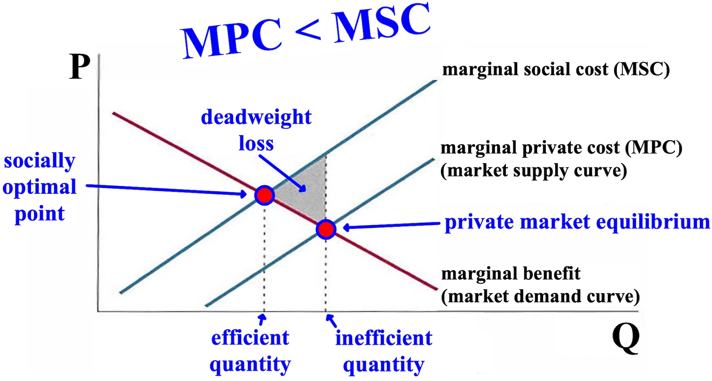
Monopolistic competition is a hybrid of monopolies and competitive markets. It has many firms with free entry and exit, but each firm has a downward sloping demand curve for its product because its products are different from other firms' products in ways that people value, called product differentiation (like Coke and Pepsi). Monopolistically competitive firms set their price (P) and quantity (Q) between those of a competitive
market and a monopoly.
When a monopolistically competitive firm increases its price (P), the quantity demanded (Qd) of its product decreases but does not plummet to zero. If Nike raises its prices, it will lose some sales to Reebok, but not a
lot because there will always be those who prefer Nike to Reebok. Nike's customers have a low-price elasticity of demand (PED) (the sensitivity and impact on demand when prices change) and the two companies have differentiated products to one another.
In the short run (SR) for both monopolistically competitive firms and monopolies, profit maximization is the same: set the quantity produced where marginal revenue (MR) equals marginal cost (MC) (MR=MC) and set the price (P) where the quantity produced intersects with demand. Both have downward-sloping demand (D) curves and both have market power. Both operate in a situation of excess costs (when costs are higher than
necessary). Both also operate with some excess capacity, where actual production is less than what is achievable or optimal for a firm because both firms choose to have some market power to keep their prices higher and output lower. But in the long-run, a competitive market's average total cost (ATC) is
minimized and is equal to the price (P) (P=ATC), creating a situation with no profit in the long-run (LR). Monopolistically competitive firms set their P=ATC in the long-run also.

Free Response Question (FRQ) #1, and answer
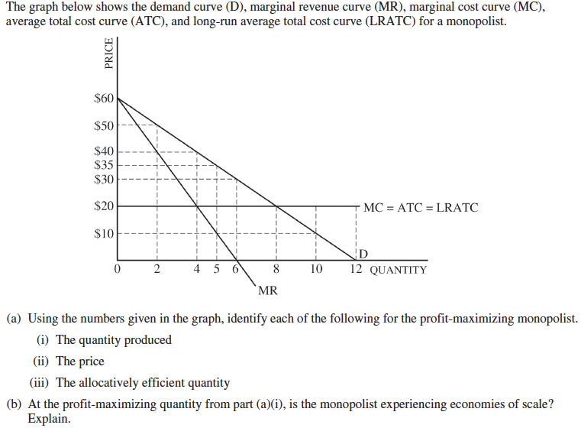
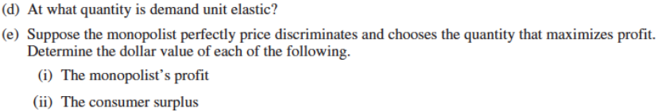

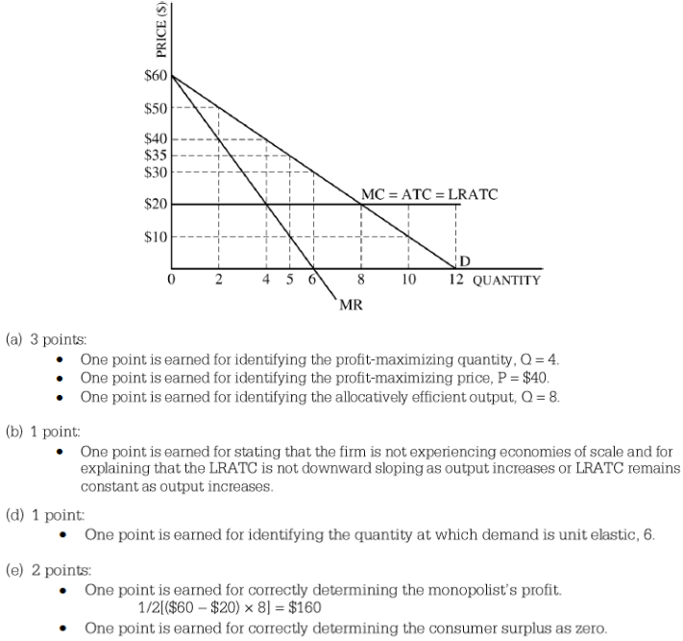
Product differentiation may be of sufficient value to consumers that it makes sense to have monopolistically competitive firms despite the deadweight loss (DWL). The deadweight loss from monopolistic competition is
part of the price consumers pay for the variety or the diversity of products.
Now we'll talk about a market structure when there are very few producers in an industry, a market structure termed oligopoly, like the oil market. Each firm can have an influence on the market price even if the goods are
similar, like by increasing or decreasing production. If the managers of a firm make the right assessment about how other firms will affect any course of action their firm takes, then the firm will profit and may become a price leader. This awareness and consideration of the market power and the reactions of other firms in the industry by other firms, called strategic behavior, only exists in oligopolies.
A common approach to the study of strategic behavior of firms in an oligarchy is the use of game theory, an area of applied mathematics that studies games of strategy, like poker or chess, to determine the best moves
to make in business. The goals of game theory are to analyze the choices facing each firm and to design utility maximizing actions, or strategies, that respond to every action of the other firms. An important example is the game called prisoner's dilemma. The game is between two people, both of whom have been arrested for the same crime and are also guilty of multiple other crimes. They are both in prison and separated while being interrogated. The goal is to see the strategy that takes place, whether it is the players work together (both remaining silent), or the two players turning on each other (one or both confess).
Prisoner's dilemma is played with a payoff matrix, which is a simple chart used in basic game theory situations to analyze and evaluate a situation in which two parties have decisions to make. The matrix has rows and columns showing the different jail terms and options for each, such as to confess or remain silent. In prisoner's dilemma, the best choice is the choice with the lowest jail time, but in most scenarios, it is the higher of the two numbers (the revenue). The question is always what strategy each person will follow when neither can or do communicate with the other, like firms in real life.
We are also looking to see if either person has a dominant strategy. A strategy is dominant if, regardless of what other players do, a player uses the same strategy every time. First, what should Pete do if Ann confesses (#1)? If Pete confesses, he will get 5 years in prison and if he remains silent, he will get 7. Definitely better for Pete to confess when Ann confesses.

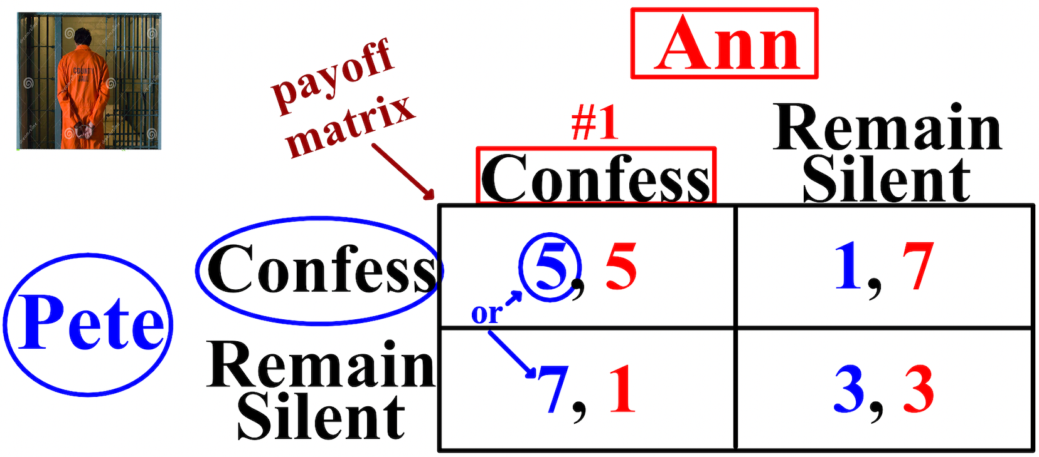

Next, what should Pete do if Ann remains silent (#2)? If Pete confesses, he will get 1 year in prison and if he remains silent, he will get 3. Again, to confess is the better strategy for Pete regardless of what Ann does, and to confess is his dominant strategy.
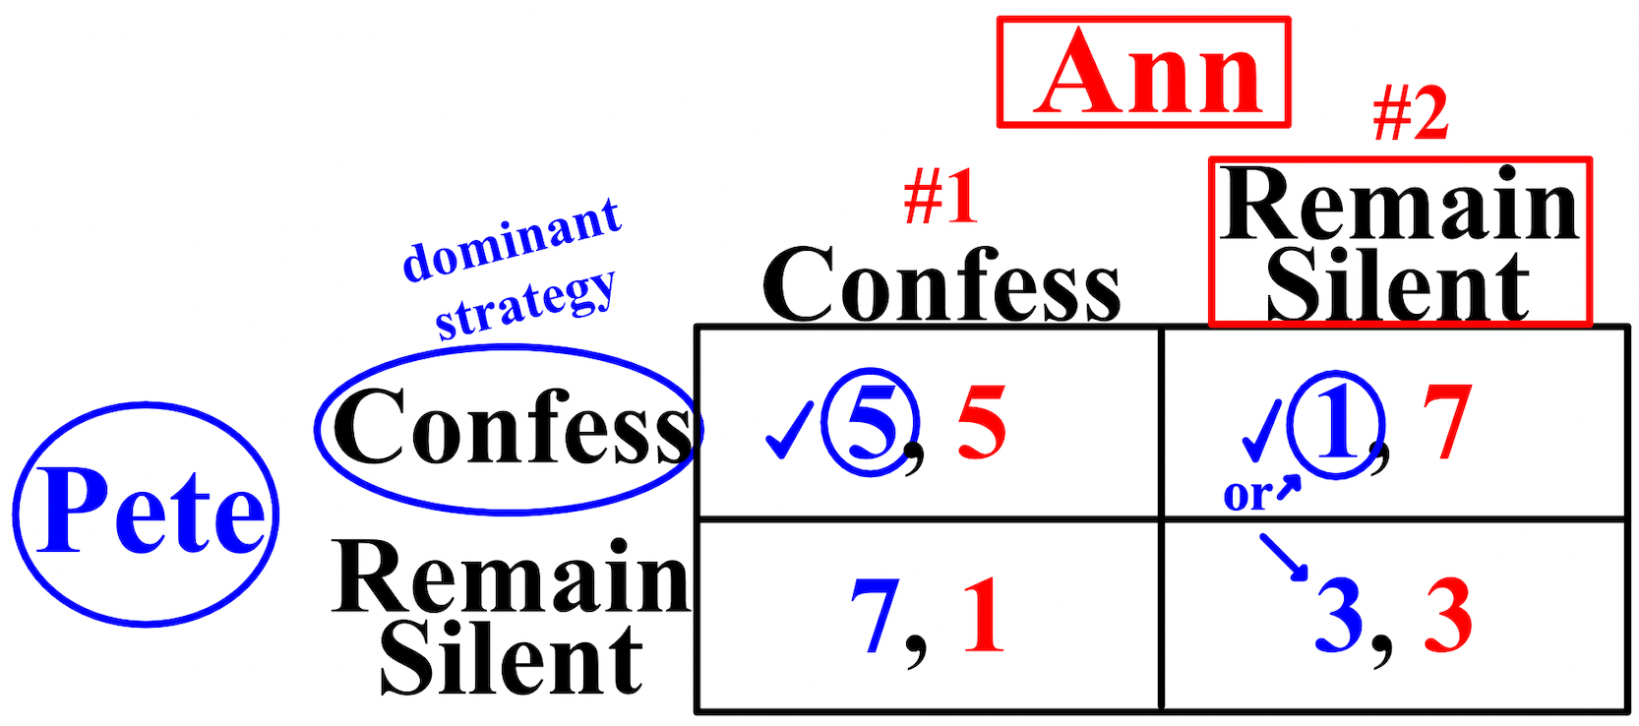
Now we have to see about Ann. What should Ann do if Pete confesses (#3)? If Ann confesses, she will get 5 years; if she remains silent, 7 years. What should Ann do if Pete remains silent (#4)? If Ann confesses, she will get 1 year; if she remains silent, 3 years. Again, to confess is the better strategy for Ann regardless of what Pete does, and to confess is her dominant strategy.
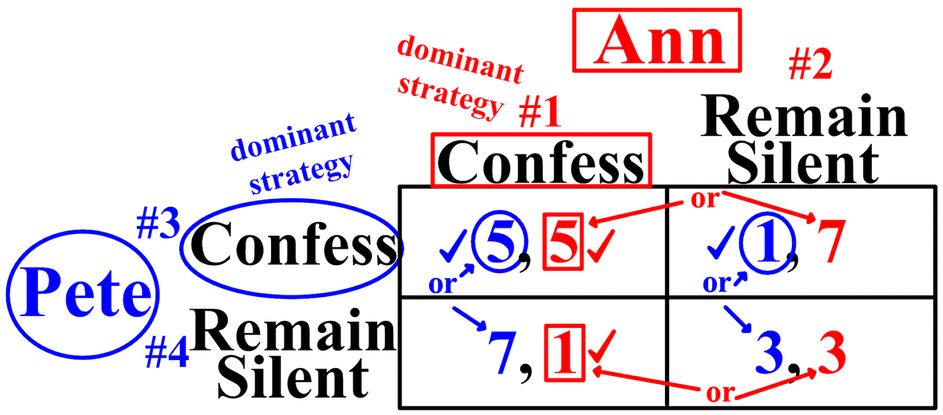
A Nash equilibrium is a set of strategies from which no player would deviate unilaterally from because there would be no financial benefit to do so while other players keep their strategy constant, like Home Depot and Lowes over time. A Nash equilibrium exists where Player A’s best response is the same as Player B’s best response (where they intersect), and since Ann and Pete's dominant strategy is to confess, there is a Nash equilibrium at 5/5, but the numbers don't have to be identical.
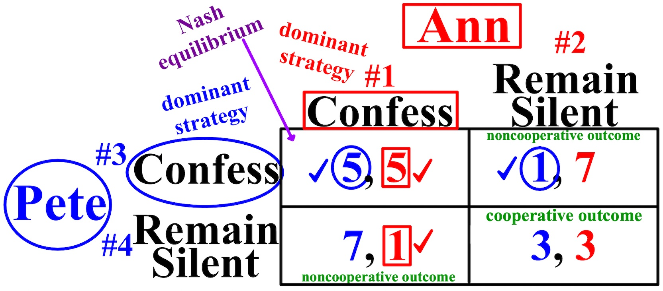
The situation where both remain silent is called the cooperative outcome. They would have had to agree in advance what to do and stick to it. Where one or the other confesses is called the noncooperative outcome (when one of them would follow an "everyone for himself or herself" strategy).
Firms know that their combined profits can be maximized if they act together as a monopoly in one of three ways. Explicit collusion is when business leaders communicate with each other and agree to fix prices or cut back on production. Tacit collusion is when there is no explicit communication between firms, but firms keep prices high by regularly following the behavior of one firm in the industry, the price leader. Last, the firms could merge.
Now we'll talk about antitrust policy. The intent of the government in commerce is to promote competition, a free market economy, market efficiency, and as little as possible deadweight loss (DWL). Antitrust policy is concerned with preventing anticompetitive practices, like price-fixing and limiting firms' market power by preventing mergers or breaking up existing firms. Regulatory policy occurs when the government requires firms that have a natural monopoly, like Florida Power and Light and water companies, to set prices at prescribed levels.

Labor markets are the markets where workers (supply) sell their labor and firms (demand) buy the labor. To maximize profits in a firm, the marginal revenue product of labor (MRPL) (the change in total revenue (TR) when one additional unit of labor (a worker) is employed) should at least equal the wage (W) workers
earn, thus MRPL = W. Paying the market wage (the highest wage (W) offered by any employer in a market) is the only way a firm can gain an advantage over another.

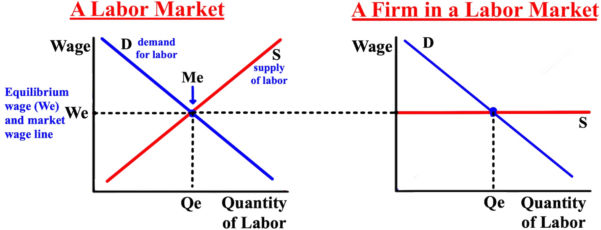

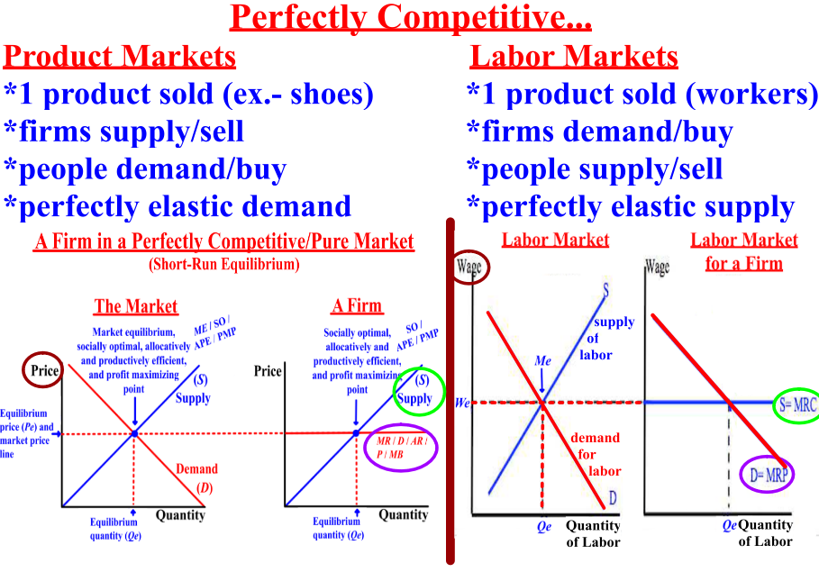
If the wage (W) for one full-time worker at the company below is $600 per week, the firm will hire a total of five workers to maximize profits. Hiring a sixth worker would result in a marginal revenue product of labor (MRPL) of only $500, $100 less than its cost.
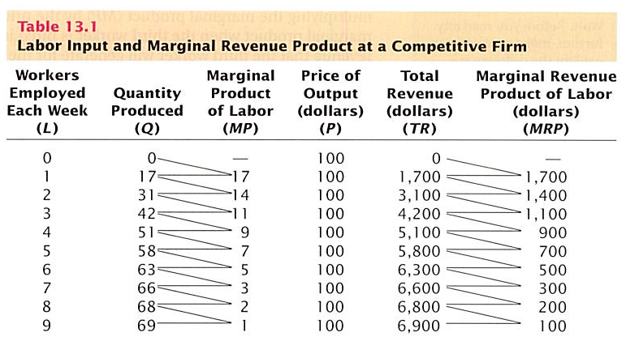
Firms are the buyers of labor in the labor market. In a monopsony, there is only one labor buyer in a market, like the only medical facility in an area who hires nurses. With only one buyer of labor in a market, wages (W) and demand (D) for workers are kept as low as possible.
We'll now talk about transfer payments from the government to its citizens and taxes. A transfer payment is a payment from the government to an individual that is not in exchange for a good or service. There are two types of government transfer payments in the U.S. Means-tested transfers, which depend on the income (the means) of the recipient and focus on helping poor people, like EBT cards, and social insurance transfers, which do not depend on the income of the recipient, like Social Security.
A tax is progressive if the amount of the tax as a percentage of income rises as income increases. The federal tax rate is progressive; the more you make the more you technically should pay. Its aim is to decrease income inequality and to make income distribution more equal. A tax is regressive if the amount of the tax as a percentage of income falls as income rises. An income tax would be regressive if people with high incomes could use deductions or other laws to reduce the tax they paid. Finally, a tax is proportional, or flat, if the amount of the tax as a percentage of income is constant as income rises or declines, such as everyone paying 20% in taxes.
The purpose of most taxes is to raise revenue, but the taxes effect people's behavior. If prices rise after a tax increase, then the tax was passed on to buyers in the form of higher prices. Tax incidence refers to who actually bears the burden of the tax, the buyers or the sellers. If one is elastic and the other is inelastic, the inelastic party will pay. If both are either elastic or inelastic, the amount will be split.
As the tax rate increases, the amount subject to the tax will fall because the higher price due to the tax reduces the quantity demanded (Qd) by consumers, especially with a high elasticity. If the quantity demanded falls sharply enough, then tax revenue could fall when the tax rate is increased. Other factors influence tax revenue when taxes get very high. Tax avoidance means finding legal ways to reduce taxes, such as buying
a home rather than renting in order to have a deduction for interest payments on a mortgage. Tax evasion is an illegal means of reducing one's tax.
At the two extremes of a 0% tax rate and 100% tax rate, tax revenue is $0. This relationship between the tax rate and tax revenue is called the Laffer curve. It implies that if the tax rate is so high that we are on the very top of a downward-sloping curve, then reducing the tax rate may actually increase tax revenue.

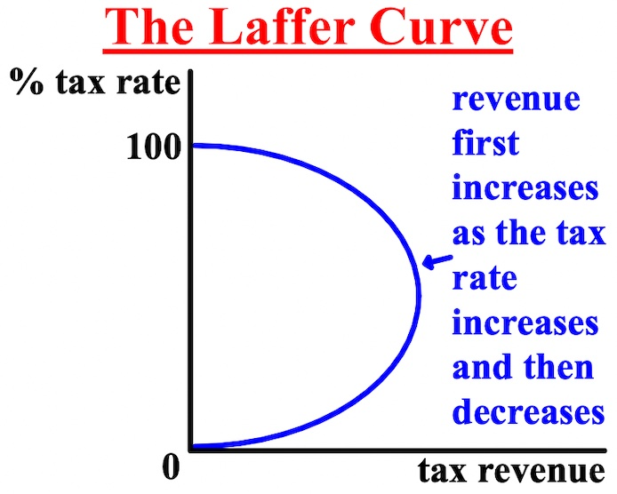

U.S. income data from 2014 is presented below. The graph shows the cumulative percentage of income on the vertical axis and the percentage representing each quintile from the first column on the horizontal axis. The five dots in the figure are the five pairs of observations from the table. By connecting the dots, we get a curve called the Lorenz curve. The extent of the curve visually shows the inequality of income.

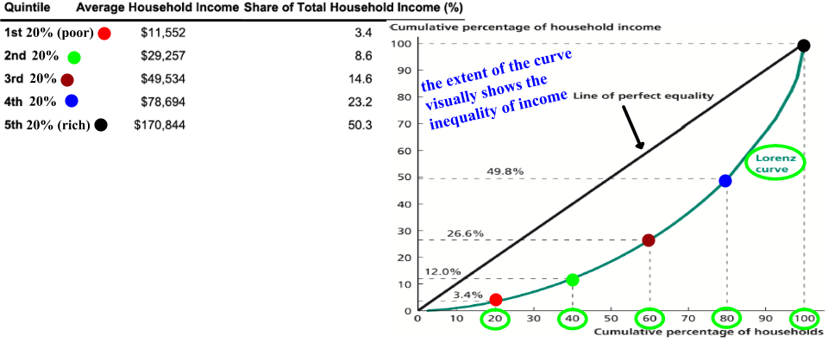

The Gini coefficient is a useful numerical measure of how bowed out the Lorenz curve is. It is defined as the ratio of the area of the gap between a 45-degree line and the Lorenz curve to the area between the lines of perfect equality and perfect inequality. The Gini coefficient can range between 0 and 1. It has a value of zero if the area between the diagonal line and the Lorenz curve is zero. Thus, when the Gini coefficient is zero, perfect income equality exists, and pigs will learn how to fly and I will win the lottery. The Gini coefficient would be 1 if only one person earned all the income in the economy.

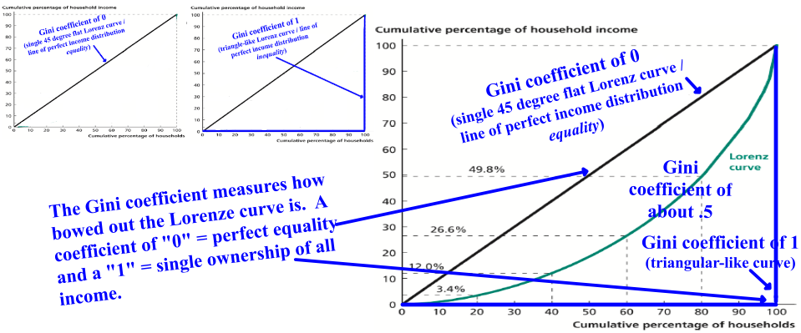
Chapter 10- Public Goods and Externalities
This chapter is about public goods and externalities that economists use to determine whether a proposal for government action is bad or good.
Since almost all goods that are produced include a competition for the good itself and therefore some can be excluded from purchasing it, governments produce public goods to benefit all of its people. A public good is a good or service that has two characteristics: nonrivalry and nonexcludability. Nonrivalry in consumption means that more consumption of a good by one person does not imply less consumption of it by another person,
like national defense or weather information. Nonexcludability means that no one can be excluded from consuming or using the item, like sewers and traffic lights. Private firms would have difficulty producing and selling national defense to the people of a country; they would go broke. For this reason, action by the government is necessary to provide public goods.
But goods that have nonrivalry in consumption and nonexcludability create a free-rider problem. People can enjoy the good or service without reducing others' enjoyment even if they do not pay, like a free public bus anyone can ride. To lessen the problem of free-rides, users are charged a user fee (when the users of a government-provided service are charged for its use.
Another reason for government involvement is known as an externality. An externality occurs when the costs of producing a good or the benefits from consuming a good spill over to individuals who are not producing or consuming the good, like pollution from a power plant, which is a negative externality because it has a negative effect, a cost, others. A positive externality occurs when a positive effect, a benefit, from a good spills over to others, like if everyone in your neighborhood paints their house and plants new bushes just before you sell your house.
Firms that create negative externalities don't factor in external costs and are inefficient when they calculate their costs; they don't charge enough. Instead of FPL charging $2.00 to include the cost of removing pollution, they only charge $1.50, thereby increasing the pollution costs for other firms. The externality (pollution) makes the private firm's marginal cost, called the marginal private cost (MPC) (the seller's cost with no externality costs factored in), less than the true marginal cost that is incurred by society, which we call the marginal social cost (MSC) (the buyer's cost with externality costs factored in). Firms are taxed to limit their negative externalities.
The marginal social cost (MSC) is the sum of the firm's marginal private cost (MPC) and the increase in external costs to society as more is produced. The marginal external cost is the change in external costs as more is produced.
marginal social cost = marginal private cost + marginal external cost

A positive externality occurs when the activity of one person makes something else better off, either reducing costs or increasing benefits. Increased earnings are a benefit from attending high school, but one's
education also benefits society. Governments want to increase positive externalities and do so by
subsidizing products and regulating increased production amounts. The externality (education) makes the marginal benefit (MB) received by the consumer, which we call the marginal private benefit (MPB), less
than the true benefit to society, which we call the marginal social benefit (MSB). There is never enough produced of an item that creates a positive externality.

marginal social benefit = marginal private benefit + marginal external benefit

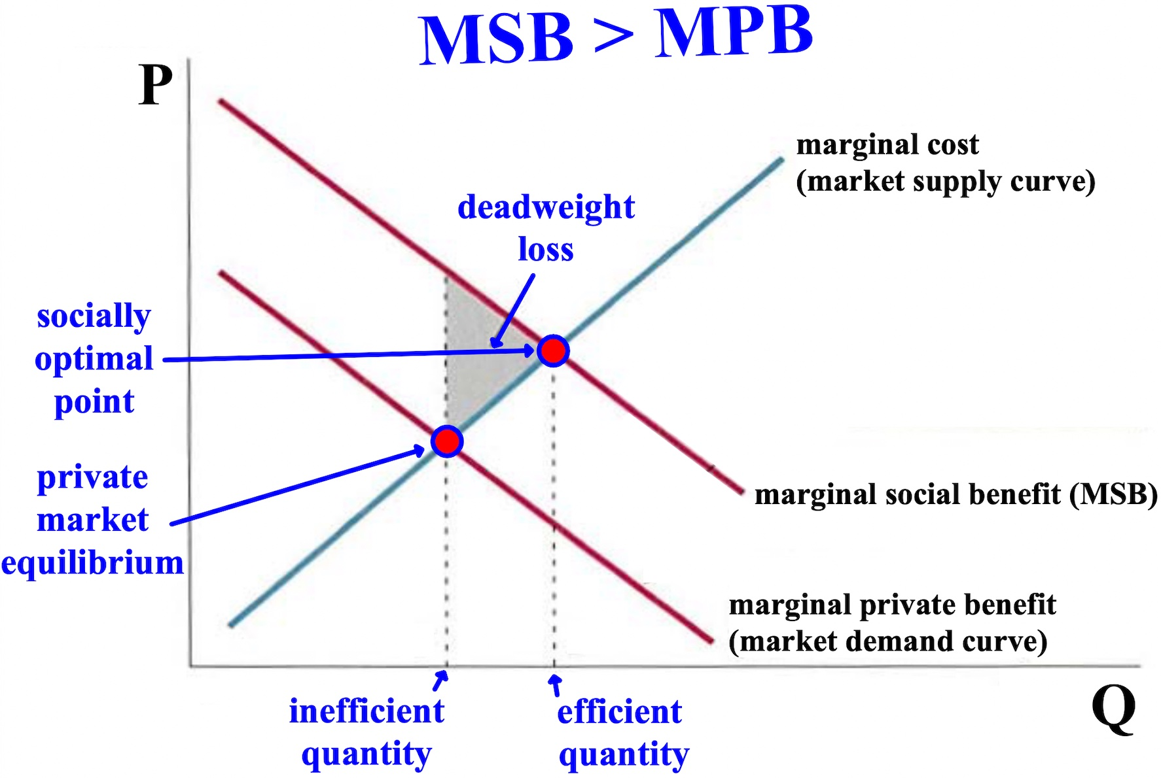

Free Response Question (FRQ) and answer
