Macroeconomics- All of the Chapters Combined
Chapter 1- Macroeconomics and Microeconomics: The Basics
In this chapter, we will learn that economics (eh-koe-nah-mics) is all about the choices we make with scarce resources. Economics is the study of how people deal with scarcity. Scarcity is a situation in which individuals, businesses, and governments have unlimited wants but their resources are limited. Economic interaction between people occurs every time they trade or exchange goods with each other, usually in a market. A market is an arrangement by which buyers and sellers can interact and exchange goods and services with each other.
Scarcity of funds and resources causes everyone to make choices. The opportunity cost of a choice is the value or cost of a positive alternative that was not chosen. If you buy sunglasses instead of a hat, then the opportunity cost (or, as we call it in class, the opportunity lost) is the hat. In teenager terminology, the
opportunity cost (or lost) is the girl or boy you decided not to go out with when you chose to date someone. But, the loss must be a positive loss. Choosing not to date someone who cheats all the time is not an example of opportunity cost; that is just a smart decision.
Free Response Question (FRQ) #1
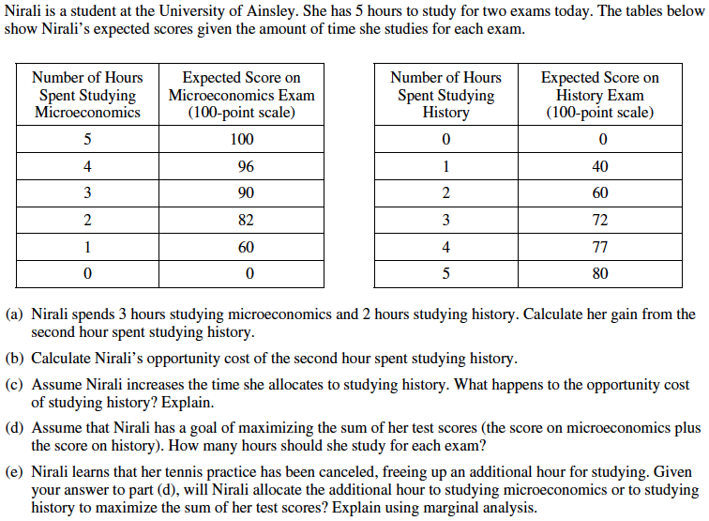

Free Response Question (FRQ) #1 (answer)
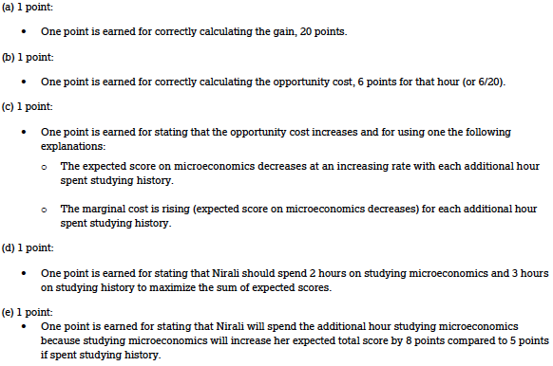

Economic interaction between multiple people, companies, countries, etc. can lead to gains from trade which reallocates (exchanges) goods in a way that benefits everyone involved. Economic interaction allows for specialization: people concentrating on what they are good at). Economic interaction also can allow for a division of labor (when some workers specialize in one task while others specialize in another task).
Suppose that an economy can produce either computers or movies. With a scarcity of resources such as labor (workers) and capital (money for business), there is a choice between producing some goods versus others. The table below gives an example of the alternative choices, or the production possibilities, for computers and movies. Each choice, A-F, leads to different production numbers. Marginal analysis (a cost-benefit analysis) is used to determine if the potential increase in profits outweigh the costs of making different decisions.
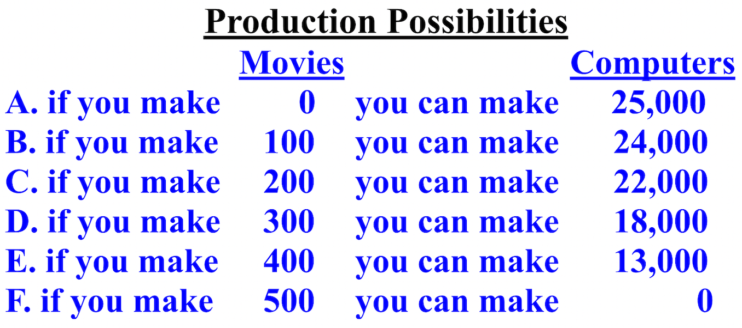

The opportunity cost of producing more movies is the value of the computers not produced, and vice versa. The opportunity cost, or lost, in terms of computers, of producing more movies increases as we require a loss of more and more computers. This is called increasing opportunity costs. Moving from production possibility A to B requires an opportunity cost of 1,000 computers (25,000 to 24,000), but moving from production possibility A to C increases the opportunity cost to 3,000 computers (25,000 to 22,000).
A production possibilities curve/frontier (PPC/PPF) graphs both short-run (SR) and long-run (LR) tradeoffs, communicates choices, scarcity, and opportunity costs. A production possibilities curve/frontier with a curved curve indicates increasing/not proportional opportunity costs anywhere on the line for both items. When moving from point D to E, to make 6 cars (0 to 6) requires an opportunity cost (loss) of 2 bikes (10 to 8). Moving from E to B increases the number of cars by 2 (6 to 8), but the opportunity cost is now another 2 bikes (8 to 6). The changes aren't constant/proportional and the resources being used are not easily adaptable between both products.
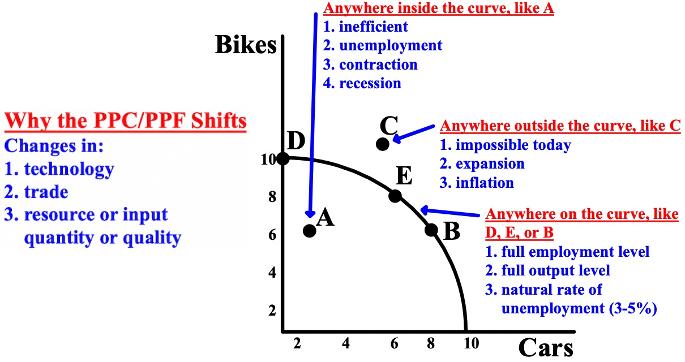

A production possibilities curve/frontier with a straight curve indicates constant and proportional opportunity costs anywhere on the curve. The resources are easily adaptable between both products are perfect substitutes. If the PPC/PPF is a straight curve, the amount of Good A you have to give up to make one more of Good B is the same everywhere, and the amount of B you have to give up to make one more A is the same everywhere as well.
For every increase of 30 of Good B, there is a decrease of Good A by 60. For every increase of Good A by 60, there is a decrease of Good B by 30. Both goods have constant opportunity costs.

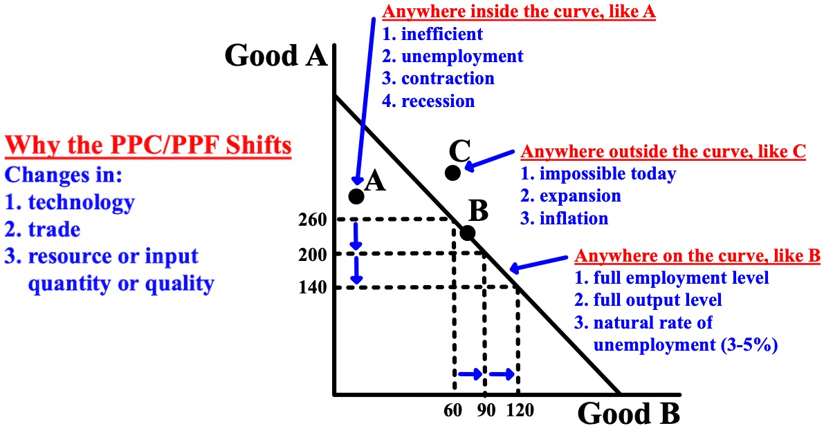
Depending on where an economy is, this determines the location of the dot ".". On either curve, curved or straight, indicates efficient or production efficient (the maximum amount that can be produced with the available resources at that time). On either curve usually but not always indicates full use of resources, full employment, and peak output in an economy. This means that production is allocatively efficient (the most efficient distribution of available resources for a firm/country). On either curve can also mean that production is socially optimal (the optimal distribution of resources in society that is best for firms/countries and for society itself).

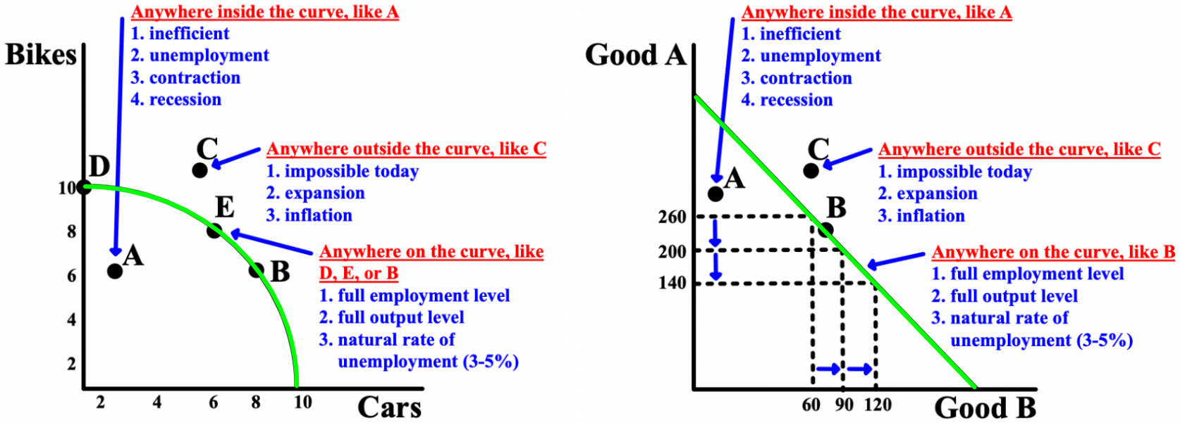

To the left of the line indicates unemployment, contraction of the economy, under production, possible labor force reduction and recession, and inefficiency because the economy can produce a larger number. Points inside the production possibilities curve/frontier, like A, are possible, but they are inefficient.
To the right of the line indicates long-run aggregate supply (LRAS) (a country’s total supply of goods and services in the long-run) expansion, over production, and an impossibility because the economy does not have the resources at that time to produce those quantities.
Free Response Question (FRQ) #2
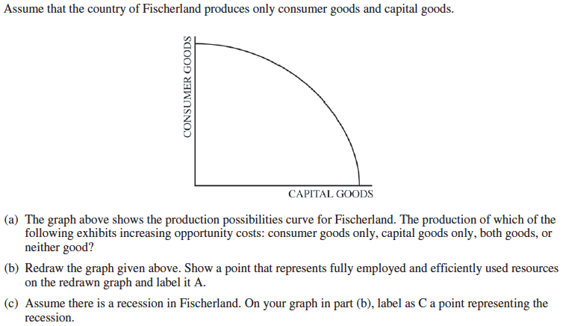
Free Response Question (FRQ) #2 (answer)
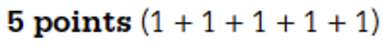
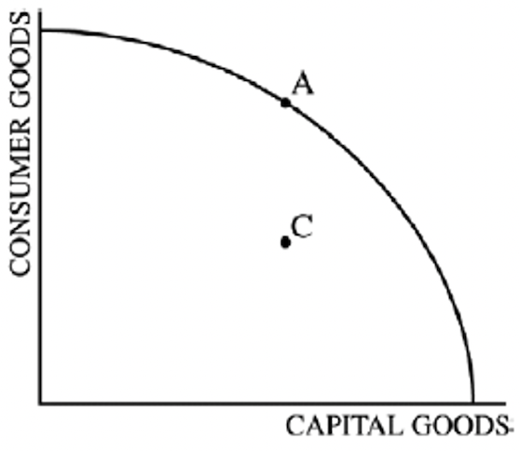
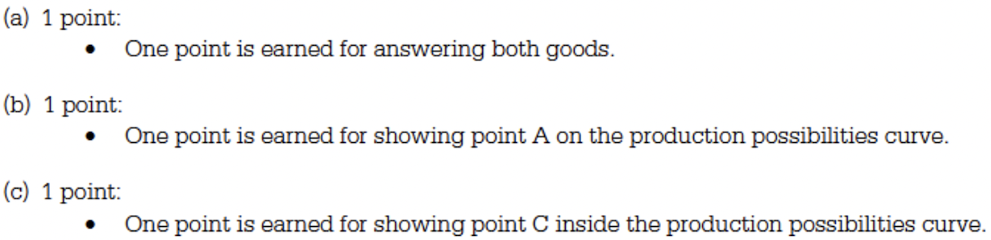

Regardless of which production possibilities curve/frontier (PPC/PPF) is graphed, both represent a tradeoff and decisions about scarce resources. When the PPC/PPF shifts out, the economy grows because more goods and services are being produced (#1 below), but it can also shift in, usually during natural disasters. The PPC/PPF can also shift in or out for only one of the variables while the other variable remains the same (#2 and #3 below). The PPC/PPF can also show an increase or decrease in the quantity demanded (Qd) of only one of the variables (#4 below).

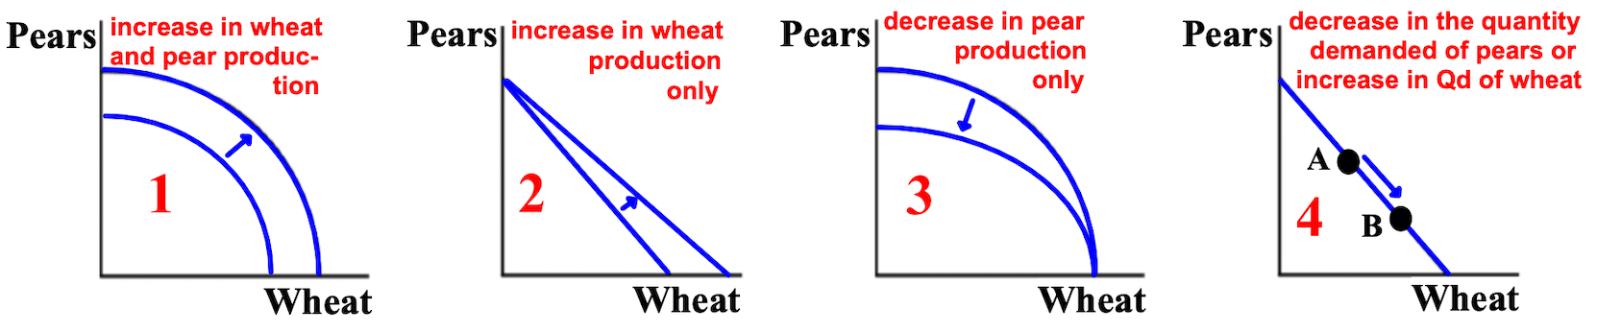

Absolute advantage is a situation in which a person, business, or country can produce more of a good than another can. One entity can simply make more of a product than another. Comparative advantage is a situation in which a person, business, or country can produce a good more efficiently and with less opportunity cost (loss) than another. McDonalds can certainly produce hamburgers more efficiently and with less opportunity cost than Best Buy. Comparative advantage is the most important calculation because it determines who should make what products allowing many to benefit from trade and specialization in the production of a product.
The USA has an absolute advantage in producing both food and clothing; they made more of both than Japan, but, comparative advantage matters more. To calculate opportunity costs= what we give up / what we get. The lowest opportunity cost (lost)/most efficient is the winner. In food, the USA has a comparative advantage: 3/6 = .5 vs. 2/1= 2 (Japan), and .5 is less than 2. In clothing, Japan wins: 1/2 = .5 vs. 6/3= 2 (USA), and .5 is less than 2.
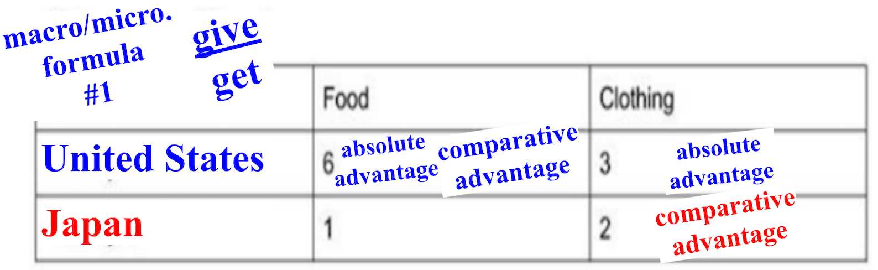
In the production possibilities curve/frontier, India has the absolute advantage in nuts and China in grapes. In grapes, China has the comparative advantage:10/10= 1 vs. 12/8= 1 1/2 (India), and 1 is less than 1 1/2. In nuts, India has the comparative advantage, 8/12= .66 to 10/10= 1 (China). China will grow grapes and India will grow nuts and both will benefit.
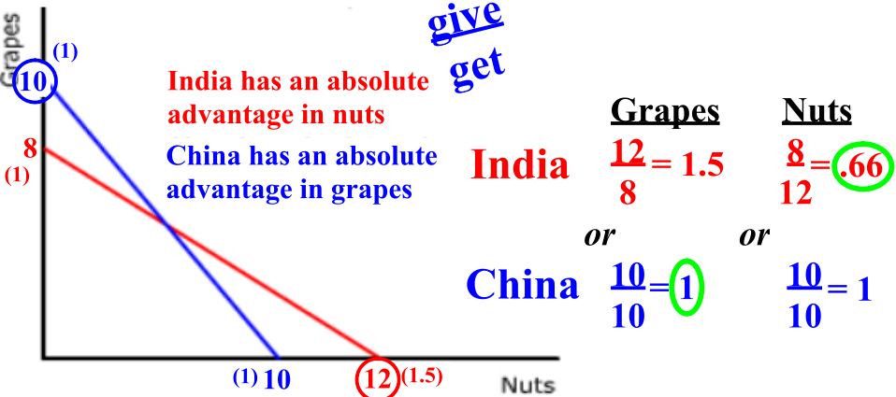
In the PPC/PPF, India has the absolute advantage in nuts and grapes. In grapes, China has the comparative advantage, 4/6 vs. 18/9. In nuts, India has the comparative advantage, 9/18 vs. 6/4. China will grow grapes and India will grow nuts.
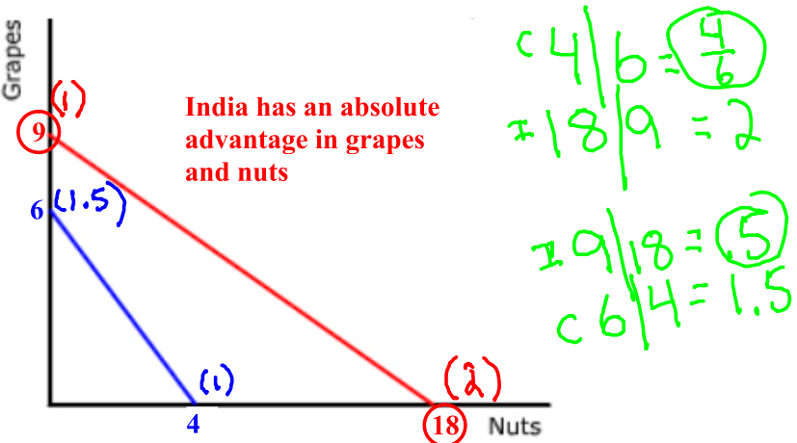
Free Response Question (FRQ) #3
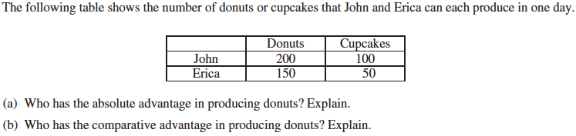

Free Response Question (FRQ) #3 (answer)
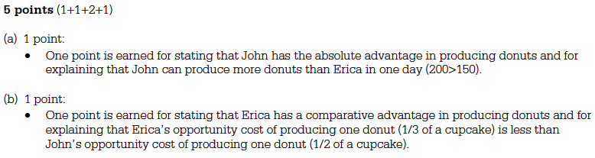
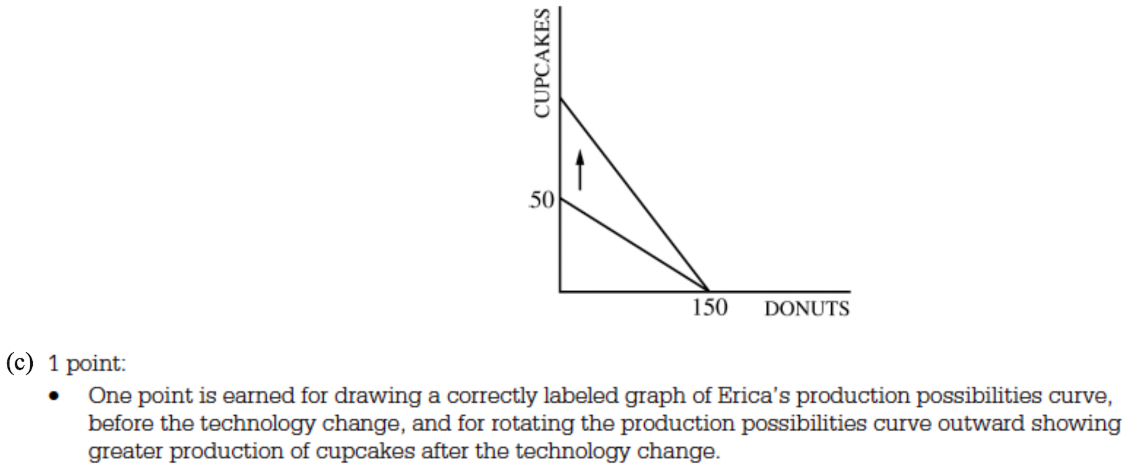

Free Response Question (FRQ) #4 and answer
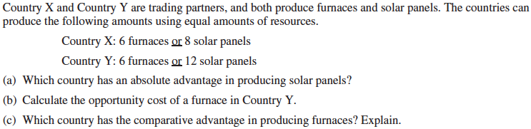

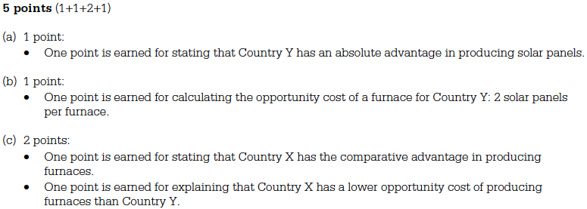
Free Response Question (FRQ) #5 and answer
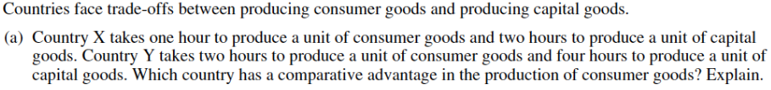

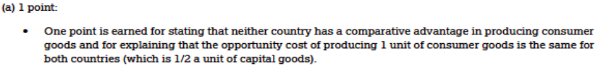
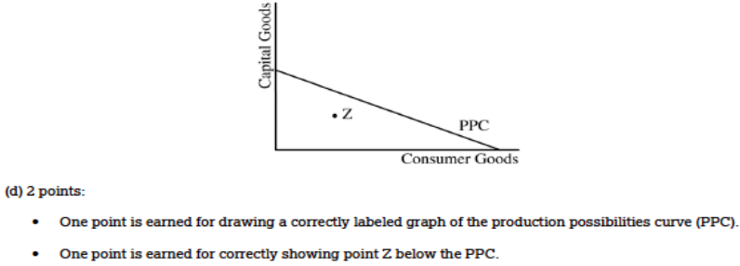

There are three essential questions or problems that every economy must find a way to solve: 1) what is to be produced, 2) how are those goods to be produced, and 3) for whom are the goods to be produced? A free market economy and a command/centrally planned economy offer different approaches to these questions. In a free market economy, democracies base their economies on capitalism and most decisions about what, how, and for whom to produce are made by individual consumers (those who buy), firms (companies), governments, and other organizations interacting in the markets. In a command or centrally planned economy, such as in a communist or socialist country, decisions about what, how, and for whom to produce are made by those in control of the government. Many economies are mixed economies, or a mixture of both.
In order to use models for prediction, economists use the assumption ceteris paribus, which means "all other things equal"; (the prediction that a variable will not change assumes there is nothing that can change it). A key belief of classical economists is the concept of laissez faire ("hands off" or little government control, where the role of the government is mainly to promote competition and reduce restrictions on the exchange of goods and services.

Chapter 2- Macro. and Micro.: The Basics: Supply and Demand
This chapter is about how the supply and demand model is used to explain how markets, such as the healthcare or car market, determine prices (P) and quantity (Q). Markets consists of three elements: 1) quantity demanded (Qd)- describing the behavior of consumers (those who demanded/buy) in the market), 2) quantity supplied (Qs)- describing the behavior of firms/businesses (those who supply/produce) in the market), and 3) market equilibrium (Me)- connecting quantity demanded and quantity supplied; the point where consumers and firms agree on the price and quantity in the market.
Classical economics- the belief that economies will self-correct over time and that governments should not get involved. If an economy is expanding (growing) or contracting (shrinking) and no financial actions are taken by the Federal Reserve or Congress, the economy will eventually return to its typical equilibrium by itself. This happens because in most situations, if an economy is in expansion/has high inflation (high prices), workers' wages will increase which will decrease how much companies have to spend. If an economy is in contraction/in recession, workers' wages will decrease which will increase how much companies have to spend.
Demand (D) is a relationship between two economic variables factors): 1) the price (P) of a particular good and 2) the quantity demanded (Qd) of a particular good (how much consumers are willing to buy at a specific price). The law of demand says that the higher the price of a good is in a market, the lower the quantity demanded of the good by consumers, and the lower the price of a good, the higher the quantity demanded.

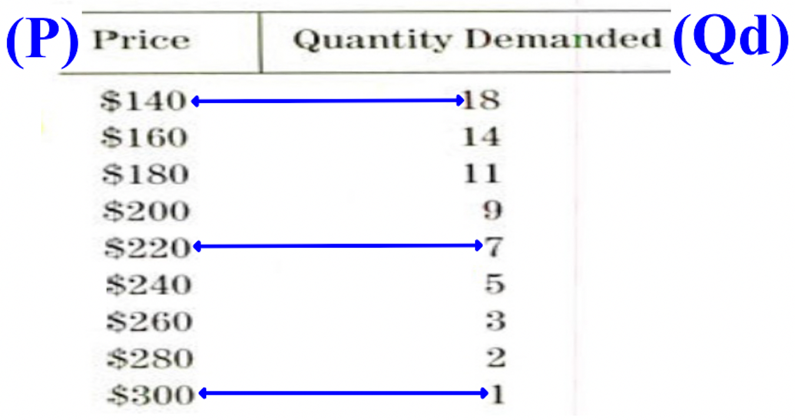

The graph below is a demand curve. It represents the law of demand graphically. The market demand curve slopes downward left to right and shows the market quantity (the quantity demanded of goods and services at any given price.

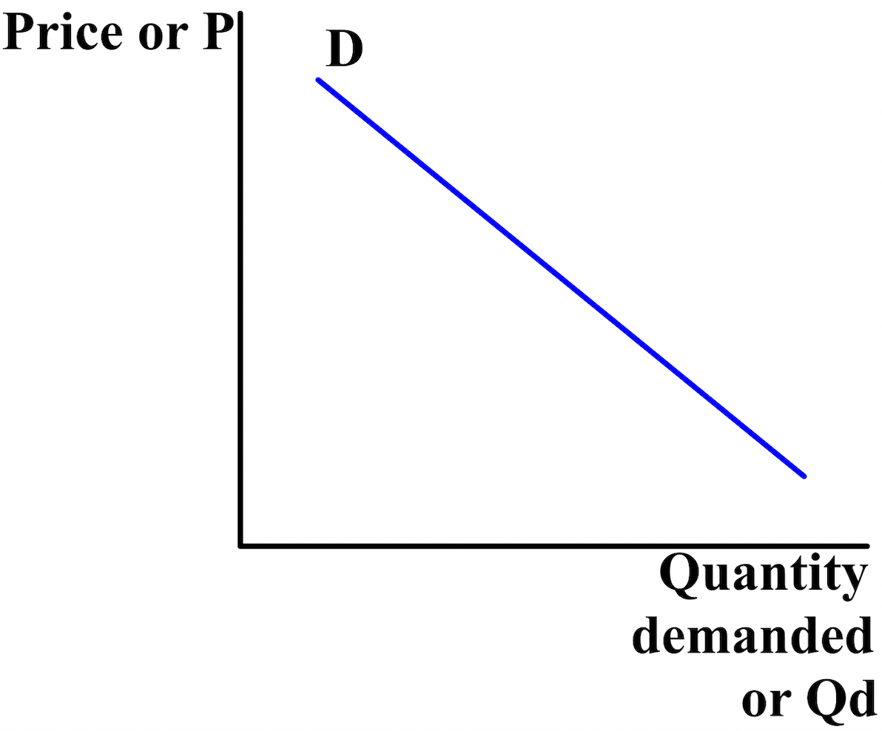
The quantity demanded (Qd) of a good or service that people buy is affected by the item's price (P), consumers' tastes and preferences, the number of consumers in the market, the price of similar goods, consumers' incomes, and consumers' expectations of the future market price (the price of something that is sold in a market). An increase in quantity demanded shifts (moves) the demand curve up/to the right (left graph). A decrease in quantity demanded shifts the demand curve down/to the left (right graph).

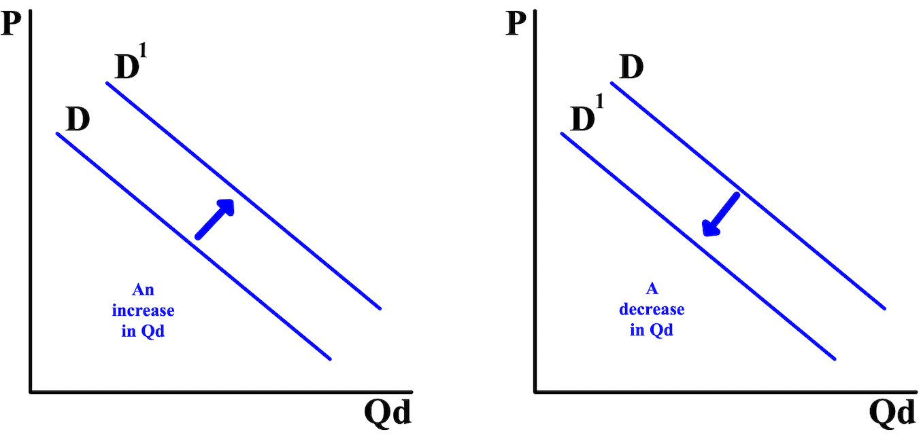

Goods for which quantity demanded (Qd) increases when income rises and decreases when income falls are called normal goods. The quantity demanded for inferior goods may decline when income increases. The prices (P) of closely related goods are also a factor. A substitute is a good that provides some of the same uses or enjoyment as another good, like buying a, electric bike instead of a motorcycle. But, a sharp increase in the cost of bicycle helmets, a good closely related to bicycles, will decrease the quantity demanded for bicycles, especially if there is a law requiring helmets. A good that tends to be consumed together with another good is called a complementary good and it plays a factor in how much another good made is wanted.
When graphing demand (D) curves, it is very important to distinguish shifts of the demand curve from movements along the demand curve. A movement along the demand curve occurs when the quantity demanded (Qd) changes as a result of a change in the price (P) of the good or service.
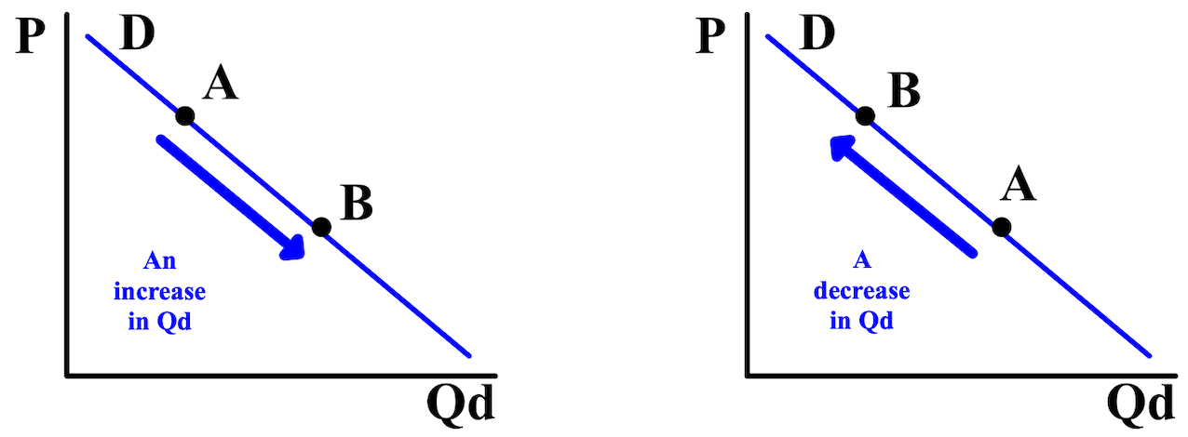
For example, if the price of bicycles decreases for any reason, the quantity demanded (Qd) by consumers will show a movement along the demand curve to the right from point A to point B (left graph). If the price of bicycles increases for any reason, the quantity demanded by consumers will show a movement along the demand curve to the left from point A to point B (right graph).
Supply (S) is a relationship between two economic variables (factors): 1) the price (P) of a particular good and 2) the quantity supplied (Qs) of a particular good (how much firms are willing to sell at a specific price). The law of supply states that the higher the price of a good is in a market, the higher the quantity supplied of the good by sellers, and the lower the price of a good, the lower the quantity supplied. When the price for a product increases, suppliers will attempt to maximize their profits by increasing the quantity supplied for sale before quantity demanded starts to fall. When the price for a product decreases, suppliers will attempt to minimize their losses by producing less.
The graph below is a supply curve. It represents the law of supply graphically. The market demand curve slopes upward left to right and shows the market quantity (the quantity supplied of goods and services at any
given price.
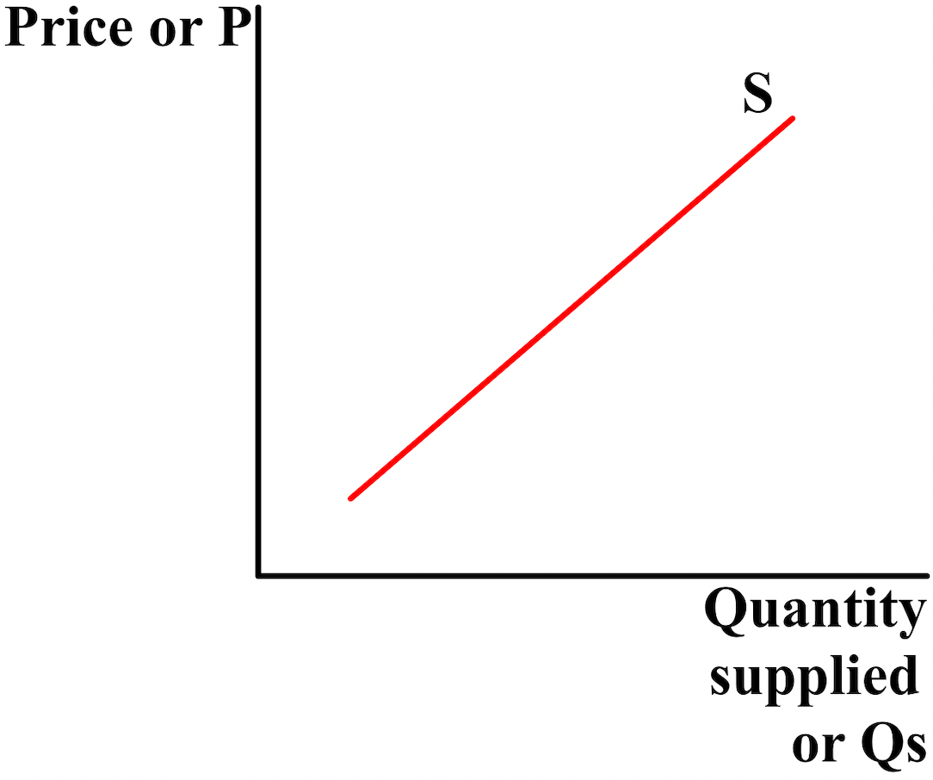

The quantity supplied (Qs) of a good or service that firms/businesses produce is affected by the price (P) and availability of inputs/resources used in production, the number of firms in the market, technology, government taxes and subsidies, and regulations, and the expectations of future prices and profit. An increase in quantity supplied shifts the supply curve down/to the right (left graph). A decrease in quantity demanded shifts the demand curve down/to the left (right graph).
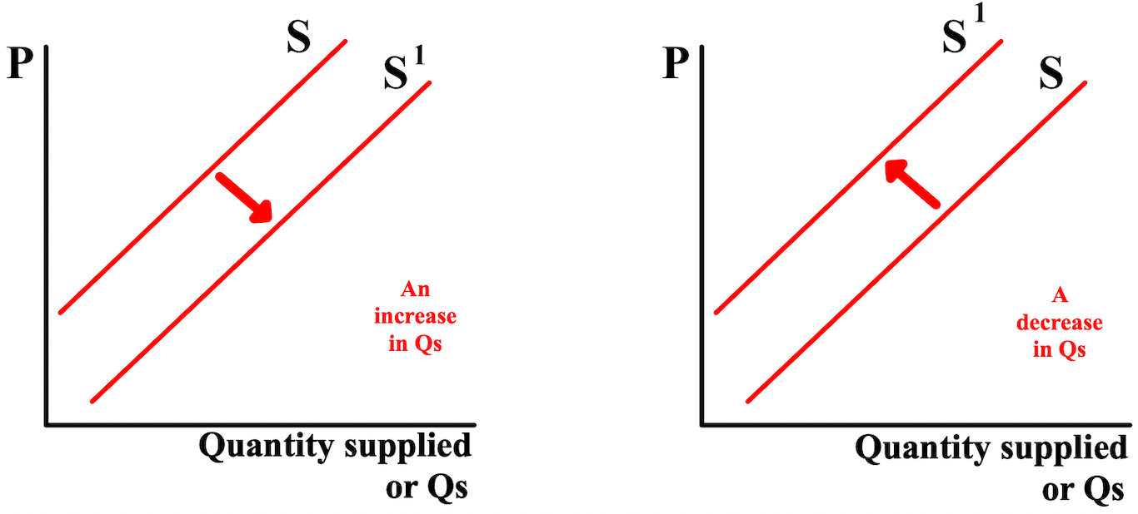

When graphing demand (S) curves, it is very important to distinguish shifts of the supply curve from movements along the demand curve. Just like with the demand curve, a movement along the supply curve
occurs when the quantity demanded (Qd) changes as a result of a change in the price (P) of the good or service.

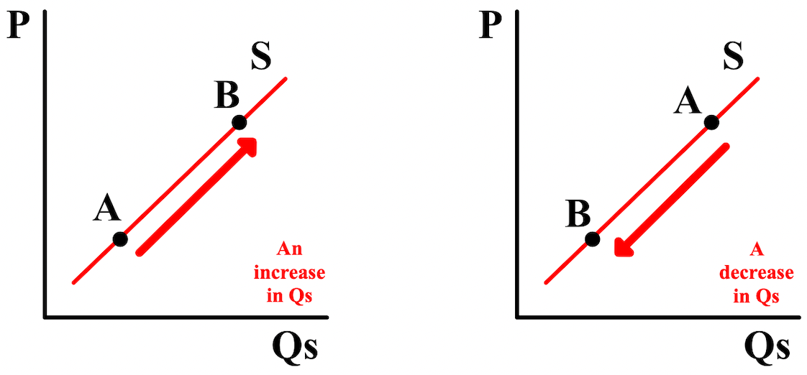

Double-shifts occur when both demand and supply shift at the same time. when this happens, both demand and supply can increase of decrease or one can increase while the other decreases. When a double-shift occurs, of the new quantity (Q) or price (P), one of them can be determined but the other will be indeterminate. The only way to know is to graph the double-shift. Below, the new price is indeterminate but the new quantity can be determined.
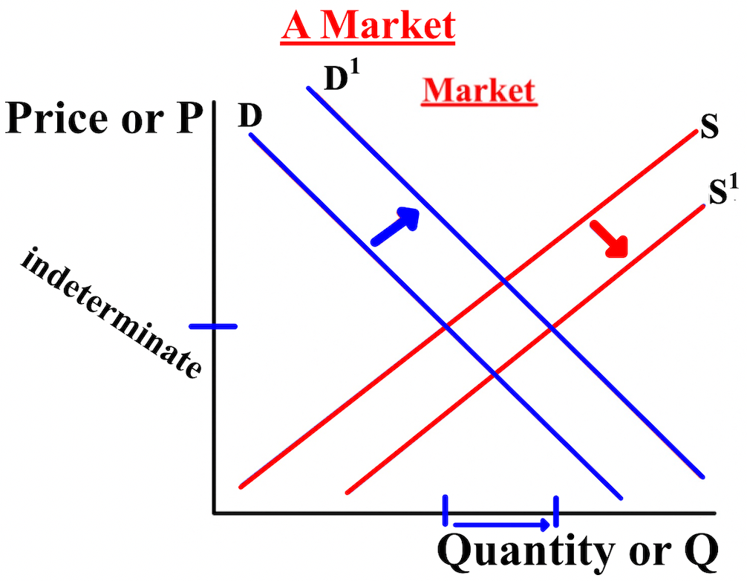
Markets determines prices. Buyers (Qd) and sellers (Qs) interact. A price that both determine and accept comes about. The prices are high enough for the sellers to cover their costs and make a profit and low enough for the buyers to afford and feel like they are benefiting from the purchase.
Looking at the bicycle price (P) of $160 below, the quantity demanded (Qd) by consumers (14 bicycles) is greater than the quantity supplied (Qs) by firms (4 bicycles); there is a shortage of 10 bicycles (14-4). A shortage, or excess demand, is a situation in which the quantity demanded is greater than the quantity supplied.
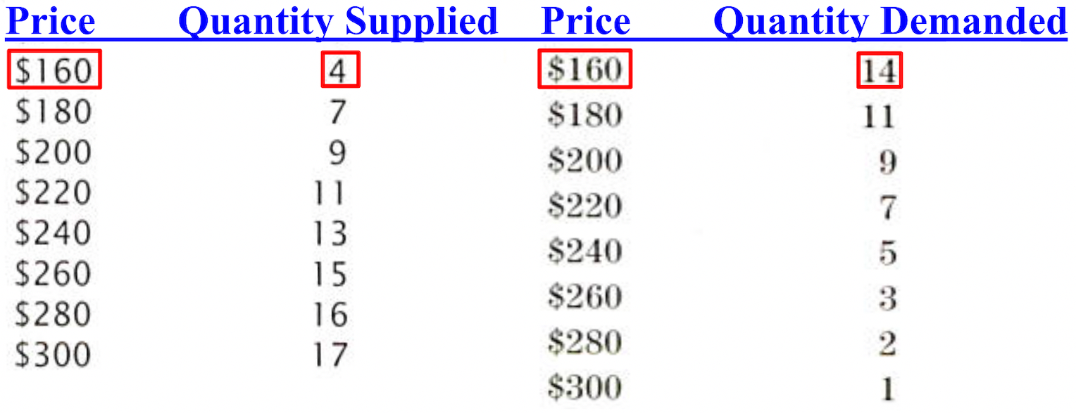
Looking at the bicycle price (P) of $260 below, the quantity demanded (Qd) by consumers (3 bicycles) is less than the quantity supplied (Qs) by firms (15 bicycles); there is a surplus of 12 bicycles (15-3). A surplus, or excess supply, is a situation in which the quantity supplied is greater than the quantity demanded.
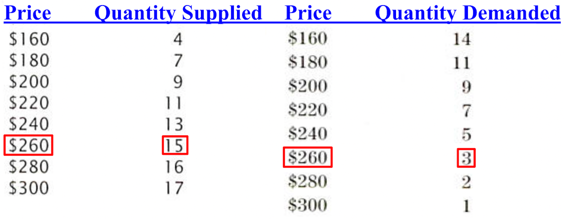
The equilibrium price (Pe) is the price at equilibrium (the price where supply (S) and demand (D) meet). The equilibrium quantity (Qe) is the quantity at equilibrium (the quantity where supply (S) and demand (D) meet). Often in our class, a market supply (S) and demand (D) diagram will not have any numerical data;
unless you are told to include numbers, don't.

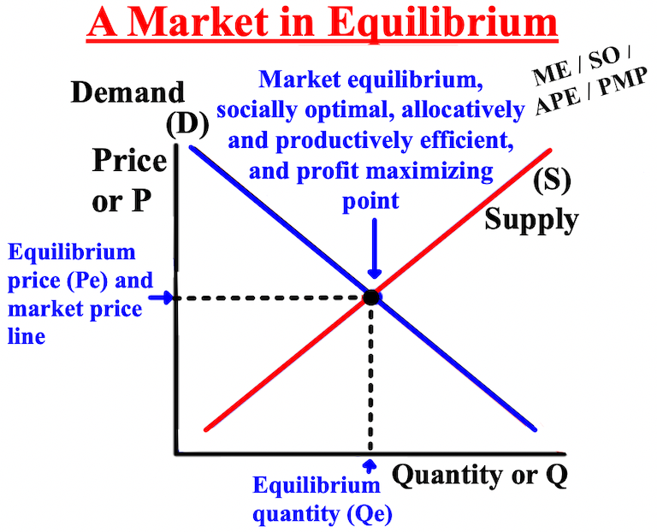
The graphs below show the effects of an increase in quantity demanded (Qd) (left graph) and a decrease in quantity demanded (right graph). The demand curves before and after the shift are labeled D for the "old
demand curve and D1 for the "new demand curve." With a shift and a new demand curve, there is a new intersection and, therefore, a new equilibrium quantity (Qe1), equilibrium price (Pe1), and market equilibrium (Me1).
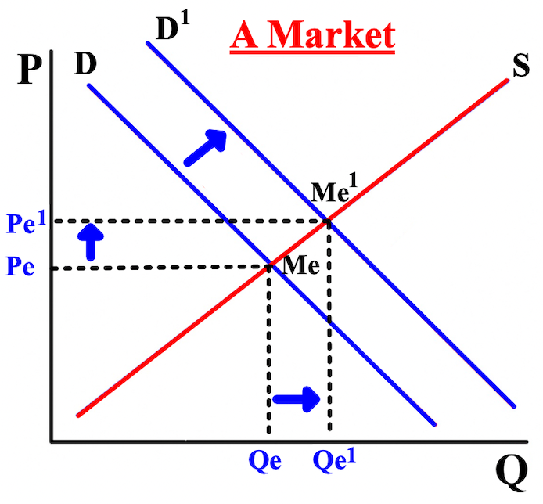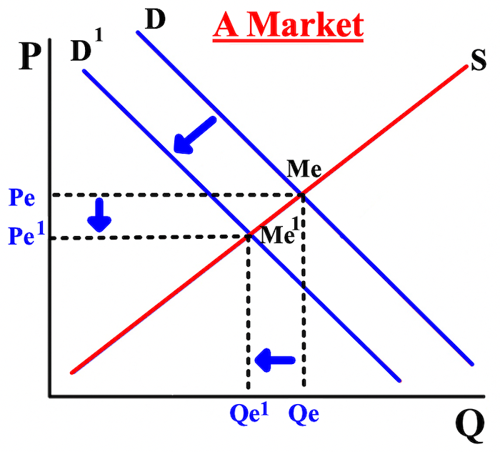

The graphs show the effects of an increase in quantity supplied (Qs) (left graph) and a decrease in quantity supplied (right graph). The supply curves before and after the shift are labeled S for the old supply curve and S1 for the new supply curve. With a shift and a new supply curve, there is a new intersection and, therefore, a new equilibrium quantity (Qe1), equilibrium price (Pe1), and market equilibrium (Me1).
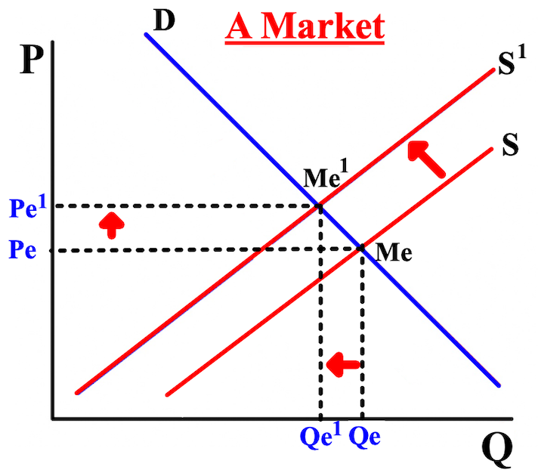
In free market economies, demand (D) and supply (S) usually determine the price (P) and quantity supplied (Qs) without government control, called freely determined prices. In socialist and communist countries, governments attempt to make the decisions and to control market prices, referred to as price controls.

There are two types of government price (P) controls. Controls can stipulate a price ceiling, or a maximum price at which a good can be bought and sold, like price controls on rental apartments. If the government sets a price ceiling, the product will be cheaper and more consumers will be able to purchase it, resulting in a shortage of the good in the market. Controls can also stipulate a price floor, or a minimum price at which a good can be bought and sold, like workers' wages. If the government sets a price floor, the product will be more expensive
and fewer consumers will be able to purchase it, resulting in a surplus of the good in the market.
If a price ceiling is set below the equilibrium price (Pe), the price ceiling is binding (also referred to as mandatory or effective) since the equilibrium price and market equilibrium (Me) can't be reached. If the price ceiling is set above the equilibrium price and market equilibrium, then the price ceiling doesn't matter since the price ceiling is above the equilibrium price and market equilibrium; the price ceiling is not binding and the equilibrium price will stay the same.
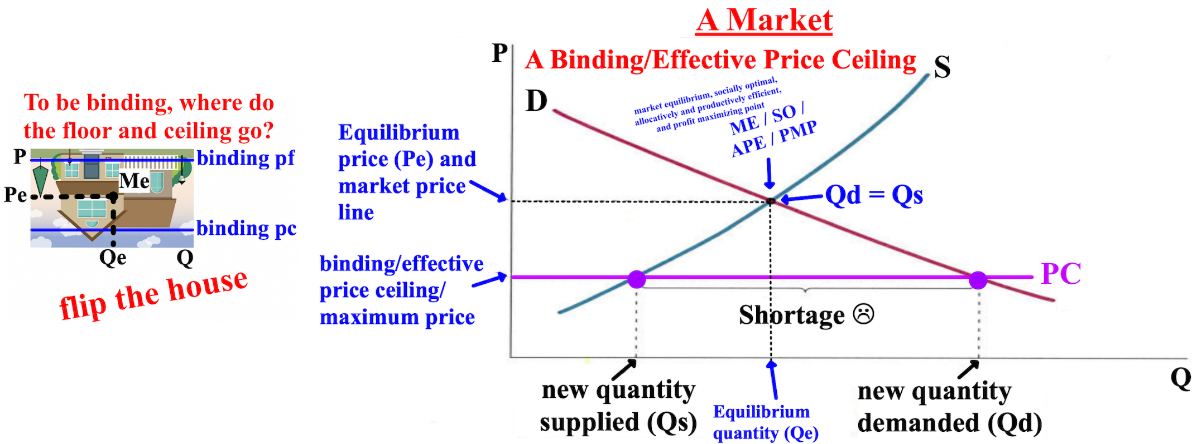

If a price floor is set above the equilibrium price (Pe), the price floor is binding (also referred to as mandatory or effective) since the equilibrium price and market equilibrium (Me) can't be reached. If the price floor is set below the equilibrium price, then the price floor doesn't matter since the price floor is below the equilibrium price/market equilibrium; the price floor is not binding and the equilibrium price will stay the same.
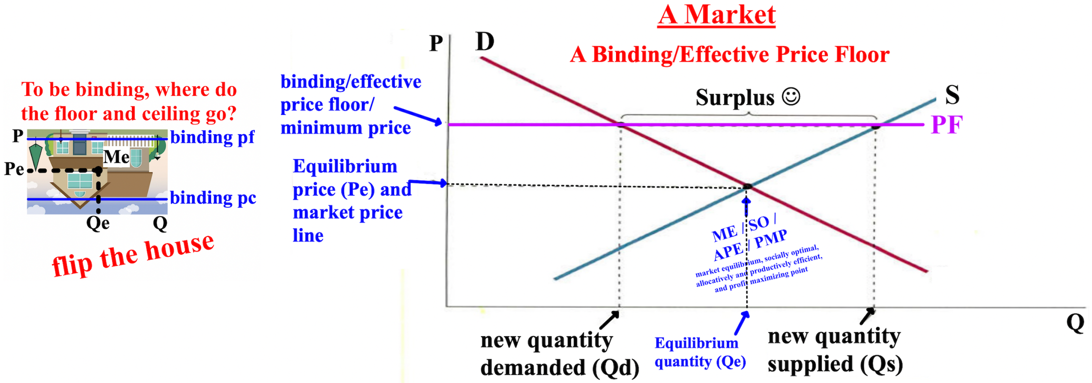

Free Response Question (FRQ) #1, and answer

Free Response Question (FRQ) #2, and answer
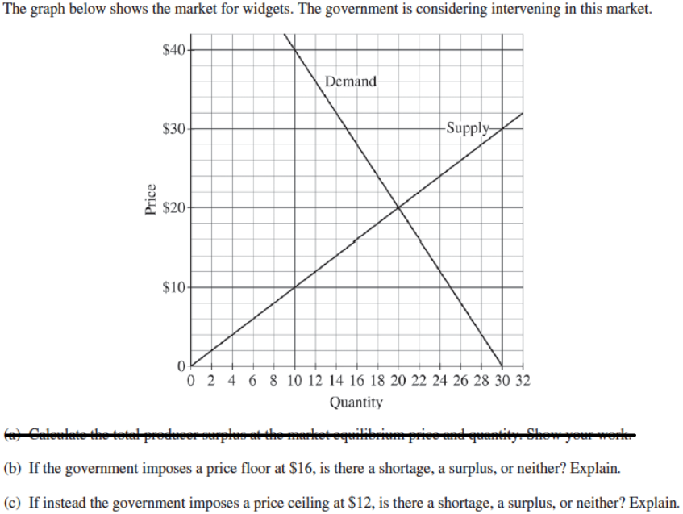

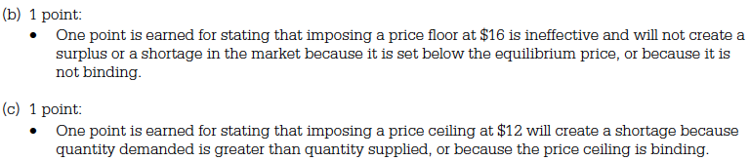

Free Response Question (FRQ) #3, and answer
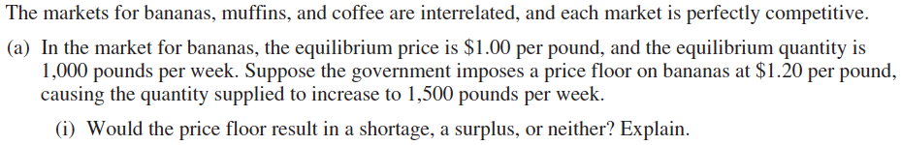

Chapter 3- Macroeconomics: The Big Picture
This chapter is about macroeconomics, which focuses on the economy as a whole, every firm/business
and every market in one country. Macroeconomics also focuses on a country's money supply, aggregate demand (AD), aggregate supply (AS), and gross domestic product (GDP). Aggregate demand is the total demand for goods and services in a country. Aggregate supply is the total supply of goods and services in a country
A country's money supply is the total amount of currency (coin and paper money) and deposits in banks in a country. Currency and checking are designated as M1 and are considered demand deposits (currency that you deposit into a bank account from which you can withdraw "on demand"- at any time without any advance notice to the bank; which is liquidity). All other currency is referred to as M2.

GDP (gross domestic product), also called nominal GDP or current GDP is the total value of all new goods and services produced in an economy during a specified period of time with the change on the price level (PL) (inflation or deflation) included in the total. GDP includes spending by consumers (C) + business investments (I) + the government (G) +/- net exports (X) (exports-imports). Inflation is the percentage increase in the average price level of all goods and services from one year to the next. Because the quantities of goods and services as well as their prices (P) change over time, economists use real gross domestic product (real GDP or Y), also called real output or output of production, to calculate economic growth from year to year. Real GDP only calculates changes in quantities purchased from year to year, not the changes in prices.

Real GDP (Y) is a country's GDP that is adjusted to take into account a change in the price level (PL) (inflation or deflation) from year to year.

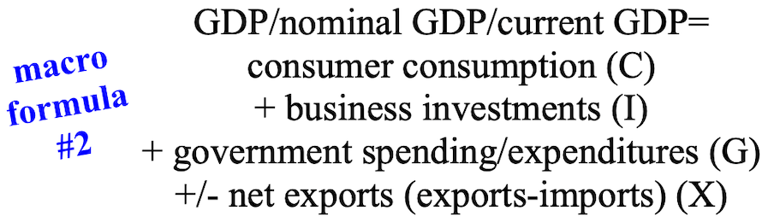
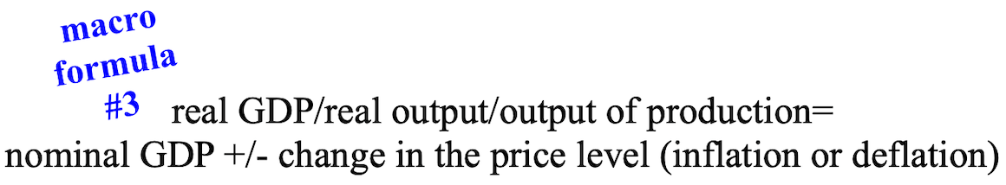

Decreases or increases in a country's money supply doesn't change real output. An increase in short-run aggregate supply (SRAS) (the total supply of goods and services in a country in the short-run) increases real output (real GDP (Y)), as does an initial decrease in workers' wages (left graph). A decrease in short-run aggregate supply, a recession, or a depression, decreases real output (real GDP (Y)) (right graph). The price level is the measurement of current prices of goods and services produced in an economy.

Because the focus in macroeconomics is on the total quantity demanded (Qd) for all goods and services in the economy and not just one industry, like when we learned about quantity demanded (Qd) in microeconomics,
we use the term aggregate demand (AD). Aggregate demand is the total amount that consumers (C), businesses (I), the government (G), net exports (X) spend on all goods and services in an economy. Aggregate
demand is GDP (AD = GDP. Aggregate demand AD is referred to as a demand-side policy because it deals with the total demand of goods and services in an economy.
Changes in government purchases, monetary policy by the FED, fiscal policy by the government, foreign demand for U.S. exports, taxes, and consumer confidence can cause aggregate demand (AD) to increase (left
graph) or decrease (right graph).
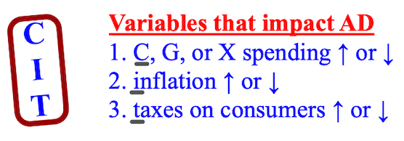

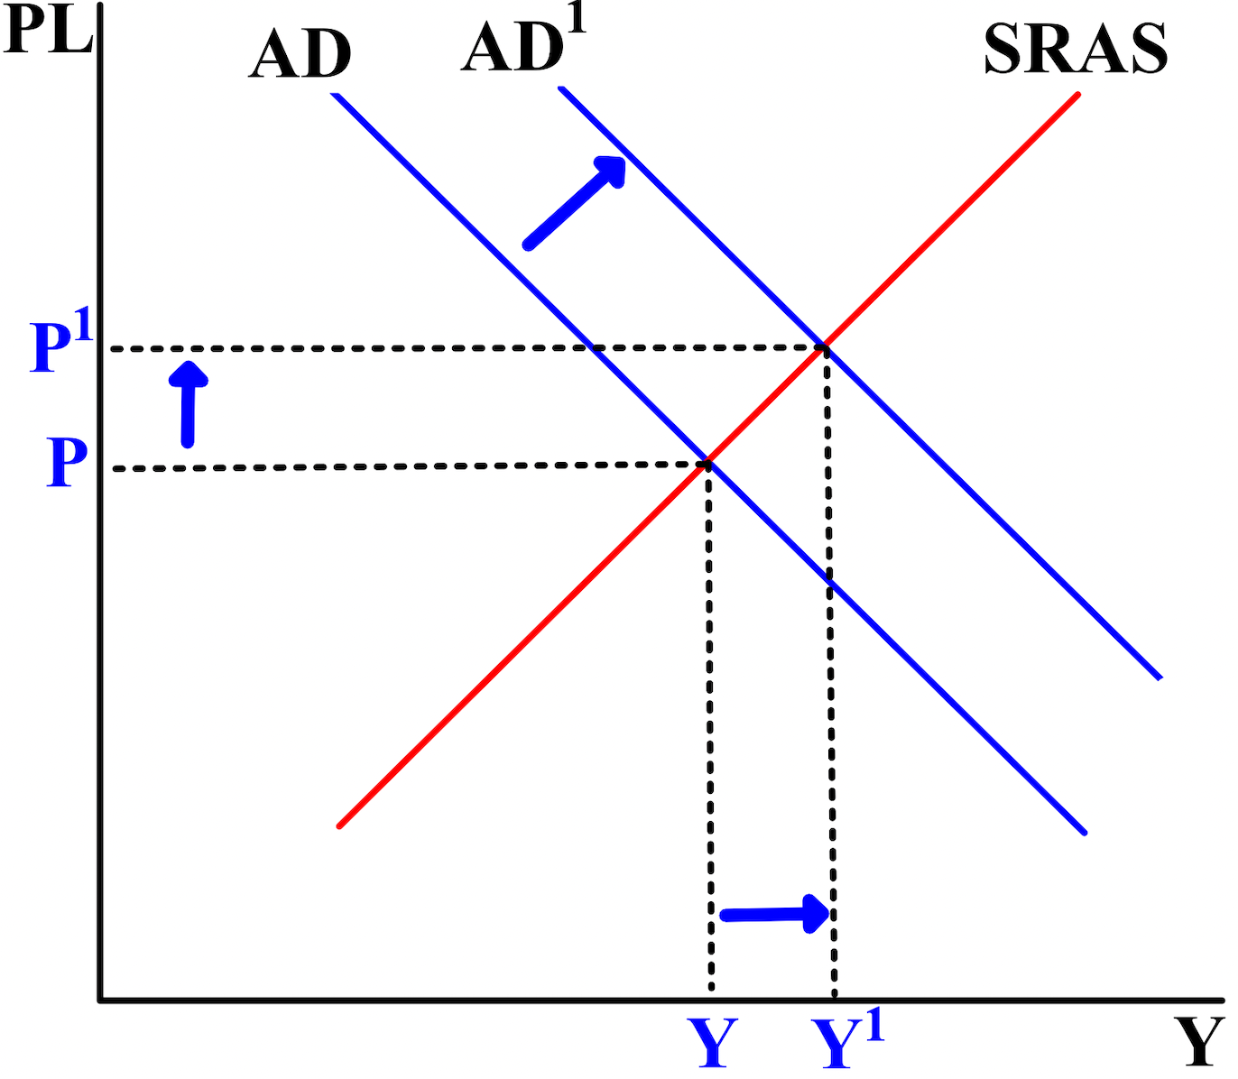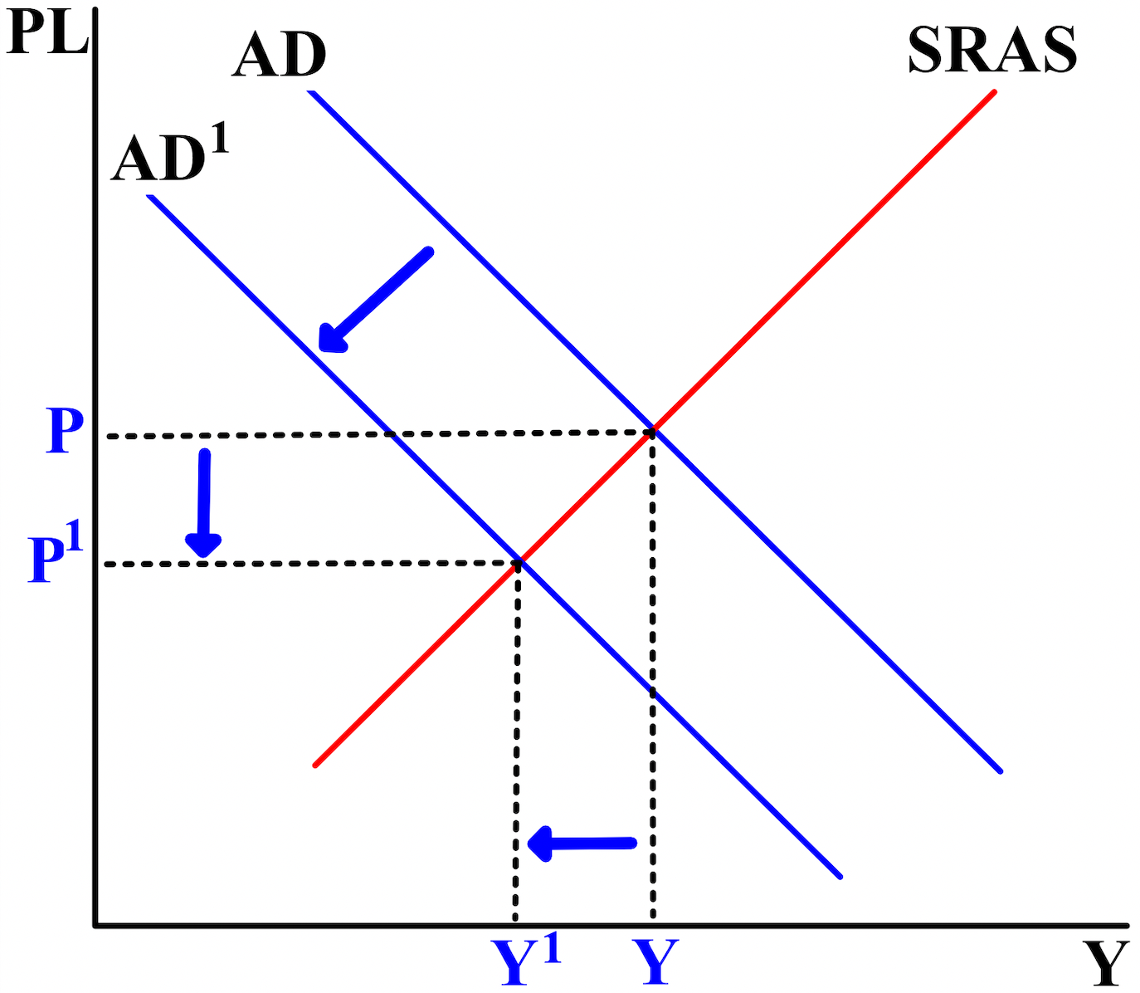

The potential GDP of an economy is best calculated by the total of what it makes or can service, its aggregate supply (AS). There are two types of aggregate supply. Short-run aggregate supply (SRAS) is all of the goods and services produced in the short-run (SR) (up to one year out) by all of the firms in an economy using the available labor, capital, and technology. The left graph shows an increase in SRAS, the right a decrease.
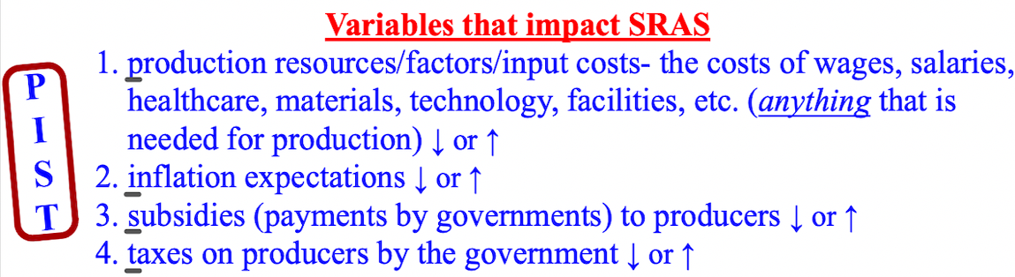

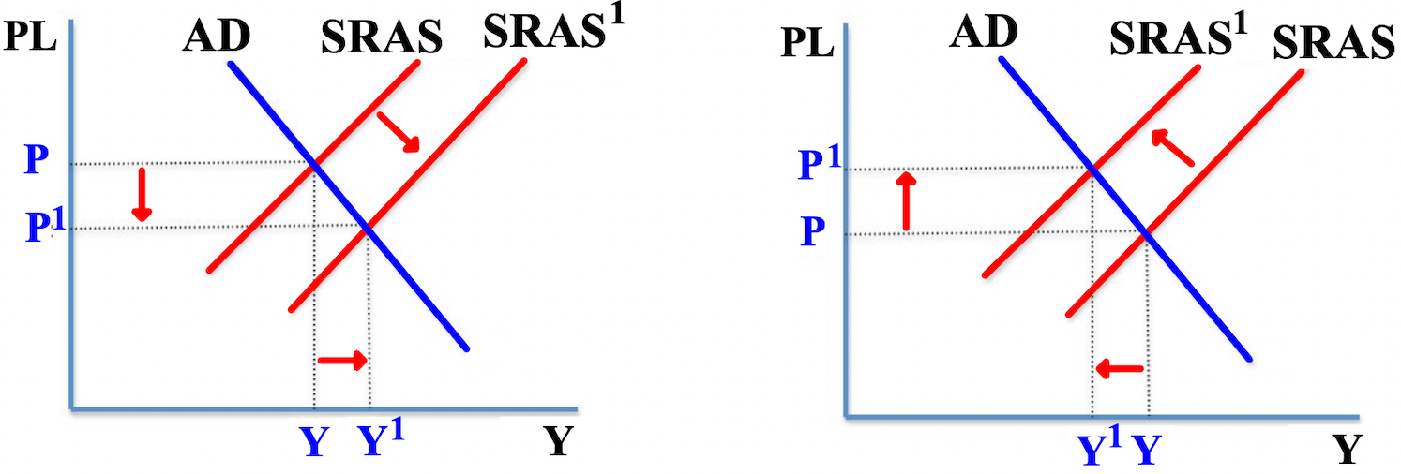
When the level of short-run aggregate supply (SRAS) is the same as aggregated demand (AD), short-run equilibrium occurs. Short-run equilibrium is a state where short-run aggregate supply (SRAS) equals aggregate demand in the short-run (less than one year). The equilibrium price level (Pe) and equilibrium output level (Ye) are the price level and output where the quantity of goods supplied (Qs) is equal to the quantity of goods demanded (Qd).
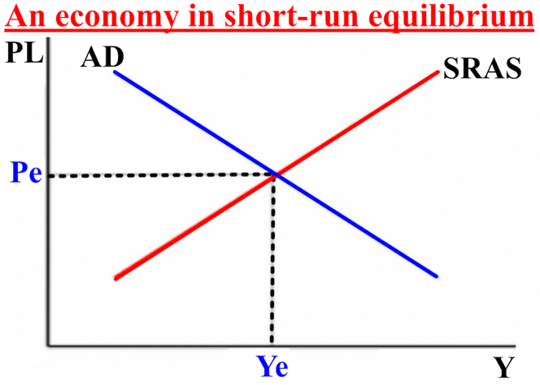
The short-run aggregate supply (SRAS) curve shifts right (increases) if the stock (worth) of physical capital (trucks, factories) or human capital (workers) increases. A decrease in production costs increase SRAS but decreases the price level. An increase in SRAS will lead to increases in income and possibly, in the long-run, less unemployment. Unanticipated increases in SRAS can cause hyperinflation because the excess supply will decrease price levels which will increase quantity demanded. The short-run aggregate supply (SRAS) curve shifts left (decreases) if labor (workers) productivity decreases or if production costs increase.

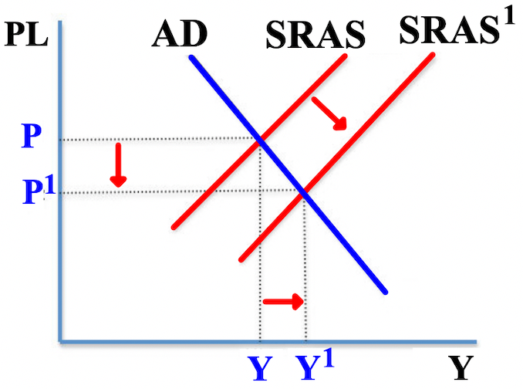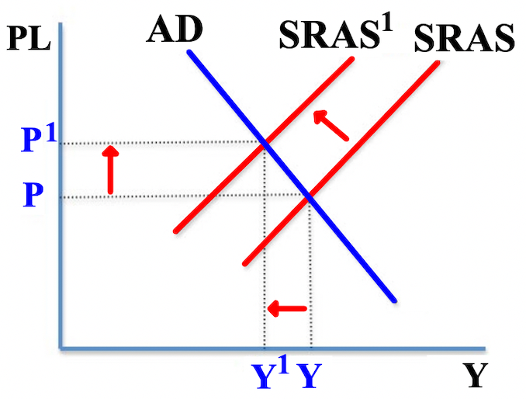

The velocity of money calculates how fast money is spent in an economy.

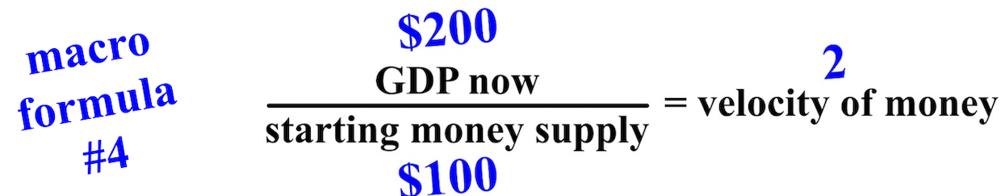

The velocity of money is an important part of an economy's GDP calculation. A country's GDP cannot be controlled through the money supply alone. If the money supply is increased in a country but its velocity decreases, GDP may stay the same or even decline. An increase in the money supply causes price levels to rise (inflation). A decrease in the money supply first causes disinflation (when the rate of inflation slows down) which then leads to deflation (a declining inflation rate). Think of how a cell phone charges... fast at first, then charges slower when nearing 100%, then loses charge when on.

When real GDP (Y) increases in an economy, it is called economic growth. Real GDP per capita (per person) is the best indicator of economic growth. In the short-run (up to one year out), economic fluctuations, also called business cycles, occur, which are small increases or decreases in real GDP. Sometimes real GDP fluctuates above or below potential GDP (where an economy should be). If the economy is above potential GDP, the country's economy is in expansion/has inflation (blue/top ovals). If it is below, economy is in a recession/in contraction (red/bottom ovals)
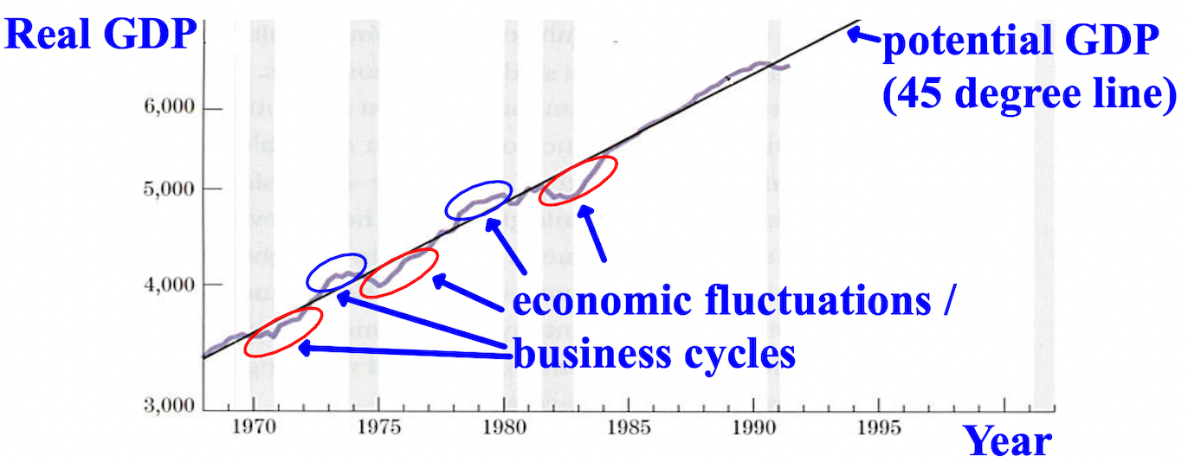

Over time, increases and decreases in real GDP (Y) and economic fluctuations, or business cycles, occur. When real GDP falls, economists say that there is a recession. The decrease in real GDP must last at least six months (two quarters) before the decline is officially considered a recession. A depression is a huge recession
The highest point before the start of a recession is called the peak. The recession (contraction of the economy) comes next. The lowest point during the recession or depression is called the trough. The period between recessions, from the trough to the next peak, is called an expansion. The early part of the expansion is called a recovery because the economy is just recovering from the recession.

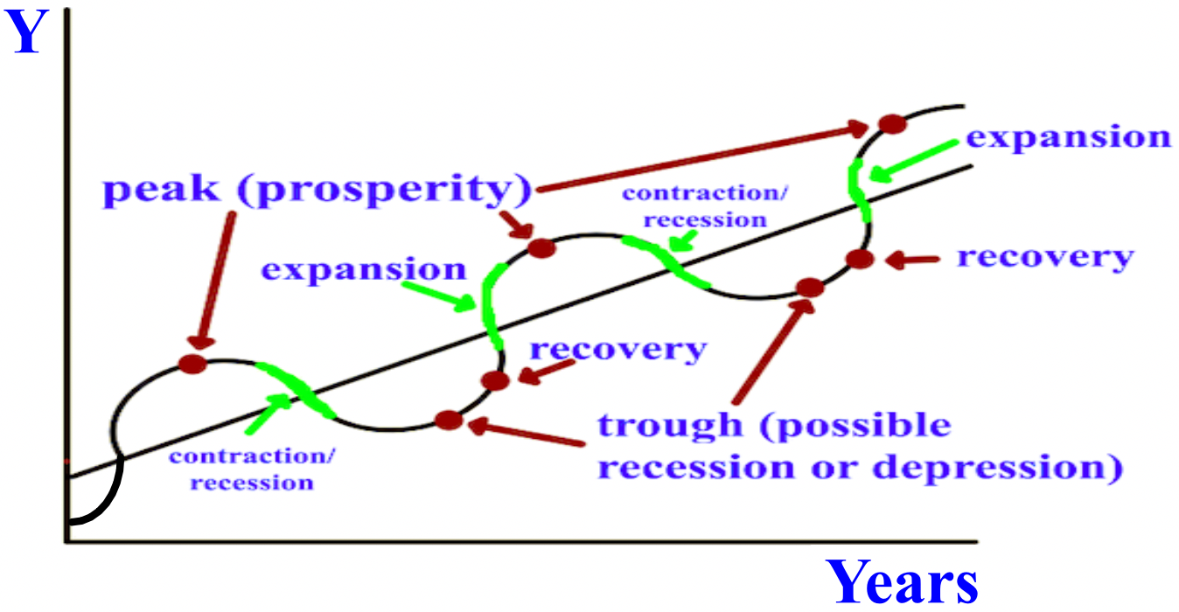
The graph below shows the increase or decrease in real GDP (Y) from 1990 to 2015. Real GDP increased around 4.1% from 1991 to 1992. Real GDP decreased around -3% from 2008 to 2009. The growth rate of real GDP can be a negative number.

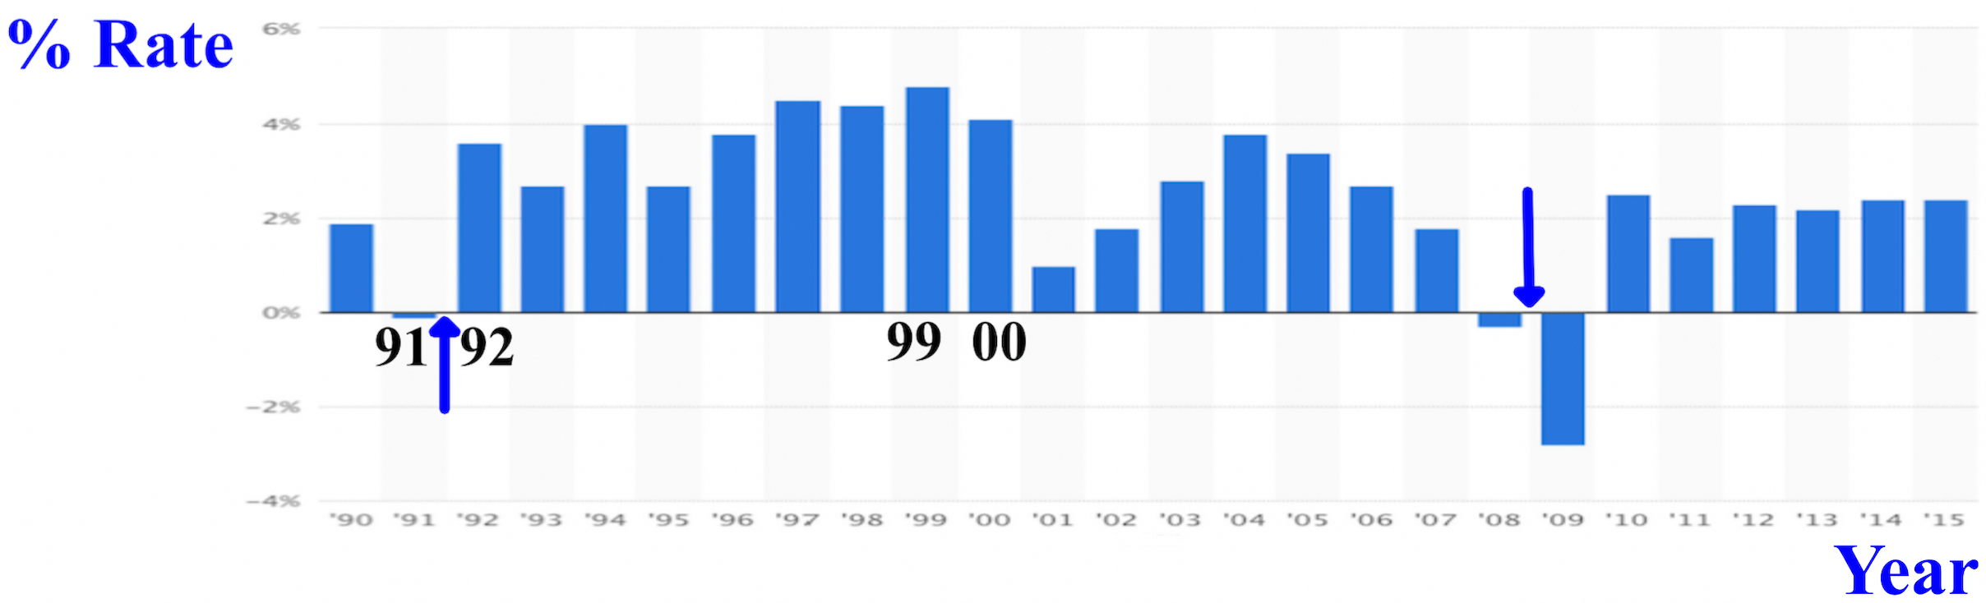
Let’s calculate the real GDP growth rate between 2017-2019. We need to find the percentage increase or decrease.
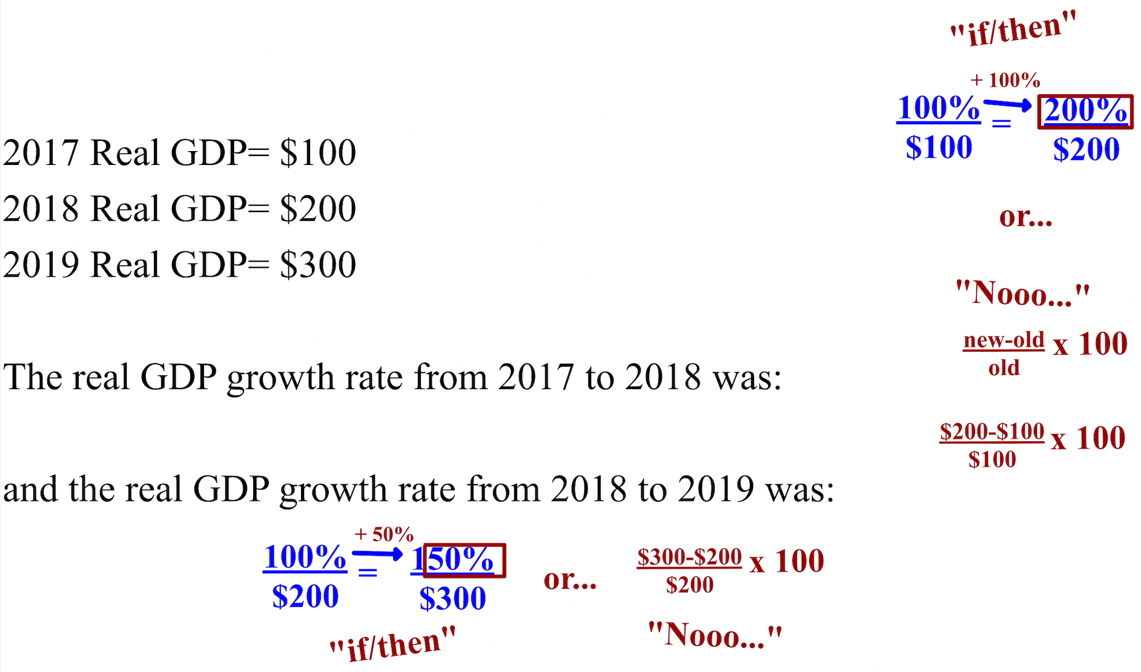

The annual growth rate from 2017 to 2019 was 75%: (100% (growth from 2017-2018) + 50% (growth from 2018-2019) = 150% / 2 = 75%. The growth rate is said to be in "chained 2017 dollars" for the three years from 2017 to 2019 because 2017 would be the base (the year the calculation started with. The base year chosen must be a year where nominal and real GDP the same amount.
Real income is income adjusted for changes in prices (inflation or deflation). If you earn $100,000 a year, but inflation is at 10%, your real income is only $90,000. A good measure of how individuals benefit from increases in real GDP (Y) is real GDP per capita (the average production per person in an economy. The formula for real GDP per capita is:

real income per capita = country’s real GDP / country’s population
If a country's real GDP is $100 and their population is 2, the country's real GDP per capita is $50 ($100 / 2). Employee skills are critical for a high real GDP per capita. Unskilled workers don't really help increase real GDP.
The annual growth rate of real GDP per capita is the percentage increase in the real GDP per capita each year. To calculate a country's percent change from one year to another, figure out the per capita for each year and then figure out the percentage change between the years. If the first year's per capita is $1,000 and the second year's is $1,099, the percent change is 9.9% (100% x $1,099 / $1,000= 109.9%, then 109.9%-100%).

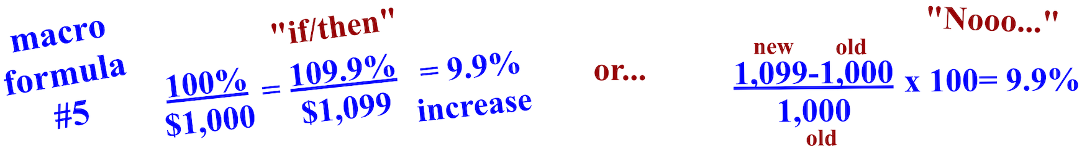
Increased real GDP per capita (labor productivity) shifts short-run aggregate supply (SRAS) right (left graph) while a decrease shifts SRAS left (right graph). An increase in quantity demanded (Qd) leads firms (businesses) to produce more to maximize their profit before quantity demanded decreases.

The annual short-run (SR) economic growth rate is the percentage increase in real GDP (Y) from one year to the next. Over time though, we look at the long-run (LR) economic growth rate, which looks at the growth of the economy from 4-5 years and beyond. The best way to promote long-run economic growth in a country is to take care of the unemployed and enhance technology, but education is key. Raise workers' stock (value) and a country's economy will expand.

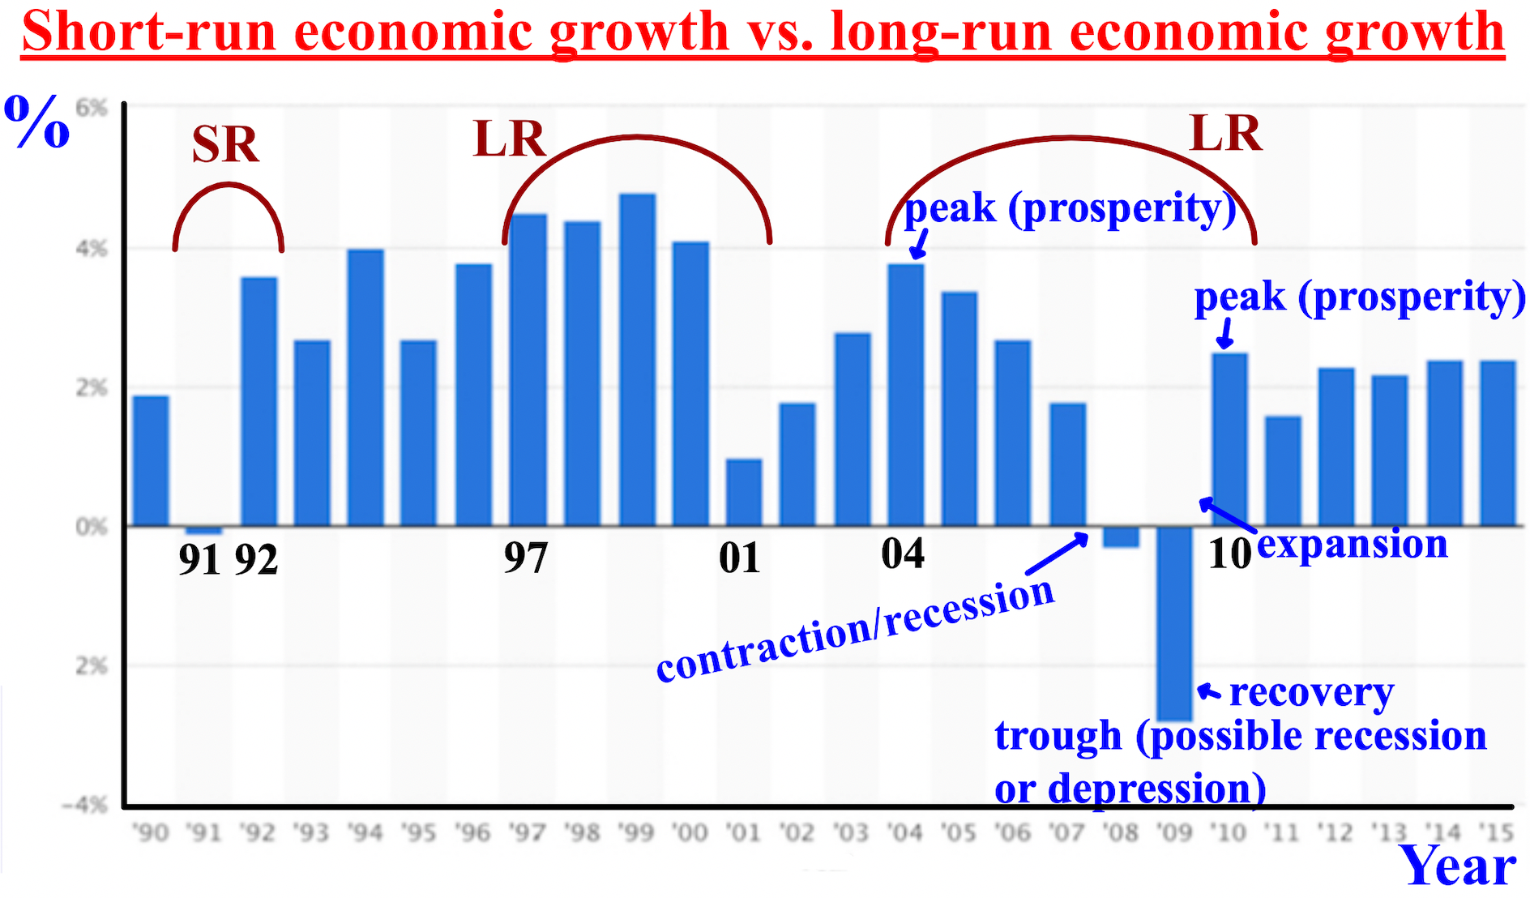

Real GDP (Y) (spending by consumers (C) + businesses (I) + the government (G) +/- net exports (X) (exports-imports) impacts inflation, interest rates, and unemployment over time. Inflation, interest rates, and unemployment impact real GDP.
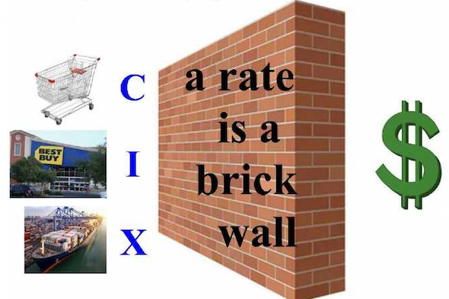
The inflation rate is the percentage increase in the average price level (PL) of all goods and services from one year to the next. The inflation rate is included in nominal GDP. The inflation rate directly impacts how much consumers (C), businesses, (I), and net exports (X) borrow and spend. If inflation (price levels) decreases, C, I, and X will borrow and spend more. If inflation (price levels) increases, C, I, and X will borrow and spend less. Inflation occurs when nominal GDP grows quicker than real GDP; when price levels increase. An inflation rate of around 2% is the goal in America's economy. Often the expected rate of inflation impacts consumer decisions. If prices are expected to go up, some will buy earlier rather than later, and vice versa.
Stagflation is persistent high inflation combined with high unemployment and stagnant demand for goods in a country's economy. Demand-pull inflation occurs when inflation is caused by an excess of aggregate demand (AD) vs. short-run aggregate supply, (SRAS), like after natural disasters occur.

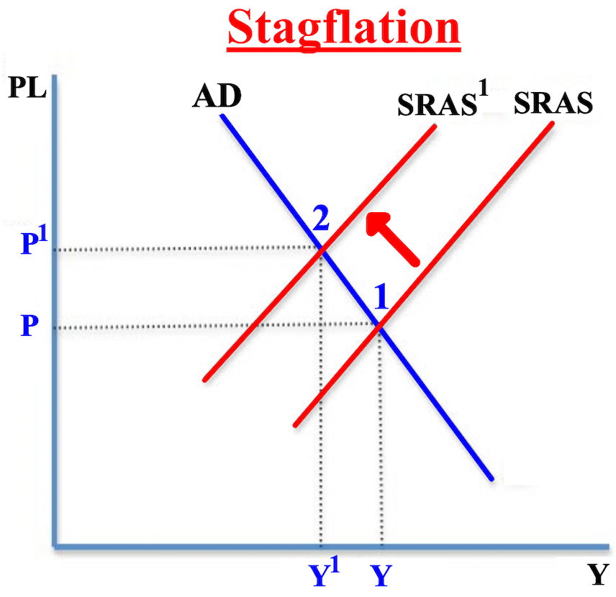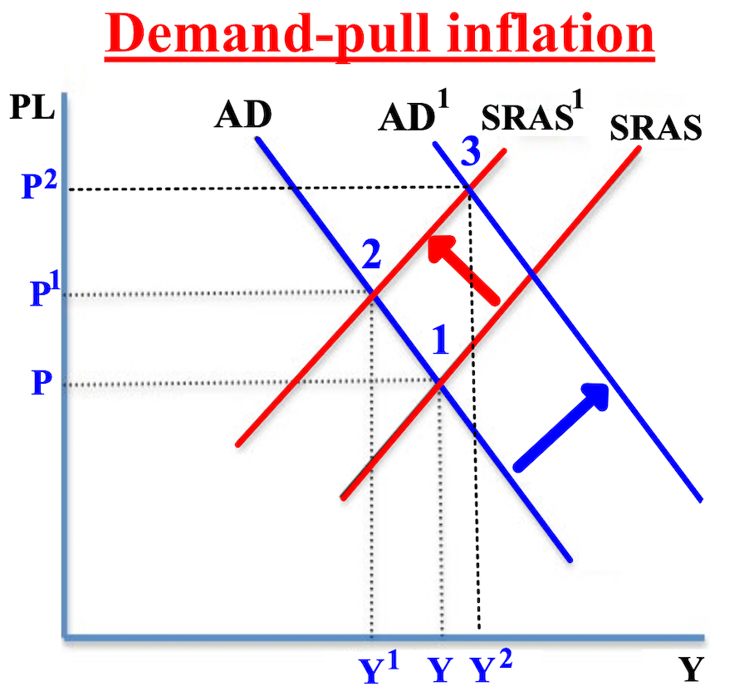

Increases in real GDP (Y)/aggregate demand (AD) causes the inflation rate to increase. Because of the increased aggregate demand, price levels (PL) increase over time. A rapid increase in a country's money supply creates hyperinflation, which explains why governments just can't print more money. Higher inflation rates make your money decrease in value. Cost-push inflation is inflation caused by an increase in prices of inputs
like labor, resources, etc. The increased price of the factors of production leads to a decreased short-run aggregate supply (SRAS) of the goods being made. When quantity supplied (QS) decreases, prices (P) increase, which is inflation.
The interest rate is the amount lenders charge borrowers when they lend money. The interest rate is another key economic variable that is related to the growth and change in real GDP (Y) of a country's economy over time. Interest rates directly impact how much consumers (C), businesses, (I), and net exports (X) borrow and spend. C, I, and X are very interest sensitive (sensitive to interest rates). If interest rates decrease, C, I, and X will borrow and spend more. This usually leads to lower unemployment and possibly expansion because more is purchased and workers are hired, increasing an economy's money supply. If interest rates increase, C, I, and X will borrow and spend less. This usually leads to higher unemployment and possibly a recession because less is purchased and workers are laid off, decreasing an economy's money supply. Fixed interest rates don't change over time while flexible interest rates do. The nominal interest rate is the interest rate on a loan, making no adjustments for inflation (a loan of 9% including 5% inflation). The real interest rate is the nominal interest rate minus the inflation rate. (9% - 5% = 4%)

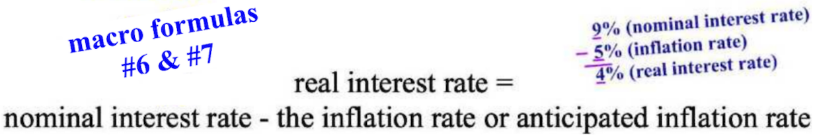
Deficit spending by a country leads to an increase in interest rates because the money supply decreases making the remaining money more valuable/more expensive.
Fluctuations in interest rates are directly connected to inflation and real GDP (Y). When inflation/price levels (PL) increase or are expected to increase, lenders charge C, I, and X a higher interest rate to cover the decrease or expected decrease in the value of money being paid back to them (higher prices = less purchasing power), and as C, I, and X borrow or spend less, the money supply decreases and real GDP/aggregate demand (AD) decreases which leads to a possibly of a recession/contraction in the economy. When inflation/price levels (PL) decrease or are expected to decrease, lenders charge C, I, and X a lower interest rate because of the increase or expected increase in the value of money being paid back to them (lower prices = more purchasing power), and as C, I, and X borrow or spend more, the money supply increases and real GDP/aggregate demand (AD) increases which leads to expansion and inflation in the economy.
The federal funds rate is the short-term interest rate banks charge other banks on overnight loans. This rate can be adjusted up or down by actions taken by the Federal Reserve (the "Fed") to expand or contract the economy. To increase the money supply and expand the economy, the government buys bonds from banks which increases the amount of money banks can loan and lowers the interest rate on the loans for C, I, and X. To decrease the money supply and contract the economy, the government sells bonds to banks which decreases the amount of money banks can loan raises the interest rate on the loans for C, I, and X. Bonds (securities) are loans that people give to a company or government and the company or government promises to pay back in full with regular interest payments.

The second type of aggregate supply (AS) is long-run aggregate supply (LRAS). LRAS is all of the goods and services produced in the long-run (LR- four to five years out) by all of the firms in an economy using the available labor, capital, and technology. The long-run aggregate supply curve is determined by all of the factors
of the factors of production since none are fixed in the long-run. Long-run equilibrium is where real GDP (Y) equals potential GDP.
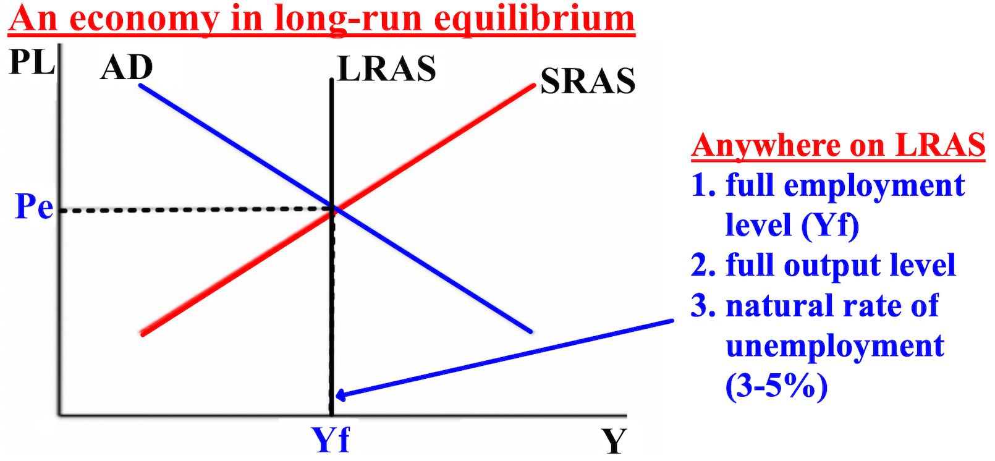

Anywhere on the LRAS curve represents an economy where all inputs: land, labor and capital, are used to full efficiency. If there was an increase in investment, growth in size of a skilled labor force, an increase in consumer confidence in the economy, LRAS might shift to the right, an indicator of positive economic growth.
Long-run aggregate supply (LRAS) can be impacted by changes in input or output costs, taxes, subsidies, government regulations, and the production of capital goods (goods created in order to produce other goods, like a robot for a car factory) and consumer goods (goods created for consumer purchase, like twinkies). Labor is the total number of hours that workers are available to work in producing real GDP. Capital is the total number of factories, machines, computers, human workers, etc., available. Technology is the total amount of know-how available.
Classical economists believe that the close alignment of wages and price levels in an economy allow a country to naturally return to long-run equilibrium, even when expansion or contraction occurs. During a recession (left graph), wages will decrease which will increase SRAS and the economy will return to long-run equilibrium. During an expansion (right graph), wages will increase which will decrease SRAS and the economy will return to long-run equilibrium.

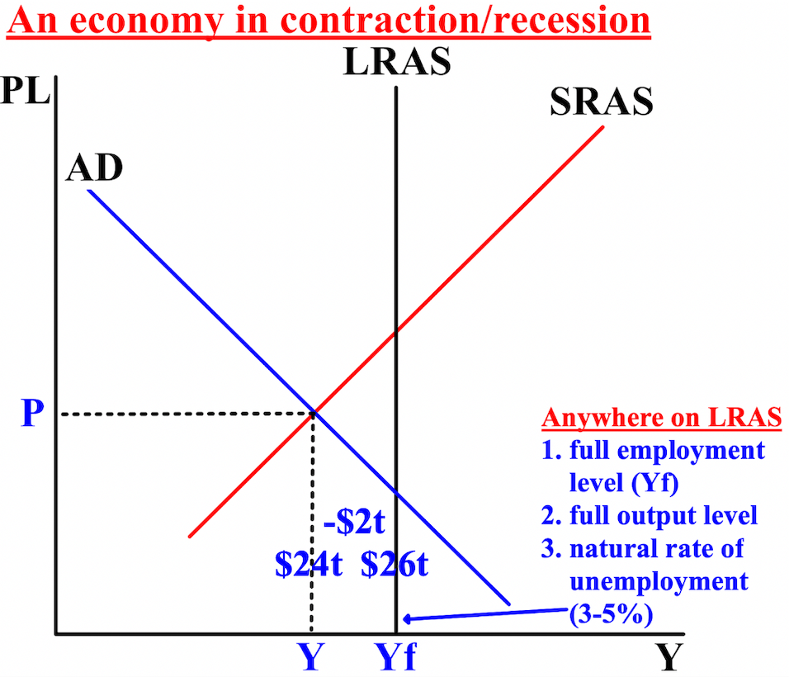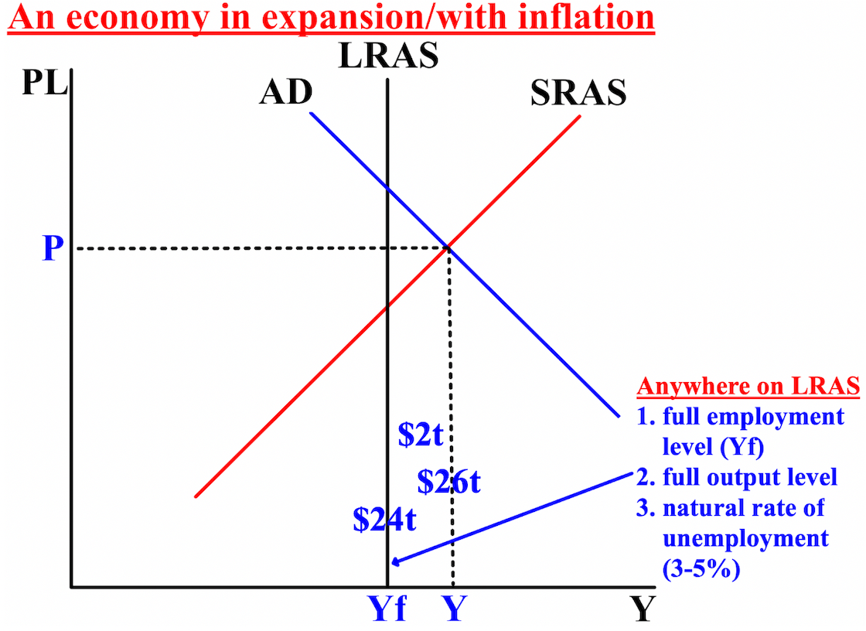

The difference between a country's potential GDP (Yf), let's say $26 trillion, and a country's real GDP (Y), let's say $24 trillion, is where the contraction/recession is occurring; real GDP in the economy is less than potential GDP. The economy is operating $2 trillion less than it should be (left graph).
The difference between a country's potential GDP (Yf), let's say $24 trillion, and a country's real GDP (Y), let's say $26 trillion, is where the expansion/inflation is occurring; real GDP in the economy is more than potential GDP. The economy is operating $2 trillion more than it technically should be (right graph).
Chapter 4- Measuring the Spending of Nations and Employment and Unemployment
This chapter is about how economists measure our nation’s real GDP, employment, and unemployment. Every three months the real GDP (Y) report is released, but then there are two revisions to the initial report. Because of the multiple reports, it is very difficult to decide fiscal policy (government taxing and spending by Congress) and monetary policy (the size of the money supply and controlling inflation by the Federal Reserve); in other words...should the economy be expanded or contracted?
When measuring GDP, it is important to not count the same item more than once, which is called double counting. If you buy a bicycle, the bike is a final good (goods that undergo no further processing). The tires are part of the bike (the tires are an intermediate goods). Only final goods are part of GDP, so you wouldn't add the cost of the tires and the bike to measure GDP because that would count the tires twice. Only the value added is used to calculate GDP because it only counts what each firm adds to the other intermediate goods to get the final product.
Sticky wages occur when workers' earnings don't adjust quickly to changes in labor market conditions. If workers' wages remain higher for longer than they should when an economy is in contraction/recession, the economy's recovery from a recession might take longer. If workers' wages remain lower for longer than they should when an economy is in expansion/has inflation, the economy's recovery from an
expansion might take longer. When sticky wages occur, the best way to raise GDP is to increase government spending (G).
America uses the spending approach as our main way to measure GDP. The spending approach determines how GDP is allocated among the four major components of spending: consumption by consumers (C), business investment (I), government purchases (G), and net exports (X) (exports - imports). Because of scare resources, all four parts of spending must compete for the for what they need.

Y = C + I + G + X

The interest rate (the part of a loan that is charged as interest to the borrower; either fixed or flexible) is a key factor that both influences and is influenced by consumer (C), businesses (I), government (G) and net exports (X) spending and borrowing. This applies more to the long-run (4-5 years out) than to the short-run (up to one year out) because it takes time for C, I and X to completely respond to changes in interest rates. Interest rates only affect the three shares of spending by the private sector: C, I, and X because C, I, and X are interest-sensitive (sensitive to interest rates). Higher interest rates decrease borrowing and spending by C, I, and X while lower rates increase borrowing and spending. Government spending/expenditures are part of the public sector and are not impacted by interest rates.
Government surpluses and deficits have to be considered when it comes to spending and borrowing by C, I, and X. If there is a government surplus, interest rates would decrease because the government would decrease its quantity demanded (Qd) of loanable funds (the amount of money in a country that is available to be loaned to
C, I, and X) from where C, I, and X get loans from. There would be a surplus of money (the more money there is the less value the money has separately) and interest rates would decrease leading to spending or borrowing by C, I, and X to increase. If there is a government deficit, interest rates would increase because the government would increase its quantity demanded (Qd) of loanable funds from where C, I, and X get loans from. There would be a decrease in the money supply (the less money there is the more value the money has separately) and interest rates would increase leading to spending or borrowing by C, I, and X to decrease.
A consumer's choice between consuming today and consuming tomorrow depends on the relative price (the price one day vs. another). Changes in the interest rate will change the relative price. A higher interest rate today will increase the price (cost) of consumption today relative to that of consumption tomorrow and also give consumers an incentive to save. A lower interest rate today will decrease the price (cost) of consumption
today relative to that of consumption tomorrow and also give consumers an incentive to spend. By spending today when interest rates are higher, you are also losing what you might have gained by saving; your opportunity cost is higher. An increase in the interest rate or taxes leads to a decrease in consumption and aggregate demand (AD/Y). A decrease in the interest rate or taxes leads to an increase in consumption and aggregate demand (AD/Y).
Business investment (I) consists of new purchases of final goods by businesses/firms. It's also called business fixed investment or private domestic investment. This includes money spent on human capital (which also increases workers' output, productivity, and wages), workers' stock (value), and capital goods (anything used to produce goods and services and to change their inventories). If companies from anywhere produce their goods in America then sell it in America, it increases America's GDP/AD. Depreciation is the amount by which anything needed for production decreases in worth each year and needs to be replaced.
Government purchases (G) is the spending or expenditures by federal, state, and local governments on new goods and services, such as the military and education. Welfare payments are transfer payments from the government to individuals and not a government purchase and thus excluded from GDP. During a recession, government spending is critical as it leads to an increase in the money supply then decreased unemployment and finally increased real GDP (Y). Ultimately inflation will occur though. A decrease of taxes frees up money in the economy to be spent.
Net exports (X) is the difference between exports and imports. Three other terms for net exports are trade balance, balance of payments, and current account. Net exports can be either favorable/positive (if exports increase) or unfavorable/negative (if exports decrease). If net exports are positive (more exports than imports), that country has a trade surplus. If net exports are negative (less exports than imports), that country has a trade deficit. The more a country exports the higher its GDP; the more it imports the lower the GDP.
The value of a country's currency has a huge impact on its trade balance. If it's economy is doing well and its money is highly valued, goods will be more expensive to purchase in that country, and exports will decrease. If its economy is doing poorly and its money is less valued, goods will be less expensive to purchase in that country, and exports will increase. Importing more than your country exports hurts its GDP because it decreases the amount of goods purchased in that country and lowers its AD/GDP. When the amount of exports decreases, the most effective fiscal policy (Congress) is to transfer money to those who need it (government
transfer payments) in order to help those negatively impacted by the decrease.
The sum of the three shares/components of GDP (consumer consumption (C), business investment (I), and net exports (X)) must equal what is left over after the government (G) takes its share, and all must equal 100%. If the government's share is 22% of GDP (Y), then the sum of the consumption (C) share, the investment (I) share, and the net export (X) share must equal 78%. A decline in private (C, I, & X) spending/investment due to an increase in government purchases/expenditures is called crowding out because spending/investment by C, I, and X are “crowded out” by government borrowing/spending. Because the government is borrowing money, it leaves less money for C, I, & X to borrow thus making the remaining money more valuable and thus raising interest rates.
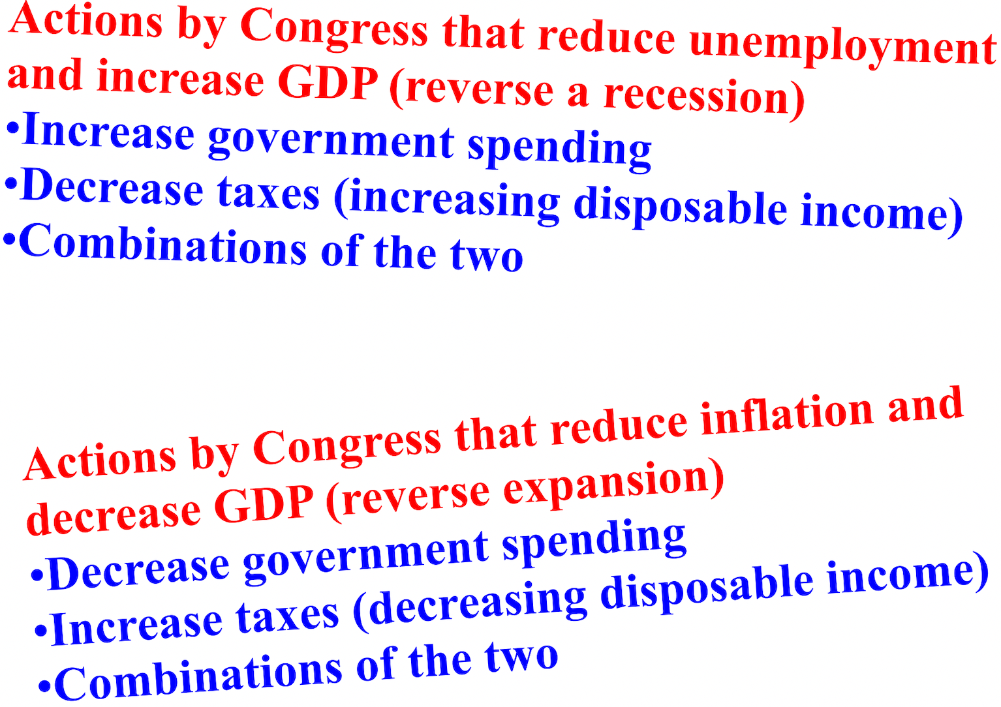
Nominal GDP gives a very misleading picture of the U.S. economy because nominal GDP grows faster than real GDP (Y) because the changes in the price level (inflation and deflation) aren't considered. If we divide nominal GDP by real GDP then multiply it by 100, we get the GDP deflator, which measures inflation in an economy. The reason for the term deflator is that to get real GDP, we can deflate nominal GDP by dividing it by the GDP deflator.
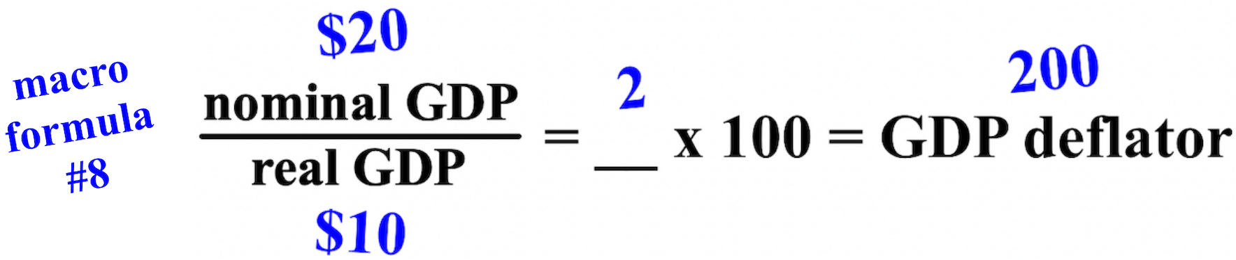

We can also start with knowing the real GDP (Y) and GDP deflator to find nominal GDP, or we can start with knowing nominal GDP and the GDP deflator to find real GDP.
There are other measures of inflation besides the GDP deflator. The consumer price index (CPI) is the price of a fixed collection: a “market basket” of 80,000 consumer goods and services in some future year divided by the price of the same collection in a base year. If a market basket consists solely of one CD and two tapes, then the CPI for 2019 (on top) compared with the base year 2018 (on the bottom) would be:
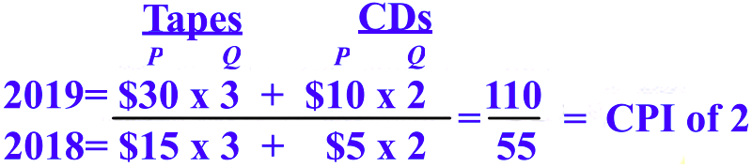
Because the quantity demanded (Qd) doesn't change from year to year, the CPI is referred to as the quantity-constant model. When the price of goods rises, the quantity demanded (Qd) should decline. The CPI doesn't allow the quantity demanded to change when the price (P) changes and the CPI doesn't allow substitutes to be purchased when the price changes. The items in the basket of goods and services are fixed and don't change.
Because quantity demanded and the basket's items don't change, the result is an overstatement of inflation.
The foreign exchange market, or FOREX is the global market for the trading of currencies from different countries. When countries buy goods from other countries, or when people travel to other countries, each country is usually paid in their own currency. The buyer must exchange their currency for that of the seller. Changes in preferences/tastes, relative incomes, relative price levels, and relative interest rates between countries can impact foreign exchange.
A higher dollar exchange rate (stronger value/purchasing power of U.S. currency compared to another country's currency) brought about by a higher interest rate would tend to make goods imported into the U.S. more attractive because it makes foreign goods cheaper with the stronger U.S. dollar. If the Federal Reserve (monetary policy) sells government bonds/securities (loans) to banks and thus the nominal interest rate rises while other countries' central banks maintain or even lowers their interest rates, then the return on savings
will be more attractive in the U.S. than in other countries. Given this higher rate in the U.S., international capital (money) will flow from other countries into the U.S. to earn higher interest rates, the dollar will appreciate (increase in value), and an increase in aggregate demand and GDP (AD/GDP/Y). A loss of funds from a country, like when interest rates decrease, depreciates (decreases) a country's currency value and decreases its AD/GDP/Y.
The higher exchange rate (either fixed/pegged or flexible/floating, the value of one currency for the purpose of conversion to another) will increase the quantity demanded (Qd) of imported goods. This is because in the country where there are higher exchange rates, their money is valued more. The people in that country will buy less of their own country's goods and will then buy more imports. The higher the exchange rate, the better the bargain for the buyer. A fixed or pegged rate is a country's exchange rate fixed completely by its own country. A flexible or floating exchange rate is an exchange rate between countries that changes depending on the supply (S) and demand (D) in the international community.
In the foreign exchange market, we only look at two countries/currencies at a time and examine the price of one currency relative to that of the other currency. If you need more dollars to buy one euro, the price for the euro appreciates (the increase in value of a country's currency with respect to a foreign currency) and the U.S. dollar depreciates (the loss in value of a country's currency with respect to a foreign currency). More dollars are then needed to buy the other currency and the dollar is said to be “weaker,” and the American price level (PL) will decrease. If you need fewer dollars to buy one euro, the U.S. dollar appreciates relative to the euro. Fewer units of dollars are needed to buy a single unit of the other currency and the dollar is then said to be “stronger,” and the American price level will increase.
If the GDP for a country is strong, the exchange rate of its currency will tend to rise, its price level (PL) will increase, the chance of inflation will increase, and the chance of recession will decrease. If the GDP for a country is weak, the exchange rate of its currency will tend to decline, its price level will decrease, the chance of inflation will decrease, and the chance of recession will increase. Higher exchange rates make U.S. exports less attractive because it makes American goods more expensive for foreigners to buy. A higher exchange rate leads to more imports and fewer exports while a lower exchange rate leads to less imports and more exports.
When thinking about FOREX and which country's currency is appreciating and which is depreciating, think of the currency that is wanted or demanded more relative to the other. If America's currency is desired by foreigners either 1) the inflation in America is decreasing relative to another country making it cheaper to buy American goods because America's price level is decreasing or 2) America's interest rate is increasing relative to another country making it more profitable for foreigners to put their money in American banks because of the higher rate of return from their investment.

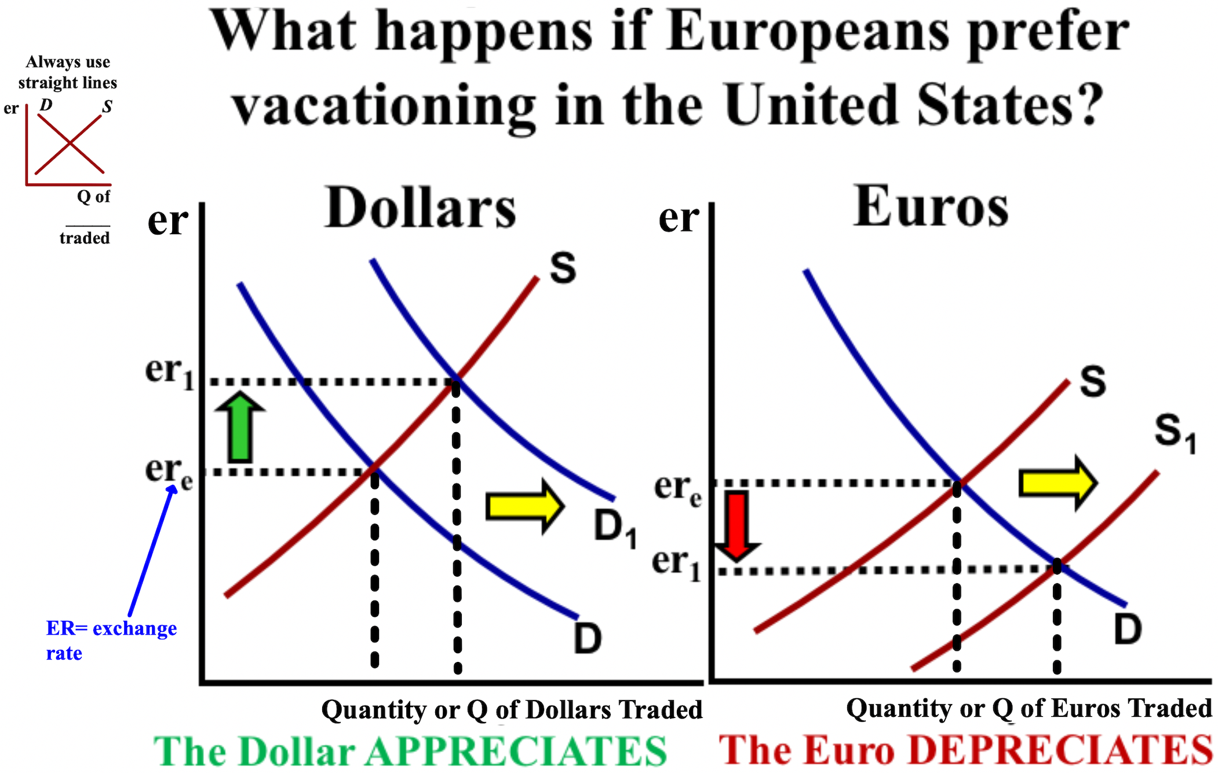

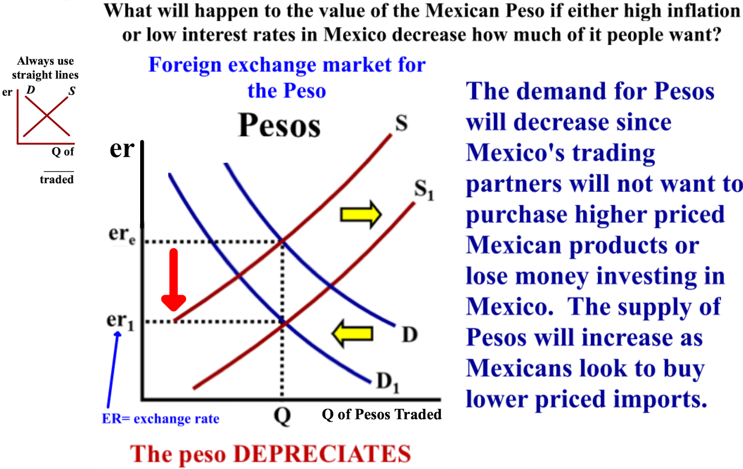

Reason for a change in FOREX (foreign exchange): Reason for a change in FOREX:
British tourists flock to the U.S. U.S. incomes increase resulting in more imports
a. demand for U.S. dollars ↑ (shifts right) a. U.S. demand for pounds ↑ (shifts right)
b. supply of British pounds ↑ (shifts right) b. supply of U.S. dollars ↑ (shifts right)
c. dollar appreciates and the pound depreciates c. pound appreciates and the dollar depreciates

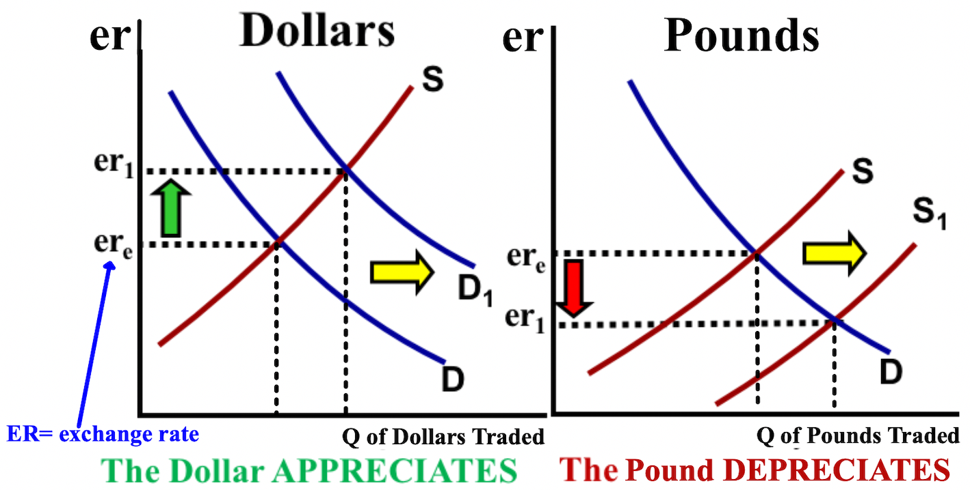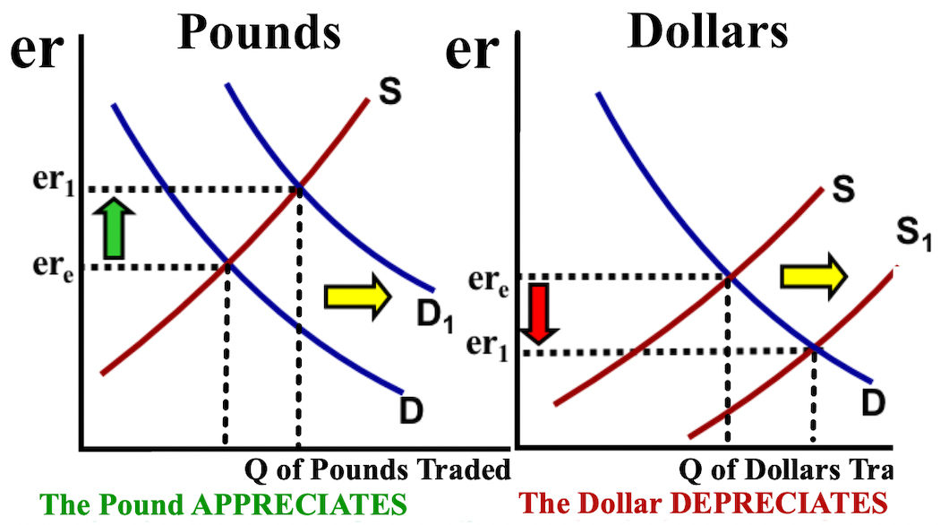

Reason for a change in FOREX: Reason for a change in FOREX:
U.S. prices increase relative to Britain U.S. has a higher interest rate relative to Britain:
resulting in more imports into the U.S. a. British people want to put money in U.S. banks
a. U.S. demand for pounds ↑ (shifts right) b. capital (money) ↑ to the U.S. (shifts right)
b. supply of U.S. dollars ↑ (shifts right) c. British demand for U.S. dollar ↑ (shifts right)
c. pound appreciates and the dollar depreciates d. British supply of pounds ↑ (shifts right)

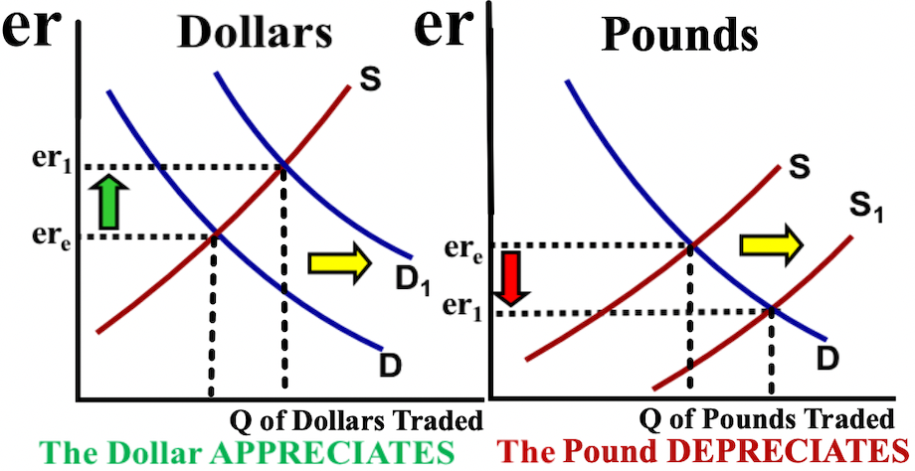
Free Response Question (FRQ) #1, and answer
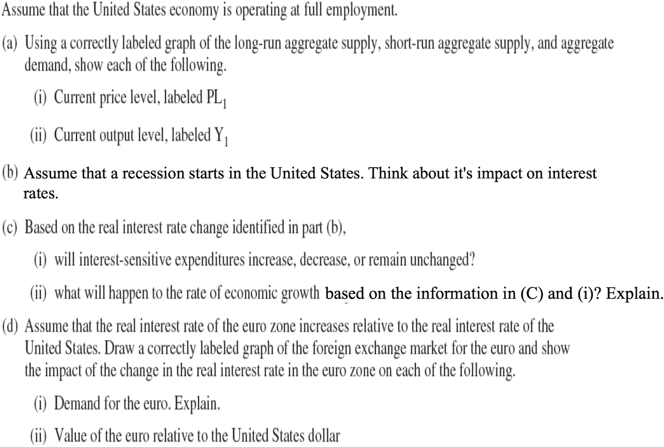

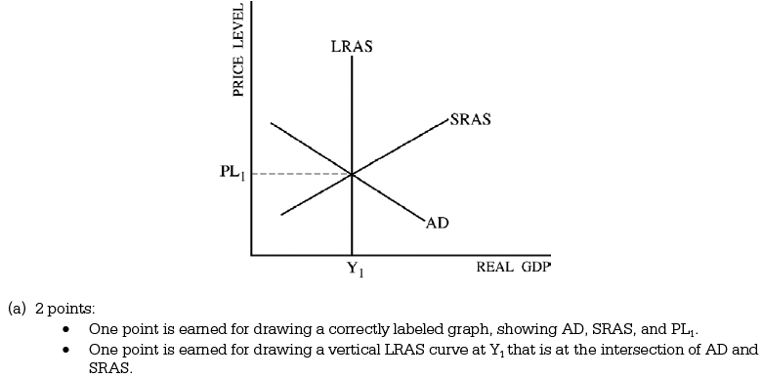

Free Response Question (FRQ) #1 answer (cont.)
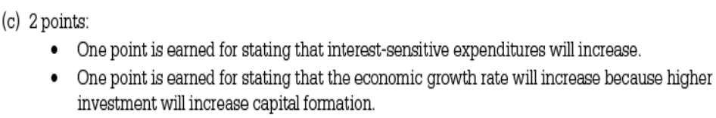

Free Response Question (FRQ) #2
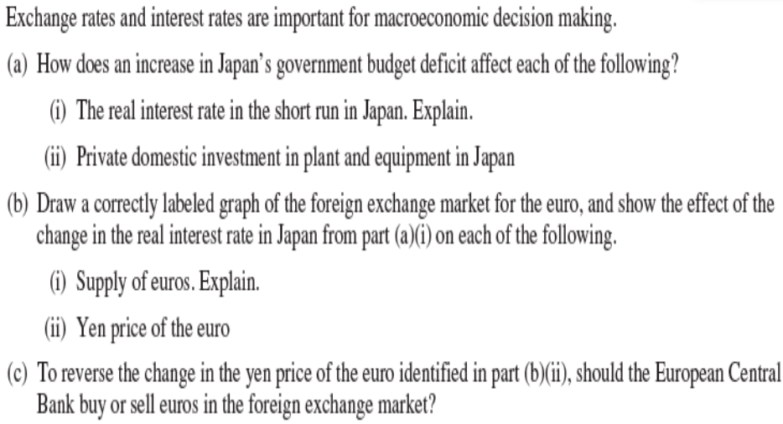
Free Response Question (FRQ) #2 answer

Now we'll discuss employment and unemployment. Economists use the term natural unemployment rate (Yf) to refer to the unemployment rate (about 3-5%) that exists when the economy is not in a recession or in an expansion and when real GDP is equal to potential GDP. An economy in equilibrium leads potential GDP to be same as the real unemployment rate. An increase in aggregate demand (AD) does not impact the natural unemployment rate. The increase in unemployment above the natural rate during recessions is called cyclical unemployment (shaded green or black below) because it is related to the short-term cycles of the economy. Increases or decreases in C, I, G, or X, impacts cyclical unemployment.

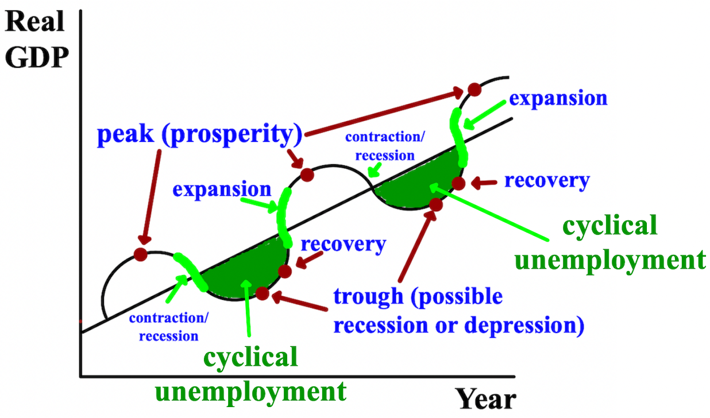
Free Response Question (FRQ) #3, and answer
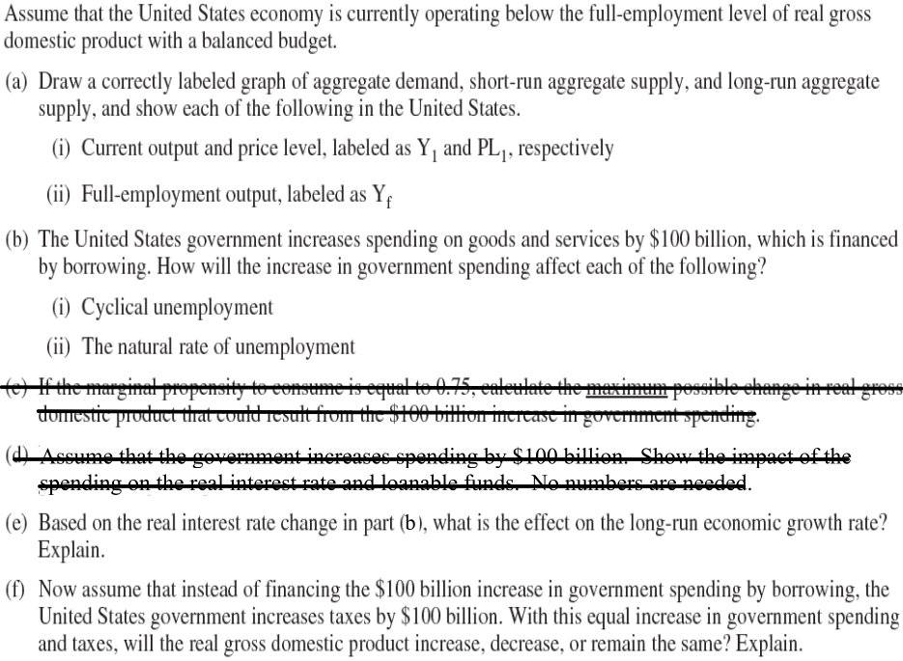

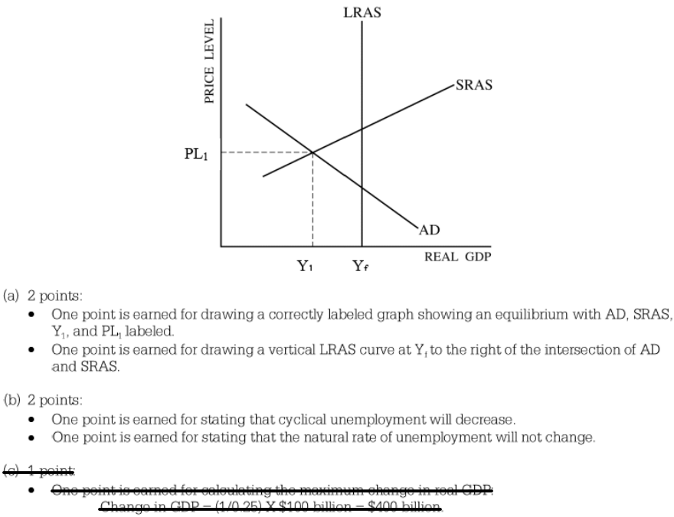

Free Response Question (FRQ) #3 answer (cont.)
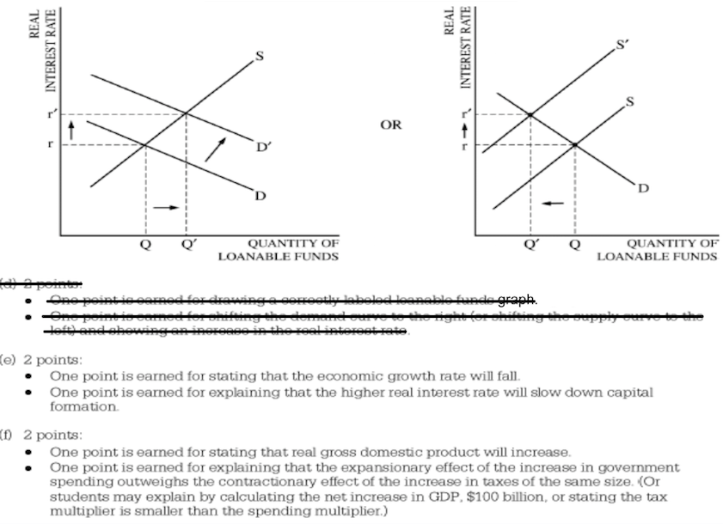

The natural unemployment rate (Yf) is caused by a combination of frictional unemployment and structural unemployment. Frictional unemployment occurs when new workers enter the labor force and must look for work, or when workers change jobs for one reason or another, like quitting a job to get another one. Most frictional unemployment is short-lived. Structural unemployment occurs if workers find that they have insufficient skills or find that their skills are no longer in demand as a result of technological change or a shift in people’s tastes toward new products. Frictional unemployment and structural unemployment are not constant and change over time.
At full employment (Yf), frictional unemployment exists but not cyclical. Economists feel that natural unemployment occurs whenever the operation of the overall macroeconomy is as close to normal in the sense that real GDP is near potential GDP.
Each month, the U.S. Census Bureau surveys households in the United States. The Census Bureau determines whether each person 16 years of age or over is employed or unemployed. Discouraged workers are workers who have left the labor force after not being able to find a job. Part-time workers are counted as employed. The official definition of a part-time worker is one who works between one and 34 hours per week. The most comprehensive measure of labor input to the production of real GDP (Y) is the total number of hours worked by all workers, or aggregate hours.

There are two key indicators of conditions in the economy. One is the unemployment rate (the percentage of the labor force that is unemployed), which = the number of citizens unemployed / the number of citizens in the labor force x 100. The labor force consists of those who are at least 16 and either working or looking for work. To be counted as unemployed, a person must be looking for work, but not have a job.
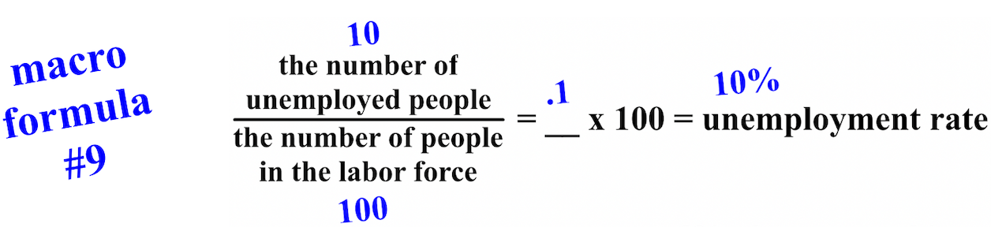

The second key indicator of conditions in the labor market is the labor force participation rate (the ratio of people in the labor force to the working-age population), which = the number of citizens in the labor force / the number of the working-age population x 100.

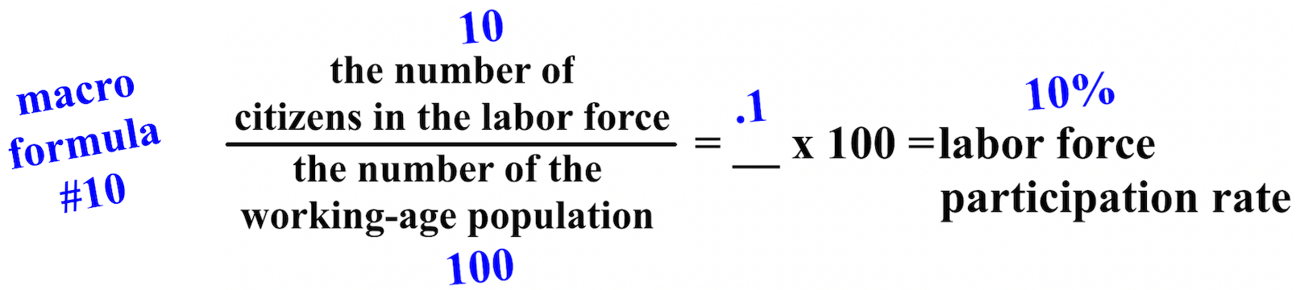

Chapter 5- Fiscal Policy by Congress and Monetary Policy by the Federal Reserve (The FED)
This chapter is about how Congress handles fiscal policy- the spending, borrowing, and taxation decisions taken by governments and how the FED uses monetary policy to stabilize an economy and to lessen the negative or excessive economic fluctuations that can weaken an economy, like employment, inflation, or real GDP that is too high or too low.
Fiscal policy is referred to as supply-side policy because it focuses on increasing long-term economic growth of aggregate supply (AS) (potential GDP). The primary tools that Congress uses to influence aggregate supply/potential GDP (AS/GDP) are 1) government spending/expenditures and 2) taxes.
When the U.S. economy is in a recession/in contraction, Congress can use expansionary fiscal policy to increase real GDP/economic output by increasing government (G) spending/expenditures and/or lowering taxes to increase the money supply and expand the economy. When the U.S. economy is in expansion/with inflation, Congress can use contractionary fiscal policy to decrease real GDP/economic output by decreasing government (G) spending/expenditures and/or increasing taxes to decrease the money supply and contract the economy.

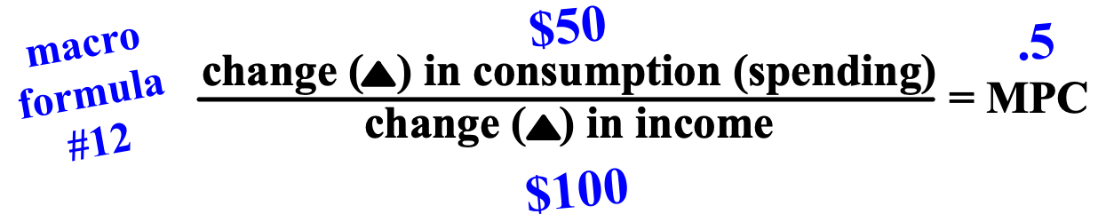

Discretionary fiscal policy refers to specific changes in laws or administrative procedures, such as a change in an existing program to speed up spending, the creation of a program (such as a new welfare program), or a change in the tax system (such as lower tax rates). These changes in the law are discretionary changes because they require action on the part of the Congress or the President.
Many of the very large changes in government taxes and spending are automatic. Unemployment compensation, Social Security payments, and welfare payments all rise in a recession. These automatic tax and spending changes are called automatic stabilizers or non-discretionary fiscal policy because they tend to
stabilize the fluctuations of real GDP.
Now we'll talk about monetary policy which are the actions taken by the Federal Reserve (the FED) to increase the money supply in an economy when the economy is in contraction/in recession or decrease the money supply when an economy is in expansion/has inflation. Monetary policy is referred to as demand-side policy because it focuses on increasing aggregate demand/real GDP (AD/Y). The primary tools that the FED uses to influence aggregate demand/real GDP are 1) bonds/securities, 2) the discount rate, and 3) the required reserve rate.
When the U.S. economy is in a recession/in contraction, the FED can use expansionary monetary policy to increase real GDP/real output by buying government bonds/securities from banks and/or decreasing the
discount rate or required reserve rate. This will increase the money supply, decrease interest rates, and
expand the economy. When the U.S. economy is in expansion/with inflation, the FED can use contractionary monetary policy to decrease real GDP/real output by selling government bonds/securities to banks and/or increasing the discount rate or required reserve rate. This will decrease the money supply, increase interest rates, and contract the economy.
Governments, usually through a central bank, control the money supply. A central bank is the main bank to other banks in a country. America's central bank is the Federal Reserve, nicknamed the "FED."
The FED makes decisions about the money supply through a committee called the Federal Open Market Committee (FOMC). The FOMC meets to decide how to implement monetary policy, such as deciding whether to raise, lower, or keep the nominal interest rate steady.
The FED regulates the money supply by changing any one of the following: 1) open market operations by buying or selling government bonds (short-term loans) from/to banks, 2) lending money to banks at a higher or lower discount rate, and 3) setting the required reserve or reserve ratio higher or lower for banks.
The FED's main monetary tool is used when either the FED buys government bonds/securities from banks or sells government bonds/securities to banks. This is referred to as open market operations. When the U.S. economy is in a recession/in contraction, the goal of the FED is to increase the money supply; more money= more chance to spend money. To do this, the FED buys government bonds/securities from banks (buy=
bigger). The FED then electronically pays the bank by increasing the bank's reserves at the FED. Banks then have more money to loan to borrowers which influences the FED to decrease the federal funds rate (the short-term interest rate that banks charge one another on overnight loans). This ultimately decreases the nominal interest rate (the interest rate that consumers and businesses pay; it includes inflation). Interest-sensitive spending increases and so does aggregate demand/real GDP (AD/Y).
When the U.S. economy is in expansion/with inflation, the goal of the FED is to decrease the money supply; less money= less chance to spend money. To do this, the FED sells government bonds/securities from banks (sells= smaller). The FED then electronically receives payment from the banks by decreasing the bank's reserves at the FED. Banks then have less money to loan to borrowers which influences the FED to increase the federal funds rate (the short-term interest rate that banks charge one another on overnight loans). This ultimately increases the nominal interest rate (the interest rate that consumers and businesses pay; it includes inflation). Interest-sensitive spending decreases and so does aggregate demand/real GDP (AD/Y).

The FED's second tool it uses to impact monetary policy is the discount rate. This is the interest rate that the FED charges commercial banks when loaning them money. Remember, think of all rates like a wall in your way; ↑ is bad and ↓ is good. To increase the money supply and expand the economy, the FED decreases the discount rate, making it cheaper for banks to borrow money from them. To decrease the money supply and slow down the economy, the FED increases the discount rate to make it more expensive for banks to borrow
from them. More money= more chance to spend money and less money= less chance to spend money
The last instrument the FED uses to impact the money supply is the required reserve or reserve ratio. This is the percent of customer deposits that banks must hold in reserve at the FED and cannot loan out. The FED sets the amount, the ratio, that banks must hold. Only a small percent of the money you have in a bank is held in reserve the rest of your money can be loaned out. This is called fractional reserve banking
When the FED wants to increase the money supply, the FED decreases the reserve requirement. Banks then loan out the excess reserves to make money. This is also what happens when deposits are made at a bank. Excess reserves are simply extra bank reserves at the FED. When the FED wants to decrease the money supply, the FED increases the reserve requirement. Banks then have less money to loan out to borrowers. This is also what happens when withdrawals are made at a bank.

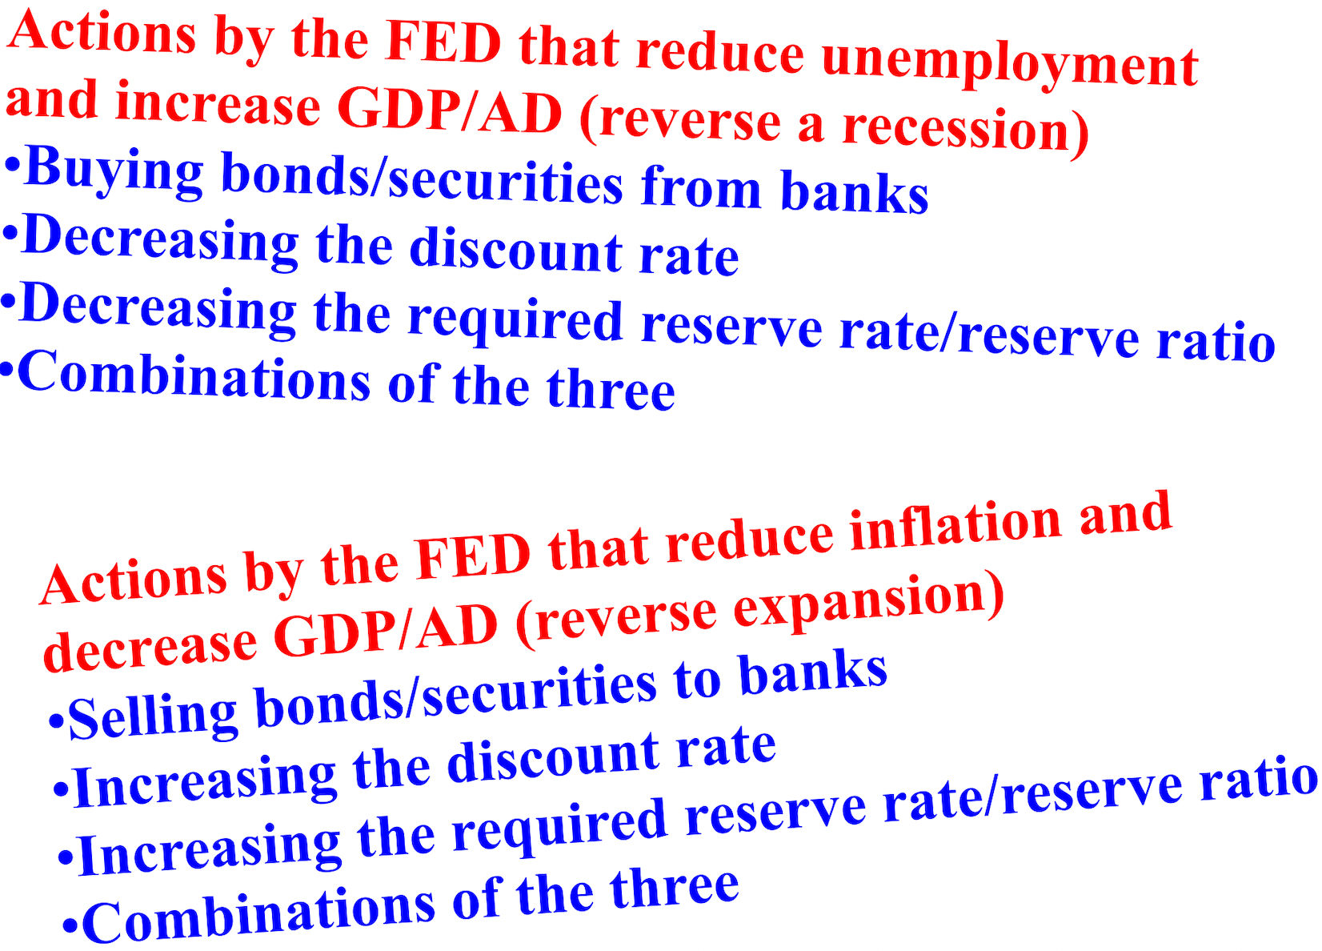

As more money flows into an economy and deposits are made at banks, those banks are now able to make additional loans. Interest rates decrease due to the increase in the money supply and aggregate demand/real GDP (AD/Y) increases. This positive ripple effect on the economy is called the money multiplier (the expansion or contraction of a country's money supply that results from banks being able to lend more or having to keep more money in their banks.
For example, if the reserve ratio is 10% (.1) and the money multiplier is 10, a $1 million purchase of bonds/securities by the FED from banks would lead to a $10 million increase in demand deposits and the overall money supply, available funds that would be available for banks to loan to customers.

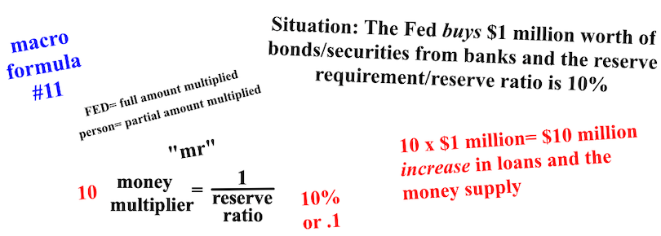
As more money flows out of an economy and withdrawals are made at banks, those banks are now able to make fewer loans. Interest rates increase due to the decrease in the money supply and aggregate demand/real GDP (AD/Y) decreases. This leads to a negative ripple effect on the economy. For example, if the reserve ratio is 10% (.1) and the money multiplier is 10, a $1 million sale of bonds/securities by the FED to banks would lead to a $10 million decrease in demand deposits and the overall money supply, less funds would be available for banks to loan to customers.

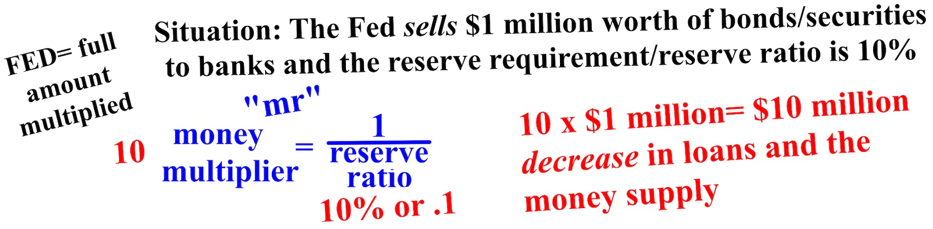

When using the money multiplier, two determinations have to be made. Is the impact on the economy a positive or negative one and is the money being referred to that will impact the economy already in the money supply or not? For example, if a person deposited $100 in cash in their bank, the money they are depositing is already in the money supply and won't be counted twice. If the required reserve is 20%, the money multiplier would be 5. The 5 would be multiplied by only $80 since $20 of the $100 (money already in the money supply) has to remain in reserve; only $80 can be loaned out. If $100 was withdrawn, there would be a decrease in loans/money supply.

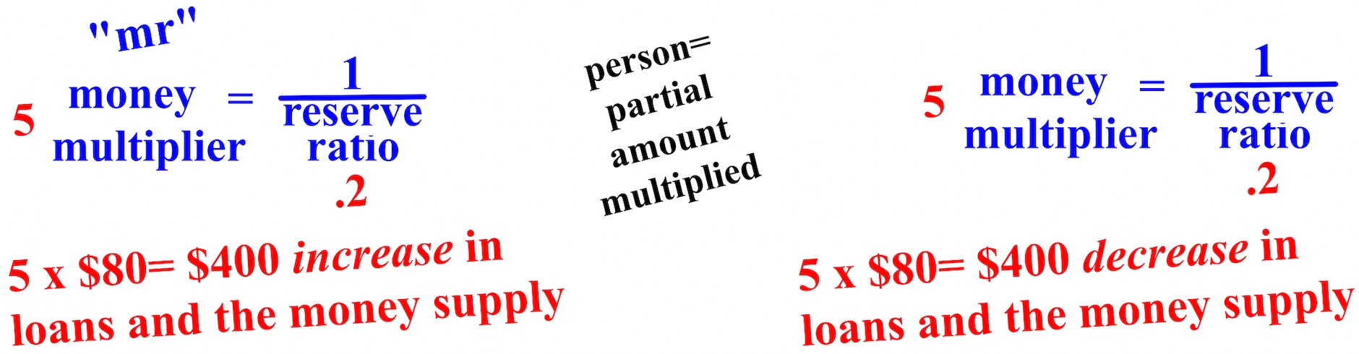

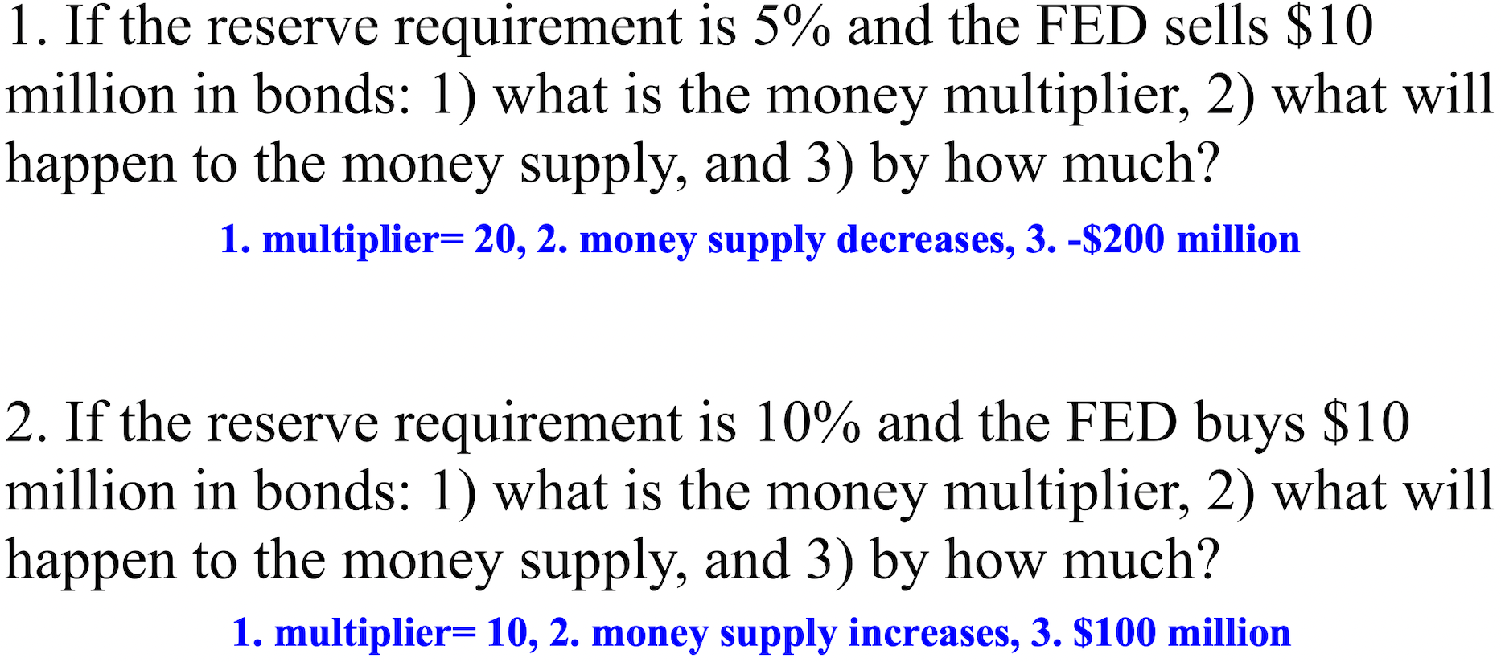

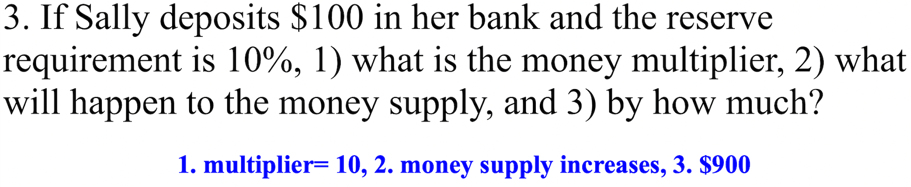
Chapter 6- Income, Consumption (Spending), Saving, the Spending Multiplier, Money Market, the Loanable Funds Market, and the Phillips Curve
This chapter is about consumers' disposable income (the income that households receive in wages, dividends, and interest payments plus transfers they may get from the government minus any taxes they pay to the government). This chapter is also about how likely it is for consumers to spend or save their disposable income.
A concept related to the consumption function is the marginal propensity to consume (MPC). The MPC measures how much people consume (spend) rather than save when there is a change in income. The MPC is always between 0 and 1, but hardly ever 0 or 1. The term propensity refers to "the inclination to."

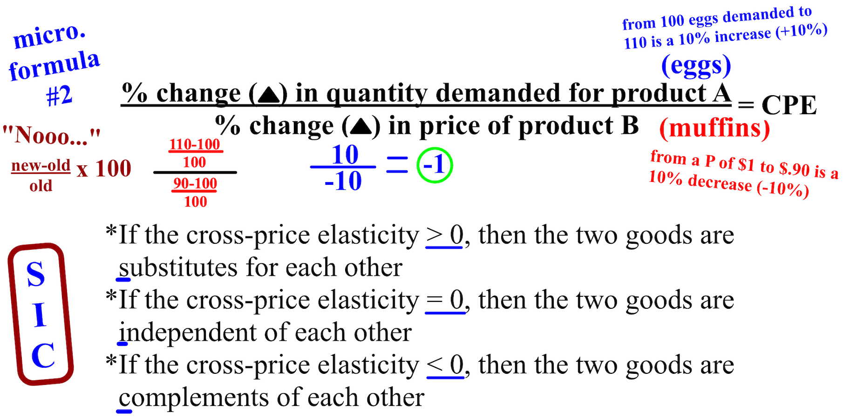

Another concept related to the consumption function is the marginal propensity to save (MPS). The marginal propensity to save measures how much people save rather than consume when there is a change in income. Just like the MPC, the MPS is always between 0 and 1, but hardly ever 0 or 1. Together, the MPC and MPS always equals 1. The reason for this is that there are only really two things that you can do with your money. You can spend it or you can save it, but there is no third option.
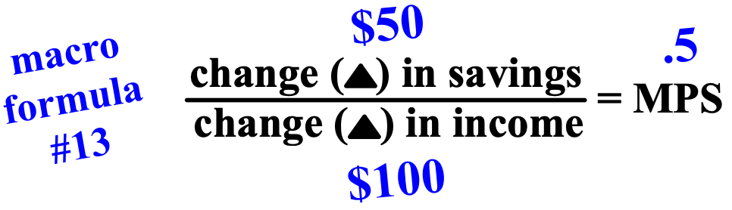

A concept directly related to the marginal propensity to consume or save is the spending multiplier. Since aggregate spending is always either increasing or decreasing in an economy, the impact on GDP/AD can be calculated. Just like the money multiplier, there is a positive or negative ripple on the economy.

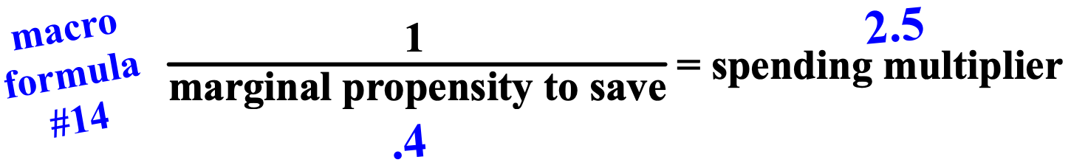

The money market is where short term loans are traded. The money market focuses on increasing and decreasing the economy's total money supply. The money market is where all of the money in an economy comes from, but only the government (G) gets its money from it.

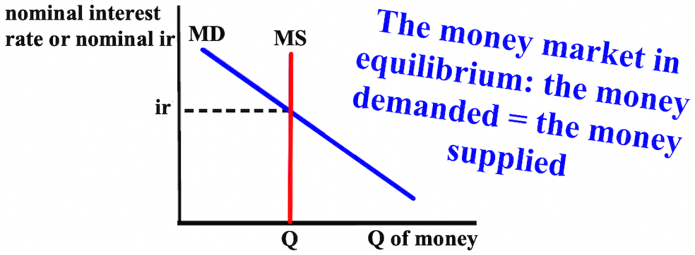

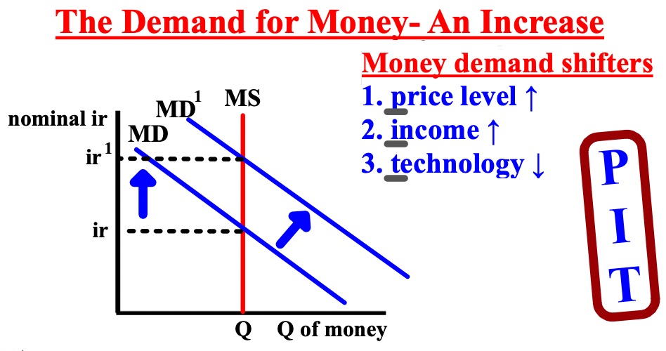

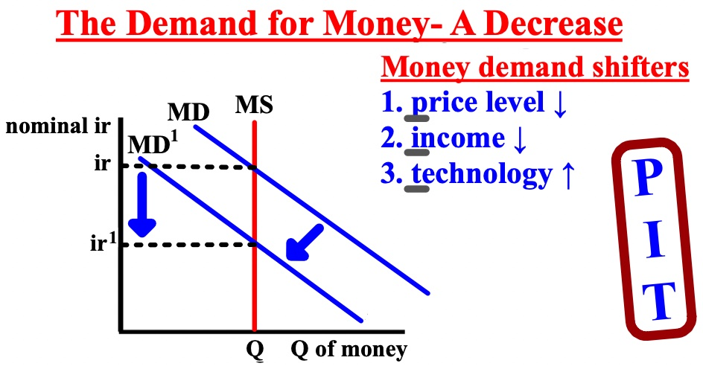
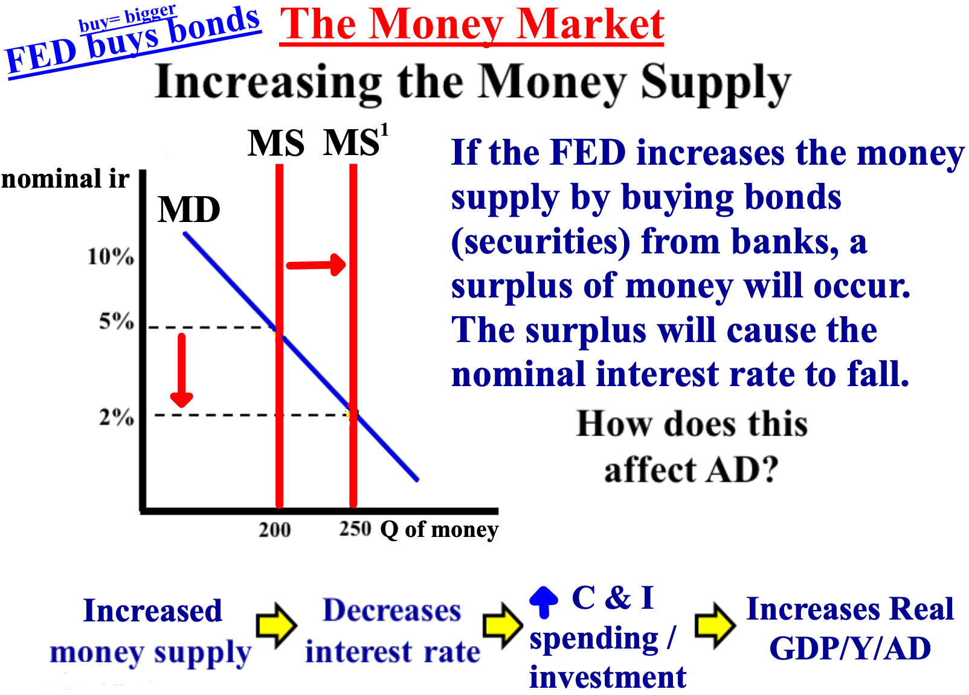

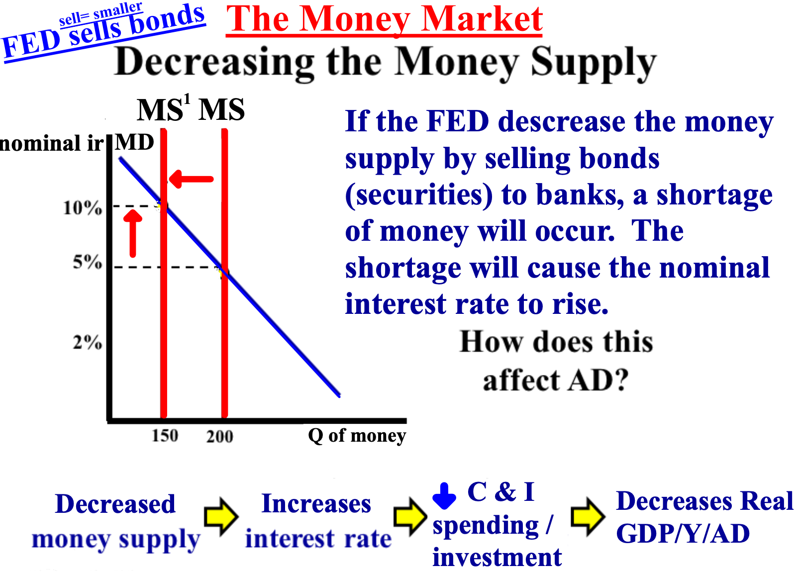
The loanable funds market is controlled by the money market and is where the private sector (C and I) gets their loans. The loanable funds market focuses on the supply and demand of loans. If interest rates are high, C and I will spend/invest/borrow less. If interest rates are low, C and I will spend/invest/borrow more.

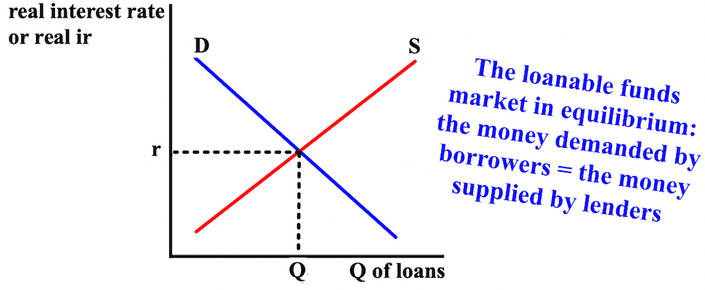

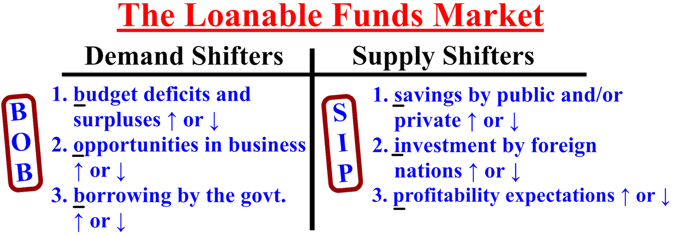

To show the inverse relationship between the inflation rate and unemployment and its overall impact on real GDP (Y), we use the short-run Phillips curve (SRPC). The short-run Phillips curve shows the tradeoff between inflation and unemployment. Notice that the higher the inflation rate, the lower the unemployment rate is. This occurs because inflation/price levels increase when the economy is in expansion (when real GDP is greater than potential GDP. As firms produce to meet the increased demand, more labor is needed.

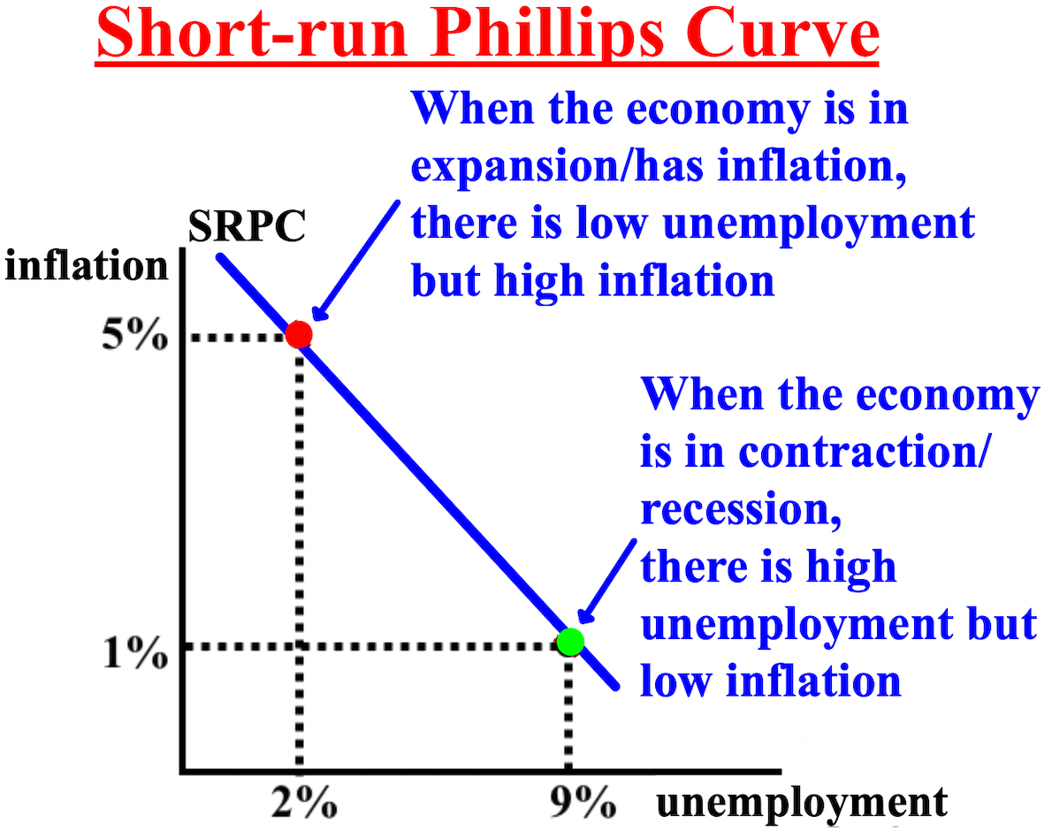

There is also a long-run Phillips curve (LRPC) shows that there is no tradeoff between inflation and unemployment in the long-run. Notice that even when the inflation rate increases, unemployment remains the same
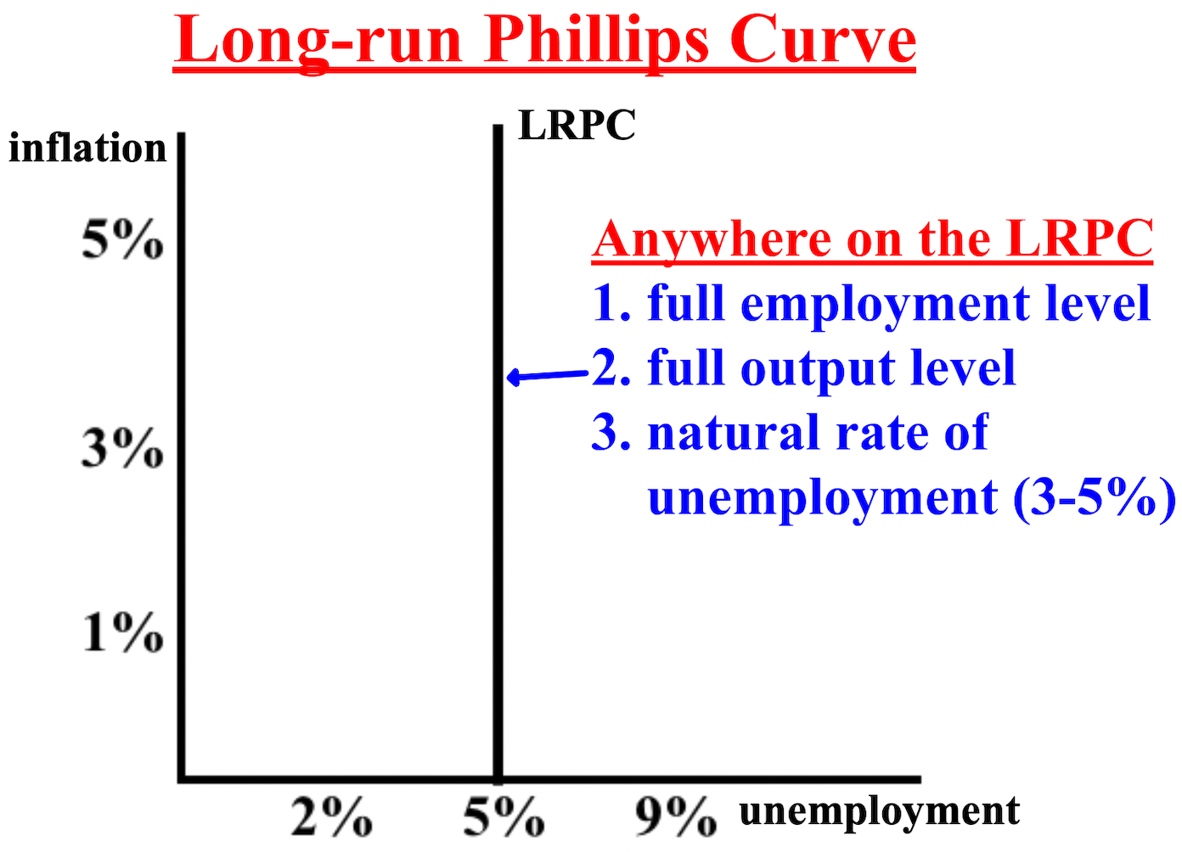
The short and long-run (SR) Phillips curves can also be combined to show the status of an economy.

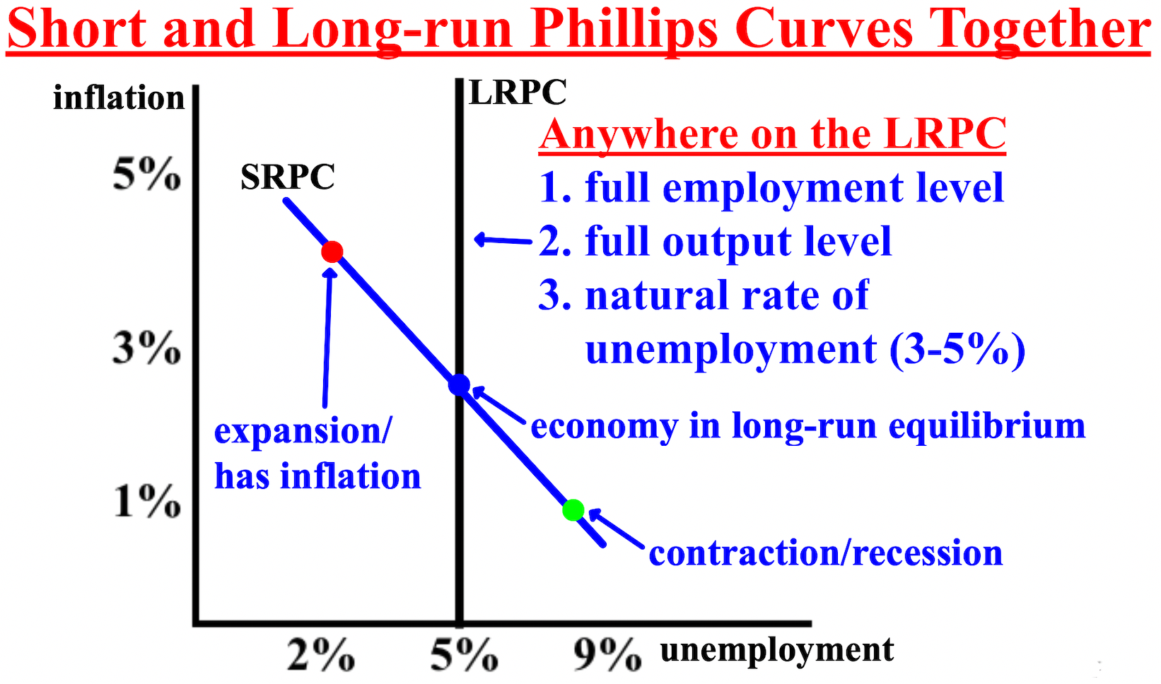

To understand how a bank functions, it is necessary to look at its balance sheet or T-account, which shows a bank's assets and liabilities. An asset is something of value owned by a person or firm. A liability is something of value that a person or firm owes to someone else. The only difference between the graph on the right compared to the left is that the right breaks down exactly what the reserves consist of (required and excess).
Loans are the money that the bank has and makes money from by loaning it. Reserves or the reserve requirement or reserve ratio (usually about 10%) are the percent of deposits that banks must hold in reserve at the FED and cannot loan out. Demand deposits are funds that are deposited into a bank account from which money can be withdrawn "on demand;" (liquidity).

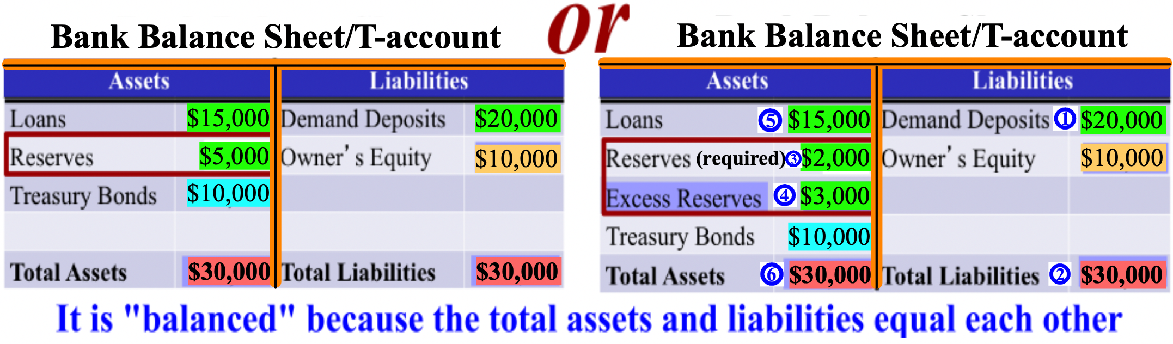

Loans, reserves, and demand deposits are directly related because the amount of loans a bank can give out and the reserves it must hold are directly related to the demand deposits it has. Of the $20,000 in demand deposits in the bank below, $5,000 is being kept in reserve while the other $15,000 can be loaned out. As you can see on the right T-account, the bank's required reserve/reserve ratio is 1 or 10% ($2,000 of $20,000 is 10%). The extra $3,000 that the bank is keeping in reserves is extra and is called excess reserves.
When money is deposited in a bank, the money is added directly to demand deposits. If $10,000 is deposited into the bank, demand deposits would become $30,000 and total liabilities would become $40,000. The required reserve would be recalculated at 10%, and the new required reserve would be $3,000. Because required reserves only equal $2,000, more must be added. If there are excess reserves, money would be taken
first from there and excess reserves would become $2,000. The $10,000 deposit would be added to the available loans. Loans would now equal $25,000 and total assets $40,000
But, if there are no excess reserves, the loans would originally equal $18,000 ($15,000 + $3,000) and the money would be taken from that amount. The amount of loans available would decrease, in this case from $18,000 to $17,000 because $1,000 would have to be transferred from loans to required reserves. The $10,000 deposit would be added to the available loans. Loans would now equal $27,000 and total assets $40,000
If $5,000 is withdrawn from this bank, the $5,000 would be withdrawn from demand deposits and demand deposits would become $15,000 and total liabilities $25,000. The required reserve would be recalculated at 10% and would become $1,500. The extra $500 in required reserves would be added to the excess reserves and
become $3,500. But, the $3,500 in excess reserves would become $0 as assets are withdrawn and the remaining $1,500 needed would be deducted from the available loans and become $13,500. Total assets now equal $25,000.
Bonds are secured loans, like an IOU. Interest rates and bond prices are inversely related, so as interest rates increase, the value of a bond decreases. As interest rates decrease, the value of a bond increases.

