Paper 2B- Good examples of thesis and history
1.
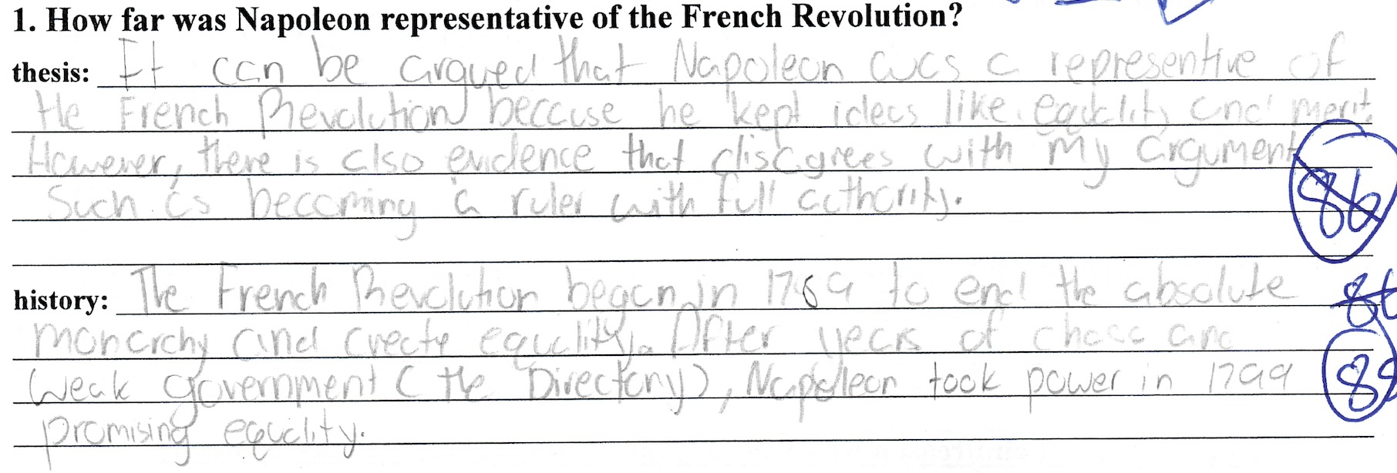

2.
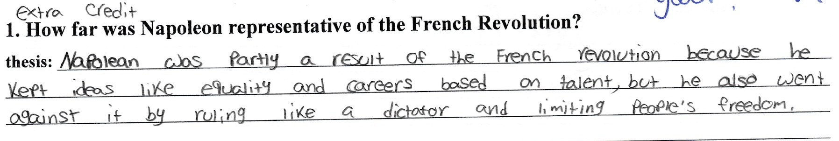

3.
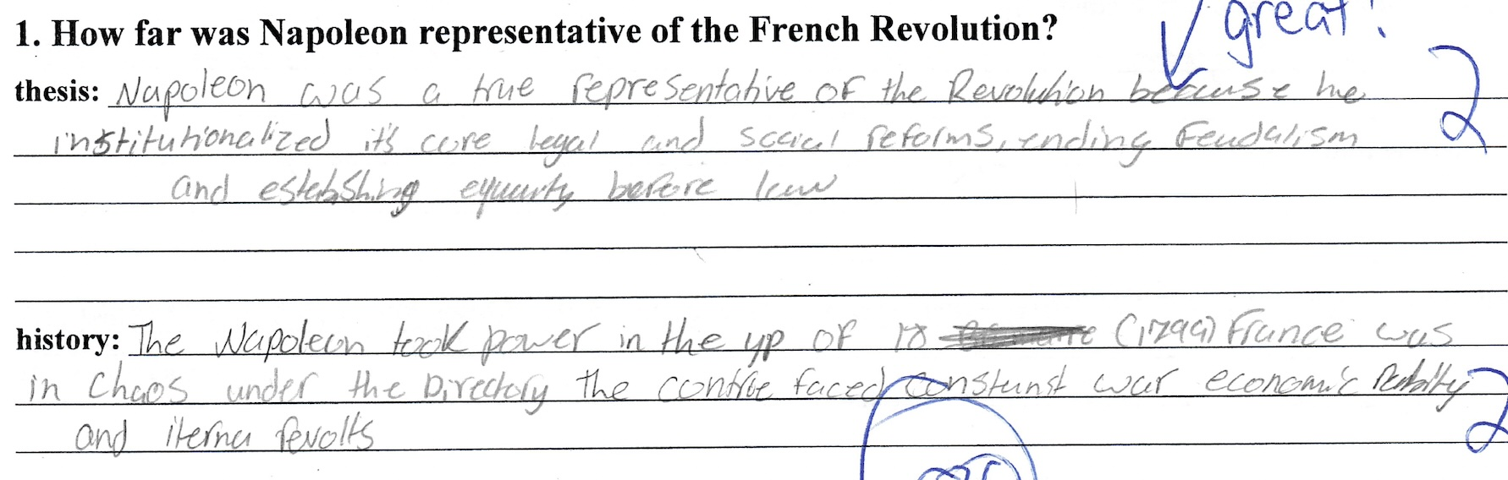

Paper 2B- Good example of an argument
1.
