AP Microeconomics Mr. Sadow Chapter 8 Extra Credit #5 of 5
Show your work and put the answer on the line or circle the correct letter. Name: ______________________________
Include specifics, like %, $, and amounts (80% or $10 million). Period: ____
***This is due on or before the day of the test review
A Firm and its Generic Cost Curves

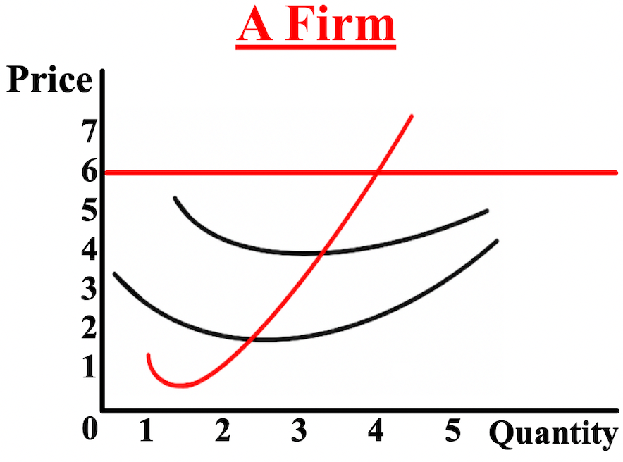

1. Label: MC/S, MR/D/AR/P/MB, ATC, AVC, and
SO/APE/PMP.

2. What is the equilibrium quantity (Qe)? __________

3. What is the profit-maximizing quantity?__________

4. What is the equilibrium price (Pe)? $__________

5. What is the market price? $__________

6. Is this firm earning a profit, loss, etc.? ___________

7. How much is the total revenue (TR)? $__________

8. How much are the total costs (TC)? $__________

9. How much is the profit or loss? $__________

10. Shade in the profit or loss.

11. Label the producer surplus (PS).

12. Is there any consumer surplus (CS)? ___________

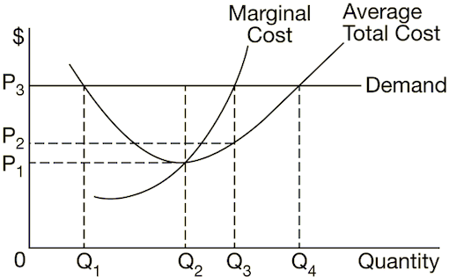
1. How many units of output should a firm with the cost and
demand curves shown above produce to maximize profit?
(A) 0
(B) Q3
(C) Q2
(D) Q4
(E) Q1

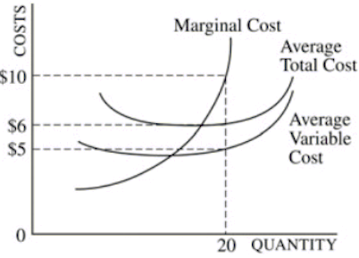
2. The graph above shows the cost curves for a competitive firm
that produces 20 units of output. What are the total cost and
the total fixed cost of producing 20 units of output?
(A) total cost= $10 , total fixed cost= $0
(B) total cost= $200 , total fixed cost= $100
(C) total cost= $200, total fixed cost= $20
(D) total cost= $120, total fixed cost= $100
(E) total cost= $120, total fixed cost= $20
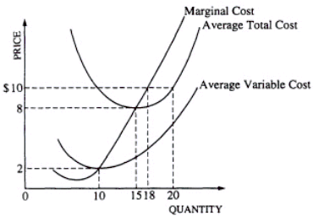
3. If the price of the output increases from $8 to $10, the
profit-maximizing firm will
(A) produce 15 units
(B) increase output to 18 units
(C) continue producing 15 units
(D) decrease output to 10 units
(E) increase output to 20 units

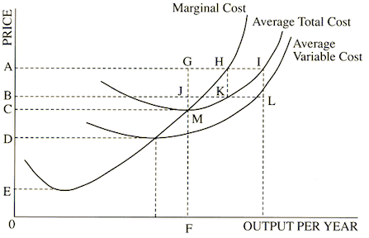

4. At the price A, economic profits are
(A) ABLI
(B) C0FM
(C) ACMG
(D) ABKH
(E) ABJG

