AP Microeconomics Mr. Sadow Chapter 8 Extra Credit #3 of 5
Show your work and put the answer on the line or circle the correct letter. Name: ______________________________
Include specifics, like %, $, and amounts (80% or $10 million). Period: ____
***This is due on or before the day of the test review

Deadweight Loss (DWL) and Tax Revenue (not a tariff)

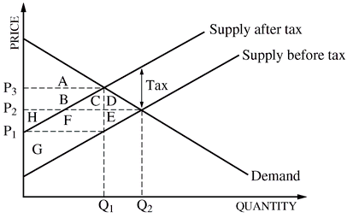
(use the letters above to answer the questions)

1. What is the equilibrium quantity (Qe)?__________

2. What is the equilibrium price (Pe)? __________

3. Label Me/SO/APE/PMP.
4. What’s the original consumer surplus (CS)? ___________

5. What’s the original producer surplus (PS)? ___________

After the tax…
6. What is the equilibrium quantity (Qe)? ___________

7. What is the equilibrium price (Pe)? ___________

8. What is the consumer surplus CS? ___________

9. What is the producer surplus PS? ___________

10. What is the deadweight loss (DWL). ___________

11. What is the tax revenue? ___________

1. After the government imposed a $0.20 per gallon tax on gas,
the price of a gallon of gasoline increased from $1.00 to
$1.15. Which of the following statements is true?
(A) Consumers and producers share the tax burden equally.
(B) There is no tax burden, since gasoline is a normal good.
(C) Consumers bear most, but not all, of the tax burden.
(D) Producers bear the entire burden of the tax.
(E) Consumers bear the entire burden of the tax.

2. The supply of corn is relatively price inelastic while the
demand is relatively price elastic. If the government imposes
a per-unit excise tax on corn, the tax will fall
(A) more on buyers than on sellers
(B) entirely on buyers
(C) entirely on sellers
(D) more on sellers than on buyers
(E) equally on both buyers and sellers

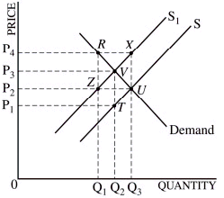
3. In the graph above, S is the original supply curve, and S₁ is the supply curve including an excise tax. The area representing the tax revenue (not a tariff) to the government is
(A) P2, P4, RZ
(B) P2, P4, XU
(C) P1, P3, VT
(D) P2, UQ3, 0
(E) P3, VQ2, 0

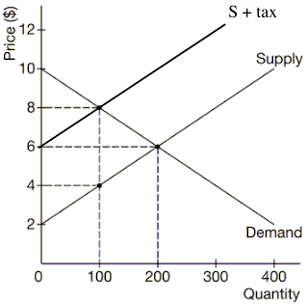
4. Assume that the government imposes a $4 per-unit tax on
a good in the market above. What is the price paid by
buyers, the after-tax price received by sellers, and the
deadweight loss?
(A) buyers: $8, sellers: $4, and deadweight loss: $200
(B) buyers: $8, sellers: $6, and deadweight loss: $100
(C) buyers: $6, sellers: $6, and deadweight loss: $0
(D) buyers: $4, sellers: $8, and deadweight loss: $100
(E) buyers: $4, sellers: $8, and deadweight loss: $200

5. After the $4 per-unit tax, the consumer surplus, producer
surplus, and deadweight loss are
(A) CS: $100, PS: $100, and deadweight loss: $200
(B) CS: $100, PS: $300, and deadweight loss: $100
(C) CS: $300, PS: $250, and deadweight loss: $250
(D) CS: $400, PS: $100, and deadweight loss: $350
(E) CS: $150, PS: $200, and deadweight loss: $225

