AP Microeconomics Mr. Sadow Chapter 8 Extra Credit #2 of 5
Show your work and put the answer on the line or circle the correct letter. Name: ______________________________
Include specifics, like %, $, and amounts (80% or $10 million). Period: ____
***This is due on or before the day of the test review

Deadweight Loss (DWL) and Consumer & Producer Surplus (CS & PS)

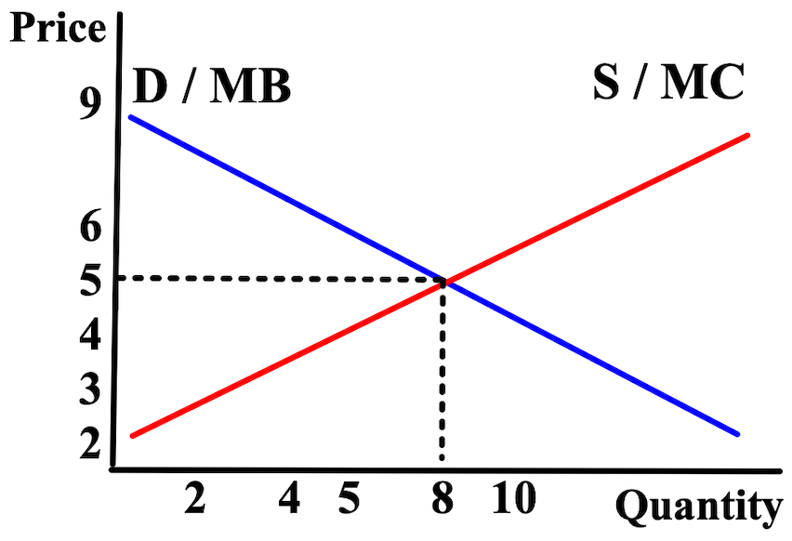

1. What is the equilibrium quantity (Qe)? $__________

2. What is the equilibrium price (Pe)? $__________

3. Label Me/SO/APE/PMP.

4. Calculate the consumer surplus (CS). $__________

5. Calculate the producer surplus (PS). $__________

6. Calculate the total surplus. $__________

Create a binding price ceiling at $4
7. Calculate the deadweight loss (DWL). $__________

8. Label the deadweight loss (DWL).

9. Label the consumer & producer surplus (CS & PS).

10. Shade in the change in consumer surplus (CS).

1. If the government imposes a per-unit tax on personal
computers, consumer surplus in the personal computer
market will
(A) increase, because personal computer manufacturers will
pass the tax on to consumers
(B) decrease, because there will be more personal computers
on the market
(C) decrease, because the price paid by consumers for
personal computers will have increased
(D) increase, because consumers will buy more imported
personal computers

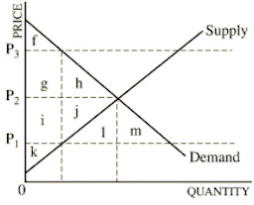
2. At market equilibrium (Me), the locations of the consumer
surplus and producer surplus are:
(A) CS at f and PS at k
(B) CS at g+h and PS at i+j
(C) CS at f+g+h and PS at i+j+k
(D) CS at f+g+h and PS at i+j+l+m

3. If a price ceiling is set at P1, the locations of the consumer
surplus and deadweight loss are:
(A) CS at f and DWL at k
(B) CS at g+i and DWL at h+j
(C) CS at f+g+h and DWL at i+j+k
(D) CS at f+g+i and DWL at h+j
(E) there is no deadweight loss

4. If a price floor is set at P3, the locations of the consumer
surplus and deadweight loss are:
(A) CS at f and DWL at h+j
(B) CS at g+i and DWL at h+j
(C) CS at f+g+h and DWL at i+j+k
(D) CS at f+g+i and DWL at h+j
(E) there is no deadweight loss

5. If a price ceiling is set at P3, the locations of the consumer
surplus and deadweight loss are:
(A) CS at f and PS at k
(B) CS at g+h and PS at i+j
(C) CS at f+g+h and PS at i+j+k
(D) CS at f+g+h and PS at i+j+l+m
(E) there is no deadweight loss

