AP Microeconomics Mr. Sadow Chapter 8 Extra Credit #1 of 5
Show your work and put the answer on the line or circle the correct letter. Name: ______________________________
Include specifics, like %, $, and amounts (80% or $10 million). Period: ____
***This is due on or before the day of the test review
Foreign Trade and Tariffs

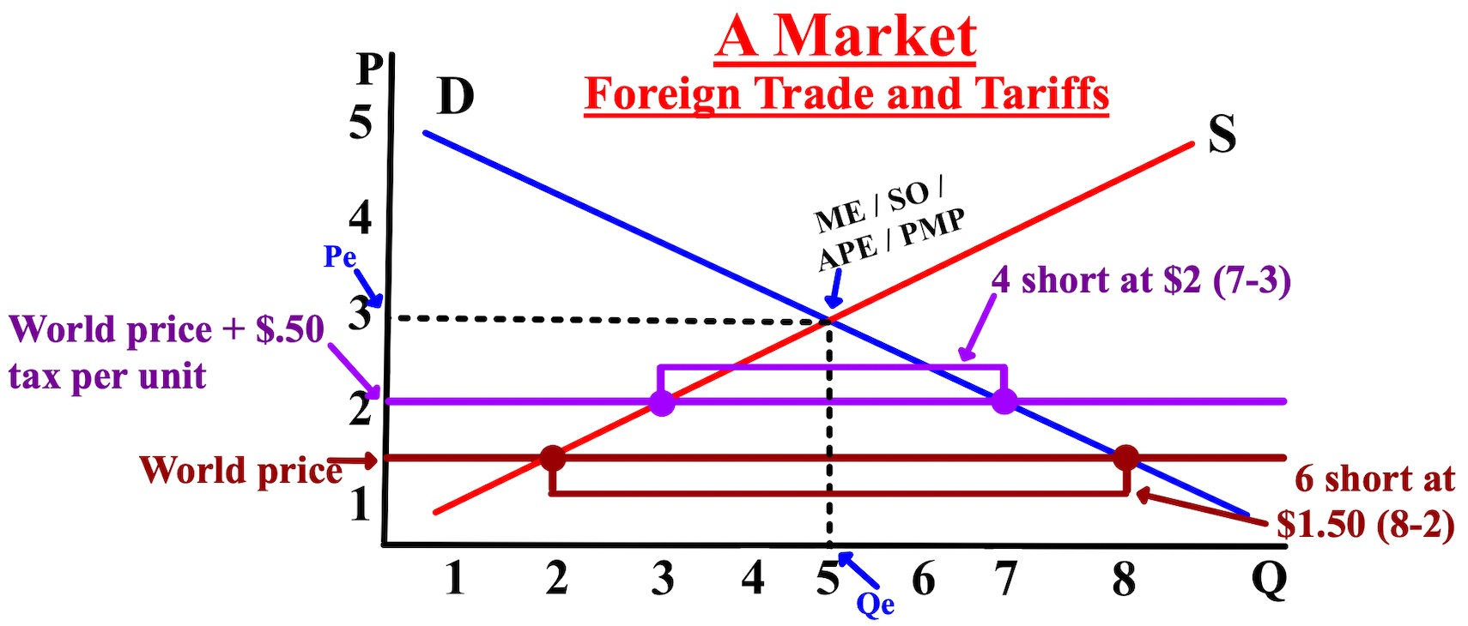

1. What is the equilibrium quantity (Qe)?__________

2. What is the equilibrium price (Pe)? $__________

3. At the world price, what is the
price (P)? $__________

4. At the world price + tax, what is
the price (P)? $__________

5. If the tariff was $10 per unit, what
is the tax revenue at the world price?$__________

6. If the tariff was $50 per unit, what
is the tax revenue at the world
price + tax? $__________

7. At the world price, what is the
quantity supplied (Qs)? __________

8. At the world price, what is the
quantity demanded (Qd)? __________

1. Assuming a downward-sloping demand curve and an upward
sloping supply curve, which of the following will occur as a result
of an increase in the sales tax on a good?
(A) Supply will increase.
(B) Demand will increase.
(C) Quantity demanded will decrease.
(D) Quantity supplied will increase.
(E) The price paid by consumers will decrease.

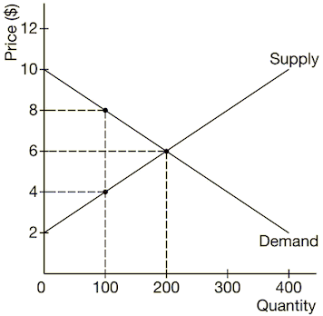
2. At $4, if the government sets a $4 per-unit tax on imported goods,
what would be the government’s tax revenue?
(A) $100
(B) $600
(C) $400
(D) $800
(E) $1,200

3. If the government imposes a tariff on imports of cheese,
the price and quantity of imported cheese will most
likely change in which of the following ways?
(A) price decreases, quantity decreases
(B) price decreases, quantity increases
(C) price increases, quantity doesn’t change
(D) price increases, quantity increases
(E) price increases, quantity decreases

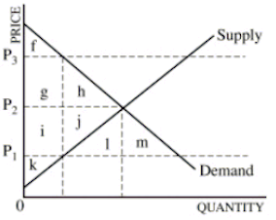
4. Country Z is both a producer and an importer of green
tea. If country Z imposes a tariff on imports of green
tea, which of the following will occur in the domestic
market of green tea?
(A) Domestic production will increase.
(B) Consumer surplus will increase.
(C) Total consumption of green tea will increase.
(D) Producer surplus will decrease.
(E) The price paid by domestic consumers will decrease.

