AP Microeconomics Mr. Sadow Chapter 7 Extra Credit #8 of 9
Show your work and put the answer on the line or circle the correct letter. Name: _______________________
Include specifics, like %, $, and amounts (80% or $10 million) Period: ____
***This is due on or before the day of the test review

Producer Surplus

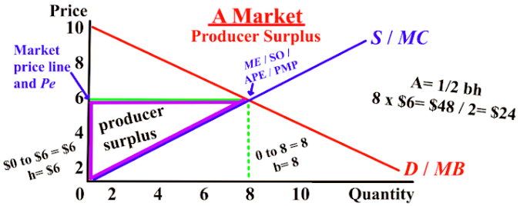

1. What is the equilibrium quantity (Qe) __________

2. What is the equilibrium price (Pe) __________

3. What is the producer surplus (PS)? __________

4. What is the PS if the equilibrium
quantity (Qe) is 2 instead of 8? __________

5. What is the PS if the equilibrium
quantity (Qe) is 9 instead of 8? __________

6. What is the PS if the equilibrium
price (Pe) is 4 instead of 6? __________

7. What is the PS if the equilibrium
price (Pe) is 5 instead of 6? __________

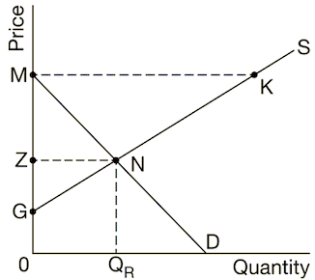
1. Based on the graph above, the producer surplus is shown by
(A) GMK
(B) GMN
(C) GZN
(D) MNK
(E) ZMN

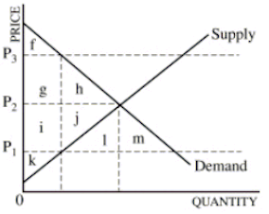
2. When the market is in equilibrium, the total economic
surplus is equal to area
(A) f + k
(B) f + g + i + k
(C) f + g + h + i + j + k
(D) g + h + i + j
(E) f + g + h + i + j + k + l + m

