AP Microeconomics Mr. Sadow Chapter 7 Extra Credit #5 of 9
Show your work and put the answer on the line or circle the correct letter. Name: ______________________________
Include specifics, like %, $, and amounts (80% or $10 million). Period: ____
***This is due on or before the day of the test review
Consumer Surplus

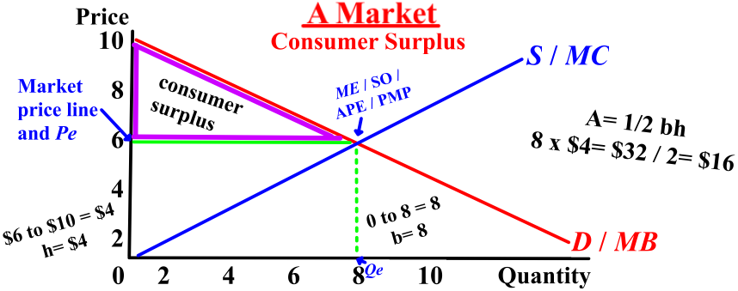

1. What is the equilibrium quantity (Qe) __________

2. What is the equilibrium price (Pe) __________

3. What is the consumer surplus (CS)? __________

4. What is the CS if the equilibrium
quantity (Qe) is 4 instead of 8? __________

5. What is the CS if the equilibrium
quantity (Qe) is 7 instead of 8? __________

6. What is the CS if the equilibrium
price (Pe) is 2 instead of 6? __________

7. What is the CS if the equilibrium
price (Pe) is 7 instead of 6? __________

1. The economic concept of total consumer surplus refers to which?
(A) The difference between the quantity of a good or service that people
purchase and the amount that they actually consume
(B) The sum of the differences between the prices that consumers are
willing to pay for a good or service and the price they actually pay
(C) Overproduction of goods and services relative to the socially optimal
(D) The sum of the differences between the prices that consumers are
willing to pay for a good or service and the minimum prices that sellers
must receive to offer that quantity
(E) The difference between the quantity demanded and the quantity
supplied of a product at a given price

2. Which of the following illustrates the concept of consumer surplus?
(A) An individual who is willing to accept a job at $7.50 per hour is
offered $7.00 per hour.
(B) A thirsty athlete pays $0.85 for a cold drink when she would
have gladly paid $1.50 for the drink.
(C) An individual pays the sale price of $15.00 for the same shirt what the
individual refused to purchase earlier at $18.00.
(D) An individual finds that the price of artichokes, a food she dislikes, has
been reduced by 50 percent.
(E) A wood-carver has a marginal cost of $5.00 for a unit of output, but
sells that unit at $6.00.

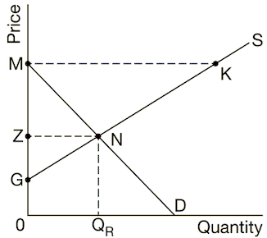
3. Based on the graph above, the consumer surplus is shown by
(A) GMK
(B) GMN
(C) GZN
(D) MNK
(E) ZMN

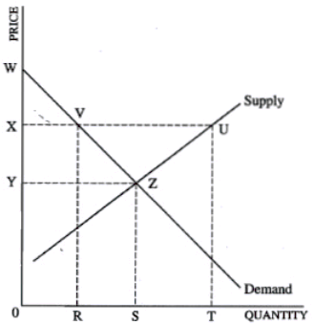
4. The consumer surplus above is the area of
(A) WYZ
(B) UVZ
(C) RVUT
(D) XVZY
(E) 0YZS

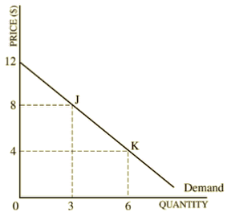
5. Given the demand curve above, if price decreases from
$8 to $4 per unit, total consumer surplus will
(A) increase by $4
(B) increase by $8
(C) increase by $18
(D) increase by $12
(E) remain constant at $24

