AP Microeconomics Mr. Sadow Chapter 7 Extra Credit #4 of 9
Show your work and put the answer on the line or circle the correct letter. Name: ______________________________
Include specifics, like %, $, and amounts (80% or $10 million). Period: ____
***This is due on or before the day of the test review

Utility, Marginal Utility / Marginal Benefit

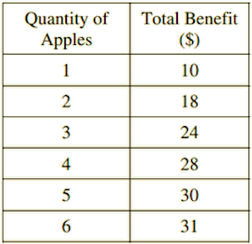

1. What is the utility or total utility of 0 apples? __________

2. What is the utility or total utility of 1 apple? __________

3. What is the utility or total utility of 3 apples? __________

4. What is the utility or total utility of 6 apples? __________

5. What is the marginal utility or marginal benefit of the 2nd apple? __________

6. What is the marginal utility or marginal benefit of the 4th apple? __________

7. What is the marginal utility or marginal benefit of the 6th apple? __________

1. According to the law of diminishing marginal utility,
which of the following is true?
(A) Total satisfaction decreases as more units of a good are
consumed.
(B) The additional satisfaction received from consuming
extra units of a good decreases as consumption of the
good decreases.
(C) The additional satisfaction received from consuming
extra units of a good decreases as consumption of the
good increases.
(D) The additional satisfaction received from consuming
extra units of a good increases as consumption of the
good increases.
(E) When marginal utility is decreasing, total utility is
decreasing.

2. According to the theory of consumer behavior, which of
the following decreases first as additional units of a
product are consumed?
(A) Total utility
(B) Average utility
(C) Marginal physical product
(D) Marginal utility
(E) Total physical product

3. If a good is available free of charge, an individual will
consume it until
(A) total utility is zero
(B) average utility is zero
(C) marginal utility is zero
(D) marginal utility equals average utility
(E) marginal utility equals total utility

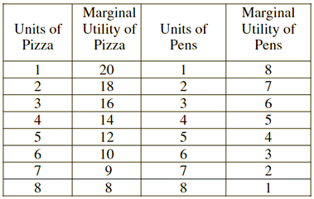
4. If the student purchases 2 units of pizza and 2 units of
pens, the student’s total utility will be
(A) 53 utils
(B) 25 utils
(C) 28 utils
(D) 50 utils
(E) 4 utils.

5. The demand curve for a normal good slopes down for
which of the following reasons?
- An increase in the price of the good induces consumers to purchase substitute products.
- An increase in the price of the goods reduces consumers' purchasing power.
- An increase in the price of the good increases consumers' utility from consuming that good.
(A) I only
(B) II only
(C) I and II only
(D) III only
(E) I and III only

