AP Microeconomics Mr. Sadow Chapter 7 Extra Credit #3 of 9
Show your work and put the answer on the line or circle the correct letter. Name: _______________________
Include specifics, like %, $, and amounts (80% or $10 million). Period: ____
***This is due on or before the day of the test review

Income Elasticity of Demand (YED)

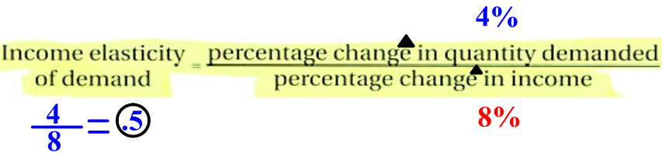



1. Qd= from 100 to 103 & income= from $1 to $.94 YED= ___________ the good is= _____________

2. Qd= from 100 to 150 & income= from $1 to $1.05 YED= ___________ the good is= _____________

3. Qd= from 50 to 40 & income= from $1 to $1.05 YED= ___________ the good is= _____________

4. Qd= from 80 to 100 & income= from $2 to $3 YED= ___________ the good is= _____________

5. YED= -1 & Qd = from 50 to 60 % change in income= ___________ the goods is= ____________

1. If the income elasticity of demand for good X is negative
and the cross-price elasticity of demand between good X and
good Y is negative, which of the following must be true of
good X?
(A) X is a normal good and is a substitute for Y.
(B) X is a normal good and is a complement to Y.
(C) X is an inferior good and is a complement to Y.
(D) X is an inferior good and is a substitute for Y.
(E) X is a normal good and Y is an inferior good.

2. Assume the income elasticity of demand for good Z equals
−5.0. Which of the following is true?
(A) An increase in income will lead to a decrease in demand.
(B) Good Z must have an inelastic demand.
(C) Good Z is a normal good.
(D) An increase in income will lead to an increase in demand.
(E) The income effect of a price increase will be a decrease in
quantity demanded at every price.

3. Which of the following statements relating to income
elasticity is true?
(A) A positive value for the income elasticity coefficient
indicates an inferior good.
(B) With an income elasticity coefficient of 5, a 10 percent
increase in income will lead to a 50 percent increase in
the quantity demanded of the good.
(C) With an income elasticity coefficient of 0.6, the demand is
inelastic and the good is an inferior good.
(D) If good X and good Y have negative income elasticities,
then both goods are substitutes.
(E) With an income elasticity coefficient of −1.2, a 10 percent
increase in income will lead to a 12 percent decrease in
the price of the good.

