AP Microeconomics Mr. Sadow Chapter 7 Extra Credit #1 of 9
Show your work and put the answer on the line or circle the correct letter. Name: ______________________________
Include specifics, like %, $, and amounts (80% or $10 million). Period: ____
***This is due on or before the day of the test review

Cross-Price Elasticity (CPE)
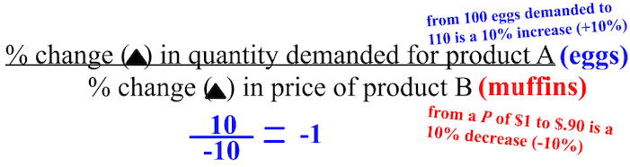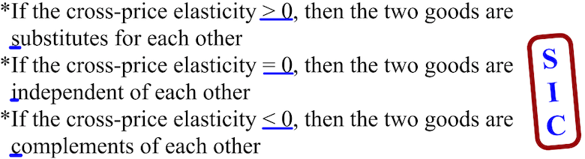

1. product A= Qd from 100 to 80 & product B= P from $1 to $.80 CPE= ________ the two goods are= _________

2. product A= Qd from 50 to 40 & product B= P from $1 to $.95 CPE= ________ the two goods are= _________

3. product A= Qd from 50 to 75 & product B= P from $2 to $1.50 CPE= ________ the two goods are= _________

4. product A= Qd from 80 to 100 & product B= P from $2 to $3 CPE= ________ the two goods are= _________

5. CPE= -1 & product B= P from $0.50 to $0.75 change in Qd= ________ the two goods are= ________

6. CPE= 0 & product A= Qd from 50 to 75 change in P = ________ the two goods are= _________

1. The cross-price elasticity of demand between goods J and K
is −3. A 20 percent decrease in the price of good K will
result in a
(A) 3 percent decrease in the quantity demanded of good K
(B) 15 percent decrease in the quantity demanded of good
(C) 60 percent increase in the quantity demanded of good J
(D) 12 percent increase in the quantity demanded of good J
(E) 6 percent increase in the quantity demanded of good J

2. If a 10 percent increase in the price of good X results in a 20
percent decrease in the quantity of good Y demanded, which
of the following is true?
(A) Good X and good Y are complementary goods, and the
cross-price elasticity is −2 .
(B) Good X and good Y are substitute goods, and the income
elasticity is +2 .
(C) Good X and good Y are complementary goods, and the
cross-price elasticity is −0.5 .
(D) Good X and good Y are normal goods, and the income
elasticity is +2 .
(E) Good X and good Y are substitute goods, and the cross
price elasticity is −2 .
3. The cross-price elasticity of demand between good X and
good Z measures the percentage change in the quantity
demanded of good X in response to a percentage change in
(A) income
(B) the price of good Z
(C) quantity demanded
(D) total expenditures on good Z
(E) the total revenue

4. Following a decrease in the supply of oranges, the price of
orange juice increased by 20 percent, which resulted in a 10
percent increase in the quantity of apple juice consumed.
This implies that the cross elasticity of demand between
orange juice and apple juice is
(A) It can indicate if a good is a necessity or a luxury.
(B) It is always negative because demand curves are
downward sloping.
(C) It is close to one if the two goods are closely related.
(D) It is greater than zero for two goods that are substitutes.
(E) It is close to zero if the two goods are closely related.

