Chapter 6- Income, Consumption (Spending), Saving, the Spending Multiplier, Money Market, Loanable Funds Market, and the Phillips Curve
This chapter is about consumers' disposable income (the income that households receive in wages, dividends, and interest payments plus transfers they may get from the government minus any taxes they pay to the government). This chapter is also about how likely it is for consumers to spend or save their disposable income.
A concept related to the consumption function is the marginal propensity to consume (MPC). The MPC measures how much people consume (spend) rather than save when there is a change in income. The MPC is always between 0 and 1, but hardly ever 0 or 1. The term propensity refers to "the inclination to."

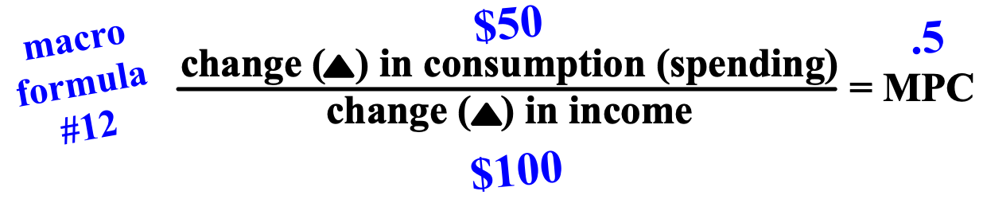

Another concept related to the consumption function is the marginal propensity to save (MPS). The marginal propensity to save measures how much people save rather than consume when there is a change in income. Just like the MPC, the MPS is always between 0 and 1, but hardly ever 0 or 1. Together, the MPC and MPS always equals 1. The reason for this is that there are only really two things that you can do with your money. You can spend it or you can save it, but there is no third option.
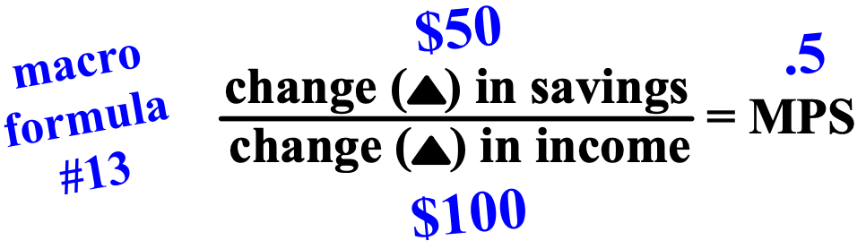

A concept directly related to the marginal propensity to consume or save is the spending multiplier. Since aggregate spending is always either increasing or decreasing in an economy, the impact on GDP/AD can be calculated. Just like the money multiplier, there is a positive or negative ripple on the economy.



The money market is where short term loans are traded. The money market focuses on increasing and decreasing the economy's total money supply. The money market is where all of the money in an economy comes from, but only the government (G) gets its money from it.

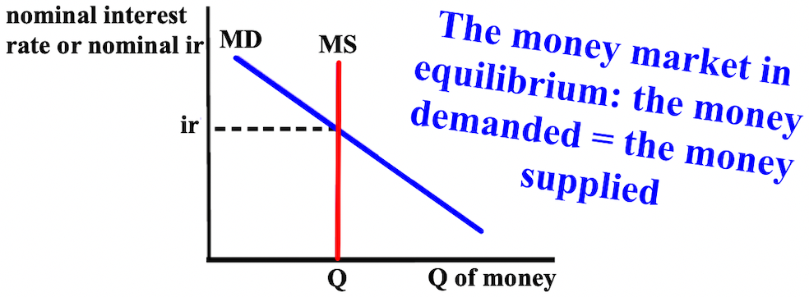

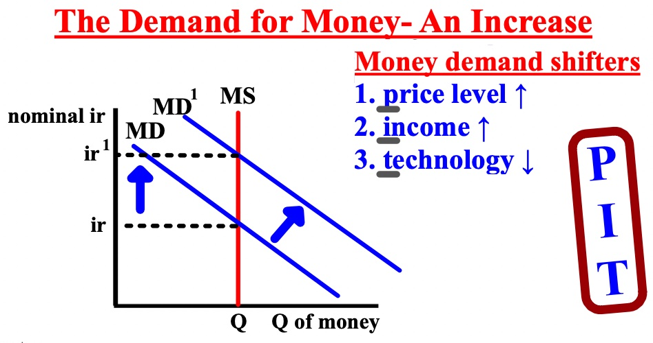

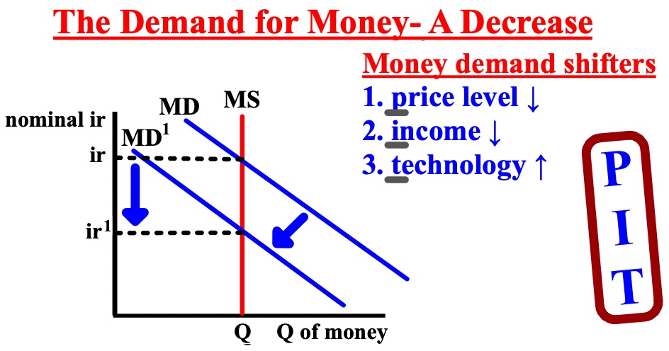
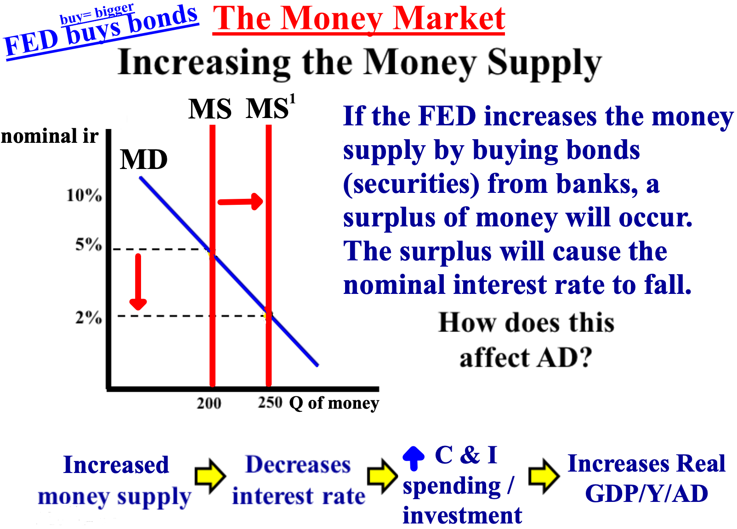

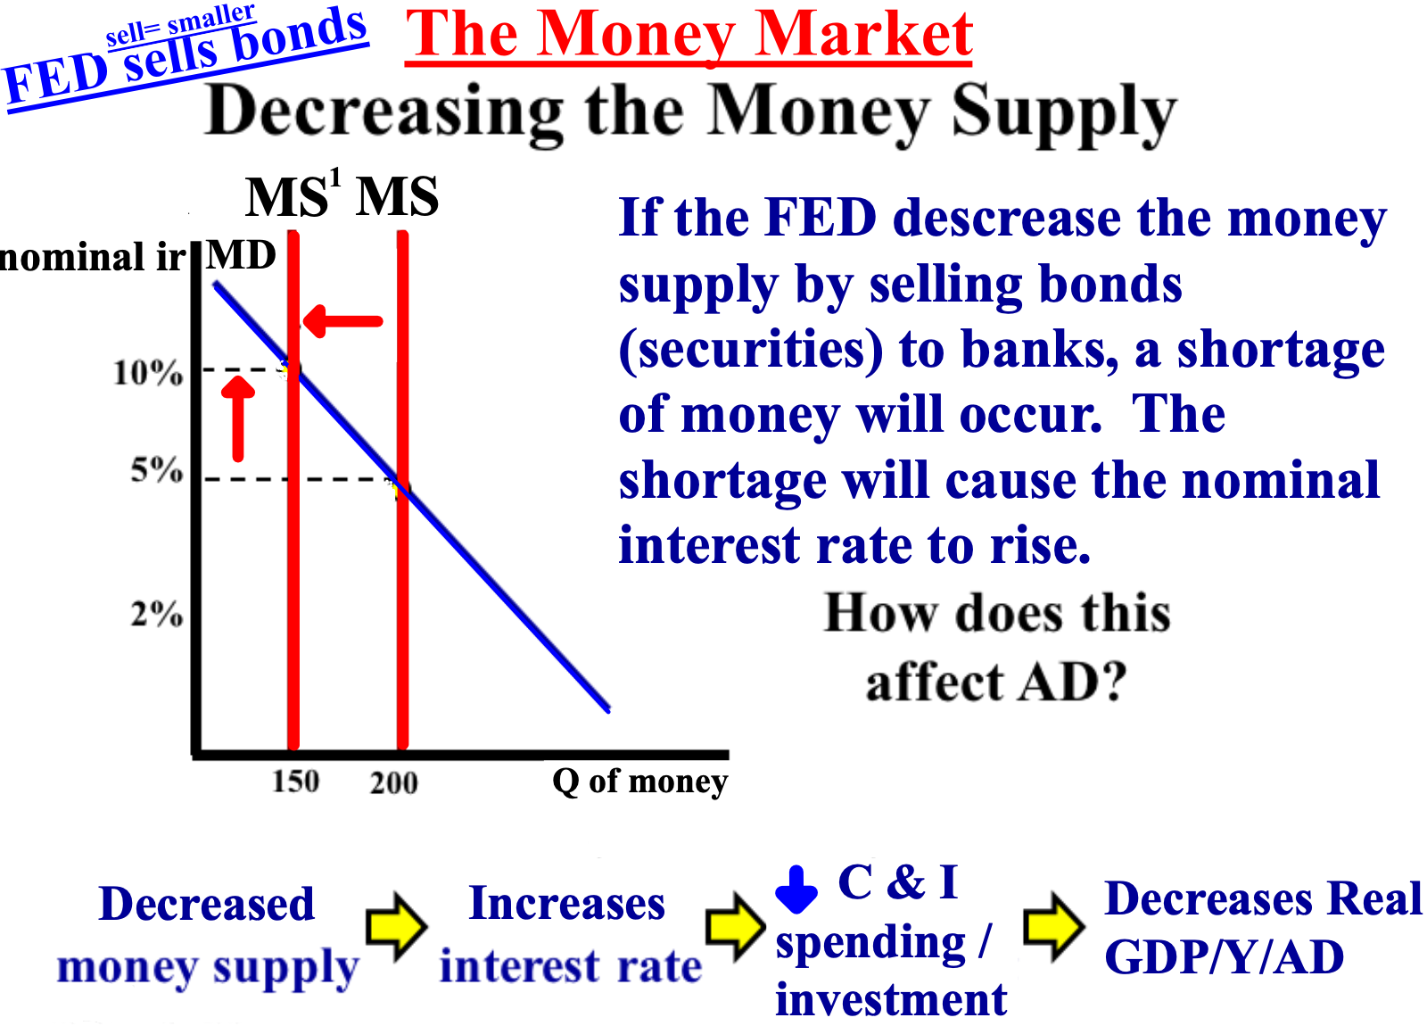
The loanable funds market is controlled by the money market and is where the private sector (C and I) gets their loans. The loanable funds market focuses on the supply and demand of loans. If interest rates are high, C and I will spend/invest/borrow less. If interest rates are low, C and I will spend/invest/borrow more.

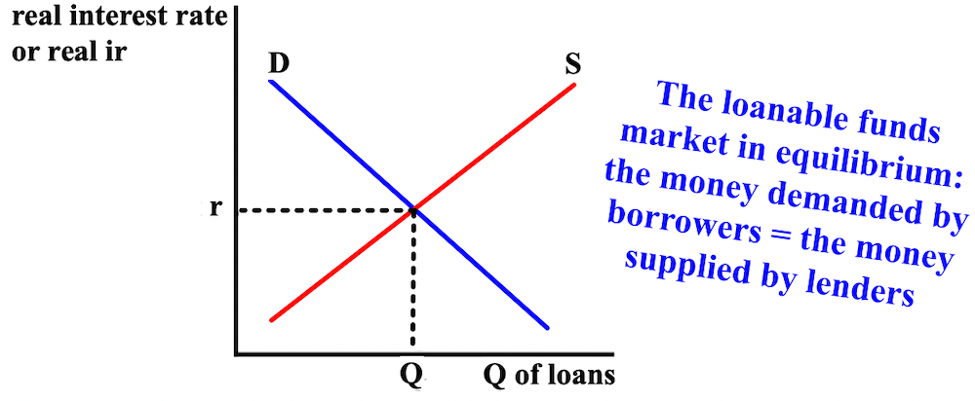

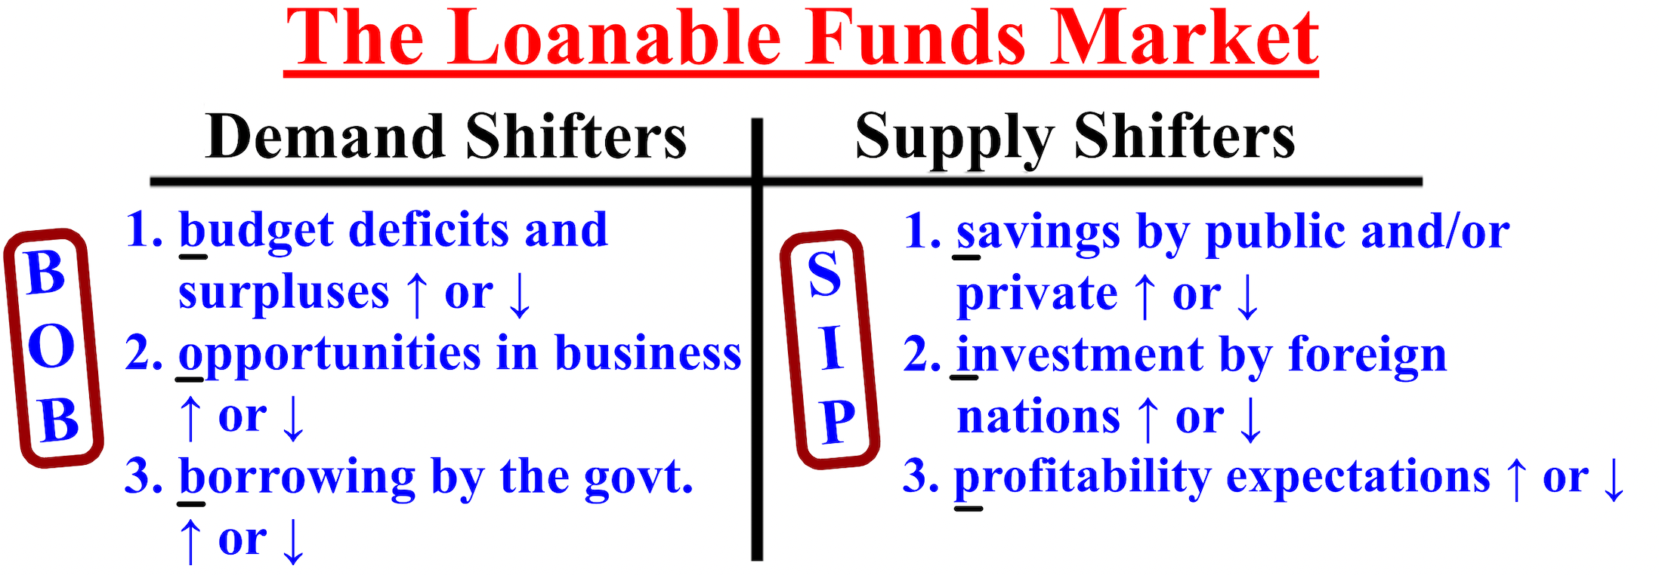

To show the inverse relationship between the inflation rate and unemployment and its overall impact on real GDP (Y), we use the short-run Phillips curve (SRPC). The short-run Phillips curve shows the tradeoff between inflation and unemployment. Notice that the higher the inflation rate, the lower the unemployment rate is. This occurs because inflation/price levels increase when the economy is in expansion (when real GDP is greater than potential GDP. As firms produce to meet the increased demand, more labor is needed.

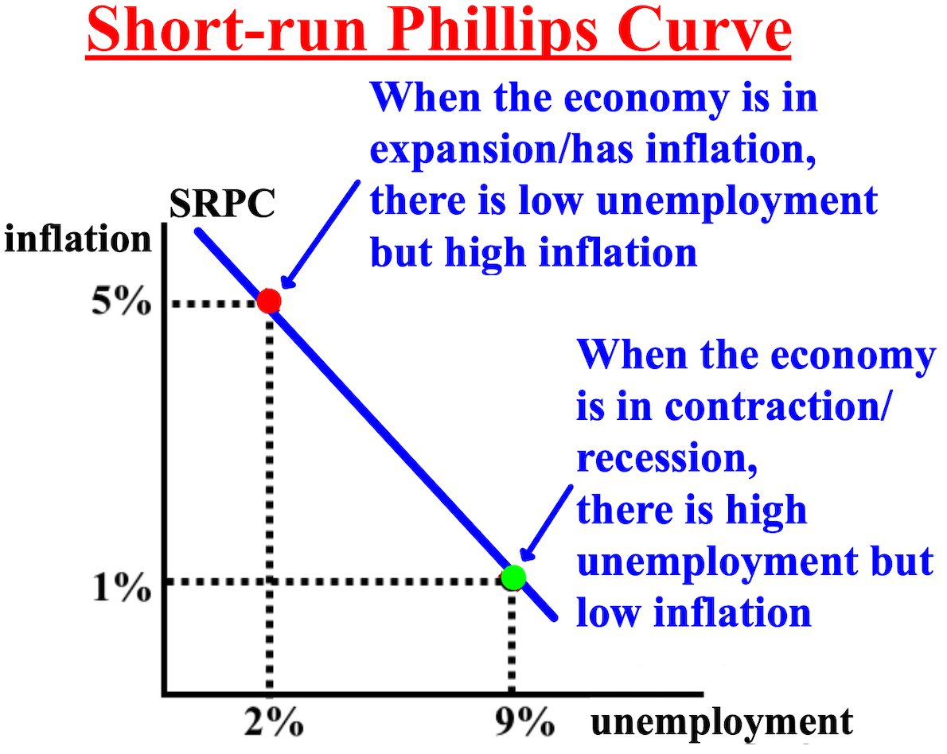

There is also a long-run Phillips curve (LRPC) shows that there is no tradeoff between inflation and unemployment in the long-run. Notice that even when the inflation rate increases, unemployment remains the same
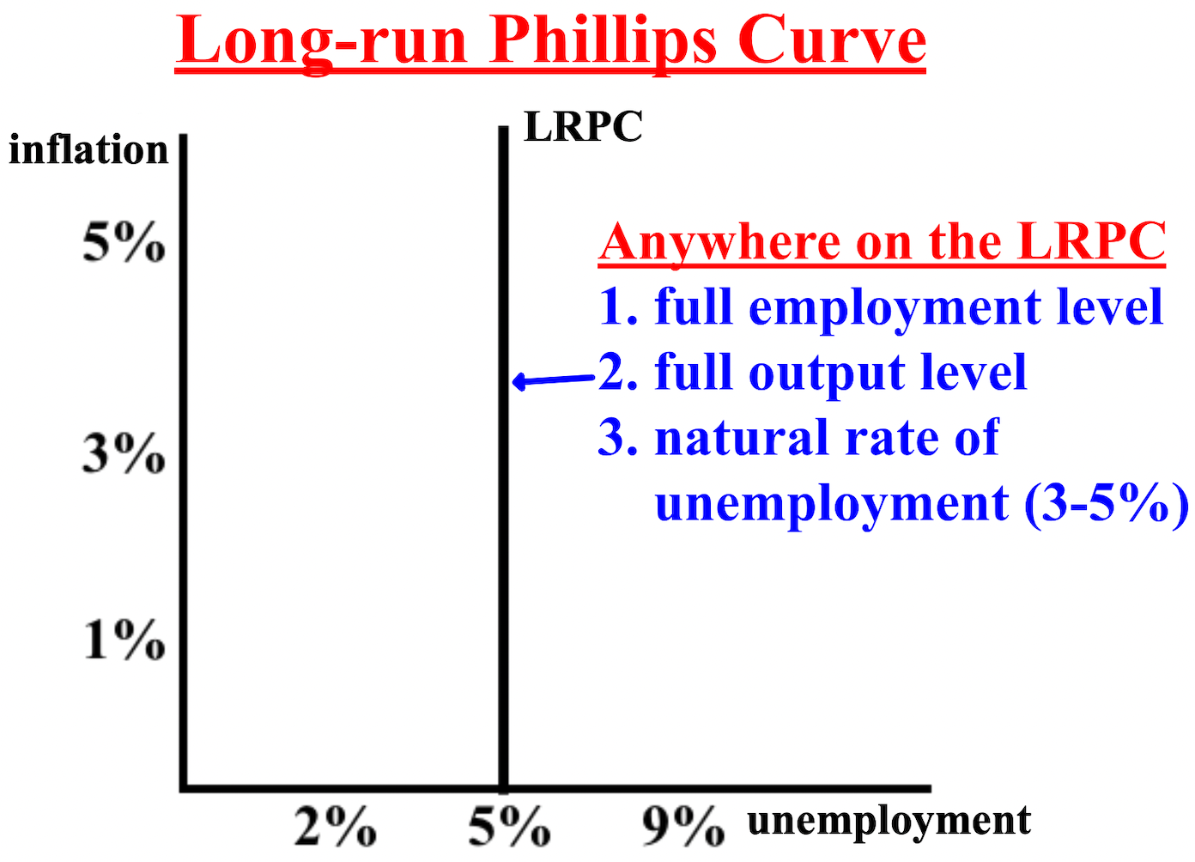
The short and long-run (SR) Phillips curves can also be combined to show the status of an economy.

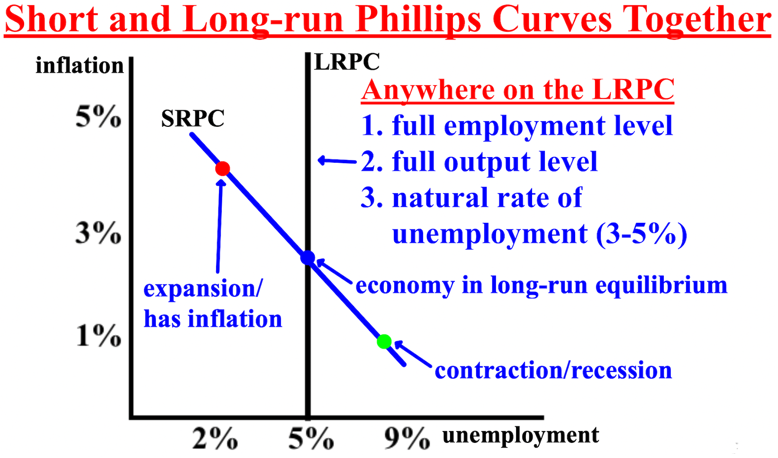

To understand how a bank functions, it is necessary to look at its balance sheet or T-account, which shows a bank's assets and liabilities. An asset is something of value owned by a person or firm. A liability is something of value that a person or firm owes to someone else. The only difference between the graph on the right compared to the left is that the right breaks down exactly what the reserves consist of (required and excess).
Loans are the money that the bank has and makes money from by loaning it. Reserves or the reserve requirement or reserve ratio (usually about 10%) are the percent of deposits that banks must hold in reserve at the FED and cannot loan out. Demand deposits are funds that are deposited into a bank account from which money can be withdrawn "on demand;" (liquidity).

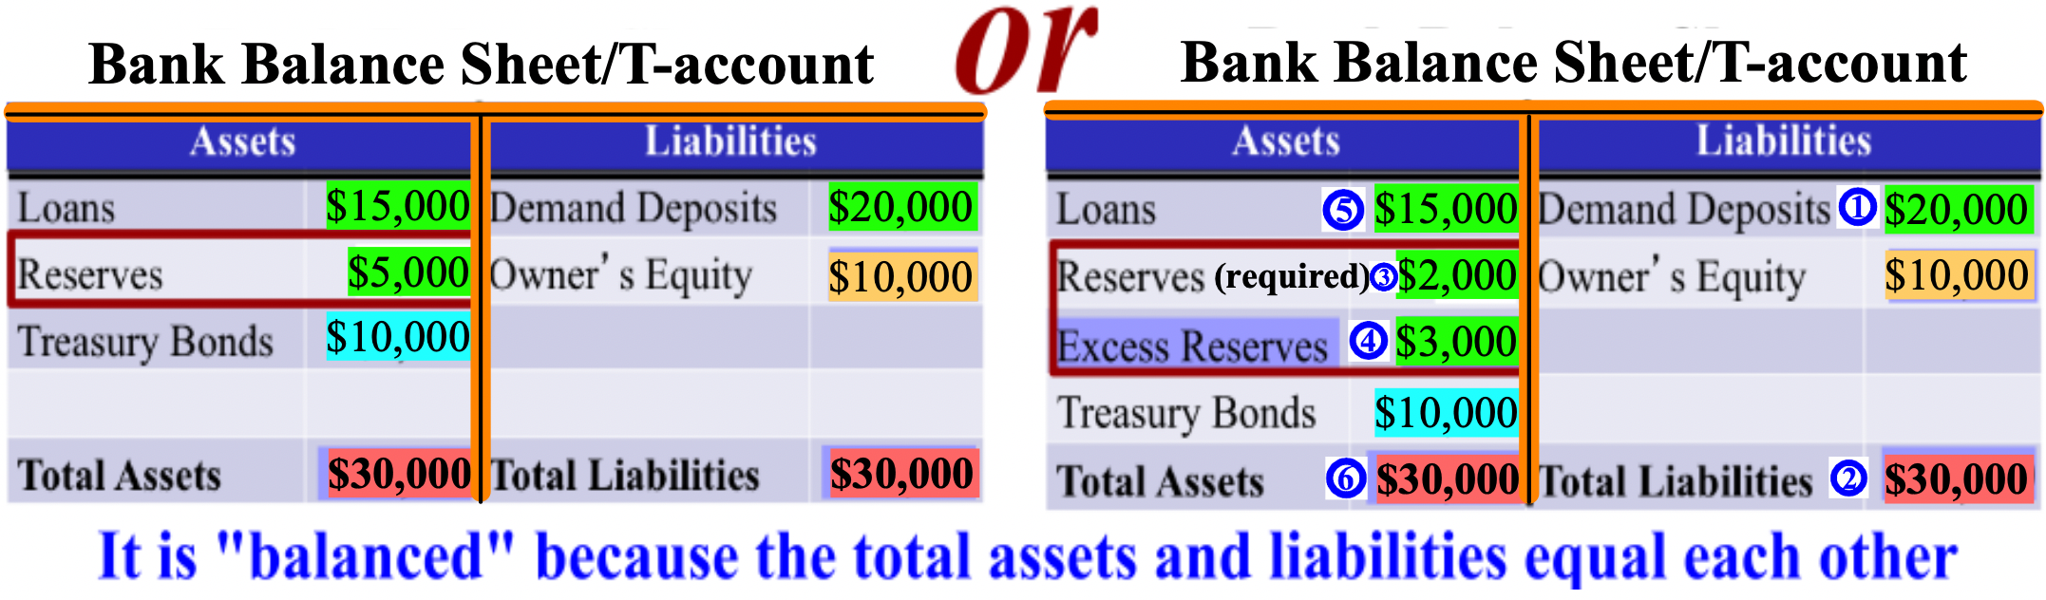

Loans, reserves, and demand deposits are directly related because the amount of loans a bank can give out and the reserves it must hold are directly related to the demand deposits it has. Of the $20,000 in demand deposits in the bank below, $5,000 is being kept in reserve while the other $15,000 can be loaned out. As you can see on the right T-account, the bank's required reserve/reserve ratio is 1 or 10% ($2,000 of $20,000 is 10%). The extra $3,000 that the bank is keeping in reserves is extra and is called excess reserves.
When money is deposited in a bank, the money is added directly to demand deposits. If $10,000 is deposited into the bank, demand deposits would become $30,000 and total liabilities would become $40,000. The required reserve would be recalculated at 10%, and the new required reserve would be $3,000. Because required reserves only equal $2,000, more must be added. If there are excess reserves, money would be taken
first from there and excess reserves would become $2,000. The $10,000 deposit would be added to the available loans. Loans would now equal $25,000 and total assets $40,000
But, if there are no excess reserves, the loans would originally equal $18,000 ($15,000 + $3,000) and the money would be taken from that amount. The amount of loans available would decrease, in this case from $18,000 to $17,000 because $1,000 would have to be transferred from loans to required reserves. The $10,000 deposit would be added to the available loans. Loans would now equal $27,000 and total assets $40,000
If $5,000 is withdrawn from this bank, the $5,000 would be withdrawn from demand deposits and demand deposits would become $15,000 and total liabilities $25,000. The required reserve would be recalculated at 10% and would become $1,500. The extra $500 in required reserves would be added to the excess reserves and
become $3,500. But, the $3,500 in excess reserves would become $0 as assets are withdrawn and the remaining $1,500 needed would be deducted from the available loans and become $13,500. Total assets now equal $25,000.
Bonds are secured loans, like an IOU. Interest rates and bond prices are inversely related, so as interest rates increase, the value of a bond decreases. As interest rates decrease, the value of a bond increases

