AP Macroeconomics Mr. Sadow Chapter 6 Extra Credit #3 of 3
Show your work and put the answer on the line. Name: _____________________________
Include specifics, like %, $, and amounts (80% or $10 million). Period: ____
***This is due on or before the day of the test review

Bank Balance Sheets and the Money Multiplier
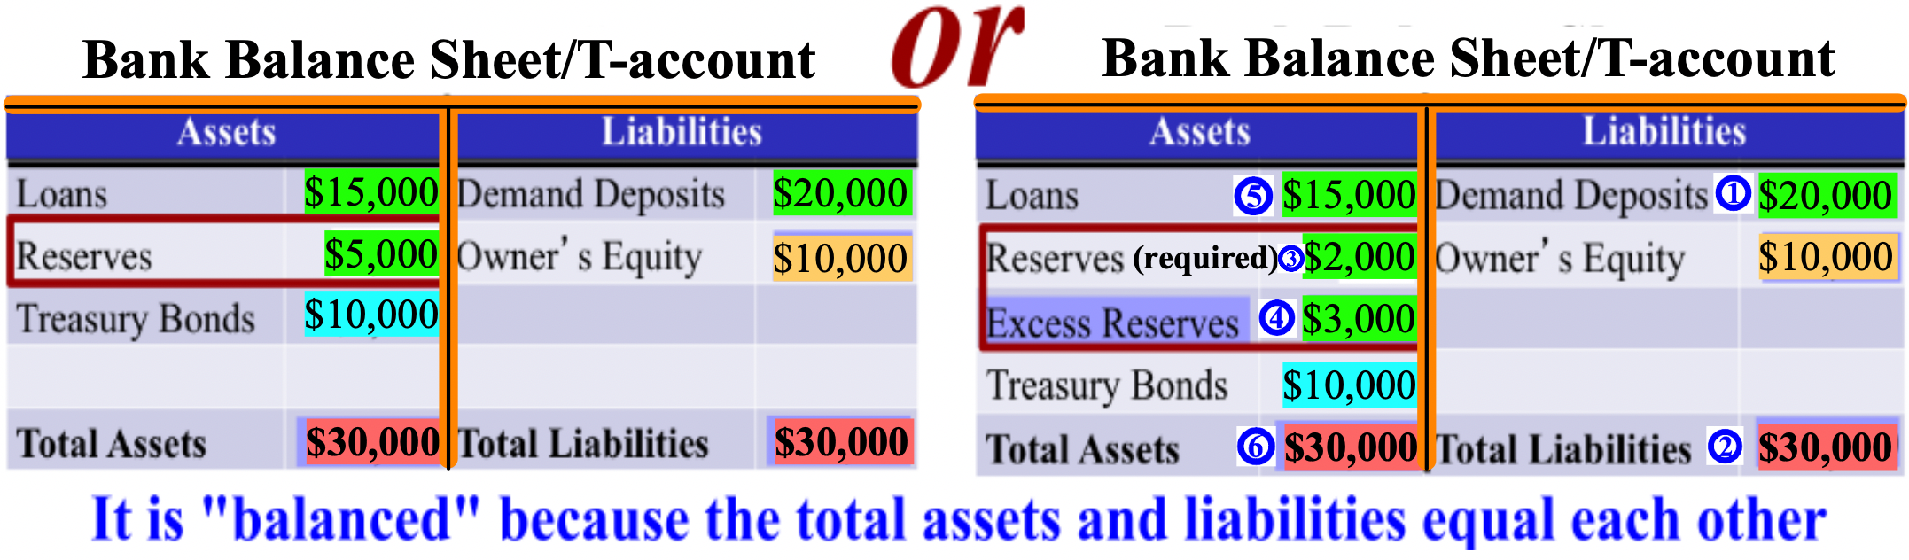

Use the bank balance sheets/t-accounts above to answer the following questions
1. Based on the information above, what is the reserve requirement/reserve ratio? ______________

2. Based on the information above, how much could the bank loan out (includ. exc. rese.)?_____________

3. Based on the information above, if the bank's total possible amount was loaned out,
what would be the financial impact on the money supply? ______________

4. If the reserve requirement was 5%, what would be the bank’s required reserve? ______________

5. If the reserve requirement was 5%, what would be the bank’s excess reserves? ______________

6. If $10,000 was deposited into this bank and the reserve requirement was 10%,
what would be the bank's demand deposits? ______________

7. If $10,000 was deposited into this bank and the reserve requirement was 10%,
what would be the bank's required reserve? ______________

8. If $10,000 was deposited into this bank and the reserve requirement was 10%,
what would be the bank's excess reserves? ______________

9. If $10,000 was deposited into this bank and the reserve requirement was 10%,
what would be the bank's "Loans" amount? ______________

10. If $10,000 was deposited into this bank and the reserve requirement was 10%,
what would "Total Assets" and "Total Liabilities" both be? ______________

11. If $10,000 was withdrawn from this bank and the reserve requirement was 10%,
what would be the financial impact on the money supply? ______________

