AP Macroeconomics Mr. Sadow Chapter 6 Extra Credit #2 of 3
Show your work and put the answer on the line. Name: _____________________________
Include specifics, like %, $, and amounts (80% or $10 million). Period: ____
***This is due on or before the day of the test review

The Spending Multiplier
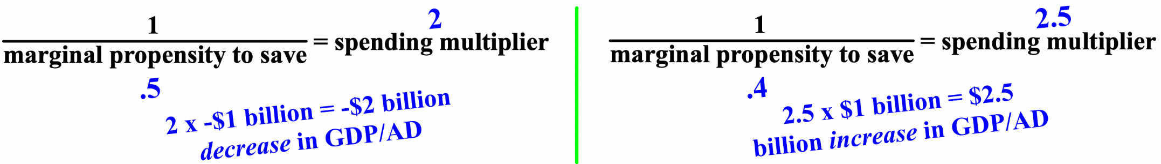

1. the marginal propensity to save is .2 spending multiplier= ______________

2. the marginal propensity to consume is .8 spending multiplier= ______________

3. the government spends $1 billion on defense and the MPS is .4 spending multiplier= ______________
dollar impact on GDP/AD= ______________

4. consumers spend $1 billion on holiday gifts and the MPC is .2 spending multiplier= ______________
dollar impact on GDP/AD= ______________

5. the government spends $1 billion less on defense and the MPS is .5 spending multiplier= ______________

dollar impact on GDP/AD= ______________

6. consumers spend $1 billion less on Valentine's Day and the MPS is .8 spending multiplier= ______________
dollar impact on GDP/AD= ______________

7. the dollar impact on GDP/AD is $2 billion and the MPC is .5 spending multiplier= ______________

amount originally spent= ______________

8. the dollar impact on GDP/AD is -$10 billion and the MPC is .2 spending multiplier= ______________

amount originally spent= ______________

