Chapter 5- Fiscal Policy by Congress and Monetary Policy by the Federal Reserve (The FED)
This chapter is about how Congress handles fiscal policy- the spending, borrowing, and taxation decisions taken by governments and how the FED uses monetary policy to stabilize an economy and to lessen the negative or excessive economic fluctuations that can weaken an economy, like employment, inflation, or real GDP that is too high or too low.
Fiscal policy is referred to as supply-side policy because it focuses on increasing long-term economic growth of aggregate supply (AS) (potential GDP). The primary tools that Congress uses to influence aggregate supply/potential GDP (AS/GDP) are 1) government spending/expenditures and 2) taxes.
When the U.S. economy is in a recession/in contraction, Congress can use expansionary fiscal policy to increase real GDP/economic output by increasing government (G) spending/expenditures and/or lowering taxes to increase the money supply and expand the economy. When the U.S. economy is in expansion/with inflation, Congress can use contractionary fiscal policy to decrease real GDP/economic output by decreasing government (G) spending/expenditures and/or increasing taxes to decrease the money supply and contract the economy.

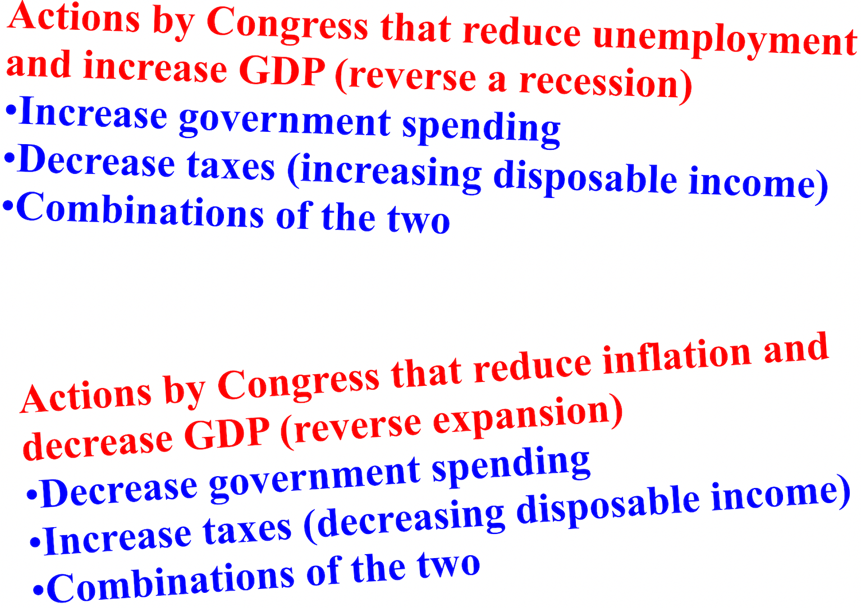

Discretionary fiscal policy refers to specific changes in laws or administrative procedures, such as a change in an existing program to speed up spending, the creation of a program (such as a new welfare program), or a change in the tax system (such as lower tax rates). These changes in the law are discretionary changes because they require action on the part of the Congress or the President.
Many of the very large changes in government taxes and spending are automatic. Unemployment compensation, Social Security payments, and welfare payments all rise in a recession. These automatic tax and spending changes are called automatic stabilizers or non-discretionary fiscal policy because they tend to
stabilize the fluctuations of real GDP.
Now we'll talk about monetary policy which are the actions taken by the Federal Reserve (the FED) to increase the money supply in an economy when the economy is in contraction/in recession or decrease the money supply when an economy is in expansion/has inflation. Monetary policy is referred to as demand-side policy because it focuses on increasing aggregate demand/real GDP (AD/Y). The primary tools that the FED uses to influence aggregate demand/real GDP are 1) bonds/securities, 2) the discount rate, and 3) the required reserve rate.
When the U.S. economy is in a recession/in contraction, the FED can use expansionary monetary policy to increase real GDP/real output by buying government bonds/securities from banks and/or decreasing the
discount rate or required reserve rate. This will increase the money supply, decrease interest rates, and
expand the economy. When the U.S. economy is in expansion/with inflation, the FED can use contractionary monetary policy to decrease real GDP/real output by selling government bonds/securities to banks and/or increasing the discount rate or required reserve rate. This will decrease the money supply, increase interest rates, and contract the economy.
Governments, usually through a central bank, control the money supply. A central bank is the main bank to other banks in a country. America's central bank is the Federal Reserve, nicknamed the "FED."
The FED makes decisions about the money supply through a committee called the Federal Open Market Committee (FOMC). The FOMC meets to decide how to implement monetary policy, such as deciding whether to raise, lower, or keep the nominal interest rate steady.
The FED regulates the money supply by changing any one of the following: 1) open market operations by buying or selling government bonds (short-term loans) from/to banks, 2) lending money to banks at a higher or lower discount rate, and 3) setting the required reserve or reserve ratio higher or lower for banks.
The FED's main monetary tool is used when either the FED buys government bonds/securities from banks or sells government bonds/securities to banks. This is referred to as open market operations. When the U.S. economy is in a recession/in contraction, the goal of the FED is to increase the money supply; more money= more chance to spend money. To do this, the FED buys government bonds/securities from banks (buy=
bigger). The FED then electronically pays the bank by increasing the bank's reserves at the FED. Banks then have more money to loan to borrowers which influences the FED to decrease the federal funds rate (the short-term interest rate that banks charge one another on overnight loans). This ultimately decreases the nominal interest rate (the interest rate that consumers and businesses pay; it includes inflation). Interest-sensitive spending increases and so does aggregate demand/real GDP (AD/Y).
When the U.S. economy is in expansion/with inflation, the goal of the FED is to decrease the money supply; less money= less chance to spend money. To do this, the FED sells government bonds/securities from banks (sells= smaller). The FED then electronically receives payment from the banks by decreasing the bank's reserves at the FED. Banks then have less money to loan to borrowers which influences the FED to increase the federal funds rate (the short-term interest rate that banks charge one another on overnight loans). This ultimately increases the nominal interest rate (the interest rate that consumers and businesses pay; it includes inflation). Interest-sensitive spending decreases and so does aggregate demand/real GDP (AD/Y).

The FED's second tool it uses to impact monetary policy is the discount rate. This is the interest rate that the FED charges commercial banks when loaning them money. Remember, think of all rates like a wall in your way; ↑ is bad and ↓ is good. To increase the money supply and expand the economy, the FED decreases the discount rate, making it cheaper for banks to borrow money from them. To decrease the money supply and slow down the economy, the FED increases the discount rate to make it more expensive for banks to borrow
from them. More money= more chance to spend money and less money= less chance to spend money
The last instrument the FED uses to impact the money supply is the required reserve or reserve ratio. This is the percent of customer deposits that banks must hold in reserve at the FED and cannot loan out. The FED sets the amount, the ratio, that banks must hold. Only a small percent of the money you have in a bank is held in reserve the rest of your money can be loaned out. This is called fractional reserve banking
When the FED wants to increase the money supply, the FED decreases the reserve requirement. Banks then loan out the excess reserves to make money. This is also what happens when deposits are made at a bank. Excess reserves are simply extra bank reserves at the FED. When the FED wants to decrease the money supply, the FED increases the reserve requirement. Banks then have less money to loan out to borrowers. This is also what happens when withdrawals are made at a bank.

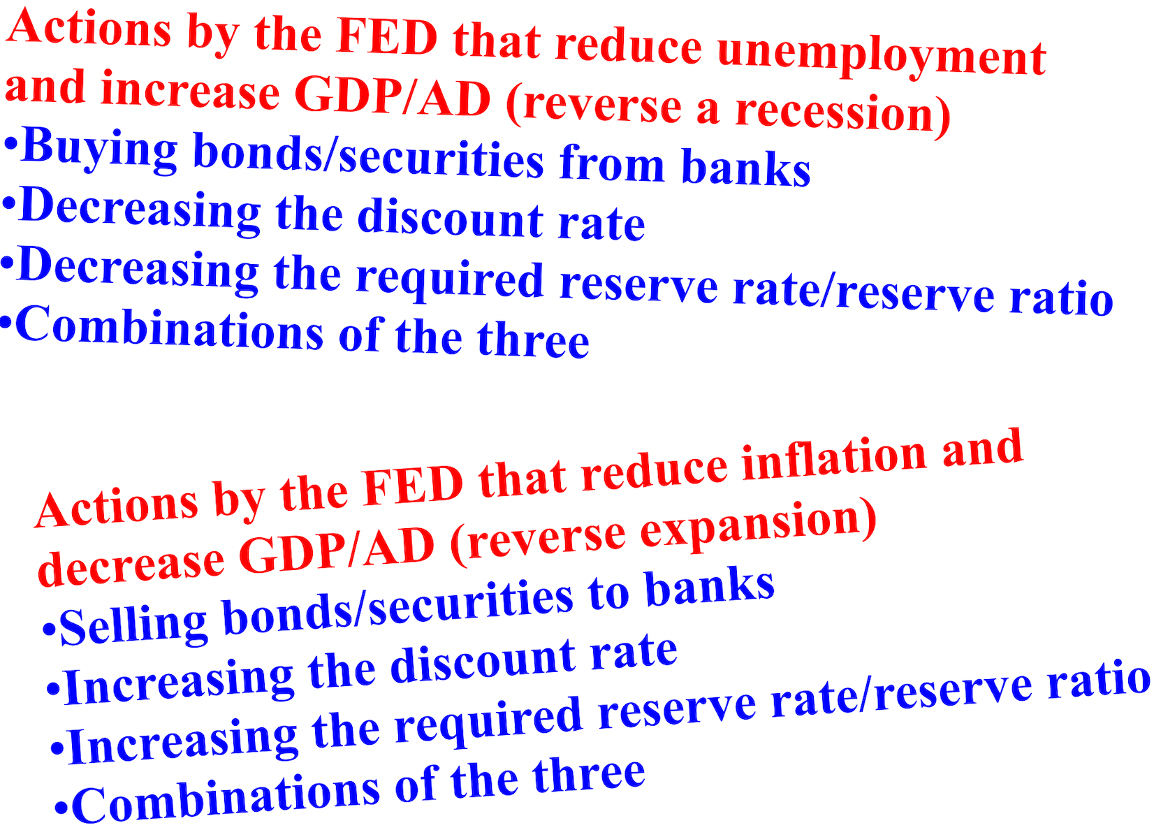

As more money flows into an economy and deposits are made at banks, those banks are now able to make additional loans. Interest rates decrease due to the increase in the money supply and aggregate demand/real GDP (AD/Y) increases. This positive ripple effect on the economy is called the money multiplier (the expansion or contraction of a country's money supply that results from banks being able to lend more or having to keep more money in their banks.
For example, if the reserve ratio is 10% (.1) and the money multiplier is 10, a $1 million purchase of bonds/securities by the FED from banks would lead to a $10 million increase in demand deposits and the overall money supply, available funds that would be available for banks to loan to customers.

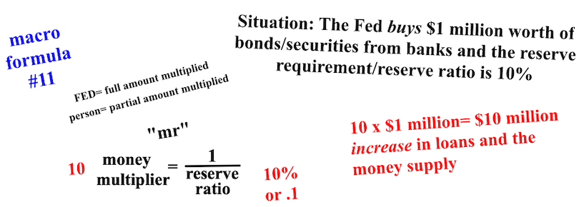

As more money flows out of an economy and withdrawals are made at banks, those banks are now able to make fewer loans. Interest rates increase due to the decrease in the money supply and aggregate demand/real GDP (AD/Y) decreases. This leads to a negative ripple effect on the economy. For example, if the reserve ratio is 10% (.1) and the money multiplier is 10, a $1 million sale of bonds/securities by the FED to banks would lead to a $10 million decrease in demand deposits and the overall money supply, less funds would be available for banks to loan to customers.

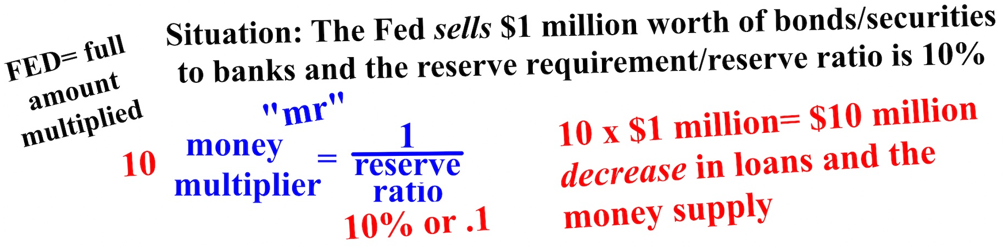

When using the money multiplier, two determinations have to be made. Is the impact on the economy a positive or negative one and is the money being referred to that will impact the economy already in the money supply or not? For example, if a person deposited $100 in cash in their bank, the money they are depositing is already in the money supply and won't be counted twice. If the required reserve is 20%, the money multiplier would be 5. The 5 would be multiplied by only $80 since $20 of the $100 (money already in the money supply) has to remain in reserve; only $80 can be loaned out. If $100 was withdrawn, there would be a decrease in loans/money supply.

