AP Macroeconomics Mr. Sadow Chapter 5 Extra Credit #1 of 1
Show your work and put the answer on the line. Name: _____________________________
Include specifics, like %, $, and amounts (80% or $10 million). Period: ____
***This is due on or before the day of the test review

The Money Multiplier
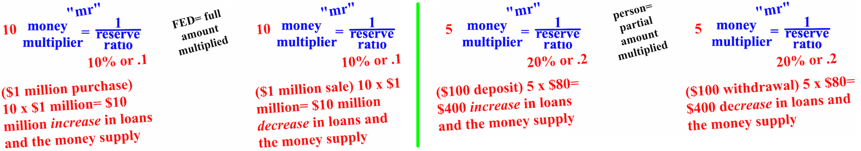

1. FED buys $10 million; required reserve= 5% money multiplier= ____ money supply change= (+ or -)$__________

2. FED sells $5 million; required reserve= 20% money multiplier= ____ money supply change= (+ or -)$__________

3. Backpack deposits $200; required reserve= 5% money multiplier= _____ money supply change= (+ or -)$_______

4. Dora withdrawals $10,000; required reserve= 10% money multiplier= ____ money supply change= (+ or -)$_____

5. FED buys $50 million; required reserve= 20% money multiplier= ____ money supply change= (+ or -)$_________

6. FED sells $1 million; required reserve= 10% money multiplier= ____ money supply change= (+ or -)$__________

7. Boots deposits $5,000; required reserve= 5% money multiplier= ____ money supply change= (+ or -)$__________

8. Diego withdrawals $100; required reserve= 5% money multiplier= ____ money supply change= (+ or -)$________

