AP Macroeconomics Mr. Sadow Chapter 3 Extra Credit #4 of 5
Show your work and put the answer on the line. Name: _____________________________
Include specifics, like %, $, and amounts (80% or $10 million). Period: ____
% Growth of an Economy ***This is due on or before the day of the test review
If real GDP in 1773 was $10 million and $15 million in 1774, what was the percent growth?

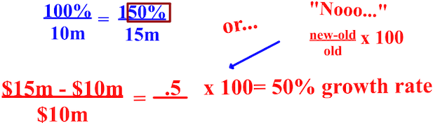

1. If real output in 1800 was $40 million and $50 million in 1801, what was the percent growth? ______________

2. If real GDP in 2019 is $20 billion and $22 billion in 2020, what will be the percent growth? ______________

3. If real GDP in 1900 was $1 billion and the percent growth from 1900 to 1901 was 15%, what was the output of
production in 1901?
______________

4. If real GDP in 1951 was $3.3 billion and the percent growth from 1950 to 1951 was 10%, what was real GDP in
1950?
______________

----------------------------------------------------------------------------------------------------------------------------------------------------------------------------
Real GDP Per Capita
If the 1st yr. per capita in a country was $10 million and the 2nd yr. per capita was $15 million, what was the annual
growth rate per capita?
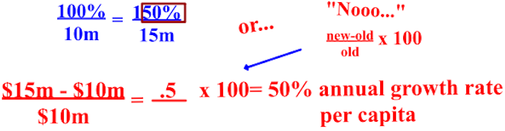

1. If the 1st yr. per capita in a country was $100 million and the 2nd yr. per capita was $112 million, what was the
annual growth rate per capita?
______________

2. If the 2nd yr. per capita in a country was $220 and the annual growth rate per capita was 10%, what was the 1st year
per capita?
______________

3. If the 2nd yr. per capita in a country was $360 and the annual growth rate per capita was 20%, what was the 1st year
per capita?
______________

4. Compute America's real GDP per capita in 1915: 4 million citizens and a real GDP of $44 million. ______________

