AP Macroeconomics Mr. Sadow Chapter 3 Extra Credit #3 of 5
Show your work and put the answer on the line. Name: _____________________________
Include specifics, like %, $, and amounts (80% or $10 million). Period: ____
***This is due on or before the day of the test review

The Velocity of Money
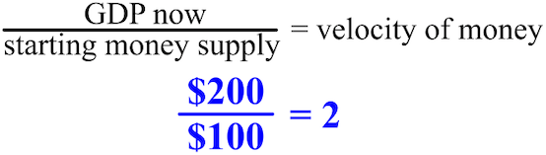

1. nominal GDP= $1,600 and the money supply was $400 velocity= ______________

2. current GDP= $1,000 and the money supply was $100 velocity= ______________

3. velocity of money= 10 and the nominal GDP= $1,000 money supply= ______________

4. velocity of money= 5 and the GDP= $2,000 money supply= ______________

5. velocity of money= 10 and the money supply was $10 nominal GDP= ______________

