AP Macroeconomics/Microeconomics Mr. Sadow Chapter 1 Extra Credit #1 of 1
Show your work and circle the answer. Name: _____________________________
Include specifics, like %, $, and amounts (80% or $10 million). Period: ____

Absolute and Comparative Advantage
The following table shows the number of donuts or cupcakes that John and Eric can produce each day.

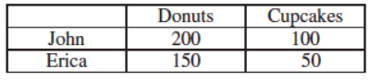

1. Who has the absolute advantage in producing donuts? Explain. (use numbers)

2. Who has the absolute advantage in producing cupcakes? Explain. (use numbers)

3. Who has the comparative advantage in producing donuts? Explain. (use numbers)

4. Who has the comparative advantage in producing cupcakes? Explain. (use numbers)

5. What is the opportunity cost of John producing 1 cupcake? Explain. (use numbers)

6. What is the opportunity cost of Erica producing 1 cupcake? Explain. (use numbers)

