Thursday, May 7: Papers 2A & 2B Review

Paper 2A
Explain Why Something Happened
Worth 20 points (10 points each 2A; use 20 minutes at most for each)
Remember... T2PEELC

Example: Question 4A: (imagine you chose Russia as one of your two chapters to focus on, if it was possible):
Why did Tsar Nicholas II's leadership lead to his demise?

1. Write "4" and "A" in the columns in your answer booklet at the top left. If you chose the French Revolution, you
would write "1A", the Industrial Revolution "2A", and the German Unification “3A”.
2. Read the question/prompt carefully and fully understand what it is asking you then plan your writing, especially your
two points/reasons and how two of your reasons are linked (connected) to each other.
3. At least write “T2PEELC” on the 1st line of the answer sheet. You can earn credit for planning but be careful how
much time you spend doing this.
4. Memorize the words below that are in italics word for word. They will be your sentence starters for every Paper 2A.

PARAGRAPH 1 IS YOUR THESIS

Paragraph 1- Your thesis (the answer to the question being asked summed up with 2 facts you learned)
1. Thesis: What are your points/reasons? What are you trying to say? Does each point/reason answer the
question/prompt? Be clear and specific and choose facts that are important and you can explain.- There are
many reasons why (restate the question). Two of them, in the order of importance, are ____ and ____.

PARAGRAPH 2: A POINT/REASON IN PEE FORMAT
1. Point #1: What is your point/reason? What are you trying to say? Does the fact answer the question/prompt? Be clear
and specific.- What is the most important fact that answers the question?- The most important reason
why (restate the question) is ____.
2. Elaborate: Use at least 2 examples you learned that support your most important reason.
3. Explain: If your elaboration isn’t very clear and specific enough, explain it.

PARAGRAPH 3: ANOTHER POINT/REASON IN PEE FORMAT THEN LINK (CONNECT)
1. Point #2: What is your point/reason? What are you trying to say? Does the fact answer the question/prompt? Be clear
and specific.- What is the least important fact that answers the question?- Another reason why or The least
important reason why is ____.
2. Elaborate: Use at least 2 examples you learned that support your other or least important reason.
3. Explain: If your elaboration isn’t very clear and specific enough, explain it.
4. Link: You are tying two of you reasons together. State a connection between two of your points/reasons, either by
one causing the other (cause and effect) or one proving the other is important (like the attack on the Bastille
proving the importance of the Tennis Court Oath). Reasons ____ and ____ are related because ____.
However, ____ is more important because ____.

PARAGRAPH 4 IS THE CONCLUSION PARAGRAPH IN PEE FORMAT
1. Point: Write again what the most important point/reason is that answers the question/prompt. The most important
reason why (restate the question) is ____.
2. Elaborate: Add 1-2 more examples your learned that support why it is the most important reason, but use examples
you haven't already used for this reason.
3. Explain: If your elaboration isn’t very clear and specific enough, explain it.
PARAGRAPH 1: YOUR THESIS
T  Thesis | What are your reasons/points? What are you trying to say? Does each reason/point answer the question/prompt? Be clear and specific and choose facts that are important and you can explain.- There are many reasons why (restate the question). Two of them, in the order of importance, are ____ and ____.  My topic: Explain why _____________________________________________________________________  __________________________________________________________________  1st point/reason-  2nd point/reason-

PARAGRAPH 2: A POINT/REASON
IN PEE FORMAT
Point #1  Most  important point/reason | What is your point/reason? What are you trying to say? Does the fact answer the question/prompt? Be clear and specific.- What is the most important fact that answers the question?- The most important reason why (restate the question) is ____.
E  Elaborate | Use at least 2 examples you learned that support your most important reason.  1st example:  2nd example:

PARAGRAPH 3: ANOTHER POINT/REASON
IN PEE FORMAT THEN LINK (CONNECT)
Point #2  Another or least important  point/reason | What is your point/reason? What are you trying to say? Does the fact answer the question/prompt? Be clear and specific.- What is the least important fact that answers the question?- Another reason why or The least important reason why is ____.
E  Elaborate | Use at least 2 examples you learned that support your other or least important reason.  1st example:  2nd example:
L  Link (connect) 2 points/  reasons | State a connection between your two points/reasons, either by one causing the other (cause and effect) or one proving the other is important (like the attack on the Bastille proving the importance of the Tennis Court Oath). Reasons ____ and ____ are related because ____. However, ____ is more important because ____.

PARA. 4: THE CONCLUSION IN PEE FORMAT
P  Most important  point/reason | Point: Write again what the most important reason is that answers the question/prompt. The most important reason why (restate the question) is ____.
E  Elaborate | Add 1-2 more examples your learned that support why it is the most important reason but use examples you haven't already used for this reason.  1st example:  2nd example:

What the people who score the AICE exams
look at to award marks (points)
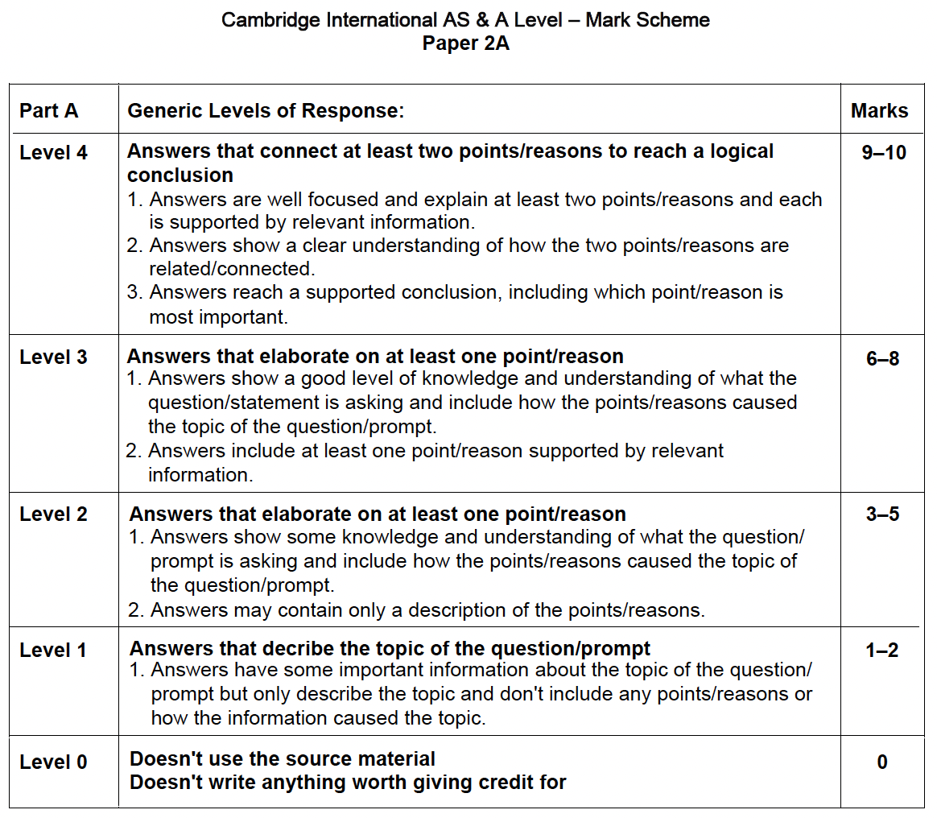

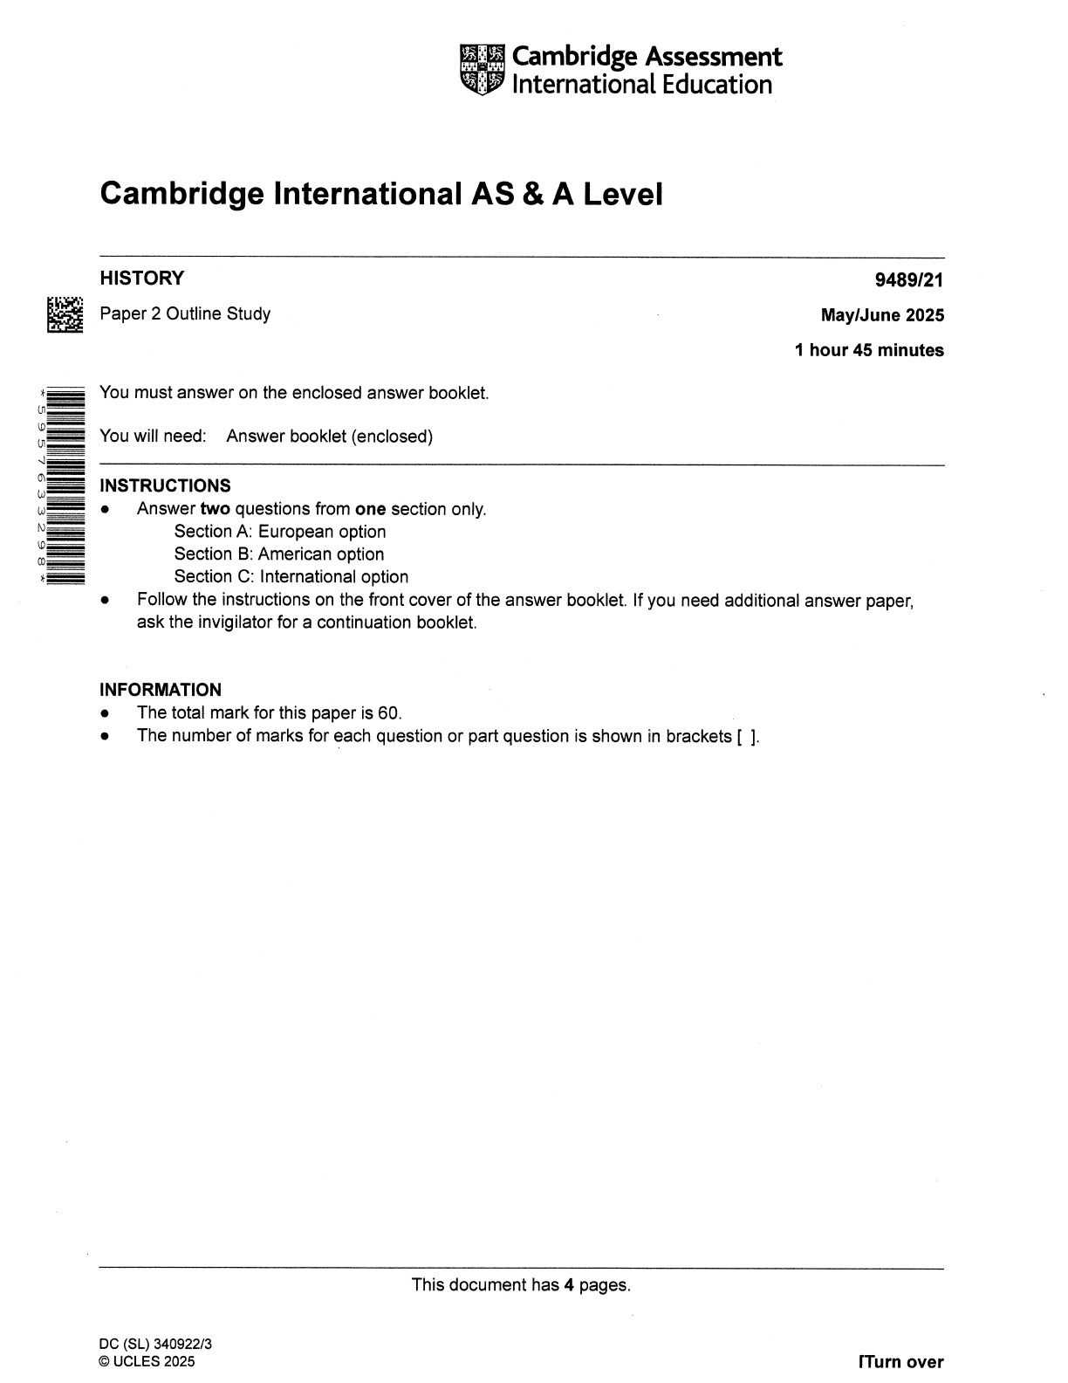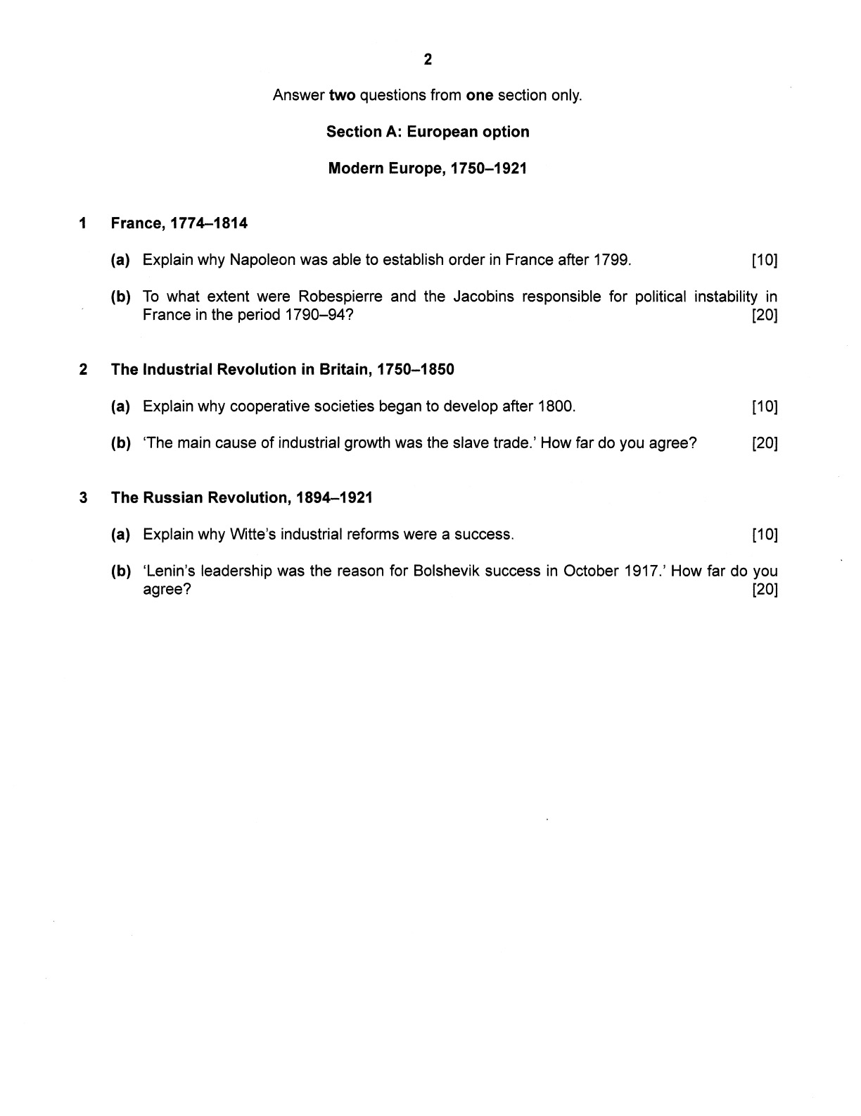
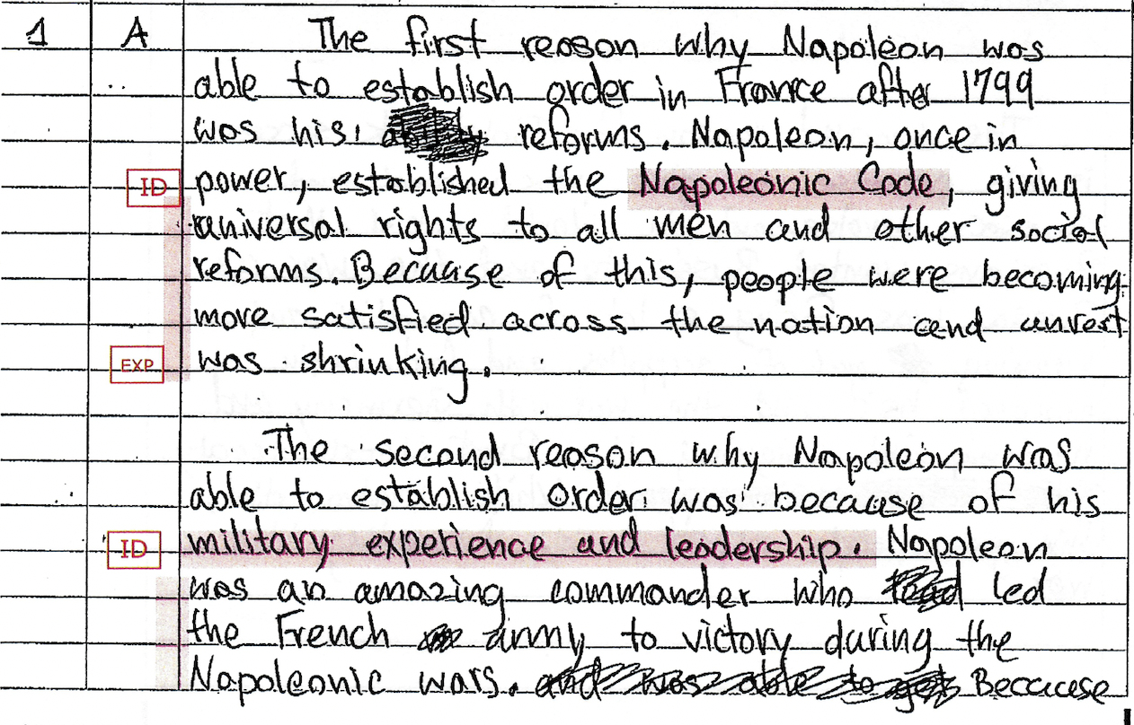
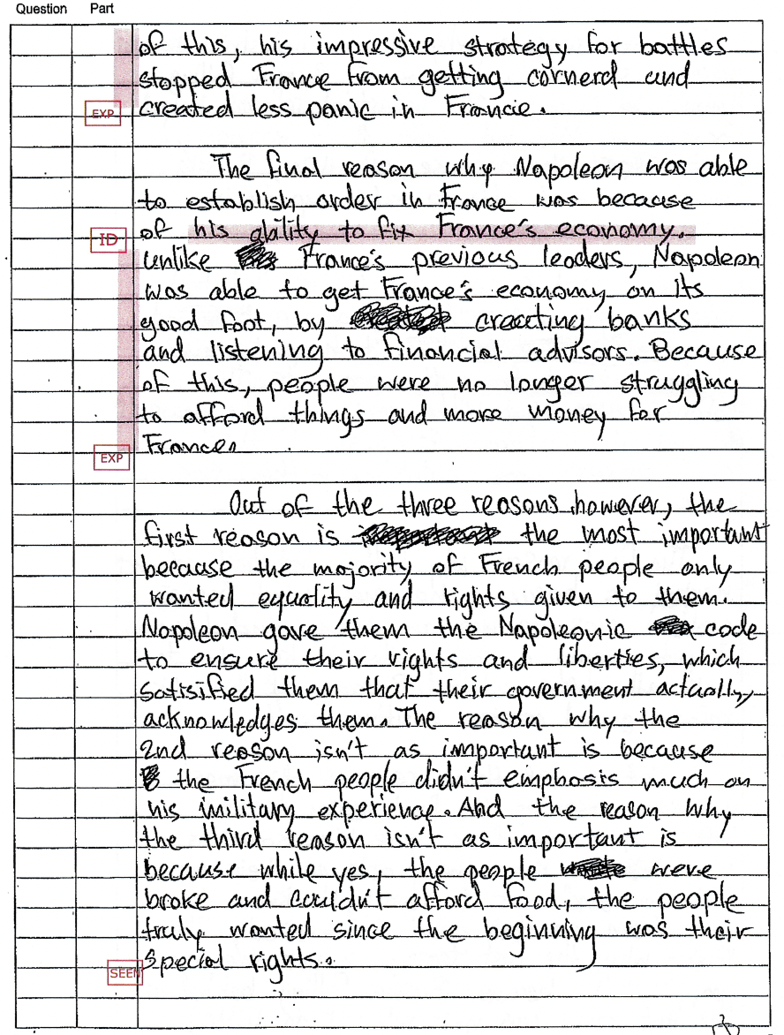
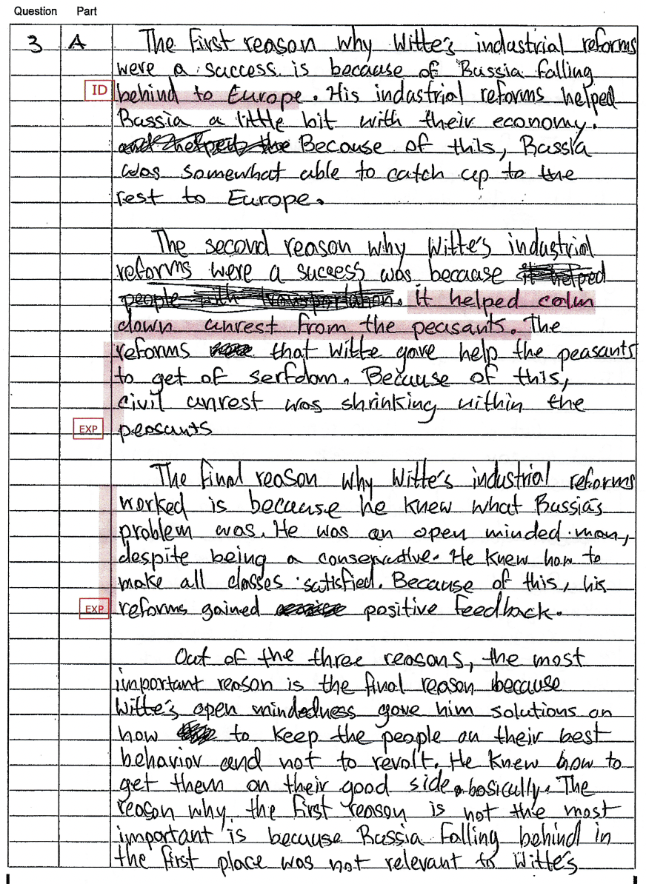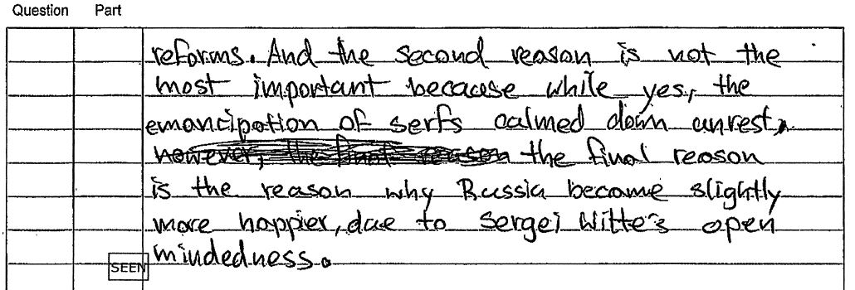

Paper 2B
Argue for and Against (a counterargument) the Question/Prompt
Worth 40 points (20 points each 2B; use 30-35 minutes at most for each)
Remember... T3H2PEE1CC

Example: Question 1B (imagine you chose France as one of your two chapters to focus on): How far did
Napoleon as First Consul from 1799-1804 maintain the principles of the French Revolution?

1. Write "1" and "B" in the columns in your answer booklet at the top left. If you chose the Industrial Revolution, you
would write "2B" and German Unification "3B.”
2. Read the question/prompt carefully and fully understand what it is asking you then plan your writing, especially your
two points/reasons for or against the topic and one against (if you chose two for) or one for (if you chose 2 against).
3. At least write “T3H2PEE1CC” on the 1st line of the answer sheet. You can earn credit for planning but be careful
how much time you spend doing this.
4. Decide if you agree with/support or disagree with/challenge the question/prompt and how much, moderately or
strongly. Whichever you choose, to agree or disagree, that will be called your argument, and you must have at least
two points/reasons to back up your choice. You'll also need at least one point/reason to provide a counterargument
(that you disagree) with what you chose. It's like you have to argue both sides of a court case, but one has two
points/reasons (your side, the argument) and the other side has at least one point/reason, your counterargument.
5. Memorize the words below that are in italics word for word. They will be your sentence starters for every Paper 2B.

PARAGRAPH 1 IS YOUR THESIS

Paragraph 1- Your thesis: for this prompt, assume that you feel Napoleon did maintain the principles of the FR
1. Thesis: What are your points/reasons? What are you trying to say? Does each point/reason answer the
question/prompt? Be clear and specific and choose facts that are important and you can explain. Let's say
you feel Napoleon as First Consul from 1799-1804 did maintain the principles of the French Revolution.
(you agree with/support the question/prompt).- It can be argued that (restate the question positively)
(Napoleon as First Consul from 1799-1804 did maintain the principles of the French Revolution) because
____ and ____. However, there is also evidence that disagrees with my argument, such as ____.

But...

If you feel Napoleon did not maintain the principles of the French Revolution (you disagree with/challenge
the question/prompt), your argument would have been- It can be argued that (restate the question
negatively) (Napoleon as First Consul from 1799-1804 did not maintain the principles of the French
Revolution) because ____ and ____. However, there is also evidence that disagrees with my argument, such
as ____.

PARAGRAPH 2 IS ABOUT HISTORY

1. Write 3 to 4 sentences explaining what was happening in history that led up to the question/prompt.

PARAGRAPH 3: YOUR ARGUMENT- A PEE PARAGRAPH
Paragraph 3- What are the reasons why you agree with/support your argument (the side you chose)?
1. Point #1: What is your point/reason? What are you trying to say? Does the fact answer the question/prompt? Be clear
and specific.- What is the most important fact that answers the question and supports your side?- The most
important reason why I agree (restate the question positively or negatively (depending on the side you
took) is ____.
2. Elaborate: Use at least 2 examples you learned that support your most important reason.
3. Explain: Read the elaboration your just wrote. If your elaboration isn’t very clear and specific enough, explain it.

1. Point #2: What is your point/reason? What are you trying to say? Does the fact answer the question/prompt? Be clear
and specific. What is another or the least important fact that answers the question?- Another reason why or
The least important reason why is ____.
2. Elaborate: Use at least 2 examples you learned that support your other or least important reason.
3. Explain: Read the elaboration your just wrote. If your elaboration isn’t very clear and specific enough, explain it.

PARAGRAPH 4: YOUR COUNTERARGUEMENT- A PEE PARAGRAPH

Paragraph 4- What is a reason why you disagree with your argument (the side you chose in paragraph 3?)
1. Point #1: What is your point/reason? What are you trying to say? Does the fact answer the question/prompt? Be clear
and specific. What is the most important fact that answers the question and disagrees with/challenges your
side?- If the argument in your thesis in paragraph 1 stated that you feel Napoleon did maintain the
principles of the French Revolution (you agreed with the question), your counterargument would be-
However, it can be argued that (restate the question negatively) (Napoleon as First Consul from 1799-1804
did not maintain the principles of the French Revolution) because ____.
2. Elaborate: Use at least 1 example you learned or researched that supports your reason.
3. Explain: Read the elaboration your just wrote. If your elaboration isn’t very clear and specific enough, explain it.

But...
If the argument in your thesis in paragraph 1 stated that you feel Napoleon did not maintain the principles
of the French Revolution, (you disagreed with/challenged the question), your counterargument would be-
However, it can be argued that (restate the question positively) (Napoleon as First Consul from 1799
1804 did maintain the principles of the French Revolution) because ____.
2. Elaborate: Use at least 1 example you learned or researched that supports your reason.
3. Explain: Read the elaboration your just wrote. If your elaboration isn’t very clear and specific enough, explain it.

PARAGRAPH 5 IS YOUR CONCLUSION PARAGRAPH

Paragraph 5- Your Conclusion
1. Agree with/support the side you chose, your argument, and then explain why your counterargument is weak. If you
feel Napoleon did maintain the principles of the French Revolution- Overall, I (moderately/strongly) believe that
(restate the question positively) (Napoleon as First Consul from 1799-1804 did maintain the principles of the French
Revolution) and feel my counterargument is wrong because ____.

But...

If you feel Napoleon did not maintain the principles of the French Revolution- Overall, I (moderately/strongly)
believe that (restate the question negatively) (Napoleon as First Consul from 1799-1804 did not maintain the
principles of the French Revolution) and feel my counterargument is wrong because ____.
PARAGRAPH 1: YOUR THESIS
T  Thesis | What are your points/reasons? What are you trying to say? Does each point/reason answer the question/prompt? Be clear and specific and choose facts that are important and you can explain. It can be argued that (restate the question positively or negatively) because ____ and ____. However, there is also evidence that disagrees with my argument, such as ____.  My thesis: To what extent or How far _________________________________________________________  __________________________________________________________________  1st point/reason to support your argument-  2nd point/reason to support your argument-  1st point/reason to support your counterargument-

PARAGRAPH 2: HISTORY
H  History | Write 3 to 4 sentences explaining what was happening in history that led up to the question/prompt.

PARAGRAPH 3: YOUR ARGUMENT- PEE
(You might agree or disagree with the question)
Point #1  Most  important point/reason | What is your point/reason? What are you trying to say? Does the fact answer the question/prompt? Be clear and specific. What is the most important fact that answers the question and supports your side?- The most important reason why I agree (restate the question positively or negatively (depending on the side you took) is ____.
E  Elaborate | Use at least 2 elaborations you learned that support your most important reason.  1st elaboration:  2nd elaboration :
E  Explain | Read the elaborations your just wrote for your first point. If your elaboration isn’t very clear and specific enough, explain it.  1st elaboration explanation:  2nd elaboration explanation:

PARAGRAPH 3: YOUR ARGUMENT- PEE (CONT.)
Point #2  Another or least important  point/reason | What is your point/reason? What are you trying to say? Does the fact answer the question/prompt? Be clear and specific. What is another or the least important fact that answers the question?- Another reason why or The least important reason why is ____.
E  Elaborate | Use at least 2 examples you learned that support your other or least important reason.  1st example:  2nd example:
E  Explain | Read the elaborations your just wrote for your second point. If your elaboration isn’t very clear and specific enough, explain it.  1st elaboration explanation:  2nd elaboration explanation:

PARAGRAPH 4
YOUR COUNTERARGUMENT- PE
(What is a reason why you disagree with your argument (the side you chose in paragraph 3?)
P#1  least important  point/reason | What is your point/reason? What are you trying to say? Does the fact answer the question/prompt? Be clear and specific.- What is the most important fact that answers the question and disagrees with/challenges the side you took in paragraph 3?- However, it can be argued that (restate the question positively or negatively (the side you didn’t take in paragraph 3). One reason why is ____.
E  Elaborate | Use at least 1 example you learned or researched that supports your reason, your counterargument.  1st example:
E  Explain | Read the elaborations your just wrote for your second point. If your elaboration isn’t very clear and specific enough, explain it.  1st elaboration explanation:

PARAGRAPH 5: YOUR CONCLUSION
C  Conclusion | Your first step is to agree with/support the side you chose, your argument, and then explain why your counterargument is weak.- Overall, I (moderately/strongly) agree that (restate the question positively or negatively (the side you took in paragraph 3) and feel my counterargument (the side you took in paragraph 4) is wrong because ____.
What the people who score the AICE exams
look at to award marks (points)
