Last Name, First Name: ____________________________ Candidate #: _________ Period: __
Paper 1B #1
Compare and Contrast 4 Sources (Agree or Disagree)
Worth 25 points- Use 45 minutes at most to complete this
Remember... 4PEEHC

Example: Question 1B: Read all of the sources. How far do these sources agree that the Russian people would
benefit from the October Manifesto?

1. At the top of your AICE exam practice booklet, write "1" and "B" in the columns.
2. Plan each PEE HAPPY paragraph. Use a T-graphs, Venn diagram, etc., but at least write “4PEEHC” on the 1st
line of the answer sheet. You can earn credit for planning but be careful how much time you spend doing this.
3. Read the question/prompt before starting each paragraph. Look at where each source is from and when each source
was written. Consider what was happening in history when the source originated.
4. While reading each source, underline or circle the evidence, and if you are planning, put the information there.
5. Read one source at a time then write the PEE HAPPY paragraph for it. Start with Source A. If Source A is a picture
and you don’t understand it 100%, start with Source B. If the first source you start with agrees with the
question/prompt, search the rest of the sources until you find a source that disagrees. If the first source you start with
disagrees with the question/prompt, search the rest of the sources until you find a source that agrees.
6. Your first 2 paragraphs must include a source that agrees and a source that disagrees.
7. When you are done with your first 2 paragraphs, make sure they are solid. Decide which paragraph is the weakest.
8. If you have time, write paragraph 3 as an agree or disagree, whichever was the weakest in your first 2 paragraphs.
There may not be a 2nd agree or disagree.
9. Memorize the words below that are in italics word for word. They will be your sentence starters for every Paper 1B.

PARAGRAPHS 1, 2, 3, AND 4 ARE PEE HAPPY PARAGRAPHS
Paragraphs 1, 2, 3, and 4: Sources A, B, C, and D
1. Point: What is your point? What are you trying to say? Does it answer the question/prompt? Be clear and specific.-
Source _ (lightly/moderately/strongly) (agrees with/disagrees with) (restate the question/prompt word for
word).
2. Evidence: Give evidence from the source that supports your point- Source _ says "____.” (quote(s) from the source)
(or Source __ shows __. if it is a picture)
3. Explain: Explain why the evidence in the source supports your point- This shows ____. (make sure the explanation
connects back to the question/prompt and explains why it matters or why it is important)
*** YOU MUST USE 2 options from HAPPY below to support your point.
4. History: What was going on in history when the source originated that supports your point?
5. Audience: Who was the intended audience for the source and how did it impact the authors' messages?
6. Point of view: Who was the author of each source and how did their position impact their messages? Include tone.
7. Purpose: Why did the author of each source create the source and what was each trying to say?
8. Your opinion: Is each source reliable or unreliable and why?- Source _ (is/isn't) reliable because ____.

PARAGRAPH 5 IS THE CONCLUSION PARAGRAPH
1. Overall, source(s) _ and _ agree that (restate the question/prompt word for word). (there may only be 1 source that
agrees, but there will at least be 1, and there may be up to 3)
2. Explain: Explain in 2-3 sentences why the source(s) agree with the question/prompt. This explanation is a short
summing up of why the sources agree with the question/prompt - Source(s) _ and _ agree because ____.
3. Source(s) _ and _ disagree. (there may only be 1 source that disagrees, but there will at least be 1, and there may be
up to 3)
4. Explain: Explain in 2-3 sentences why the source(s) disagree with the question/prompt. This explanation is a short
summing up of why the sources disagree with the question/prompt - Source(s) _ and _ disagree because ____.
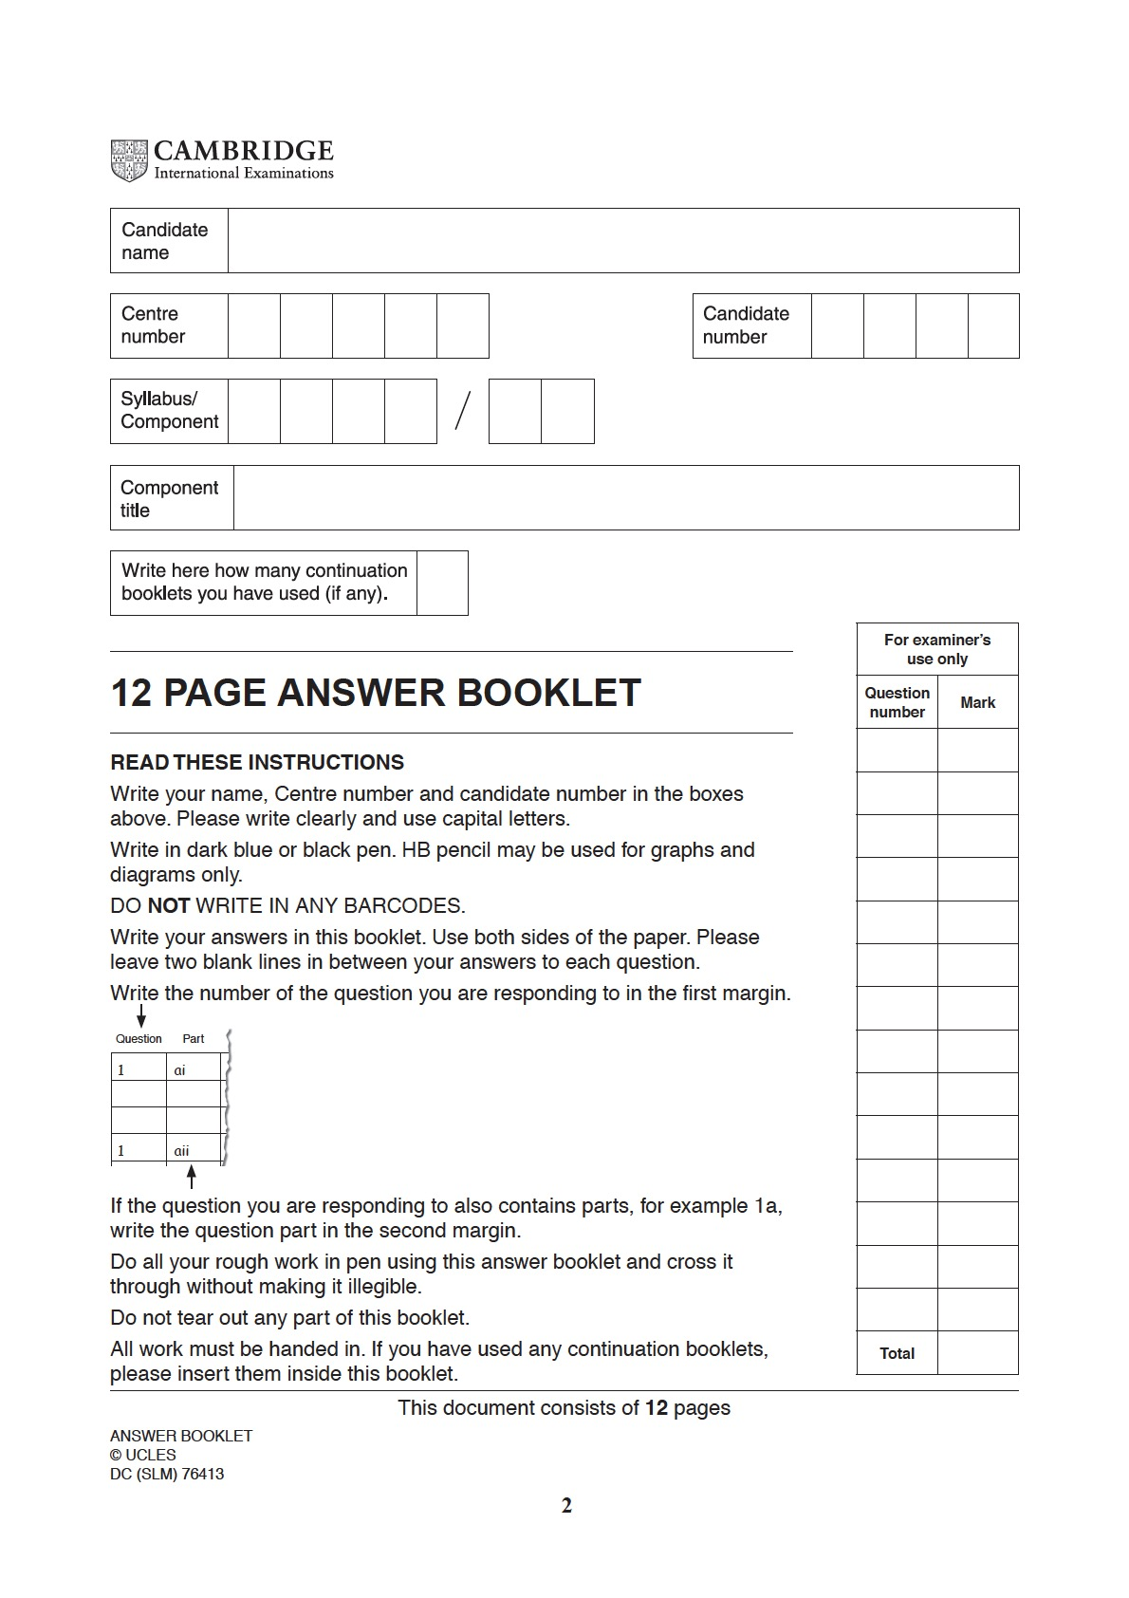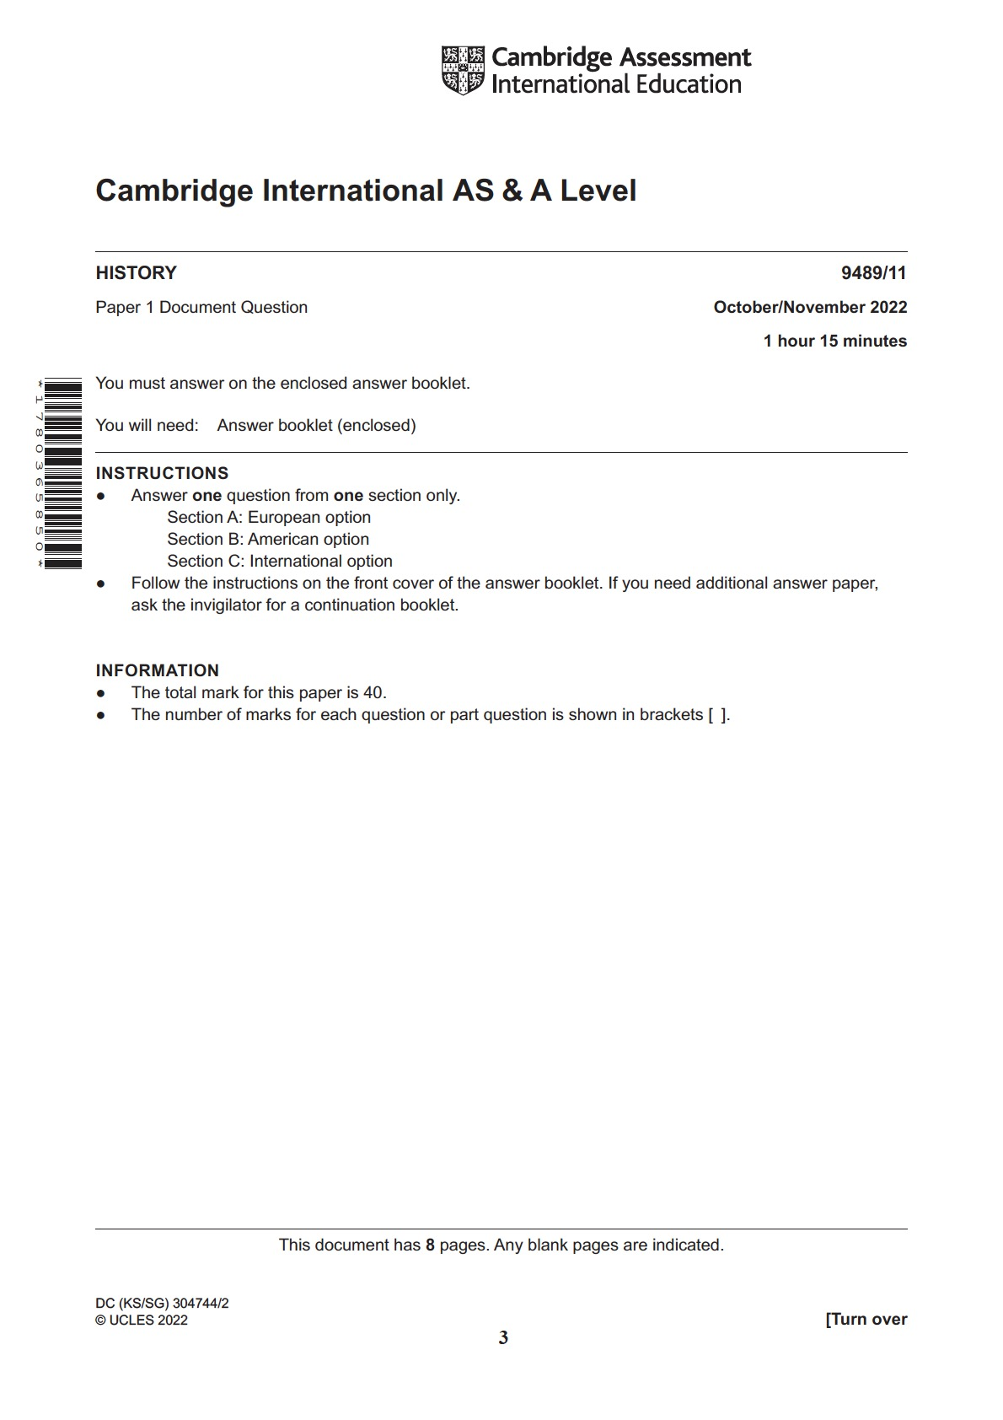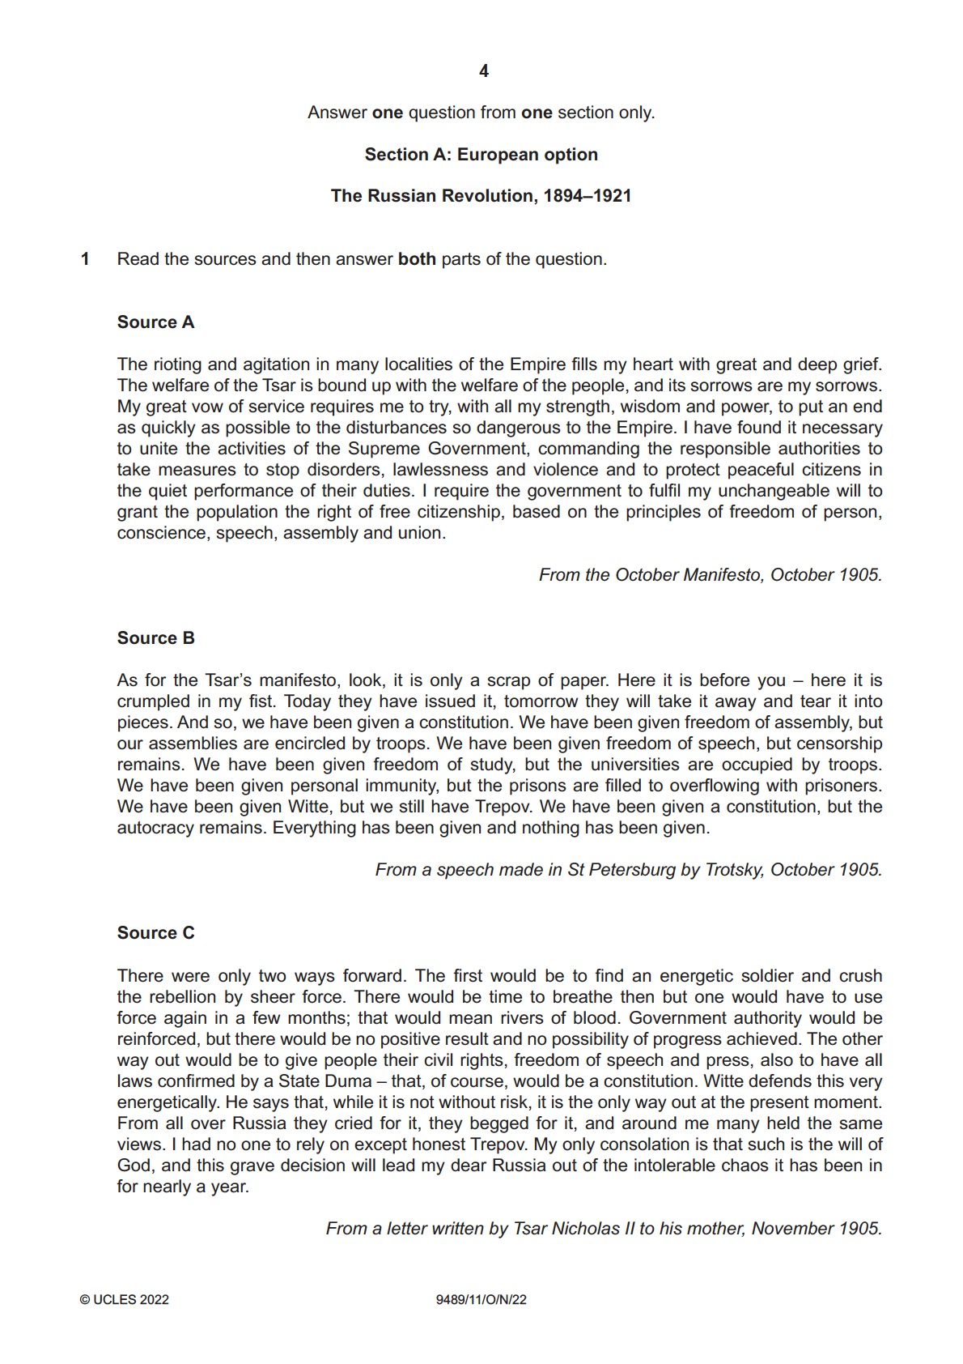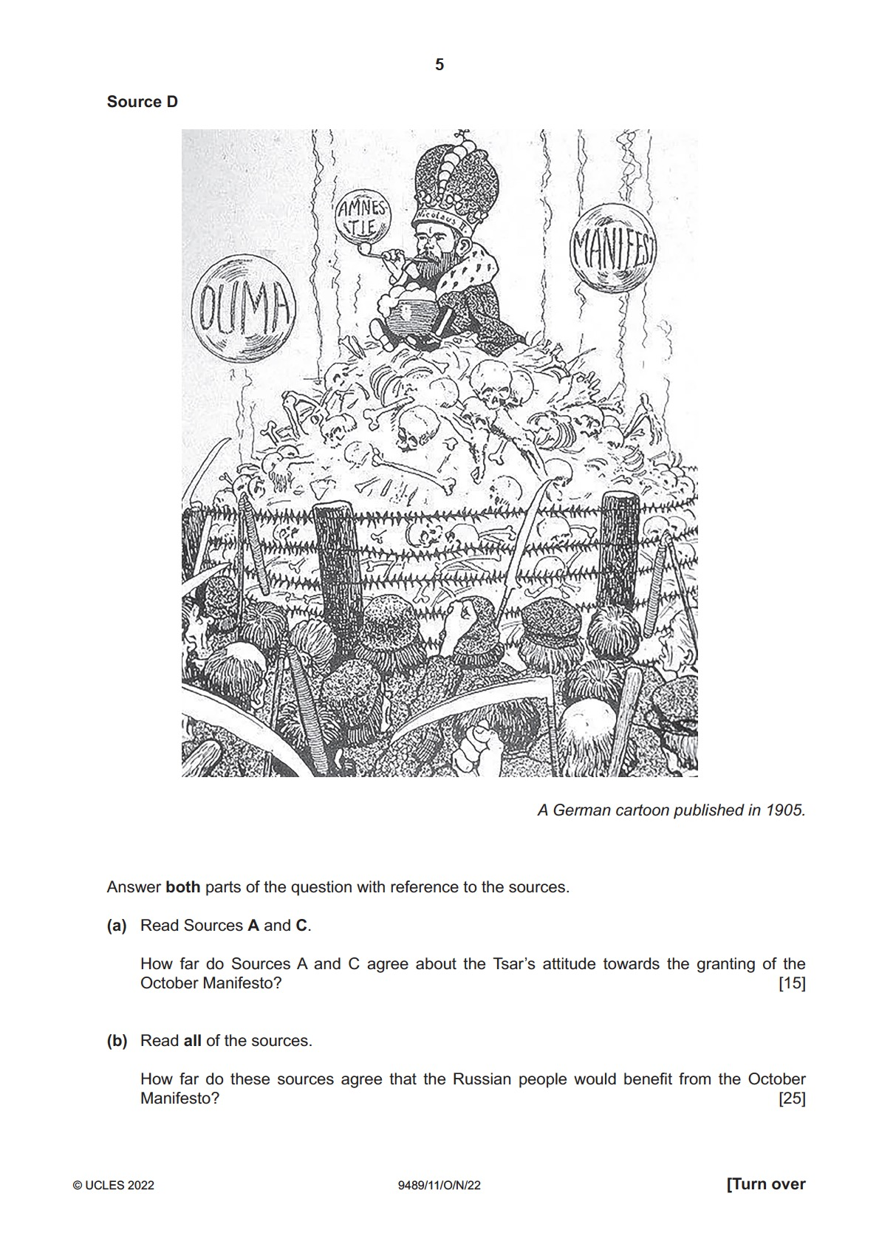
PARAGRAPH 1- PEE HAPPY: SOURCE ___
P  Point | What is your point? What are you trying to say? Source __ (slightly/moderately/strongly) (agrees with/disagrees with) (restate the question/prompt word for word).
E  Give evidence | Give evidence from the source that supports your point. Source __ says “___.” (or Source __ shows __. if it is a picture)
E  Explain the evidence | Explain why the evidence in the source supports your point. This shows ___. (make sure the explanation connects back to the question/prompt and explains why it matters or why it is important)
H  History  (an option) | What was going on in history when the source originated?
A  Audience  (an option) | Who was the intended audience for the source and how did it impact the authors' message?
P  Point of View  (an option) | Who was the author of the source and how did their position impact their messages? Include tone.
P  Purpose  (an option) | Why did the author of the source create the source and what was he trying to say?
Y  Opinion  (an option) | Is the source reliable or unreliable and why?- Source __ (is/isn't) reliable because ____.

PARAGRAPH 2- PEE HAPPY: SOURCE ___
P  Point | What is your point? What are you trying to say? Source __ (slightly/moderately/strongly) (agrees with/disagrees with) (restate the question/prompt word for word).
E  Give evidence | Give evidence from the source that supports your point. Source __ says “___.” (or Source __ shows __. if it is a picture)
E  Explain the evidence | Explain why the evidence in the source supports your point. This shows ___. (make sure the explanation connects back to the question/prompt and explains why it matters or why it is important)
H  History  (an option) | What was going on in history when the source originated?
A  Audience  (an option) | Who was the intended audience for the source and how did it impact the authors' message?
P  Point of View  (an option) | Who was the author of the source and how did their position impact their messages? Include tone.
P  Purpose  (an option) | Why did the author of the source create the source and what was he trying to say?
Y  Opinion  (an option) | Is the source reliable or unreliable and why?- Source __ (is/isn't) reliable because ____.

PARAGRAPH 3- PEE HAPPY: SOURCE ___
P  Point | What is your point? What are you trying to say? Source __ (slightly/moderately/strongly) (agrees with/disagrees with) (restate the question/prompt word for word).
E  Give evidence | Give evidence from the source that supports your point. Source __ says “___.” (or Source __ shows __. if it is a picture)
E  Explain the evidence | Explain why the evidence in the source supports your point. This shows ___. (make sure the explanation connects back to the question/prompt and explains why it matters or why it is important)
H  History  (an option) | What was going on in history when the source originated?
A  Audience  (an option) | Who was the intended audience for the source and how did it impact the authors' message?
P  Point of View  (an option) | Who was the author of the source and how did their position impact their messages? Include tone.
P  Purpose  (an option) | Why did the author of the source create the source and what was he trying to say?
Y  Opinion  (an option) | Is the source reliable or unreliable and why?- Source __ (is/isn't) reliable because ____.

PARAGRAPH 4- PEE HAPPY: SOURCE ___
P  Point | What is your point? What are you trying to say? Source __ (slightly/moderately/strongly) (agrees with/disagrees with) (restate the question/prompt word for word).
E  Give evidence | Give evidence from the source that supports your point. Source __ says “___.” (or Source __ shows __. if it is a picture)
E  Explain the evidence | Explain why the evidence in the source supports your point. This shows ___. (make sure the explanation connects back to the question/prompt and explains why it matters or why it is important)
H  History  (an option) | What was going on in history when the source originated?
A  Audience  (an option) | Who was the intended audience for the source and how did it impact the authors' message?
P  Point of View  (an option) | Who was the author of the source and how did their position impact their messages? Include tone.
P  Purpose  (an option) | Why did the author of the source create the source and what was he trying to say?
Y  Opinion  (an option) | Is the source reliable or unreliable and why?- Source __ (is/isn't) reliable because ____.

What the people who score the AICE exams
look at to award marks (points)
