Tuesday, May 7: Papers 1A & 1B Review

Paper 1A
Compare and Contrast 2 Sources (Similar or Different)
Worth 15 points- Use 30 minutes at most to complete this
Remember... After you PEEEE twice you will be PHAPPY (or 2PEEEE PHAPPY)

Example: Question 1A: Read Source B and Source C. Compare and contrast these sources as evidence of the
strength of Prussia?

1. At the top of your AICE exam practice booklet, write "1" and "A" in the columns. Create 2 T-graphs. Label the 1st
graph “Agree” and label one side “Source A” and the other “Source B.” Do the same thing with the 2nd graph but
label it “Disagree.”
2. Plan each PEEEE and PHAPPY paragraph. Use a T-graphs, Venn diagram, etc., but at least write “2PEEEE
PHAPPY” on the 1st line of the answer sheet. You can earn credit for planning but be careful how much time you
spend doing this.
3. Read the question/prompt before starting each paragraph. Look at where each source is from and when each source
was written. Consider what was happening in history when the source originated.
4. While reading each source, circle what is similar between the two sources and underline what is different, and if you
are planning, put the information there.
5. Your first 2 paragraphs must include something that both sources agree on and something both disagree on.
6. Memorize the words below that are in italics word for word. They will be your sentence starters for every Paper 1A.
7. When you are done with your first 2 paragraphs, make sure they are solid. Decide which paragraph is the weakest.
8. If you have time, write paragraph 3 as an agree or disagree, whichever was the weakest in your first 2 paragraphs.
There may not be a 2nd agree or disagree.

PARAGRAPHS 1 AND 2 ARE PEEEE PARAGRAPHS

Paragraph 1: How are the sources similar (what do they both agree on)?
1. Point: What is your point? What are you trying to say? Does it answer the question/prompt? Be clear and specific.-
Sources A and B both agree (restate the question/prompt word for word) because ____.
2. Evidence: Give evidence from Source A that supports your point- Source A says "____.” (quote(s) from the source)
3. Explain: Explain why the evidence in Source A supports your point- This shows ____. (make sure the explanation
connects back to the question/prompt and explains why it matters or why it is important)
4. Evidence: Give evidence from Source B that supports your point- Source B says "____." (quote(s) from the source)
5. Explain: Explain why the evidence in Source B supports your point- This shows ____. (make sure the explanation
connects back to the question/prompt and explains why it matters or why it is important)

Paragraph 2: How are the sources different (what do they both disagree on)?
1. Point: What is your point? What are you trying the say? Be clear and specific. Does it answer the question/prompt?-
Sources A and B disagree (restate the question/prompt word for word) because A says ____ and B says ____.
2. Evidence: Give evidence from Source A that supports your point- Source A says "____." (quote(s) from the source)
3. Explain: Explain why the evidence in Source A supports your point- This shows ____. (make sure the explanation
connects back to the question/prompt and explains why it matters or why it is important)
4. Evidence: Give evidence from Source B that supports your point- Source B says "____." (quote(s) from the source)
5. Explain: Explain why the evidence in Source B supports your point- This shows ____. (make sure the explanation
connects back to the question/prompt and explains why it matters or why it is important)
PARAGRAPH 3 IS THE PHAPPY PARAGRAPH

Paragraph 3: Are the sources more similar or more different and why?
Point: What is your point? Be clear and specific. Does it answer the question/prompt?- Sources A and B are more
(similar/different) and (lightly/moderately/strongly) (agree/disagree) with each other (restate the
question/prompt word for word) for several reasons.
*** YOU MUST USE 2 options from HAPPY to support your point.
1. History: What was going on in history when each source originated that supports your point?
2. Audience: Who was the intended audience for each source and how did it impact the authors' messages?
3. Point of view: Who was the author of each source and how did their position impact their messages? Include tone.
4. Purpose: Why did the author of each source create the source and what was each trying to say?
5. Your opinion: Is each source reliable or unreliable and why?- Source A is/isn't reliable because ____.

PARAGRAPH 1
HOW ARE THE SOURCES SIMILAR?
P  Point | What is your point? What are you trying to say? Does it answer the question?- Sources A and B both agree (restate the question/prompt word for word) because ____.
E  Give evidence from the  1st source | Give evidence from Source A that supports your point. Source A says ___. (quote(s) from the source)
E  Explain the  evidence from the 1st source | Explain why the evidence in Source A supports your point. This shows ___. (make sure the explanation connects back to the question/prompt and explains why it matters or why it is important)
E  Give evidence from the  2nd source | Give evidence from Source B that supports your point. Source B says ___. (quote(s) from the source)
E  Explain the  evidence from the 2nd source | Explain why the evidence in Source B supports your point. This shows ___. (make sure the explanation connects back to the question/prompt and explains why it matters or why it is important)

PARAGRAPH 2
HOW ARE THE SOURCES DIFFERENT?
P  Point  What are you trying to say? | What is your point? What are you trying to say? Does it answer the question?- Sources A and B both disagree (restate the question/prompt word for word) because A says ____ and B says ____.  Source A says:  Source B says:
E  Give evidence from the  1st source | Give evidence from Source A that supports your point. Source A says ___. (quote(s) from the source)
E  Explain the  evidence from the 1st source | Explain why the evidence in Source A supports your point. This shows ___. (make sure the explanation connects back to the question/prompt and explains why it matters or why it is important)
E  Give evidence from the  2nd source | Give evidence from Source B that supports your point. Source B says ___. (quote(s) from the source)
E  Explain the  evidence from the 2nd source | Explain why the evidence in Source B supports your point. This shows ___. (make sure the explanation connects back to the question/prompt and explains why it matters or why it is important)
PARAGRAPH 3- ARE THE TWO SOURCES
MORE SIMILAR OR MORE DIFFERENT?
AFTER WRITING YOUR POINT,
YOU MUST USE 2 OPTIONS FROM HAPPY
TO SUPPORT YOUR POINT
P  Point  (mandatory) | Rephrase the prompt and provide a brief answer. (Sources A and B are (more similar/more different) and (lightly/moderately/strongly) (agree/disagree) (restate the question/prompt word for word).
H  History  (an option) | What was going on in history when each source originated?  1st source:  2nd source:
A  Audience  (an option) | Identify the person or the group each source expected to inform or influence and think about how this impacted the source's message.  1st source:  2nd source:
P  Point of View  (an option) | What does the author think or believe?  1st source:  2nd source:
P  Purpose  (an option) | Why was each source created?  1st source:  2nd source:
Y  Opinion  (an option) | What is your opinion... is each source reliable and what makes it reliable or not?  1st source:  2nd source:
What the people who score the AICE exams
look at to award marks (points)
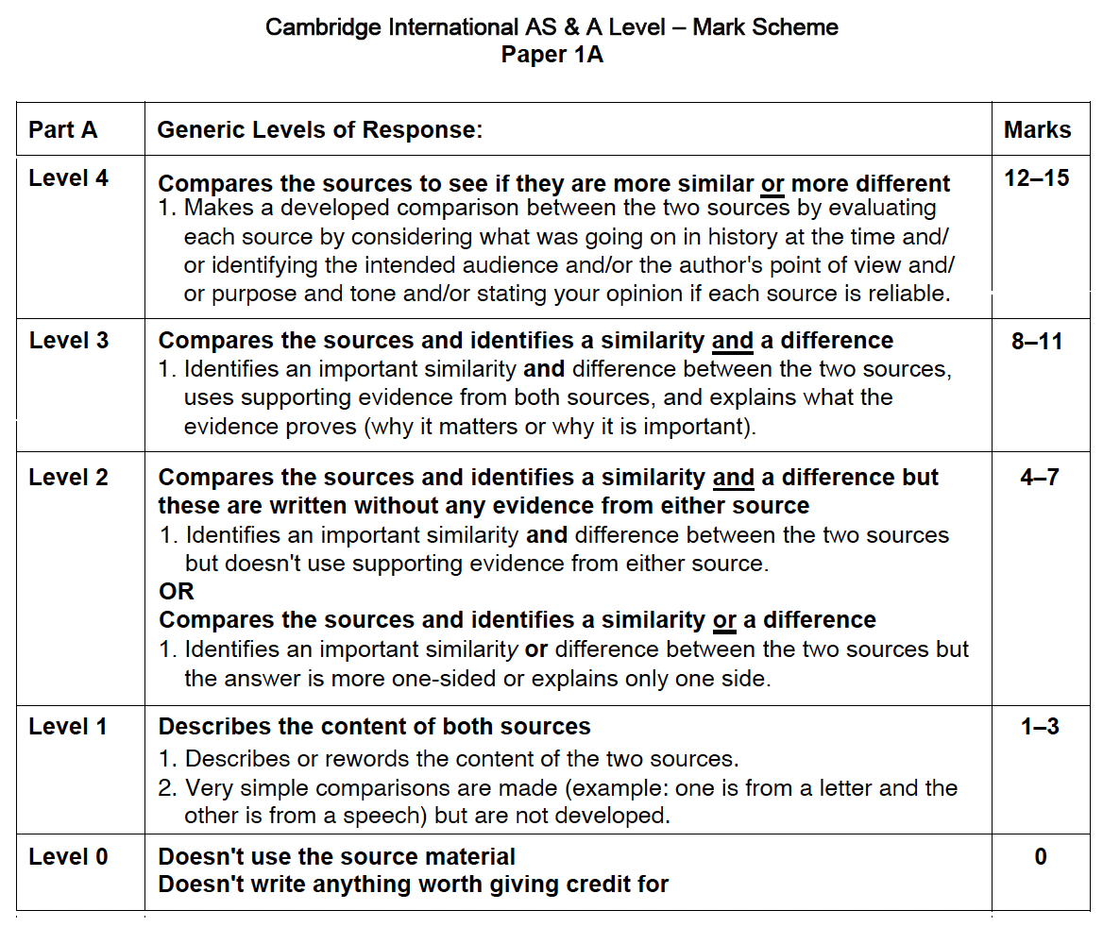

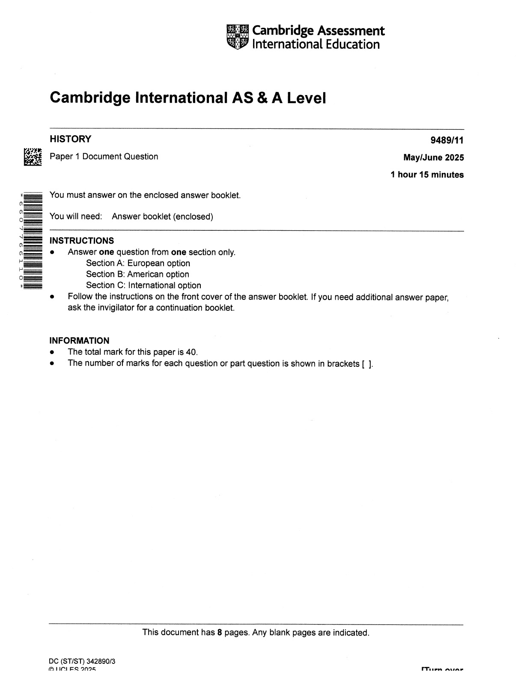
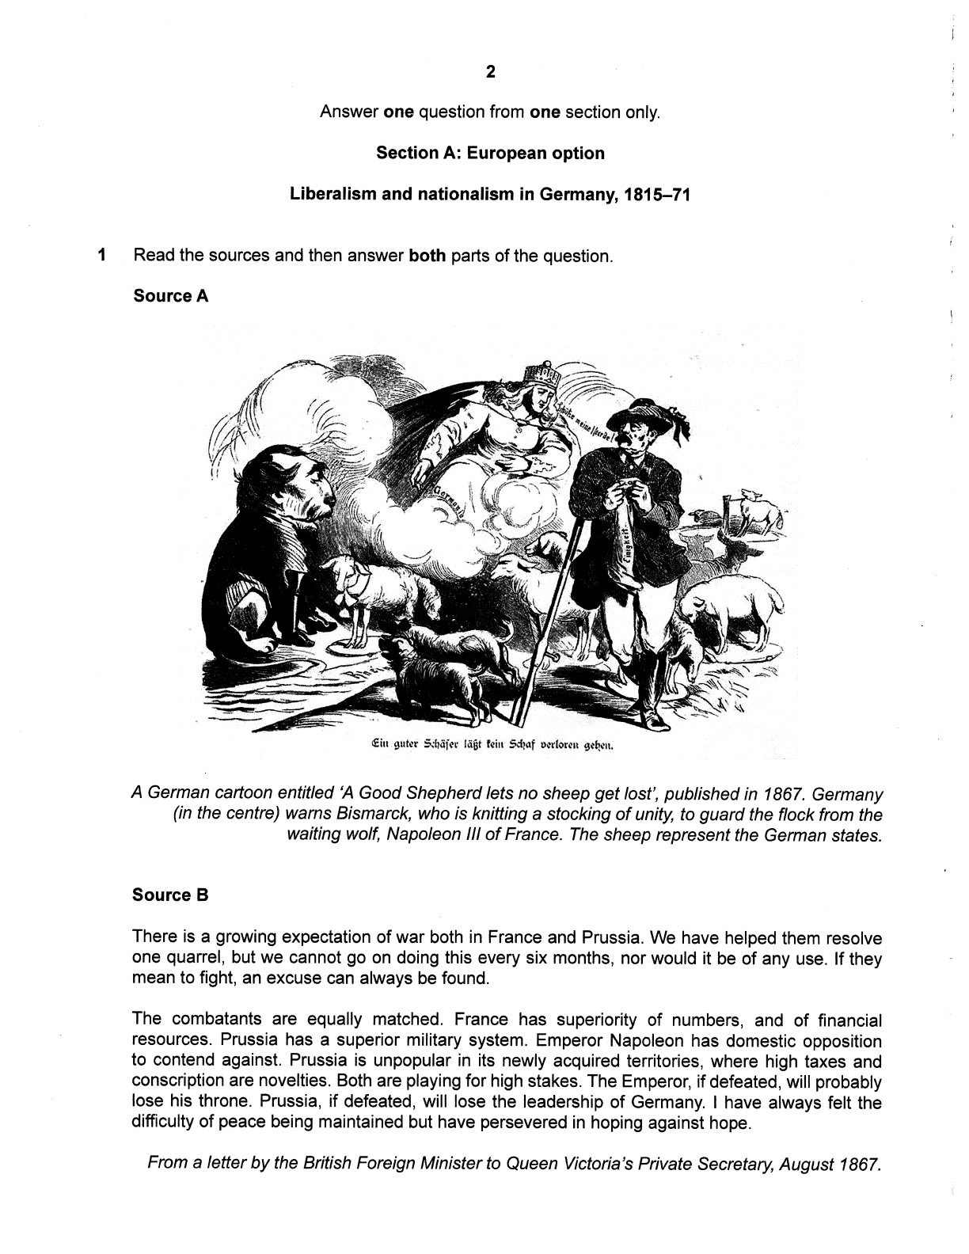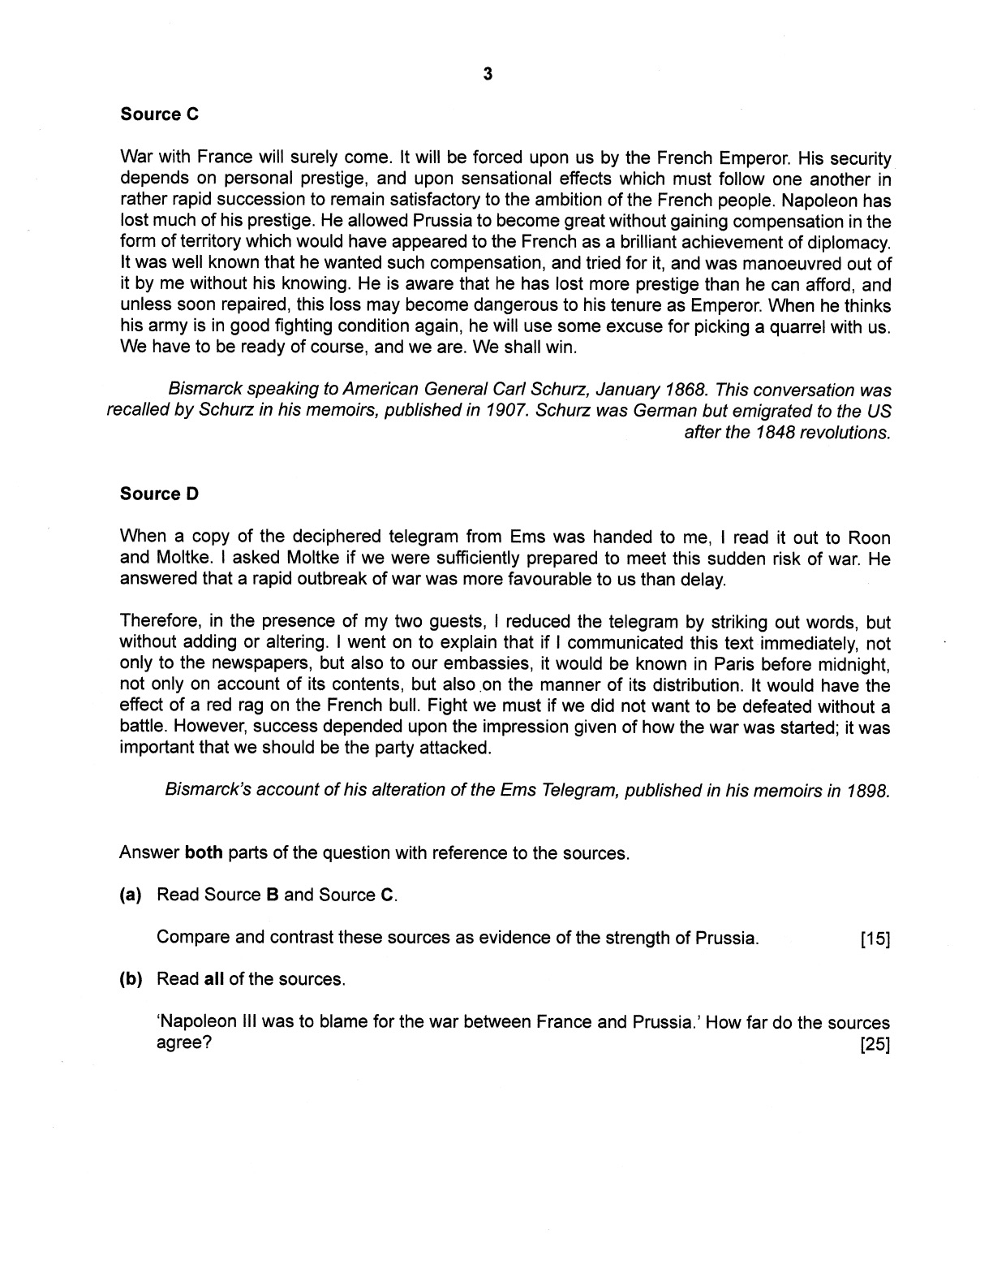
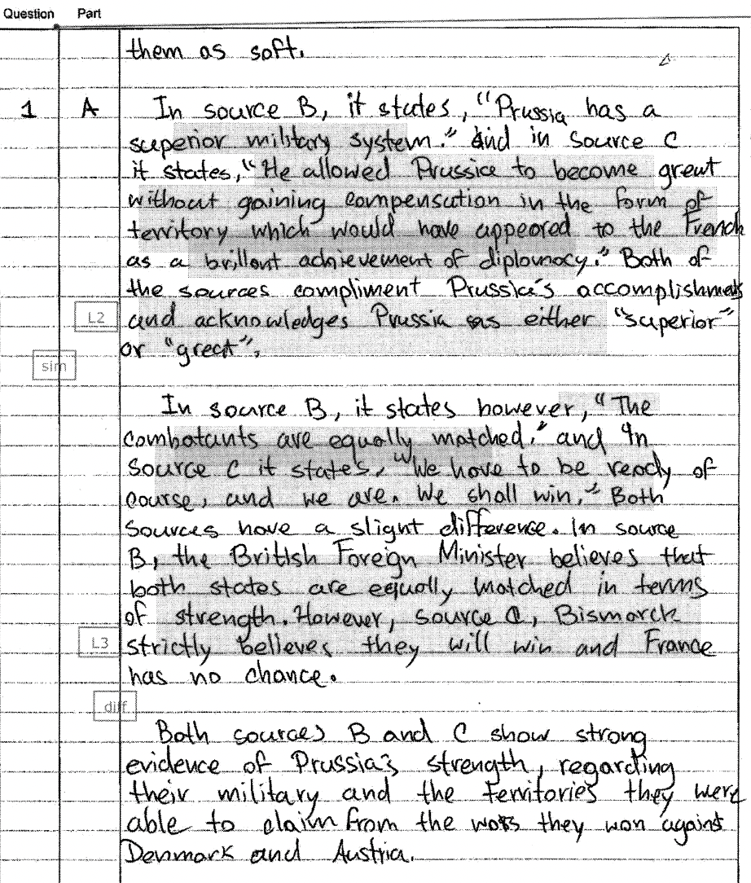

Paper 1B
Compare and Contrast 4 Sources (Agree or Disagree)
Worth 25 points- Use 45 minutes at most to complete this
Remember... 4PEEHC

Example: Question 1B: Napoleon III was to blame for the war between France and Prussia. How
far do the sources agree?

1. At the top of your AICE exam practice booklet, write "1" and "B" in the columns.
2. Plan each PEE HAPPY paragraph. Use a T-graphs, Venn diagram, etc., but at least write “4PEEHC” on the 1st
line of the answer sheet. You can earn credit for planning but be careful how much time you spend doing this.
3. Read the question/prompt before starting each paragraph. Look at where each source is from and when each source
was written. Consider what was happening in history when the source originated.
4. While reading each source, underline or circle the evidence, and if you are planning, put the information there.
5. Read one source at a time then write the PEE HAPPY paragraph for it. Start with Source A. If Source A is a picture
and you don’t understand it 100%, start with Source B. If the first source you start with agrees with the
question/prompt, search the rest of the sources until you find a source that disagrees. If the first source you start with
disagrees with the question/prompt, search the rest of the sources until you find a source that agrees.
6. Your first 2 paragraphs must include a source that agrees and a source that disagrees.
7. When you are done with your first 2 paragraphs, make sure they are solid. Decide which paragraph is the weakest.
8. If you have time, write paragraph 3 as an agree or disagree, whichever was the weakest in your first 2 paragraphs.
There may not be a 2nd agree or disagree.
9. Memorize the words below that are in italics word for word. They will be your sentence starters for every Paper 1B.

PARAGRAPHS 1, 2, 3, AND 4 ARE PEE HAPPY PARAGRAPHS
Paragraphs 1, 2, 3, and 4: Sources A, B, C, and D
1. Point: What is your point? What are you trying to say? Does it answer the question/prompt? Be clear and specific.-
Source _ (lightly/moderately/strongly) (agrees with/disagrees with) (restate the question/prompt word for
word).
2. Evidence: Give evidence from the source that supports your point- Source _ says "____.” (quote(s) from the source)
(or Source __ shows __. if it is a picture)
3. Explain: Explain why the evidence in the source supports your point- This shows ____. (make sure the explanation
connects back to the question/prompt and explains why it matters or why it is important)
*** YOU MUST USE 2 options from HAPPY below to support your point.
4. History: What was going on in history when the source originated that supports your point?
5. Audience: Who was the intended audience for the source and how did it impact the authors' messages?
6. Point of view: Who was the author of each source and how did their position impact their messages? Include tone.
7. Purpose: Why did the author of each source create the source and what was each trying to say?
8. Your opinion: Is each source reliable or unreliable and why?- Source _ (is/isn't) reliable because ____.

PARAGRAPH 5 IS THE CONCLUSION PARAGRAPH
1. Overall, source(s) _ and _ agree that (restate the question/prompt word for word). (there may only be 1 source that
agrees, but there will at least be 1, and there may be up to 3)
2. Explain: Explain in 2-3 sentences why the source(s) agree with the question/prompt. This explanation is a short
summing up of why the sources agree with the question/prompt - Source(s) _ and _ agree because ____.
3. Source(s) _ and _ disagree. (there may only be 1 source that disagrees, but there will at least be 1, and there may be
up to 3)
4. Explain: Explain in 2-3 sentences why the source(s) disagree with the question/prompt. This explanation is a short
summing up of why the sources disagree with the question/prompt - Source(s) _ and _ disagree because ____.

PARAGRAPH 1- PEE HAPPY: SOURCE ___
P  Point | What is your point? What are you trying to say? Source __ (slightly/moderately/strongly) (agrees with/disagrees with) (restate the question/prompt word for word).
E  Give evidence | Give evidence from the source that supports your point. Source __ says “___.” (or Source __ shows __. if it is a picture)
E  Explain the evidence | Explain why the evidence in the source supports your point. This shows ___. (make sure the explanation connects back to the question/prompt and explains why it matters or why it is important)
H  History  (an option) | What was going on in history when the source originated?
A  Audience  (an option) | Who was the intended audience for the source and how did it impact the authors' message?
P  Point of View  (an option) | Who was the author of the source and how did their position impact their messages? Include tone.
P  Purpose  (an option) | Why did the author of the source create the source and what was he trying to say?
Y  Opinion  (an option) | Is the source reliable or unreliable and why?- Source __ (is/isn't) reliable because ____.
PARAGRAPH 2- PEE HAPPY: SOURCE ___
P  Point | What is your point? What are you trying to say? Source __ (slightly/moderately/strongly) (agrees with/disagrees with) (restate the question/prompt word for word).
E  Give evidence | Give evidence from the source that supports your point. Source __ says “___.” (or Source __ shows __. if it is a picture)
E  Explain the evidence | Explain why the evidence in the source supports your point. This shows ___. (make sure the explanation connects back to the question/prompt and explains why it matters or why it is important)
H  History  (an option) | What was going on in history when the source originated?
A  Audience  (an option) | Who was the intended audience for the source and how did it impact the authors' message?
P  Point of View  (an option) | Who was the author of the source and how did their position impact their messages? Include tone.
P  Purpose  (an option) | Why did the author of the source create the source and what was he trying to say?
Y  Opinion  (an option) | Is the source reliable or unreliable and why?- Source __ (is/isn't) reliable because ____.
PARAGRAPH 3- PEE HAPPY: SOURCE ___
P  Point | What is your point? What are you trying to say? Source __ (slightly/moderately/strongly) (agrees with/disagrees with) (restate the question/prompt word for word).
E  Give evidence | Give evidence from the source that supports your point. Source __ says “___.” (or Source __ shows __. if it is a picture)
E  Explain the evidence | Explain why the evidence in the source supports your point. This shows ___. (make sure the explanation connects back to the question/prompt and explains why it matters or why it is important)
H  History  (an option) | What was going on in history when the source originated?
A  Audience  (an option) | Who was the intended audience for the source and how did it impact the authors' message?
P  Point of View  (an option) | Who was the author of the source and how did their position impact their messages? Include tone.
P  Purpose  (an option) | Why did the author of the source create the source and what was he trying to say?
Y  Opinion  (an option) | Is the source reliable or unreliable and why?- Source __ (is/isn't) reliable because ____.
PARAGRAPH 4- PEE HAPPY: SOURCE ___
P  Point | What is your point? What are you trying to say? Source __ (slightly/moderately/strongly) (agrees with/disagrees with) (restate the question/prompt word for word).
E  Give evidence | Give evidence from the source that supports your point. Source __ says “___.” (or Source __ shows __. if it is a picture)
E  Explain the evidence | Explain why the evidence in the source supports your point. This shows ___. (make sure the explanation connects back to the question/prompt and explains why it matters or why it is important)
H  History  (an option) | What was going on in history when the source originated?
A  Audience  (an option) | Who was the intended audience for the source and how did it impact the authors' message?
P  Point of View  (an option) | Who was the author of the source and how did their position impact their messages? Include tone.
P  Purpose  (an option) | Why did the author of the source create the source and what was he trying to say?
Y  Opinion  (an option) | Is the source reliable or unreliable and why?- Source __ (is/isn't) reliable because ____.

What the people who score the AICE exams
look at to award marks (points)
